Supplementary Information

Structural and stereochemical determinants for hGAT3 inhibition: development of novel conformationally constrained and substituted analogs of (S)-isoserine.

Bavo F, Kickinger S, Lie MEK, Avgerinos C, Wilhelmsen KS, Wellendorph P and Frølund B.

Department of Drug Design and Pharmacology, University of Copenhagen, Copenhagen, Denmark

E-mail correspondent author: bfr@sund.ku.dk

Description | Page
¹H-NMR and ¹³C-NMR of final compounds. | 2-21
Investigation of the absolute configuration of (S)-6a and (S)-7a. | 22-24
HPLC chromatograms. | 25-31
Pharmacology: Figure S1. | 32

¹H-NMR and ¹³C-NMR of final compounds.
3-carboxy-3-hydroxyazetidin-1-ium chloride 3.
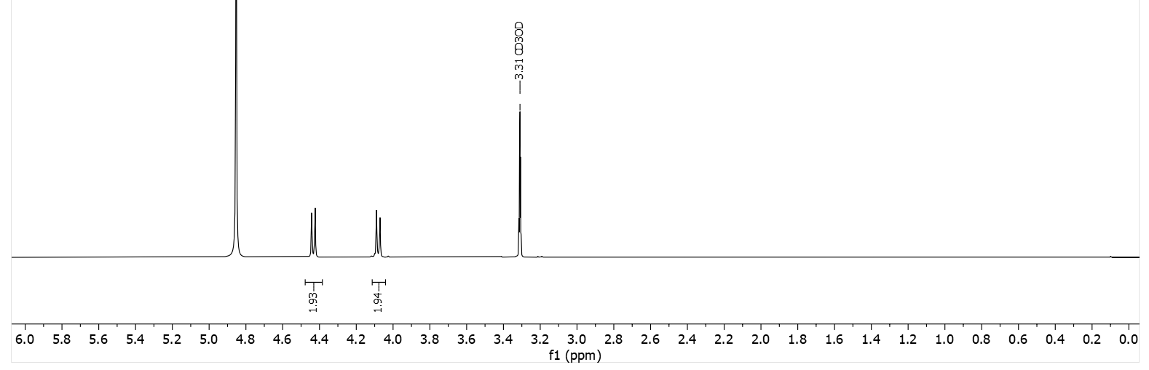
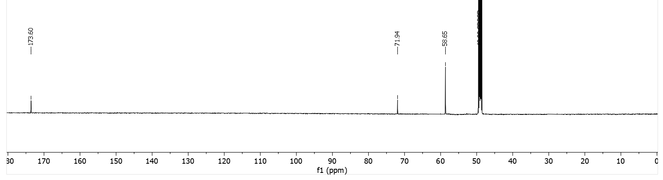
(rac)-3-hydroxypyrrolidine-3-carboxylic acid (rac)-4.
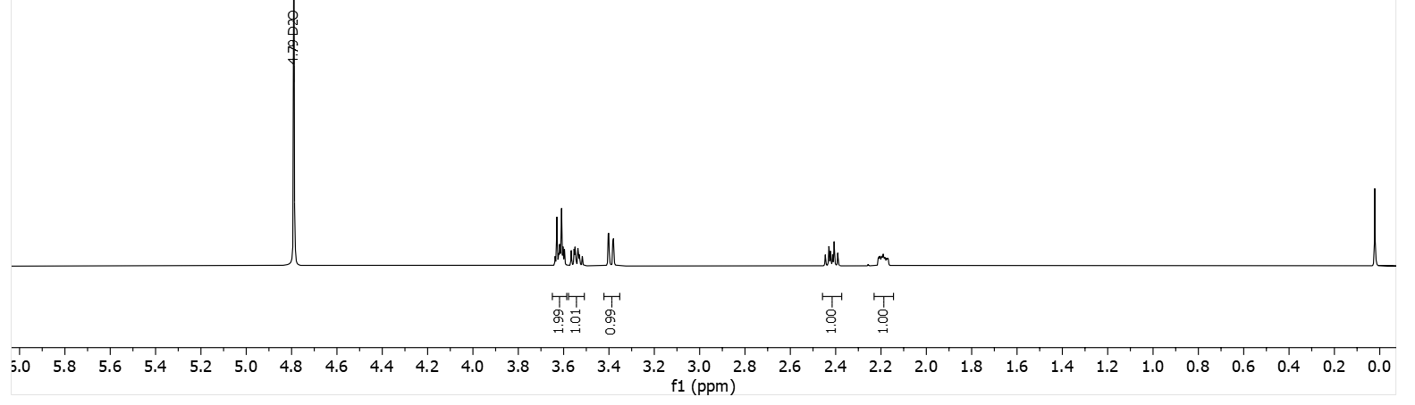
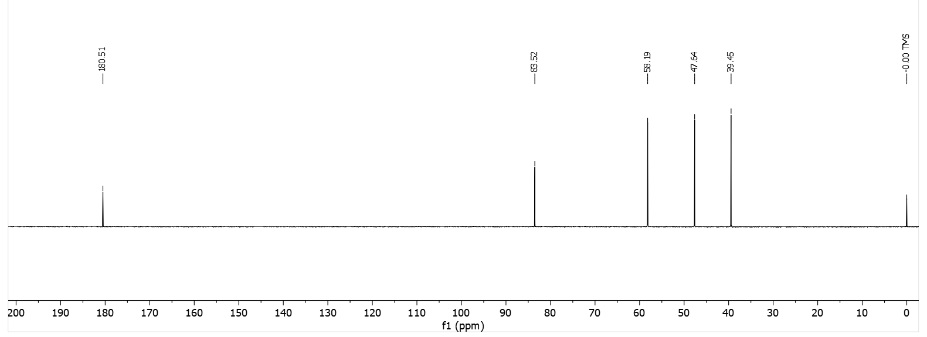

(S)-2-((S)-azetidin-2-yl)-2-hydroxyacetic acid (S,S)-6a.
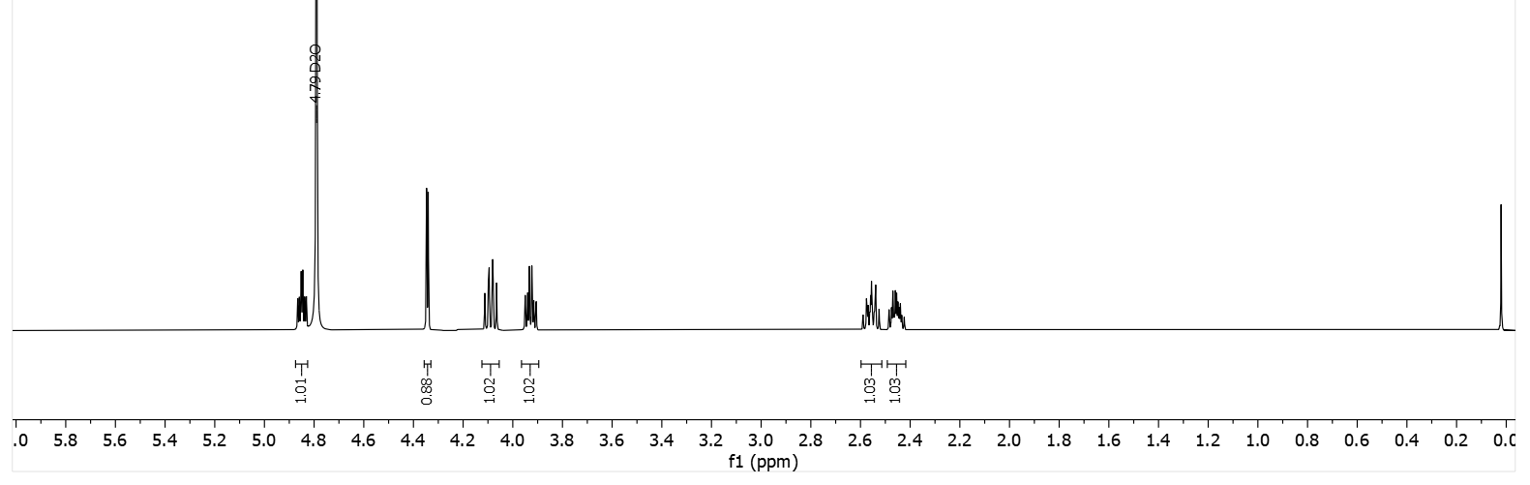
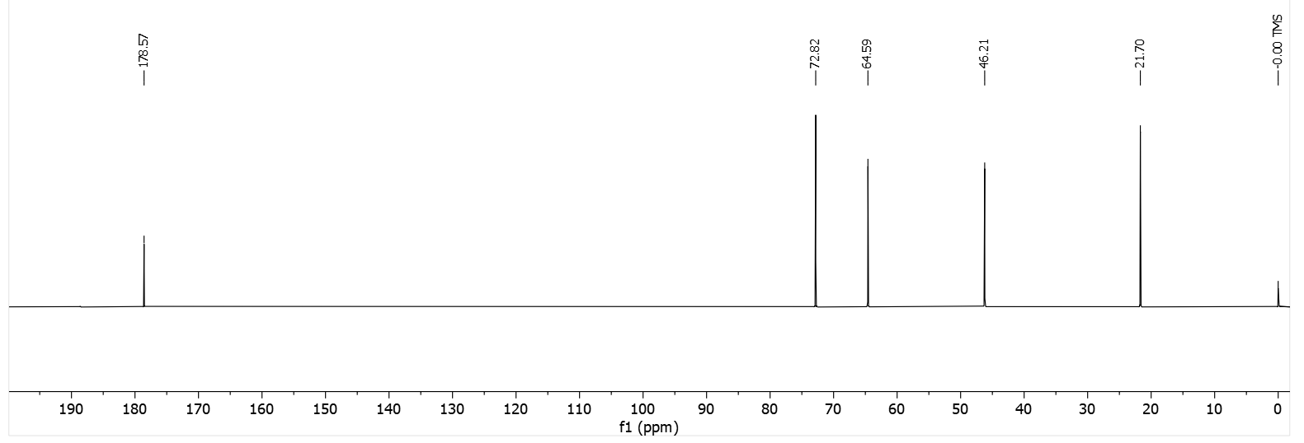
(R)-2-((S)-azetidin-2-yl)-2-hydroxyacetic acid (S,R)-6b.

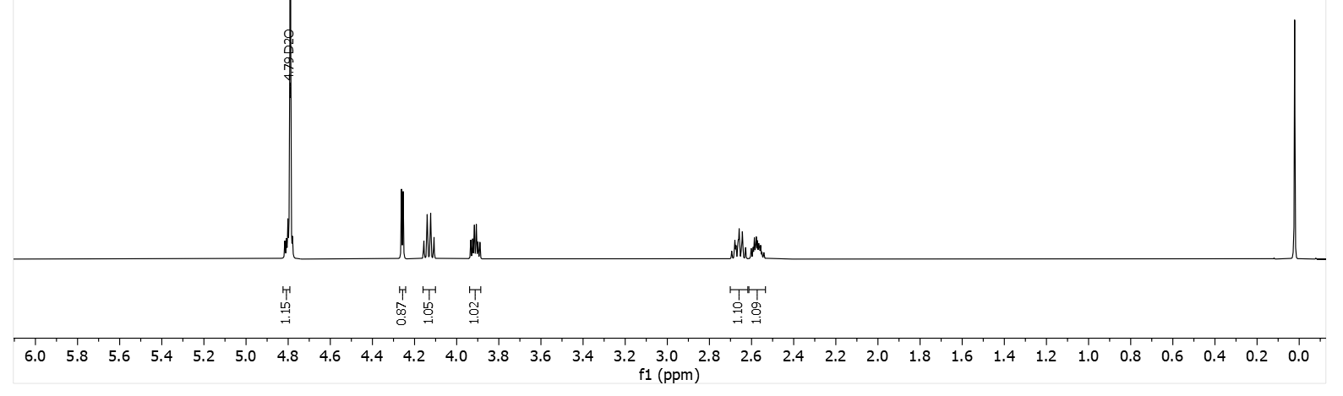
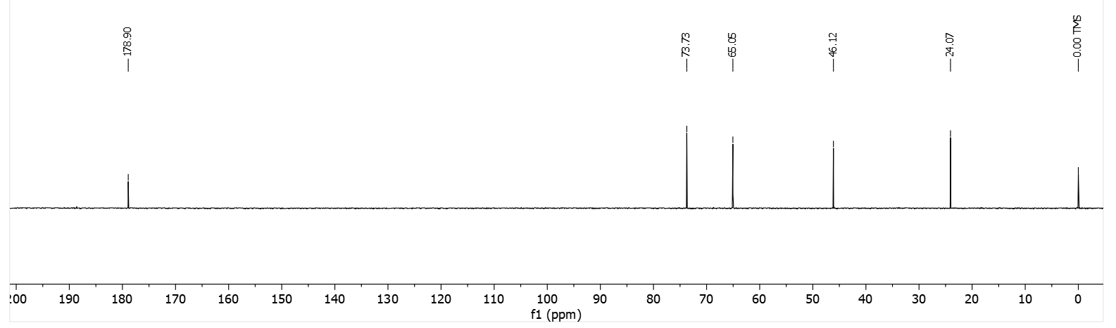
(R)-2-((R)-azetidin-2-yl)-2-hydroxyacetic acid (R,R)-6a.
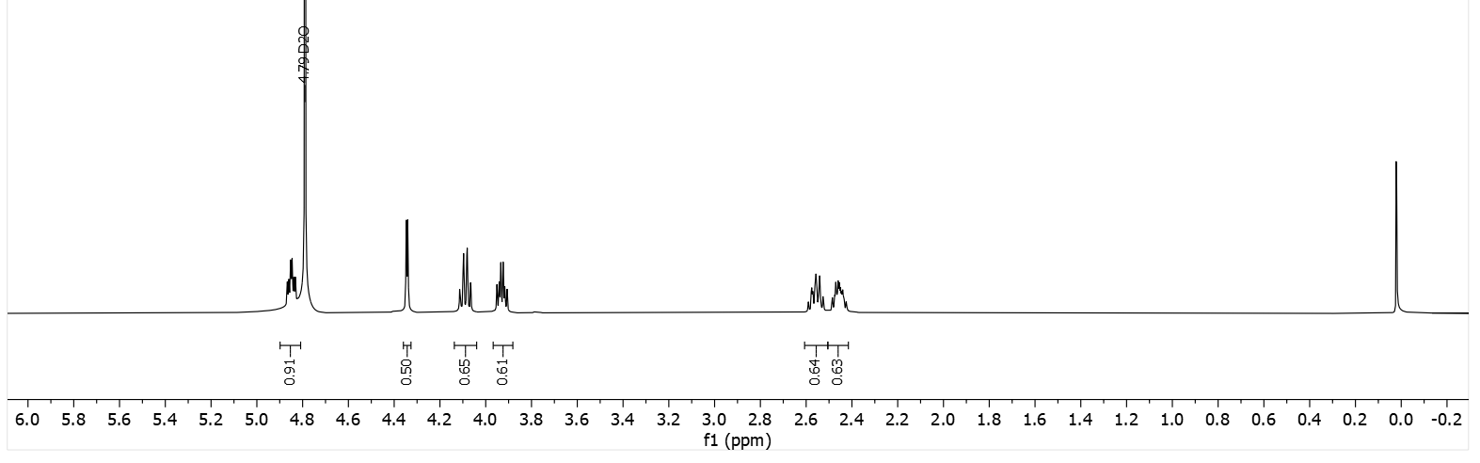
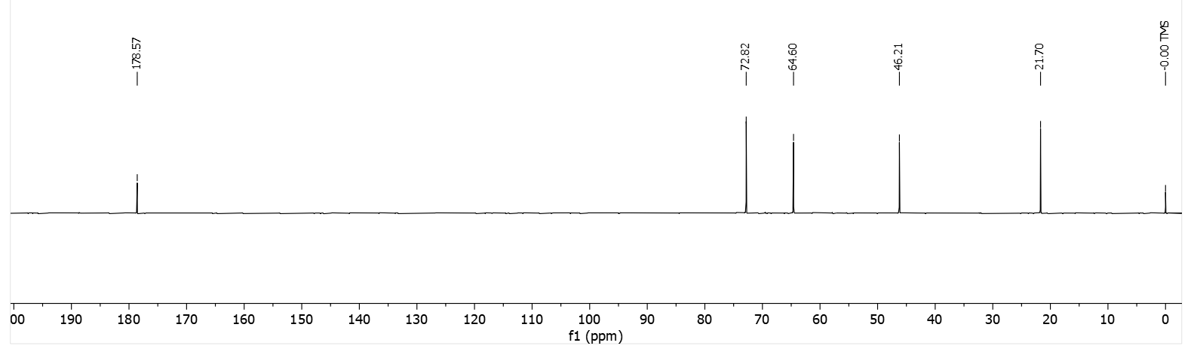
(S)-2-((R)-azetidin-2-yl)-2-hydroxyacetic acid (R,S)-6b.

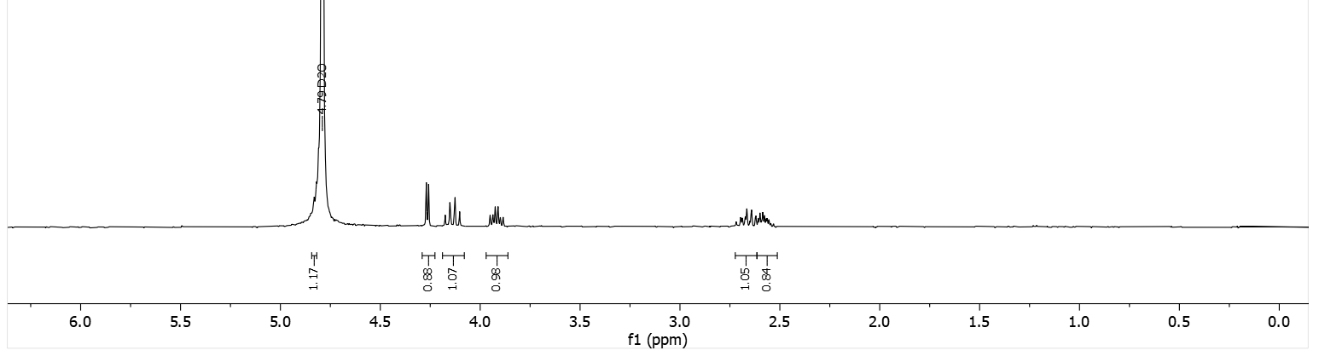
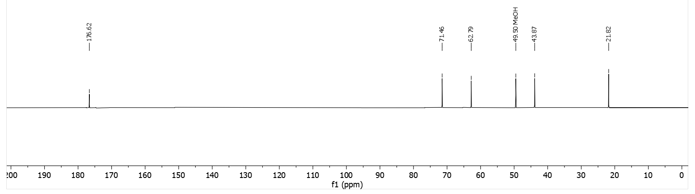
(S)-2-((S)-pyrrolidin-2-yl)-2-hydroxyacetic acid (S,S)-7a.
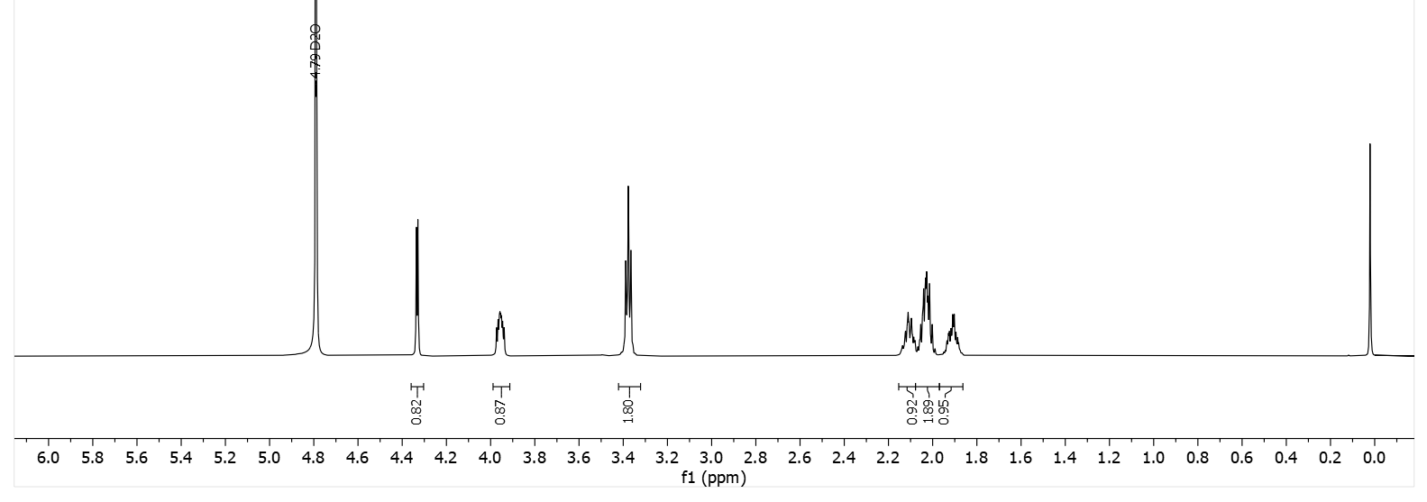
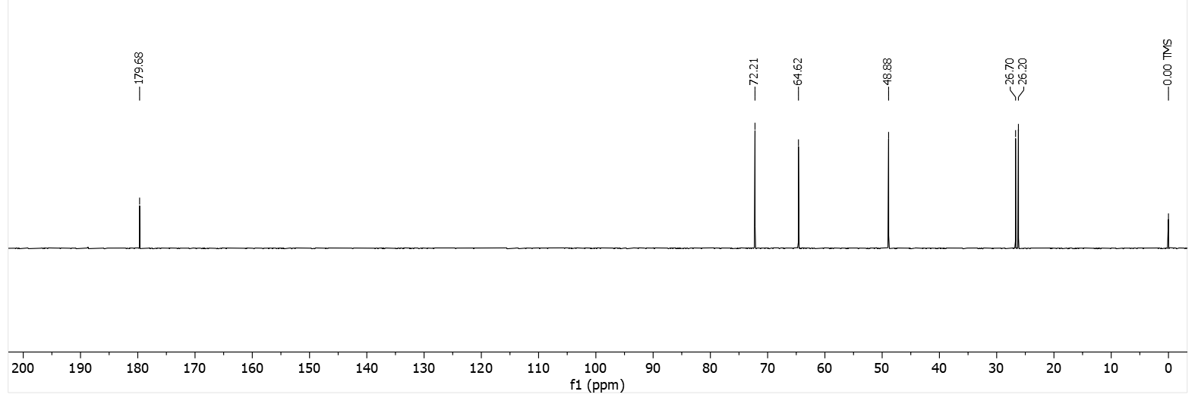
(R)-2-((S)-pyrrolidin-2-yl)-2-hydroxyacetic acid (S,R)-7b.
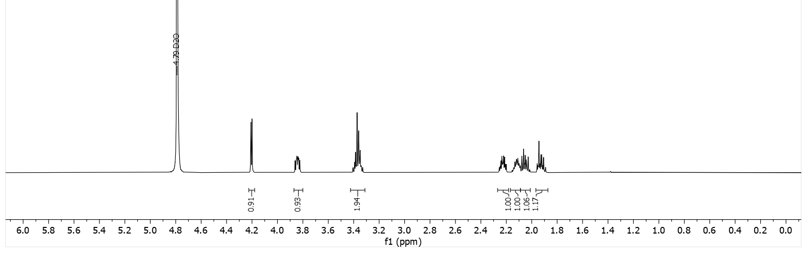
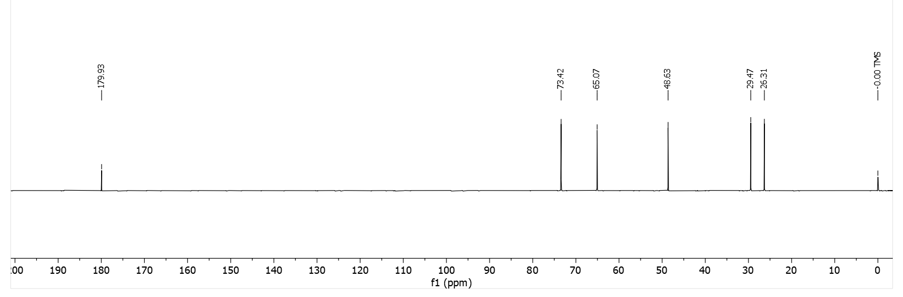

(R)-2-((R)-pyrrolidin-2-yl)-2-hydroxyacetic acid (R,R)-7a.
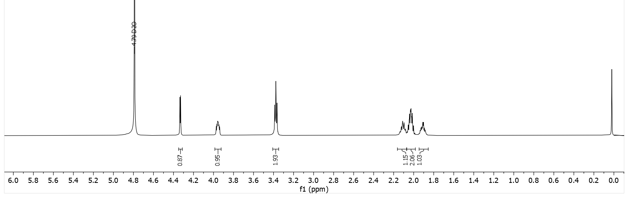
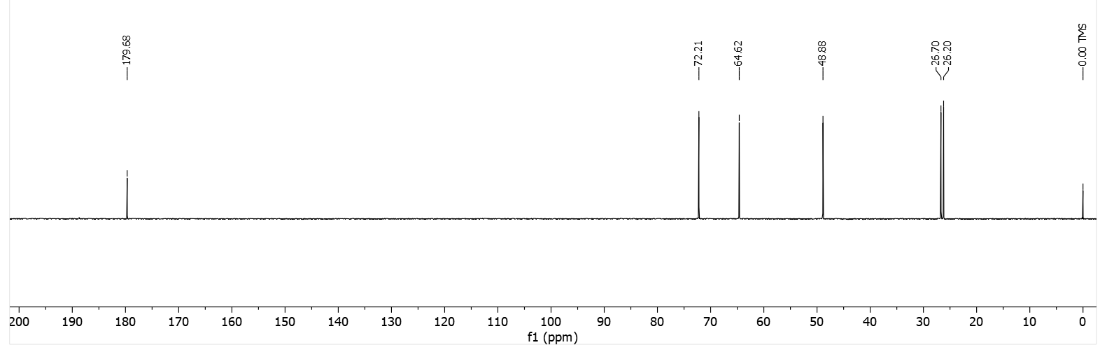
(S)-2-((R)-pyrrolidin-2-yl)-2-hydroxyacetic acid (R,S)-7b.
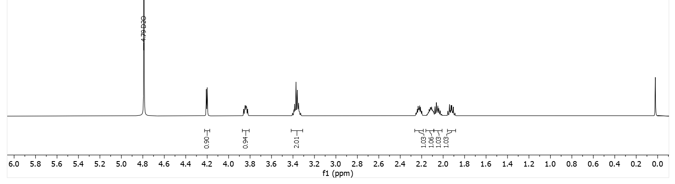
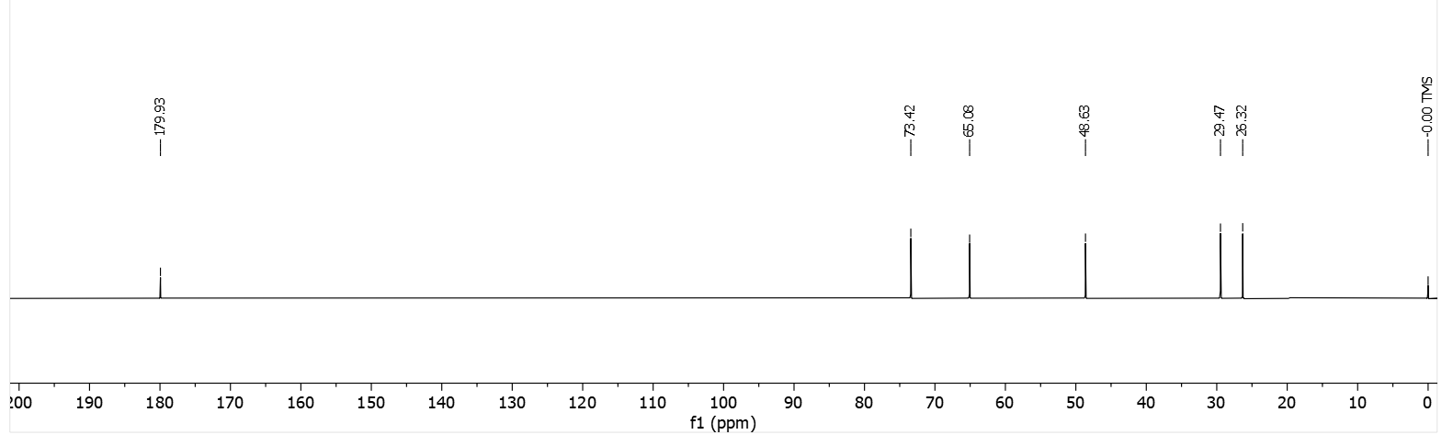

(rac)-2-(pyrrolidin-2-yl)-2-hydroxyacetic acid (rac)-8a.
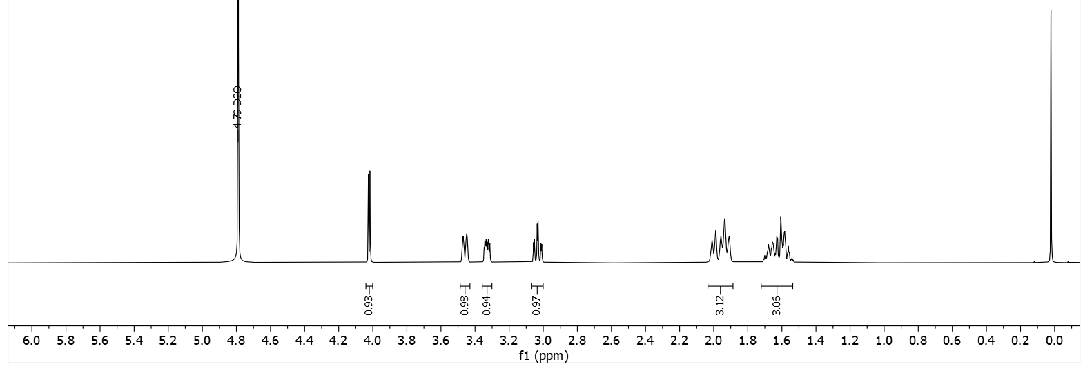
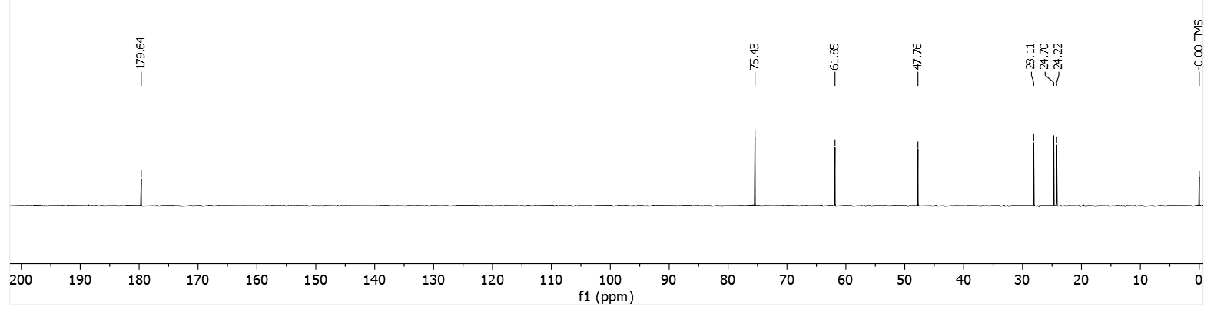
(rac)-2-(pyrrolidin-2-yl)-2-hydroxyacetic acid (rac)-8b.

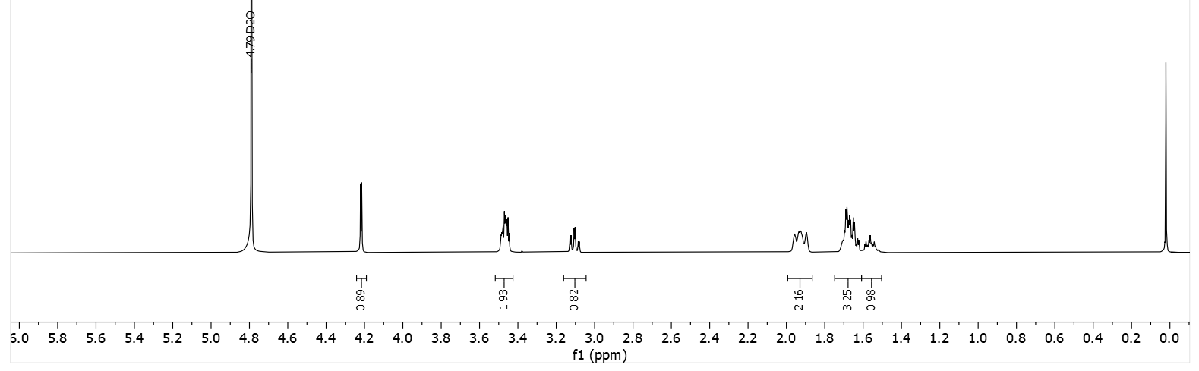
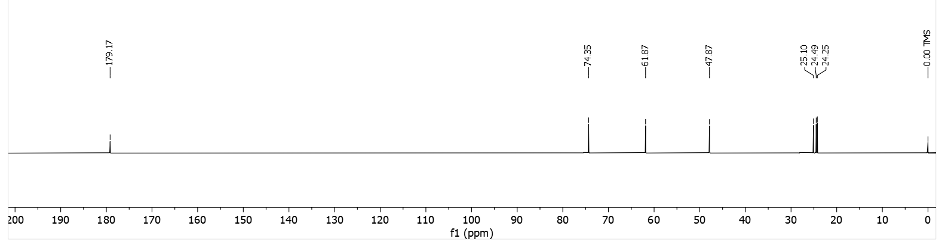

2-(azetidin-3-yl)-2-hydroxyacetic acid (rac)-9.
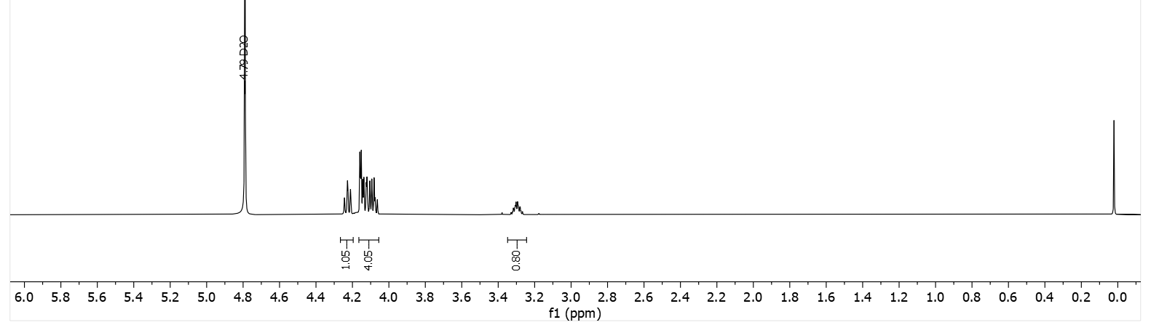
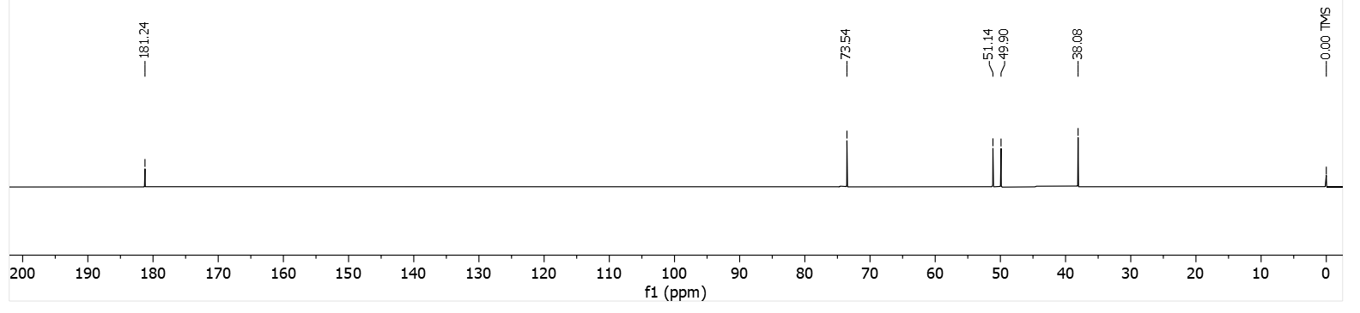

2-hydroxy-2-((S)-pyrrolidin-3-yl)acetic acid (S)-10a.
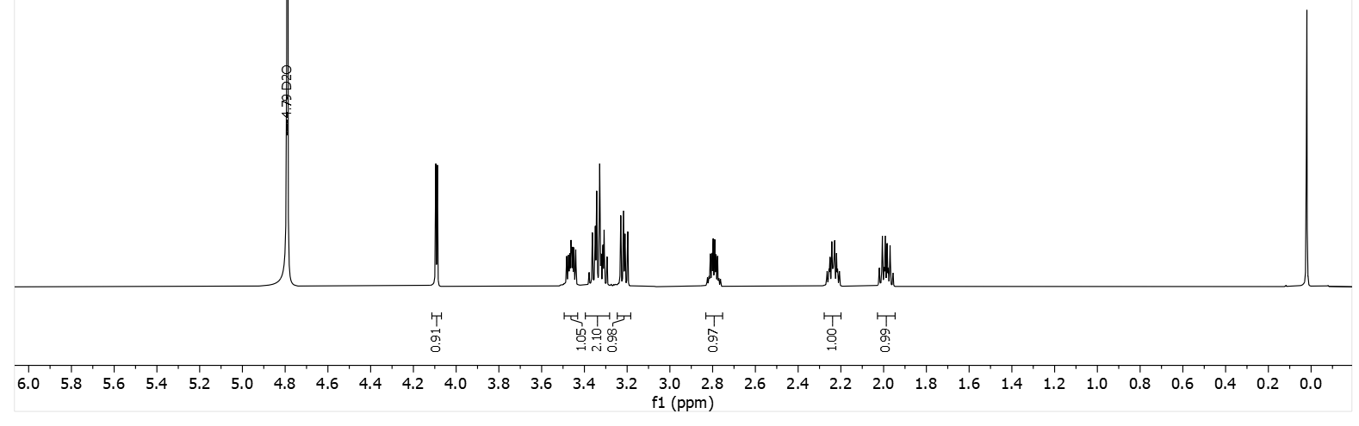
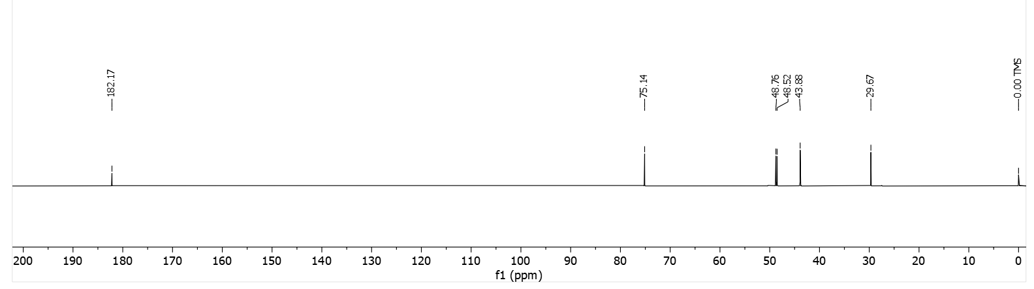
2-hydroxy-2-((S)-pyrrolidin-3-yl)acetic acid (S)-10b.
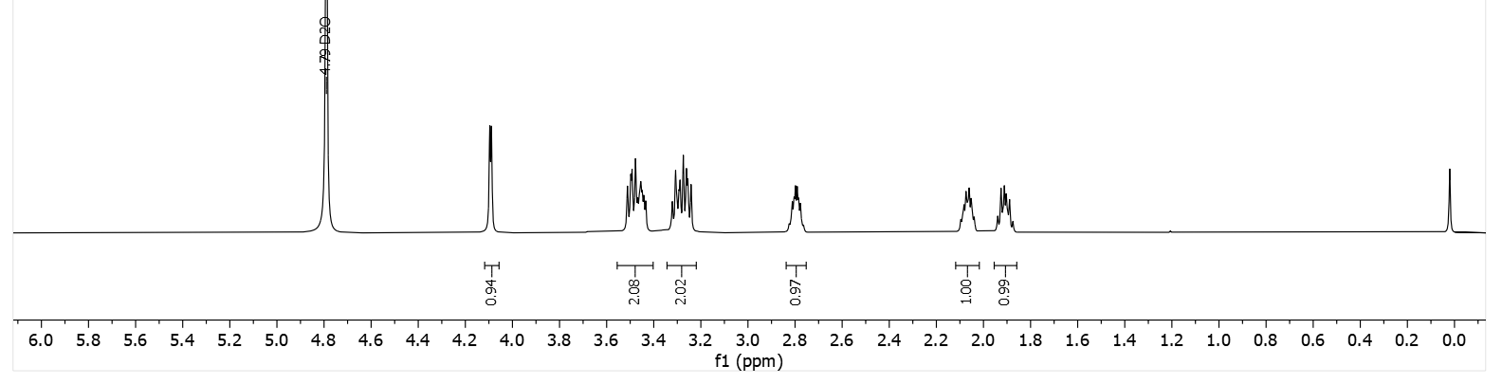
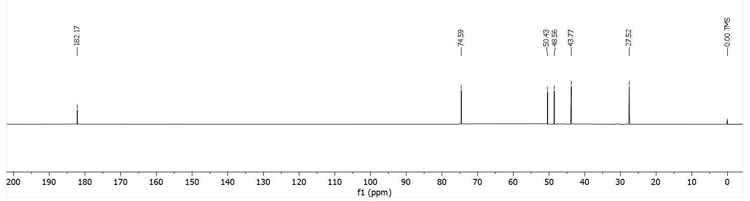

2-hydroxy-2-((R)-pyrrolidin-3-yl)acetic acid (R)-10a.
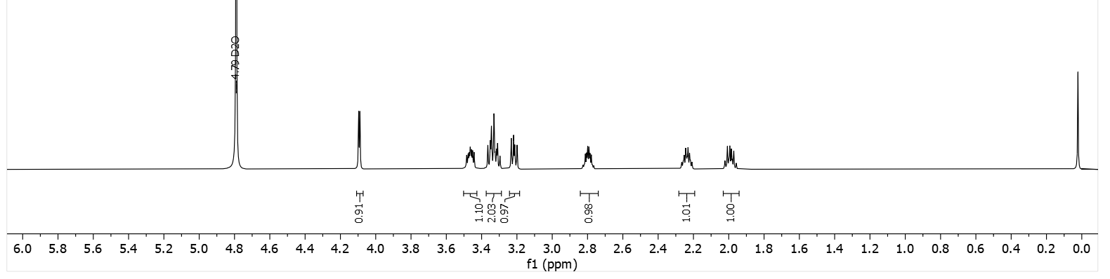
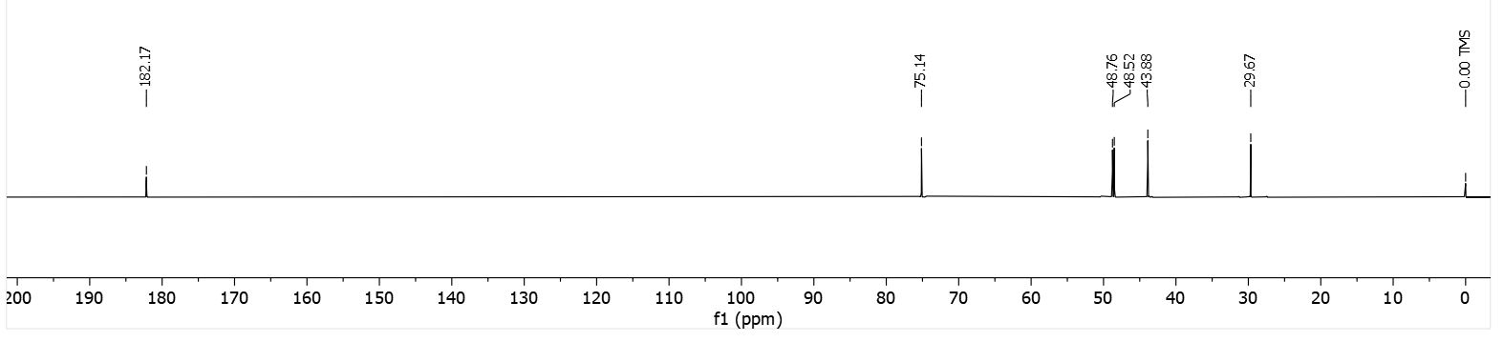
2-hydroxy-2-((R)-pyrrolidin-3-yl)acetic acid (R)-10b.
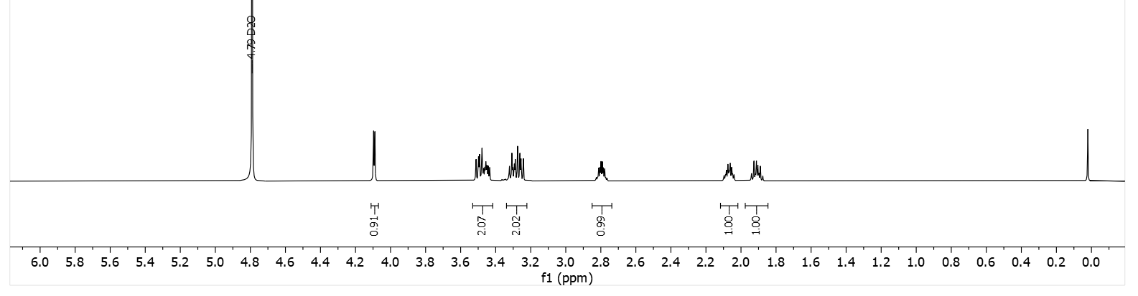
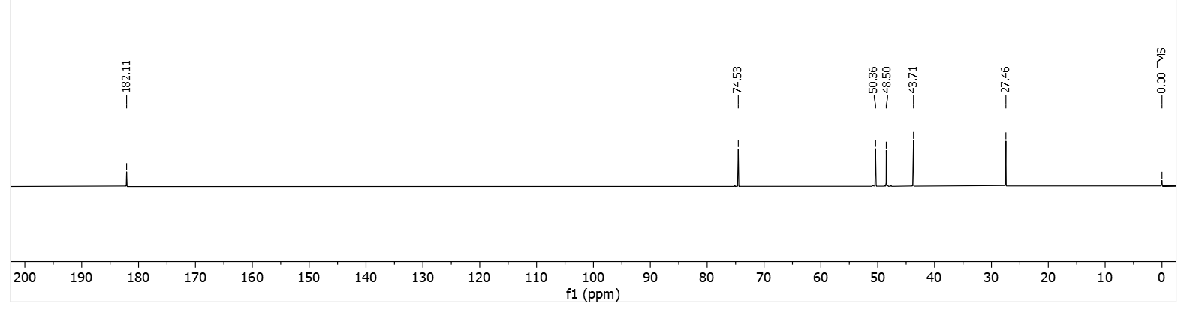

2-hydroxy-2-((S)-piperidin-3-yl)acetic acid (S)-11a.
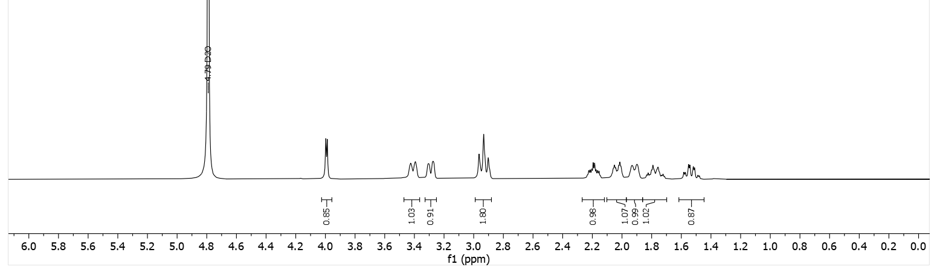
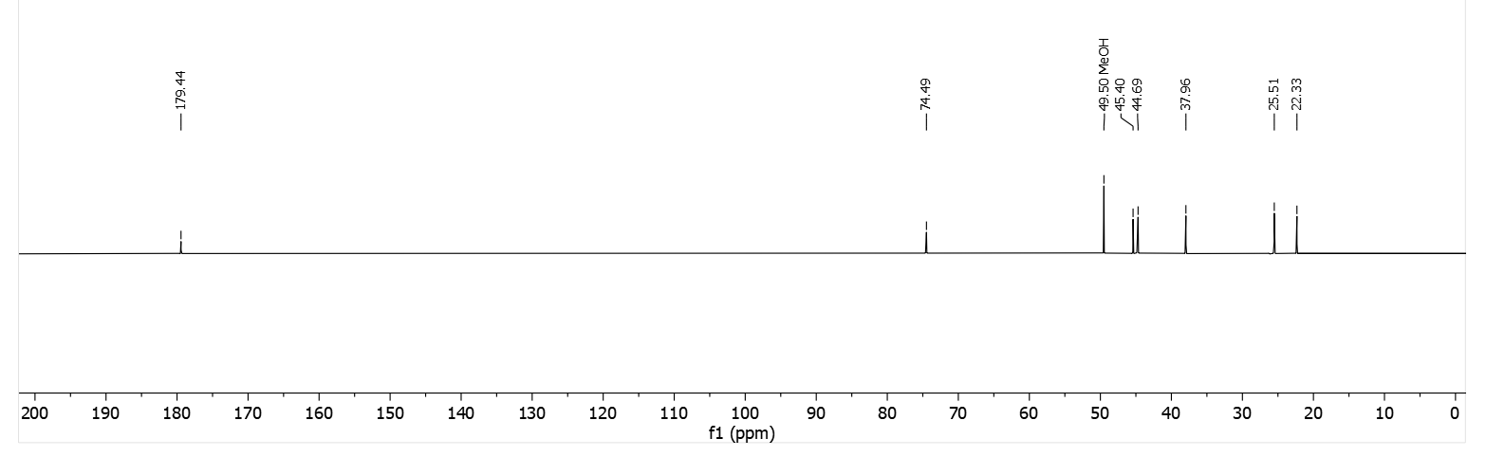
2-hydroxy-2-((S)-piperidin-3-yl)acetic acid (S)-11b.
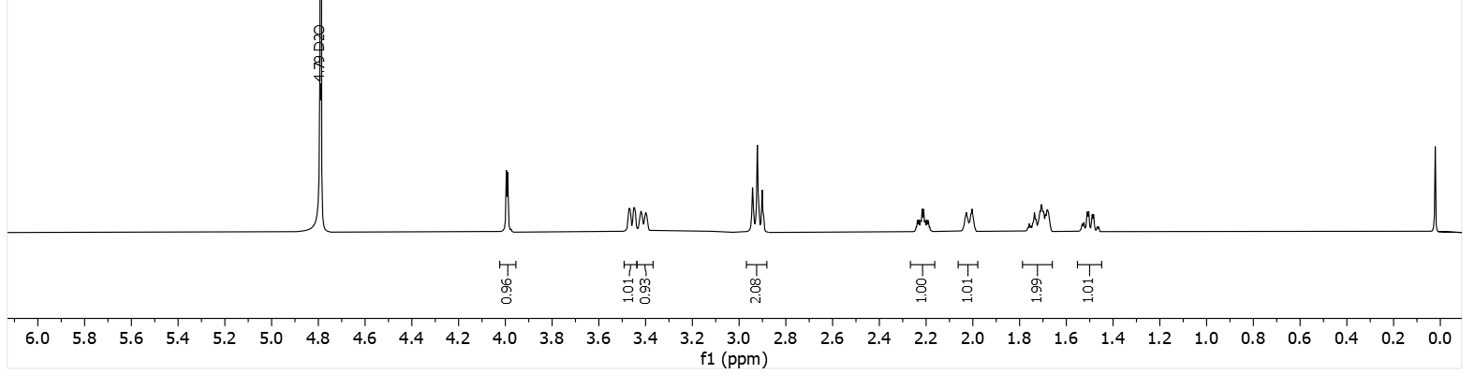
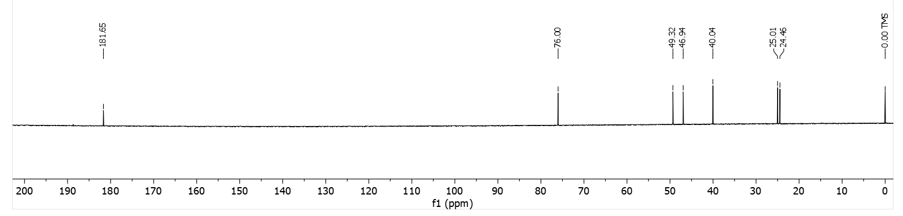

2-hydroxy-2-((R)-piperidin-3-yl)acetic acid (R)-11a.
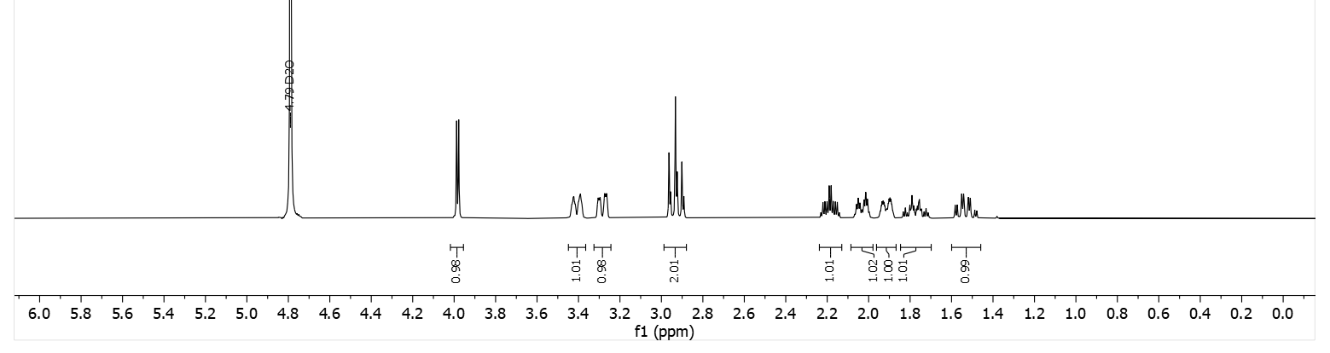
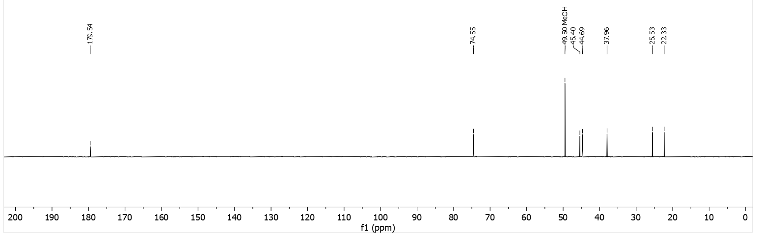
2-hydroxy-2-((R)-piperidin-3-yl)acetic acid (R)-11b.
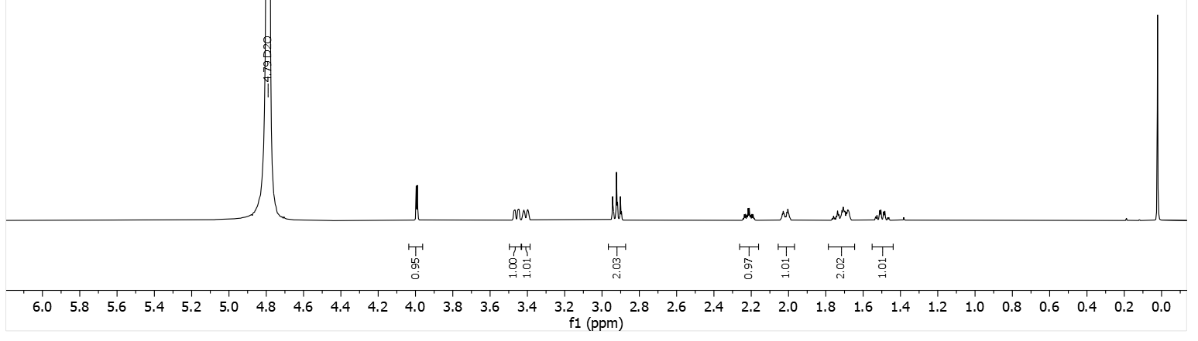
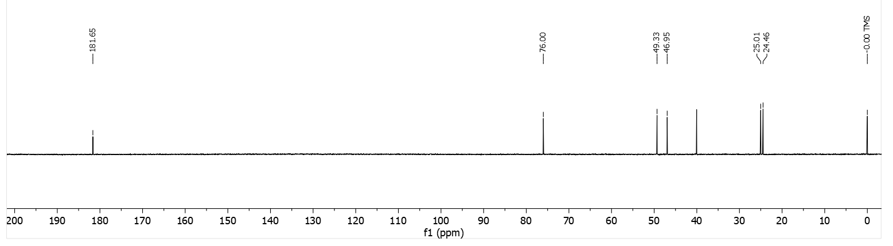

(S)-2-((S)-1-benzylazetidin-2-yl)-2-hydroxyacetic acid (S,S)-12.
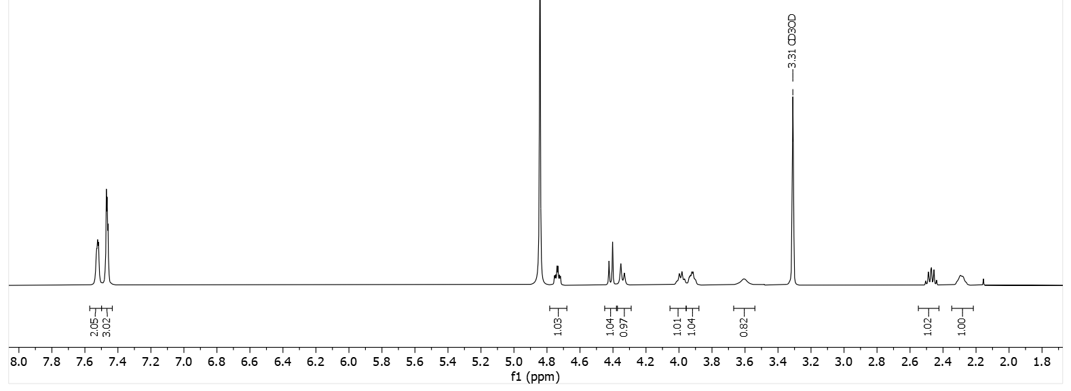
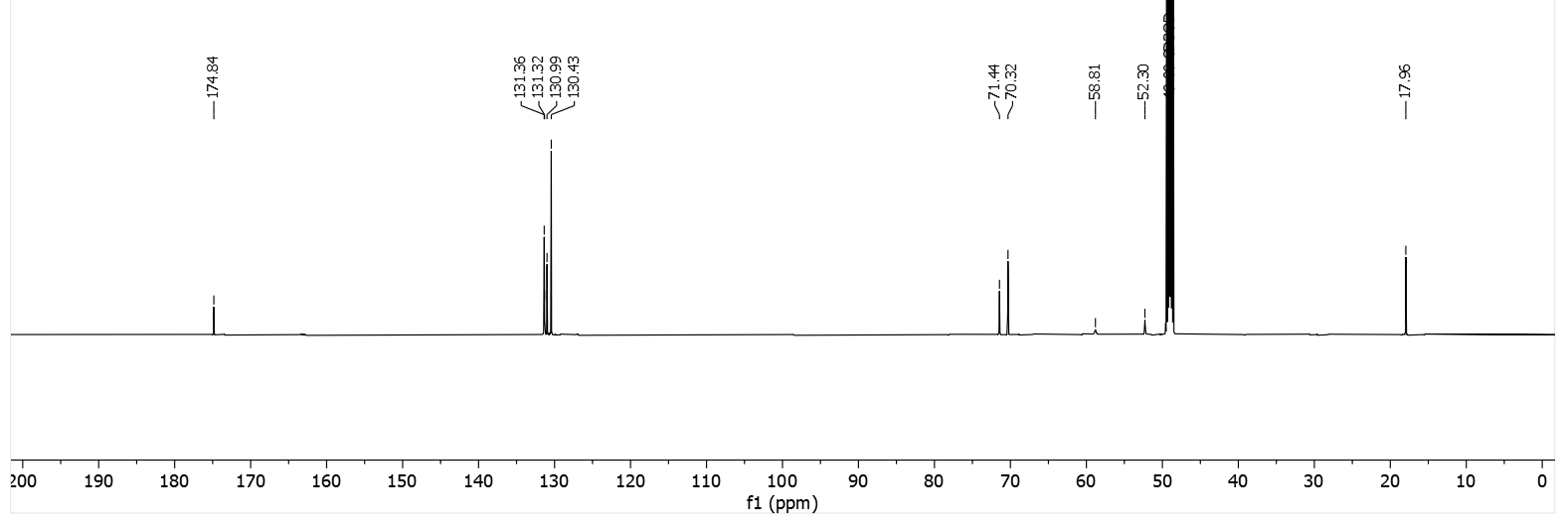
(S)-2-((S)-1-([1,1'-biphenyl]-3-ylmethyl)azetidin-2-yl)-2-hydroxyacetic acid (S,S)-13.
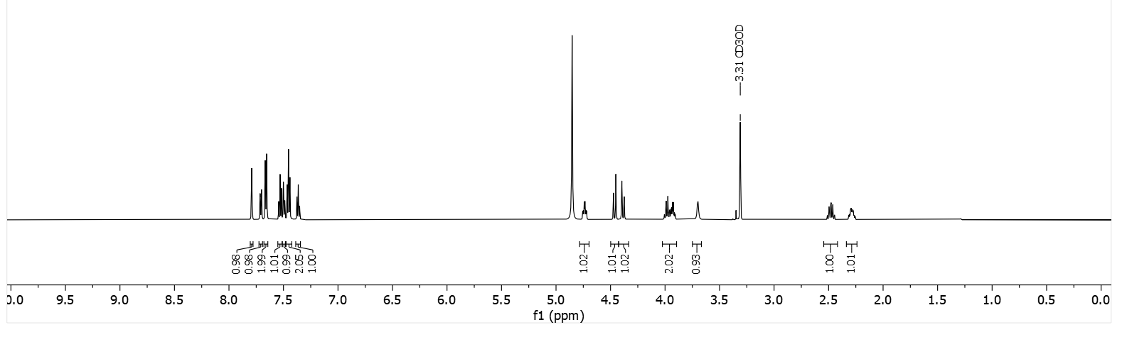
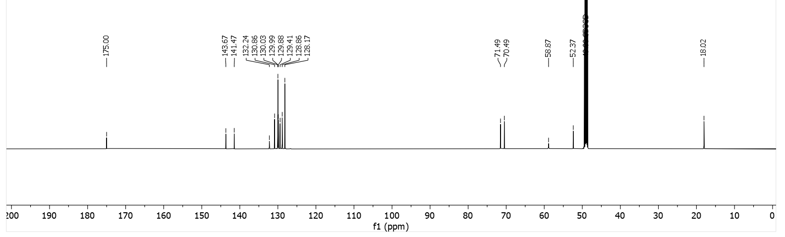

(S)-2-((S)-1-([1,1'-biphenyl]-4-ylmethyl)azetidin-2-yl)-2-hydroxyacetic acid (S,S)-14.
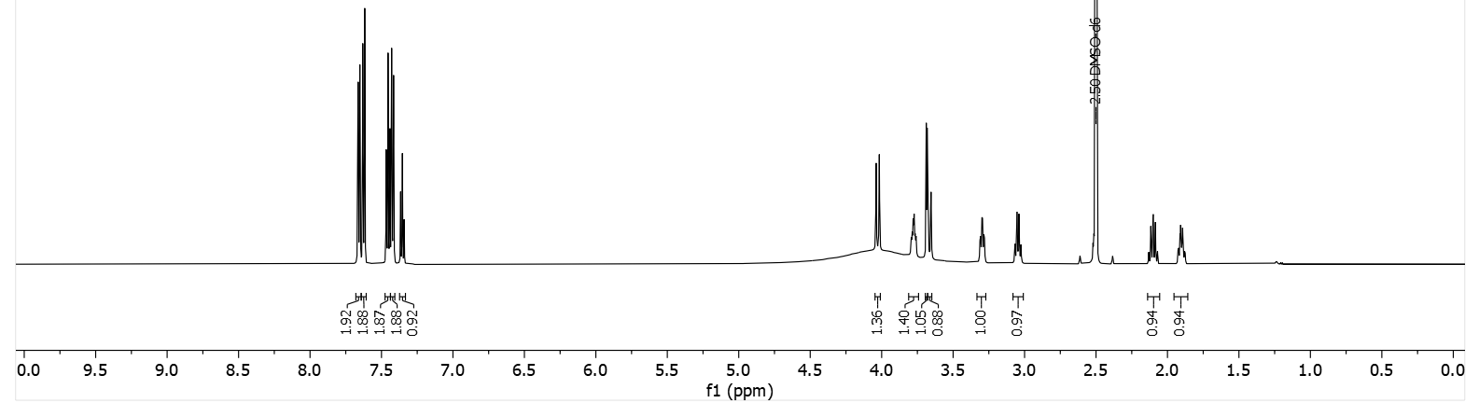
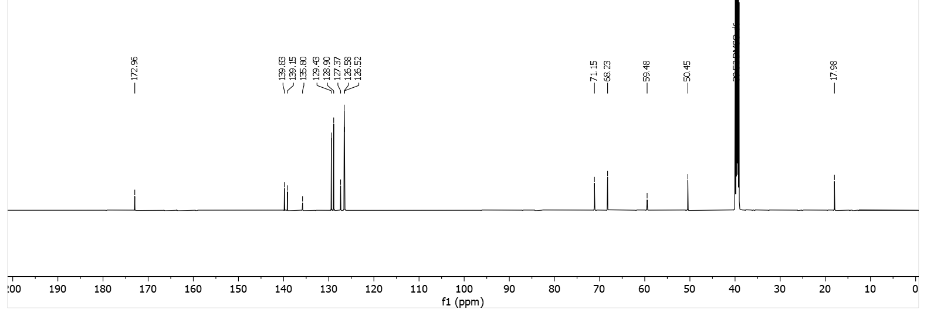
(S)-2-((S)-1-(4-(benzyloxy)benzyl)azetidin-2-yl)-2-hydroxyacetic acid (S,S)-15.
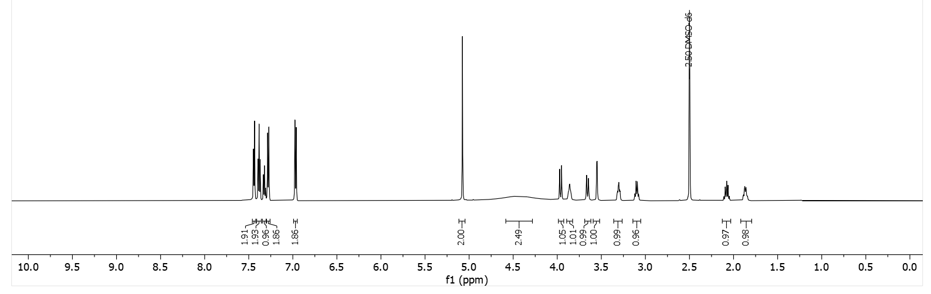
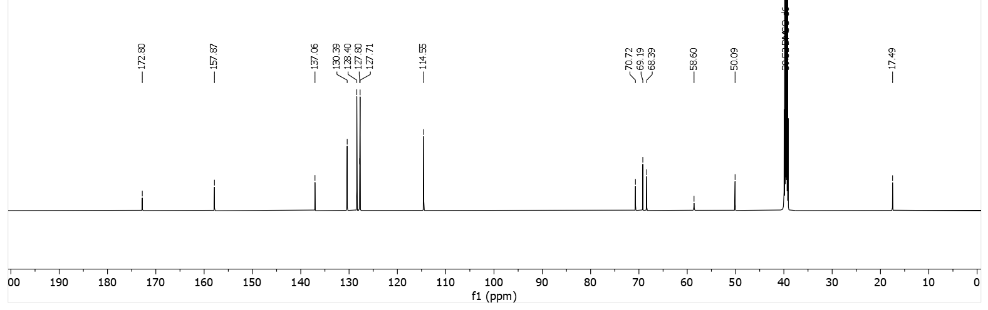

(S)-2-hydroxy-2-((S)-1-(4-hydroxybenzyl)azetidin-2-yl)acetic acid (S,S)-16.
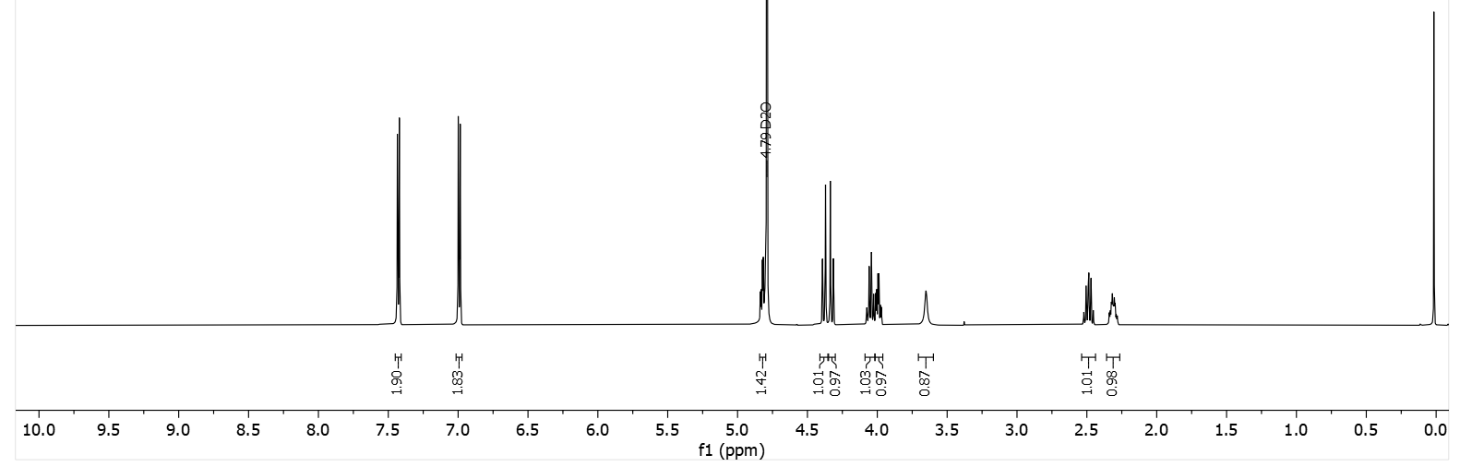
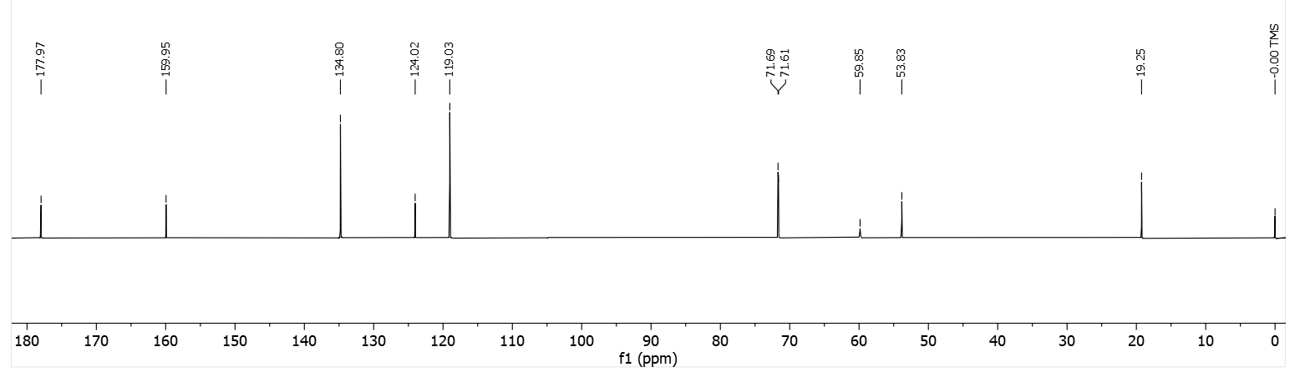
(S)-2-((S)-1-(4-acetamidobenzyl)azetidin-2-yl)-2-hydroxyacetic acid (S,S)-17.
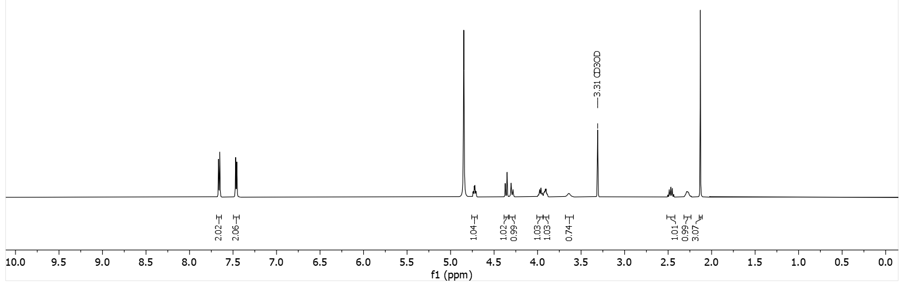
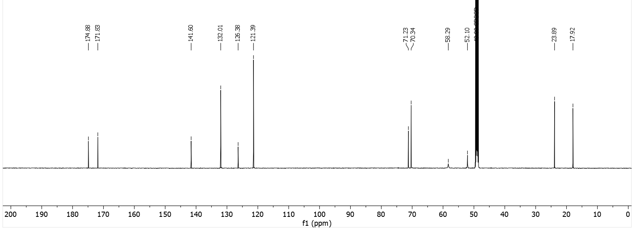

(S)-2-((S)-1-benzylpyrrolidin-2-yl)-2-hydroxyacetic acid (S,S)-18.
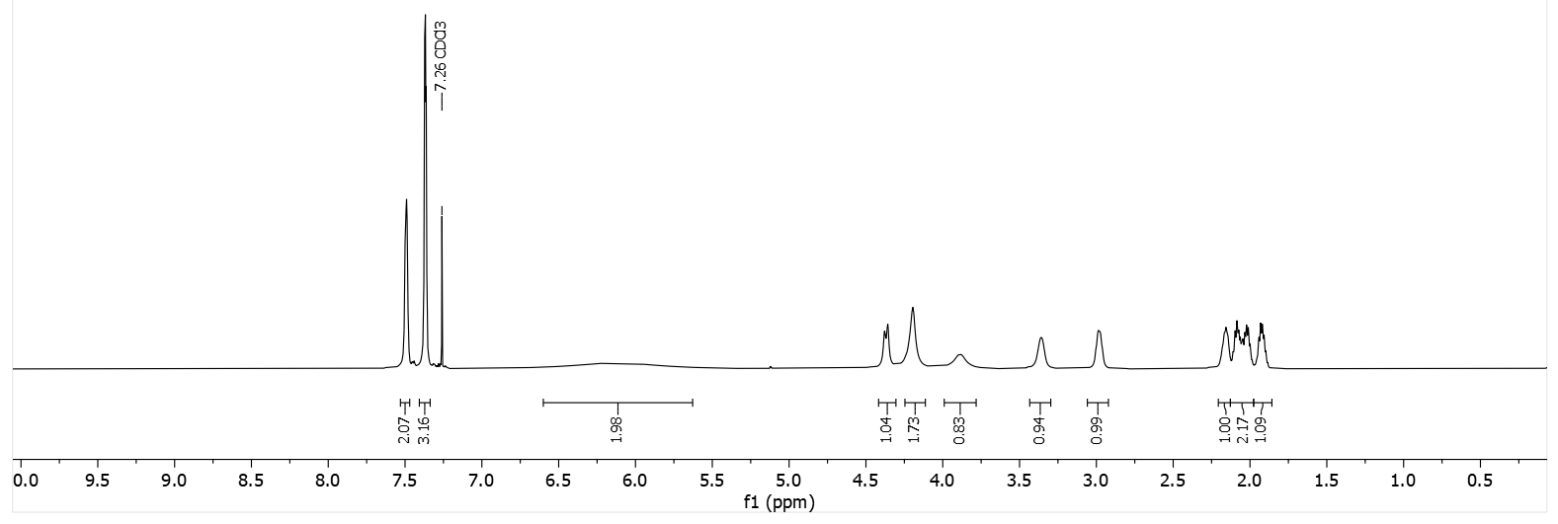
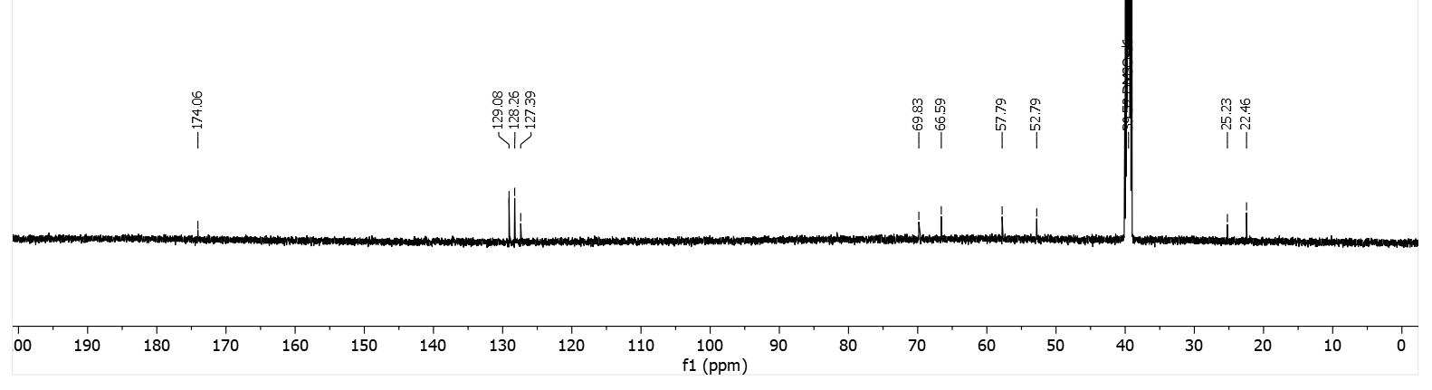
(S)-2-((S)-1-([1,1'-biphenyl]-3-ylmethyl)pyrrolidin-2-yl)-2-hydroxyacetic acid TFA (S,S)-19.
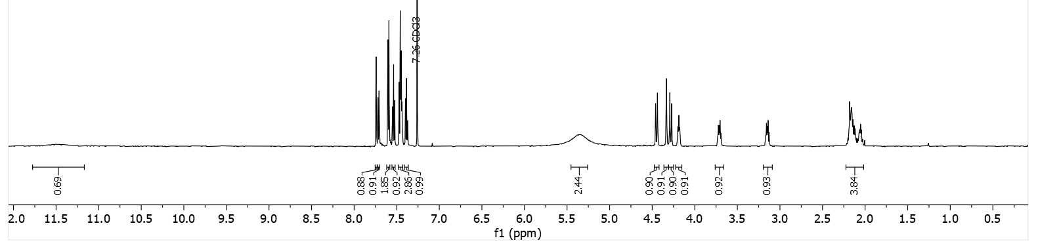
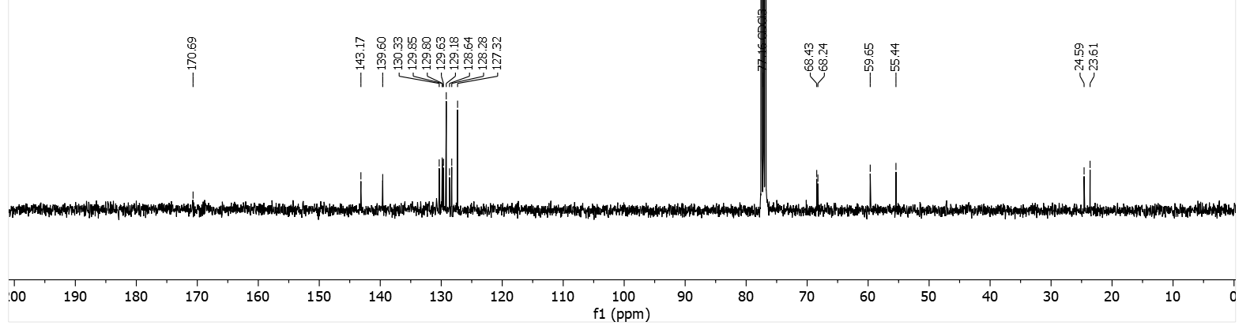
(S)-2-((S)-1-([1,1'-biphenyl]-4-ylmethyl)pyrrolidin-2-yl)-2-hydroxyacetic acid (S,S)-20.
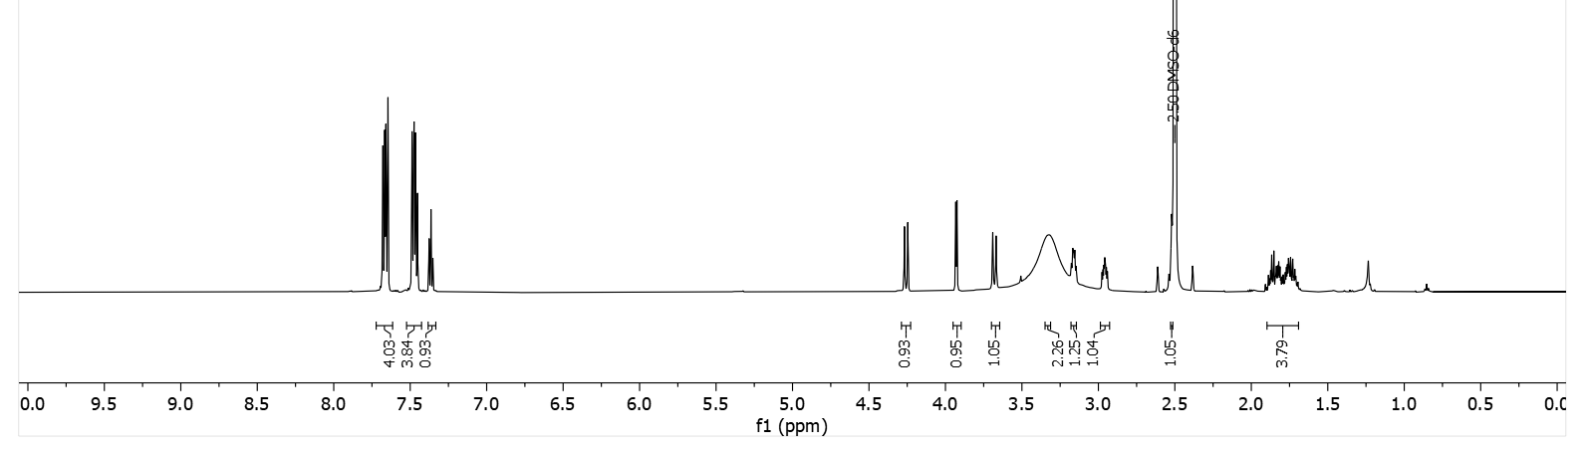
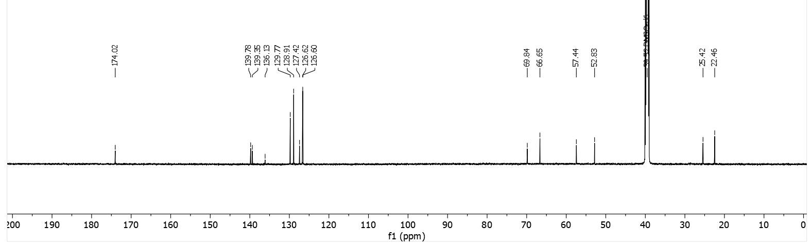
2-((S)-azetidin-2-yl)-2-hydroxypropanoic acid (S)-21a.
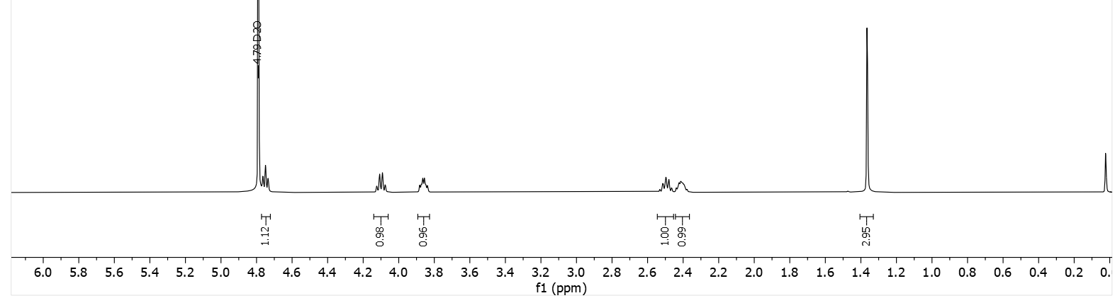
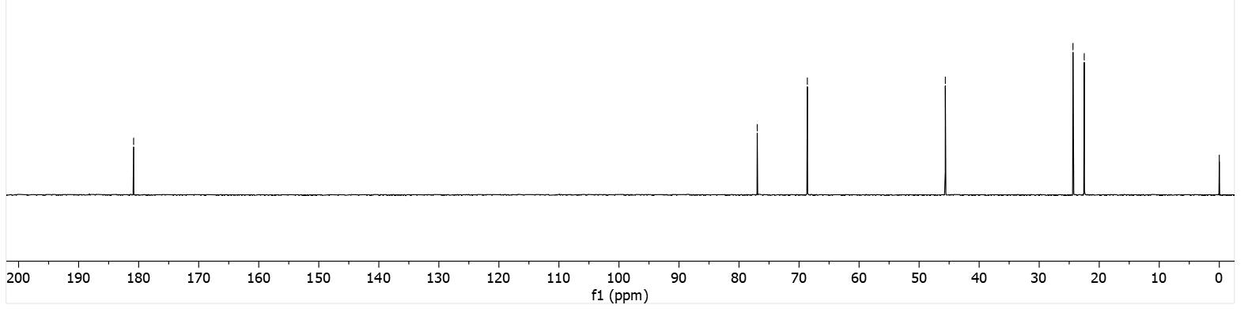

2-((S)-azetidin-2-yl)-2-hydroxypropanoic acid (S)-21b.
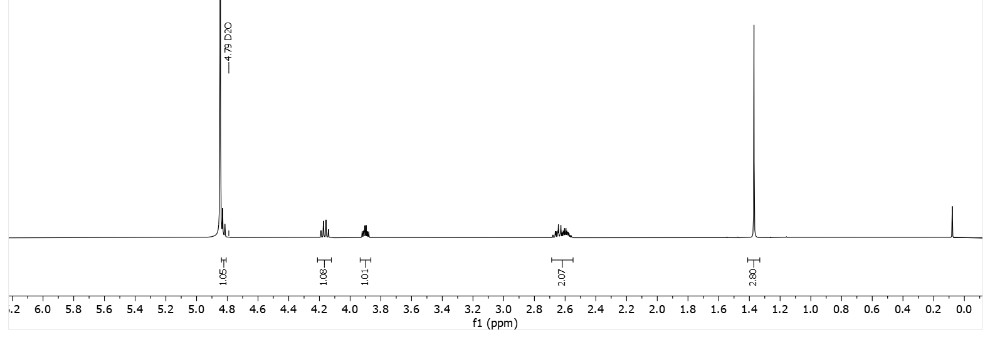
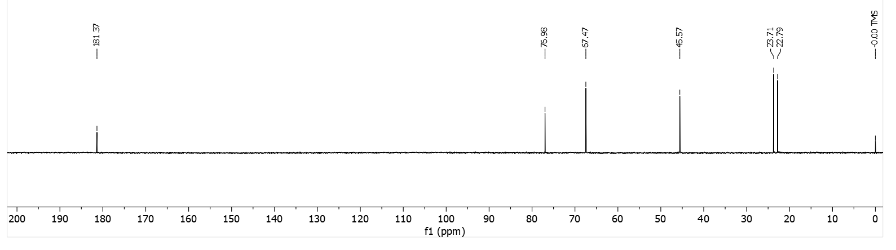
(S)-2-hydroxy-2-((S)-1-((E)-4,4,4-tris(4-methoxyphenyl)but-2-en-1-yl)azetidin-2-yl)acetic acid TFA (S,S)-22a.
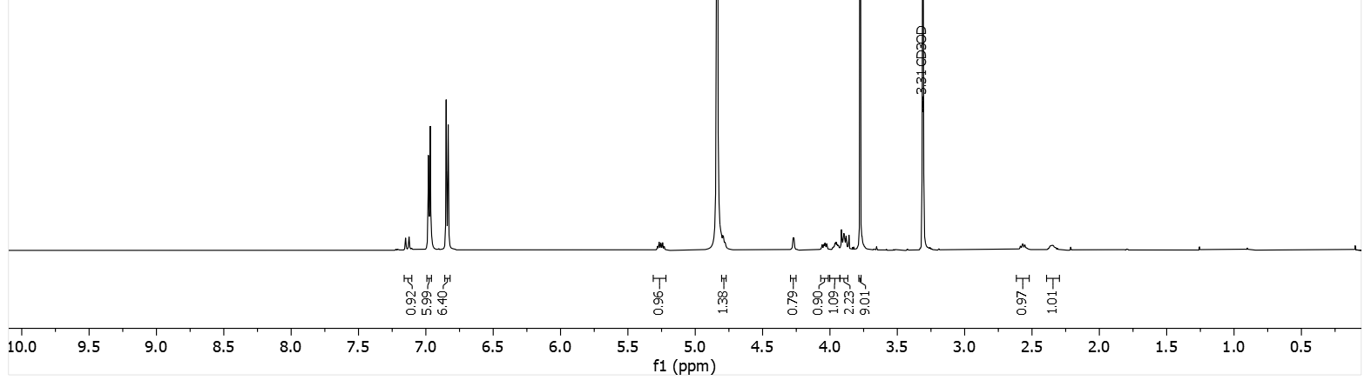
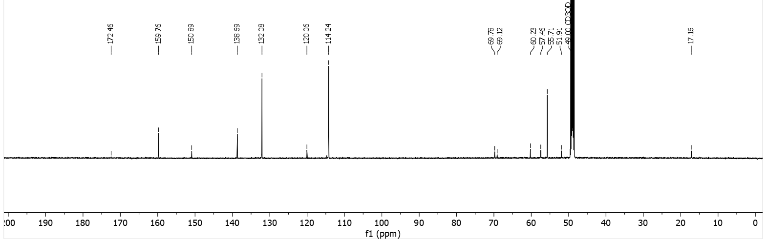

(S)-2-hydroxy-2-((S)-1-((E)-4,4,4-tris(4-methoxyphenyl)but-2-en-1-yl)pyrrolidin-2-yl)acetic acid TFA (S,S)-23a.
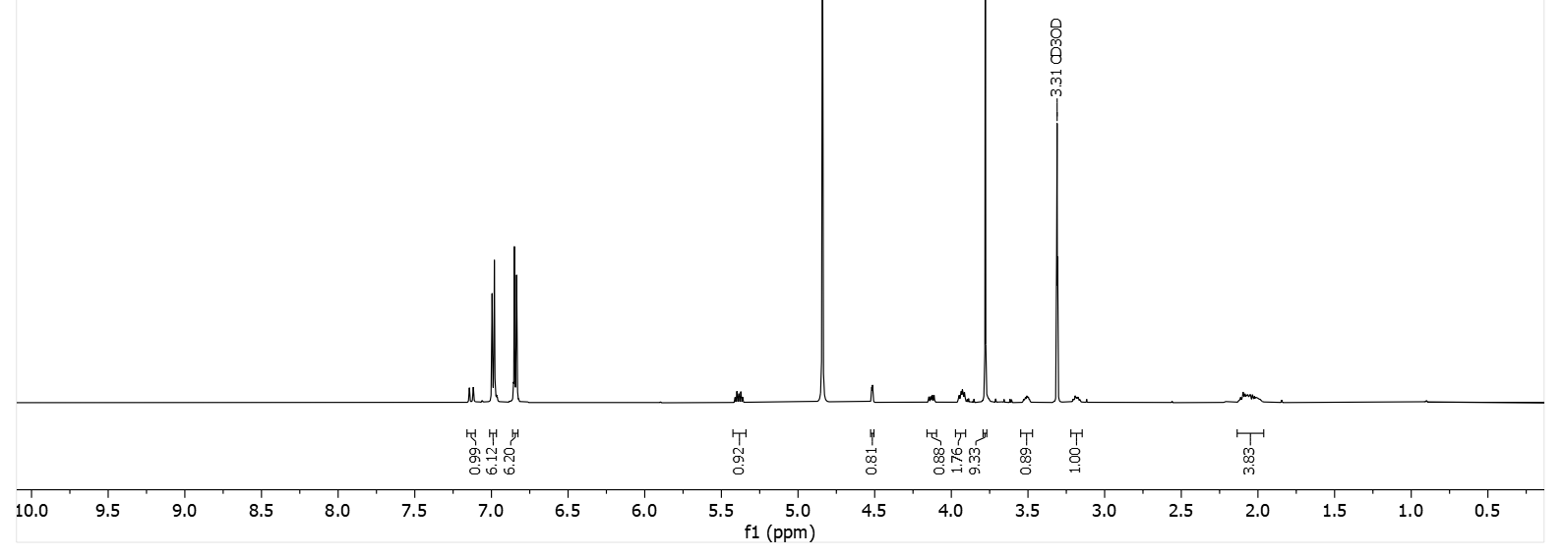
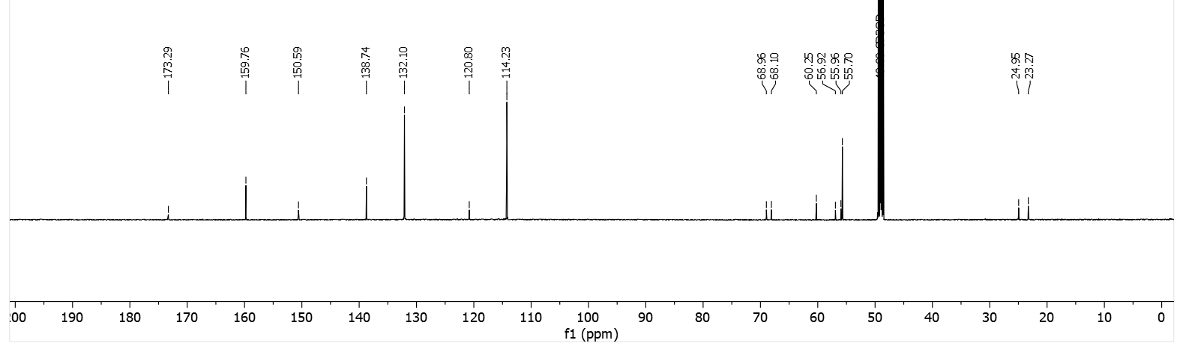
(R)-2-hydroxy-2-((S)-1-((E)-4,4,4-tris(4-methoxyphenyl)but-2-en-1-yl)pyrrolidin-2-yl)acetic acid TFA (S,R)-23b.
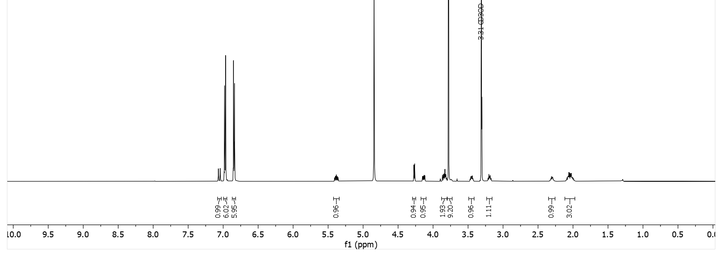
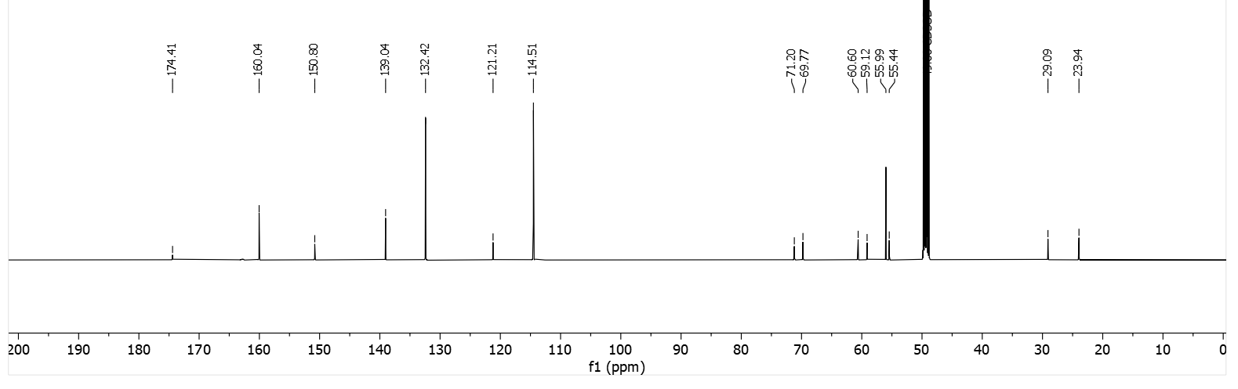
(R)-2-hydroxy-2-((R)-1-((E)-4,4,4-tris(4-methoxyphenyl)but-2-en-1-yl)pyrrolidin-2-yl)acetic acid TFA (R,R)-23a.
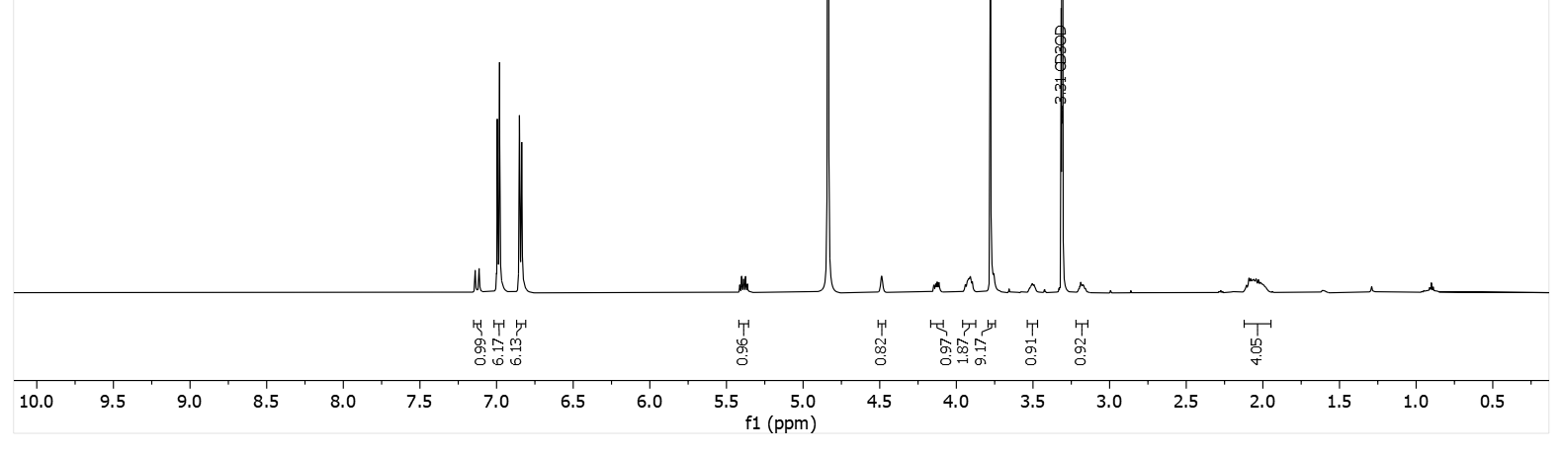
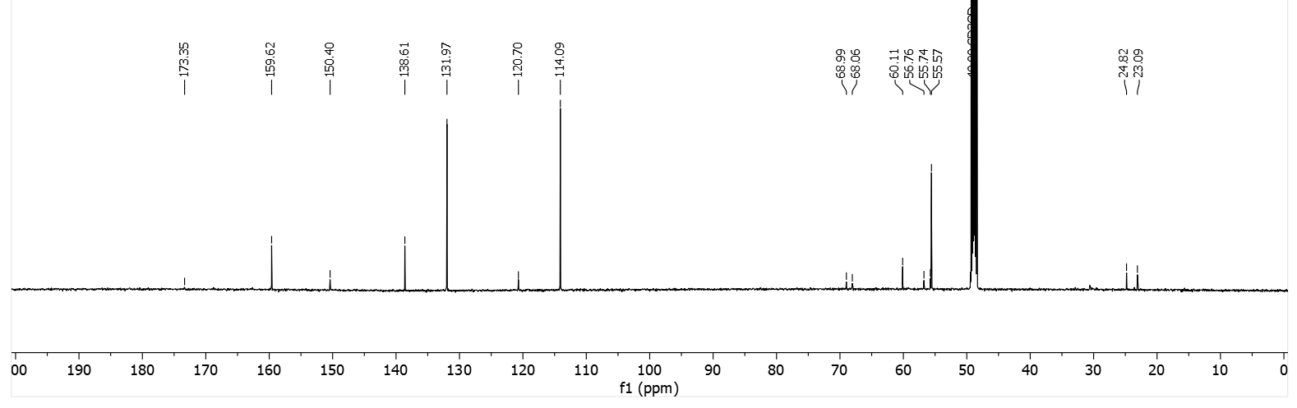
(S)-2-hydroxy-2-((R)-1-((E)-4,4,4-tris(4-methoxyphenyl)but-2-en-1-yl)pyrrolidin-2-yl)acetic acid TFA (R,S)-23b.
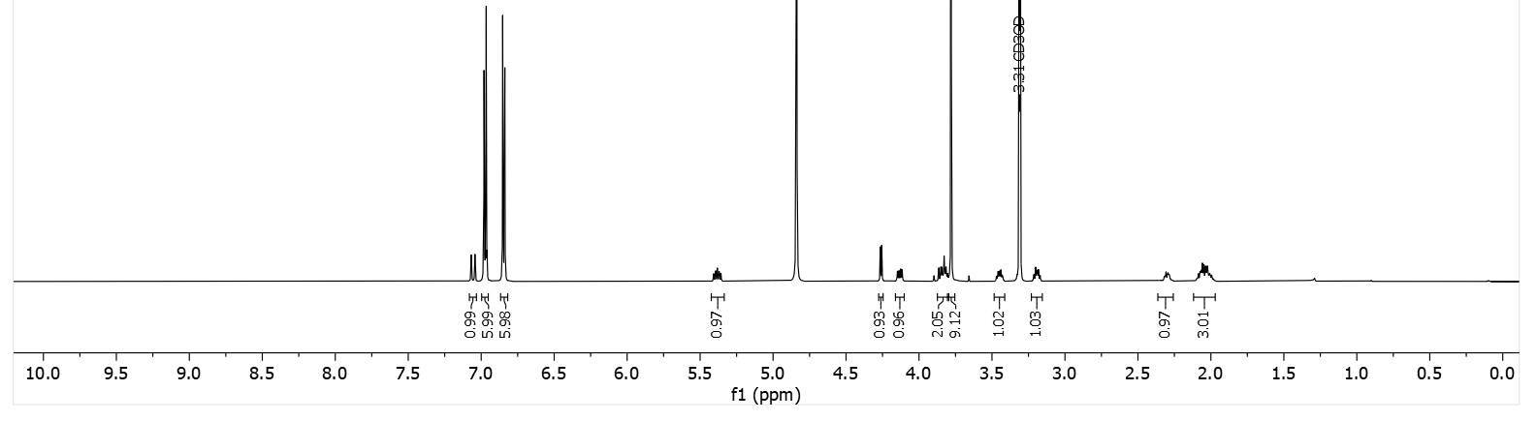
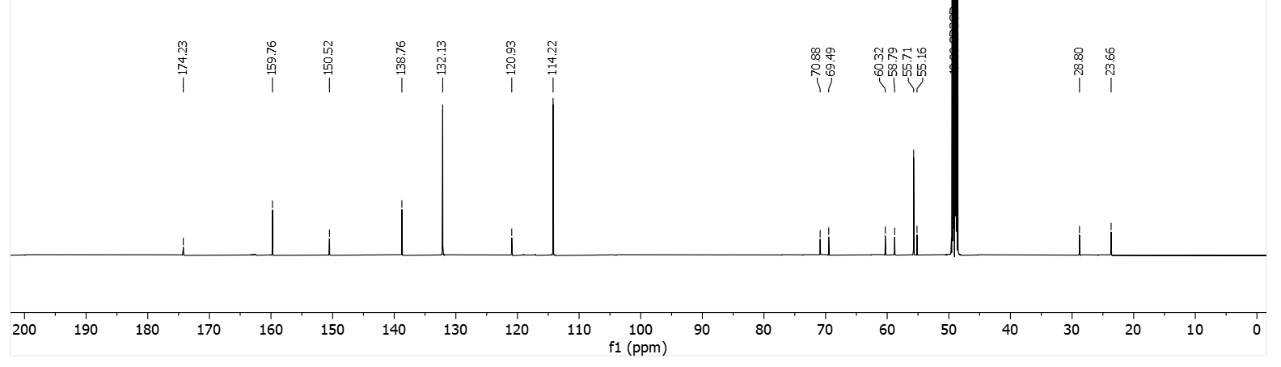

(S)-2-((S)-pyrrolidin-2-yl)-2-hydroxyacetic acid (S,S)-7a-TFA.
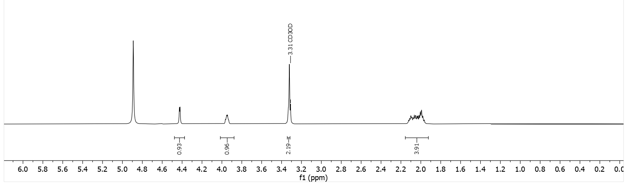
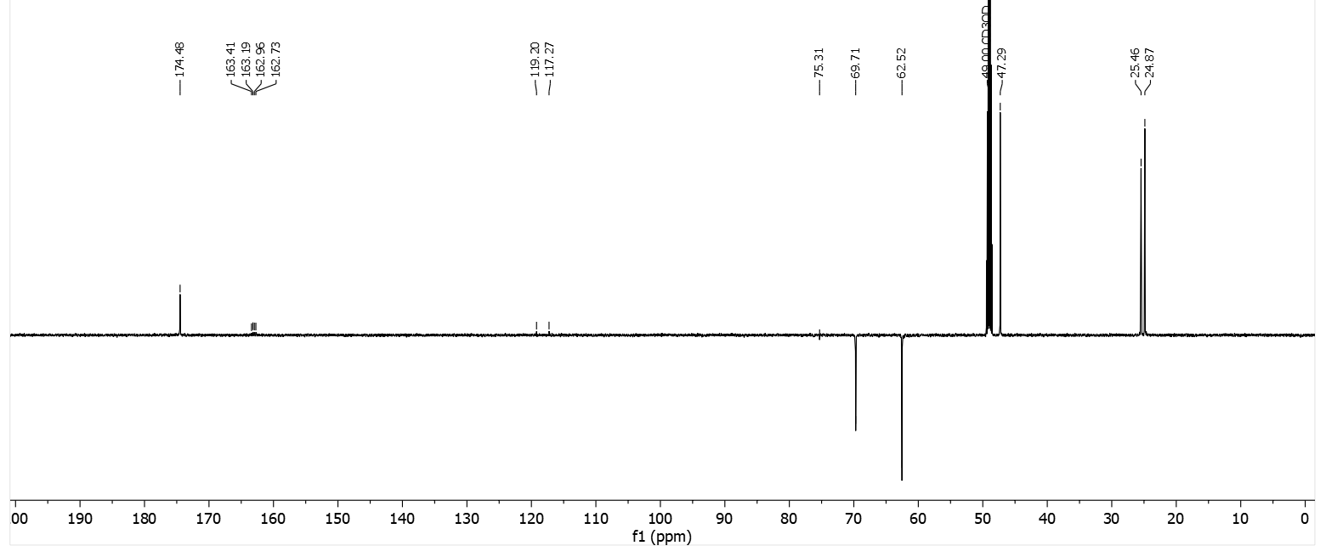

Investigation of the absolute configuration of (S)-6a and (S)-7a

- Mosher analysis of (S)-28a and (S)-27a.
General procedure for the preparation of (S)- and (R)-MTPA esters of the (S)-28a and (S)-27a.
In an oven-dried microwave vial under inert atmosphere, a solution of tert-butyl (S)-2-(cyano(hydroxy)methyl)pyrrolidine-1-carboxylate (S)-28a or tert-butyl (S)-2-(cyano(hydroxy)methyl)azetidine-1-carboxylate (S)-27a (0.066 mmol, 1 eq) in dry DCM (1 mL) was treated with dry pyridine (3.1 eq) and with either (R)- or (S)-MTPA chloride (1.9 eq). The reaction mixture was stirred at room temperature overnight, diluted with diethyl ether (3 mL) and washed with water (1 mL). The water layer was re-extracted with diethyl ether (3 × 3 mL), and the reunited organic phases were dried over anhydrous sodium sulfate, filtered, and the solvent evaporated under reduced pressure at 25 °C. The crude products were purified by silica gel flash column chromatography (gradient from heptane to heptane/ethyl acetate 7:3) affording the (S)- or (R)-MTPA esters of (S)-28a and (S)-27a in low yields.

tert-butyl (S)-2-((S)-cyano(hydroxy)methyl)pyrrolidine-1-carboxylate (S,S)-28a-(S)-MTPA ester.
Obtained according to the general procedure in 17% yield, using (S)-28a and (R)-MTPA-Cl. Rf (heptane/ethyl acetate 8:2) = 0.3. ¹H NMR (600 MHz, Methanol-d₄) δ 7.57 – 7.41 (m, 5H), 6.19 – 5.98 (m, 1H), 4.32 – 4.16 (m, 1H), 3.50 (s, 3H), 3.44 – 3.36 (m, 1H), 3.23 – 3.15 (m, 1H), 2.28 – 2.12 (m, 1H), 2.07 – 1.87 (m, 1H), 1.84 – 1.70 (m, 2H), 1.54 – 1.39 (m, 9H).

tert-butyl (S)-2-((S)-cyano(hydroxy)methyl)pyrrolidine-1-carboxylate (S,S)-28a-(R)-MTPA ester.
Obtained according to the general procedure in 35% yield, using (S)-28a and (S)-MTPA-Cl. Rf (heptane/ethyl acetate 8:2) = 0.3. ¹H NMR (600 MHz, Methanol-d₄) δ 7.55 – 7.40 (m, 5H), 6.21 – 6.07 (m, 1H), 4.18 (dt, J = 8.4, 3.3 Hz, 1H), 3.63 (s, 3H), 3.12 (q, J = 8.9 Hz, 1H), 2.65 – 2.53 (m, 1H), 2.20 – 2.08 (m, 1H), 2.04 – 1.94 (m, 1H), 1.67 – 1.57 (m, 1H), 1.55 – 1.44 (m, 10H).

tert-butyl (S)-2-((S)-cyano(hydroxy)methyl)azetidine-1-carboxylate (S,S)-27a-(S)-MTPA ester.
Obtained according to the general procedure, using (S)-27a and (R)-MTPA-Cl. ¹H NMR (600 MHz, Chloroform-d) δ 7.54 – 7.49 (m, 2H), 7.49 – 7.40 (m, 3H), 6.12 (d, J = 2.8 Hz, 1H), 4.57 – 4.51 (m, 1H), 3.73 – 3.64 (m, 2H), 3.61 (s, 3H), 2.33 – 2.27 (m, 1H), 2.24 – 2.16 (m, 1H), 1.46 (s, 9H).

tert-butyl (S)-2-((S)-cyano(hydroxy)methyl)azetidine-1-carboxylate (S,S)-27a-(R)-MTPA ester.
Obtained according to the general procedure, using (S)-27a and (S)-MTPA-Cl. ¹H NMR (600 MHz, Chloroform-d) δ 7.53 – 7.49 (m, 2H), 7.45 – 7.43 (m, 3H), 6.01 (d, J = 2.8 Hz, 1H), 4.60 (t, J = 7.3 Hz, 1H), 3.84 (q, J = 7.9 Hz, 1H), 3.56 (s, 3H), 2.44 – 2.35 (m, 1H), 2.32 – 2.23 (m, 1H), 1.44 (s, 9H).

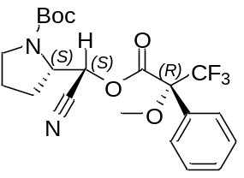
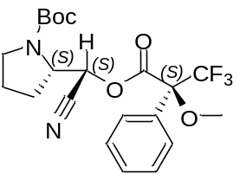
Δδ^{(SR)} for signals residing on the pyrrolidine ring and azetidine ring
H_{A}
H_{B}
H_{C}
H_{A}
H_{B}
H_{C}
Signal | δ^{S} ester | δ^{R} ester | Δδ ^{(SR)} ppm  (Hz, 600 MHz)
H_{A}¹ | 3.40 | 3.12 | + 0.28 (+ 168)
H_{A}² | 3.19 | 2.59 | + 0.6 (+ 360)
H_{C}¹ | 2.20 | 2.13 | + 0.07 (+ 42)
H_{C}² | 1.97 | 1.99 | + 0.02 (+ 12)
H_{B} | 1.78 | 1.62 | + 0.16 (+ 96)
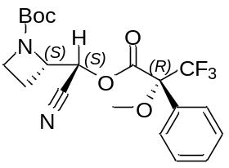
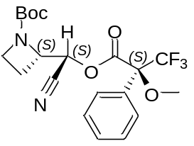
H_{A}
H_{B}
H_{A}
H_{B}
Signal | δ^{S} ester | δ^{R} ester | Δδ ^{(SR)} ppm  (Hz, 600 MHz)
H_{A} | 3.69 | 3.84 | + 0.15 (+ 90)
H_{B}¹ | 2.30 | 2.38 | + 0.08 (+ 48)
H_{B}² | 2.20 | 2.29 | + 0.09 (+ 54)

- Conformational analysis and ¹H-NMR analysis of (S)-27a and (S)-27b

Extract of ¹H-NMR of (S)-27a. Since no coupling is detected between the red α-H and the blue β-H, they can´t be in anti-periplanar relative disposition. Conformational analysis revealed that the conformer with lowest relative potential energy of (S,S)-27a disposes the α-H and the β-H in gauche relative disposition.
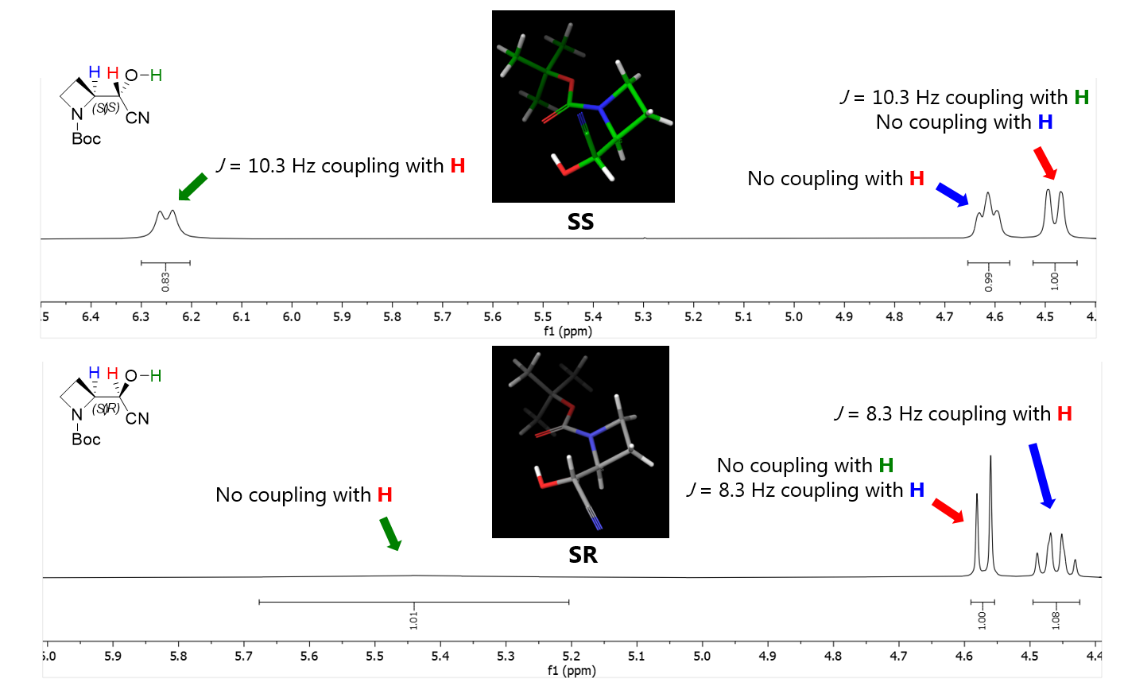
Extract of ¹H-NMR of (S)-27b. Since a J coupling constant of 8.3 Hz is detected between the red α-H and the blue β-H, they can´t be in a gauche relative disposition. Conformational analysis revealed that the conformer with lowest relative potential energy of (S,R)-27b disposes the α-H and the β-H in anti-periplanar relative disposition.

HPLC chromatograms.

(S)-2-((S)-1-benzylazetidin-2-yl)-2-hydroxyacetic acid (S,S)-12.
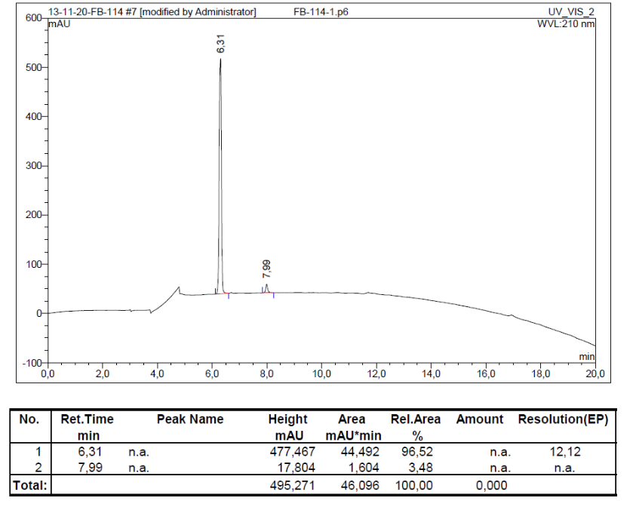

(S)-2-((S)-1-([1,1'-biphenyl]-3-ylmethyl)azetidin-2-yl)-2-hydroxyacetic acid (S,S)-13.
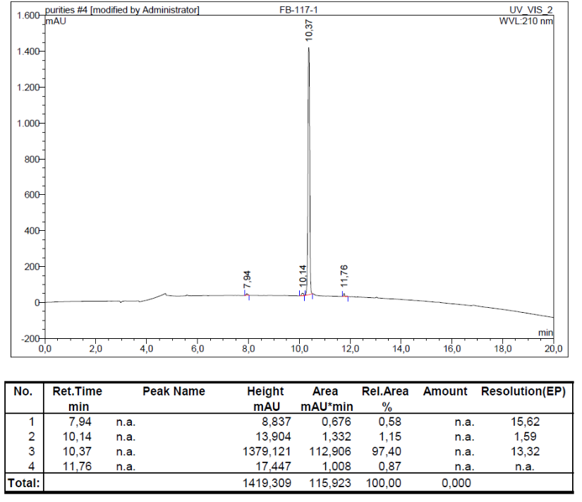

(S)-2-((S)-1-([1,1'-biphenyl]-4-ylmethyl)azetidin-2-yl)-2-hydroxyacetic acid (S,S)-14.
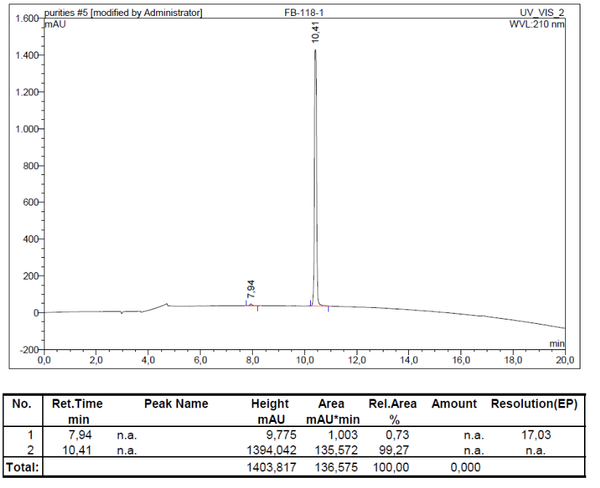

(S)-2-((S)-1-(4-(benzyloxy)benzyl)azetidin-2-yl)-2-hydroxyacetic acid (S,S)-15.
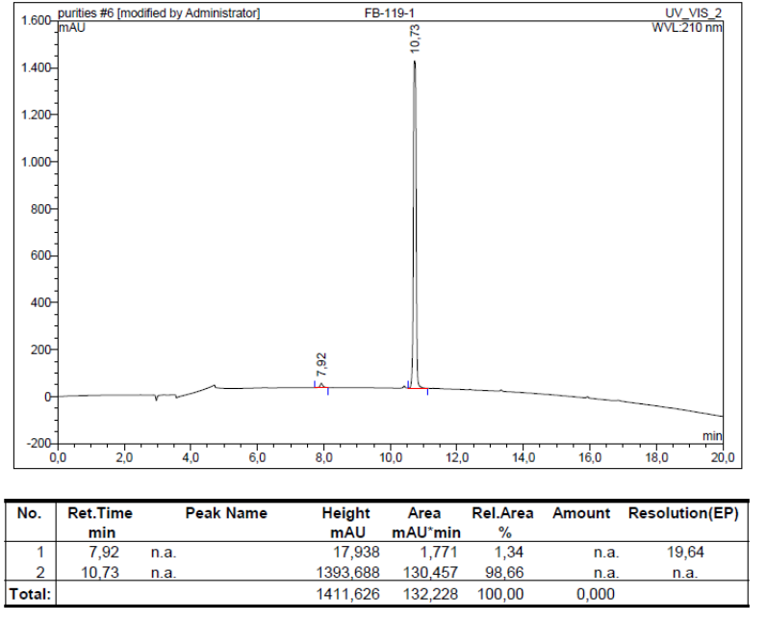

(S)-2-hydroxy-2-((S)-1-(4-hydroxybenzyl)azetidin-2-yl)acetic acid (S,S)-16.
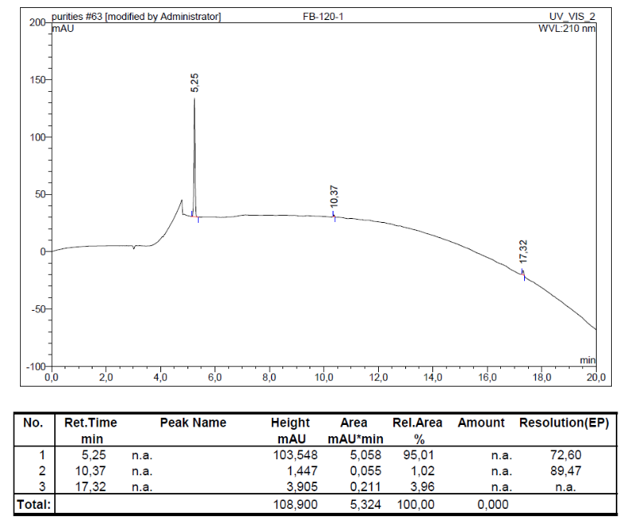
(S)-2-((S)-1-(4-acetamidobenzyl)azetidin-2-yl)-2-hydroxyacetic acid (S,S)-17.
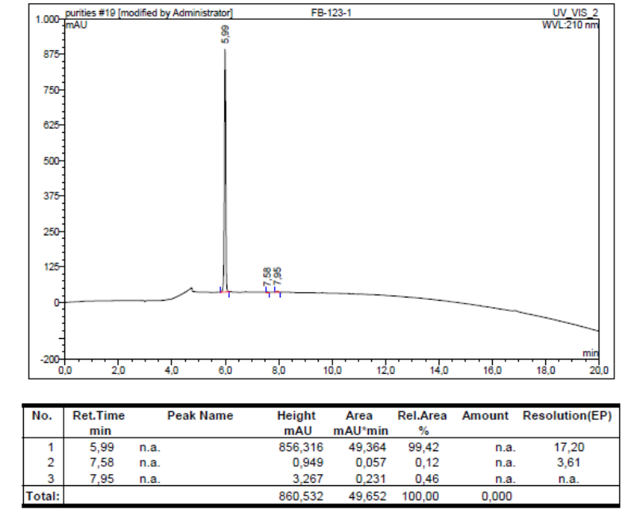

(S)-2-((S)-1-benzylpyrrolidin-2-yl)-2-hydroxyacetic acid (S,S)-18.
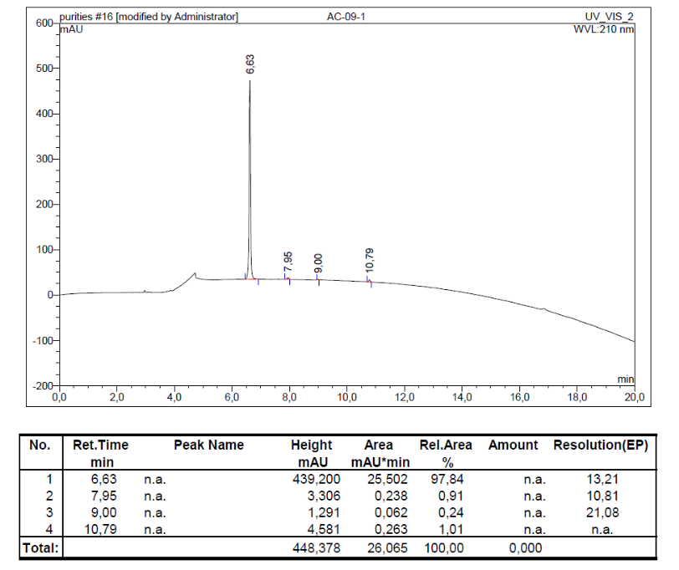
(S)-2-((S)-1-([1,1'-biphenyl]-3-ylmethyl)pyrrolidin-2-yl)-2-hydroxyacetic acid TFA (S,S)-19.
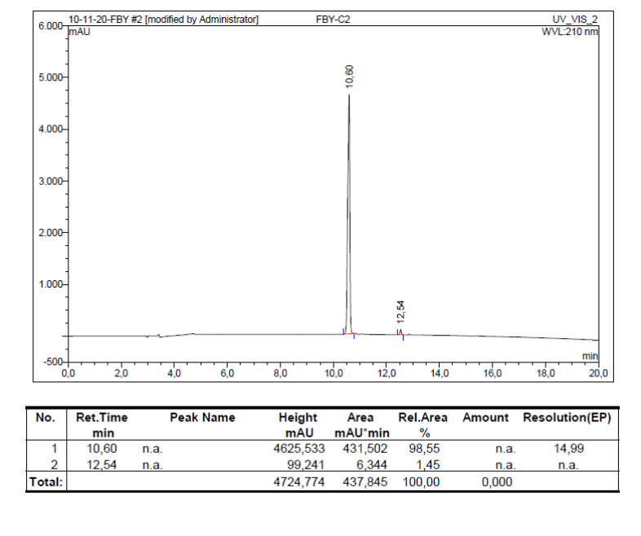

(S)-2-((S)-1-([1,1'-biphenyl]-4-ylmethyl)pyrrolidin-2-yl)-2-hydroxyacetic acid (S,S)-20.
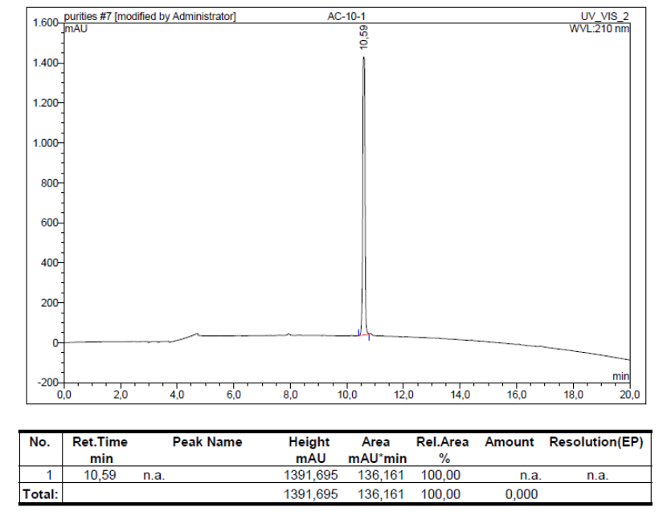

(S)-2-hydroxy-2-((S)-1-((E)-4,4,4-tris(4-methoxyphenyl)but-2-en-1-yl)azetidin-2-yl)acetic acid (S,S)-22a.

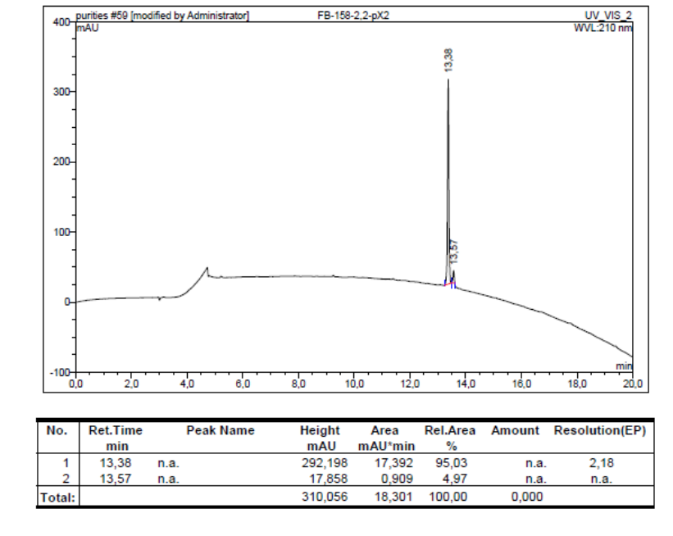

(S)-2-hydroxy-2-((S)-1-((E)-4,4,4-tris(4-methoxyphenyl)but-2-en-1-yl)pyrrolidin-2-yl)acetic acid (S,S)-23a.
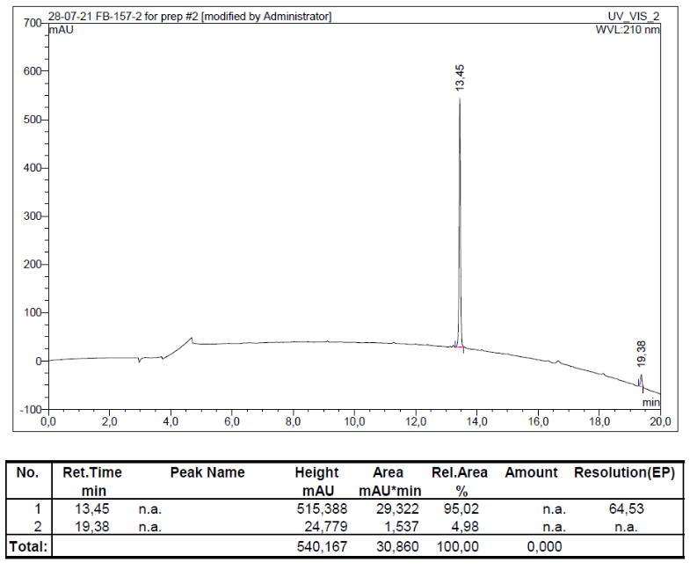
(R)-2-hydroxy-2-((S)-1-((E)-4,4,4-tris(4-methoxyphenyl)but-2-en-1-yl)pyrrolidin-2-yl)acetic acid (S,R)-23b.
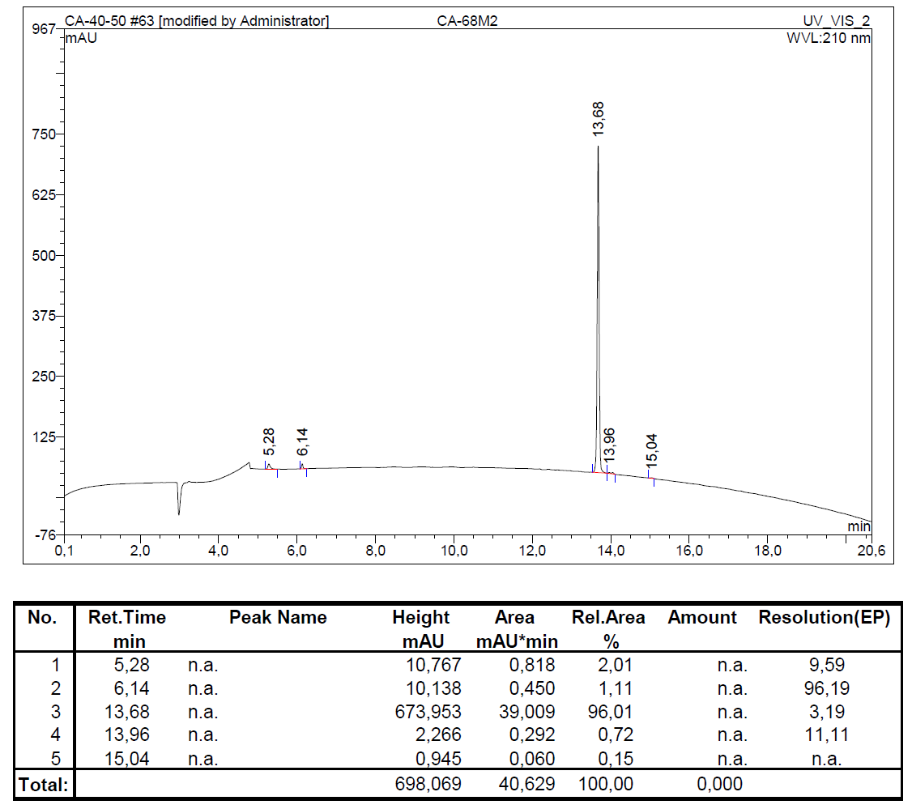

(R)-2-hydroxy-2-((R)-1-((E)-4,4,4-tris(4-methoxyphenyl)but-2-en-1-yl)pyrrolidin-2-yl)acetic acid (R,R)-23a.
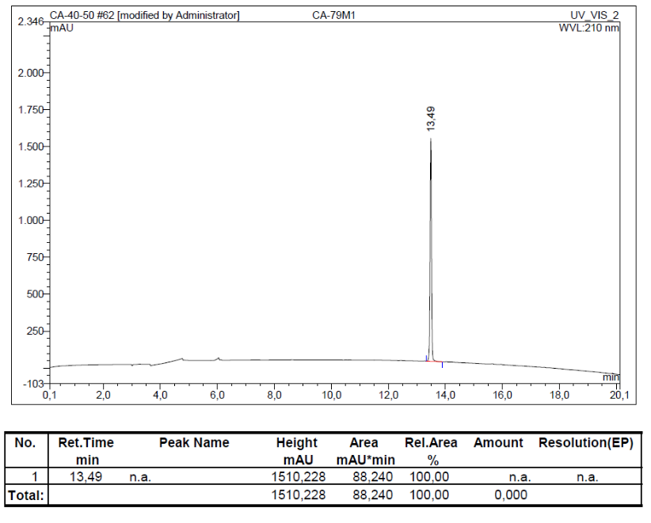
(S)-2-hydroxy-2-((R)-1-((E)-4,4,4-tris(4-methoxyphenyl)but-2-en-1-yl)pyrrolidin-2-yl)acetic acid (R,S)-23b.
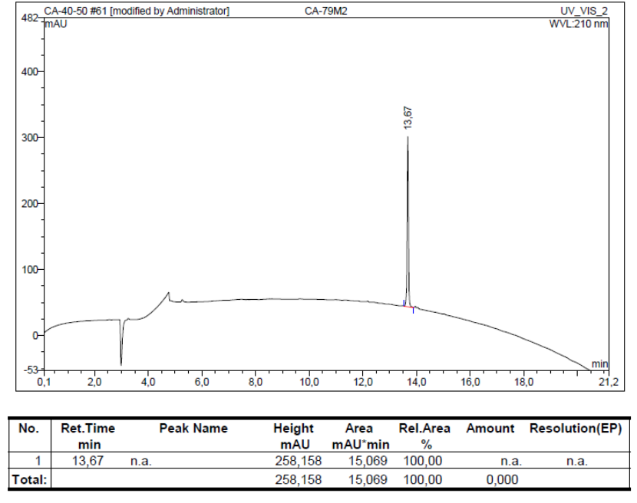

Pharmacology: Figure S1.
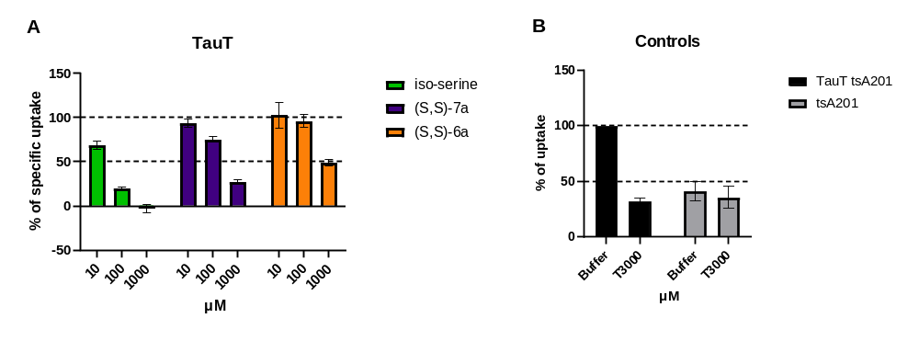
Figure S1. (A) Inhibitory activity of (S,S)-6a and (S,S)-7a at hTauT transiently expressed in tsA201 cells measured via [³H]taurine uptake assay. Data shown are specific [³H]taurine uptake (unspecific uptake was removed) normalized to 100 % [³H]taurine uptake and pooled from four independent experiments with three technical replicas. Error bars show the standard error of the mean. (B) Unspecific uptake of [³H]taurine in non-transfected tsA201 cells. Buffer: contains 22 nM radioligand. T3000 3 mM taurine.

