Additional file for
On the use of tsunami-source data for high resolution fault imaging of offshore earthquakes
by Hisahiko Kubo, Tatsuya Kubota, Wataru Suzuki, Takeshi Nakamura

Relationship of fault-parameter ensembles in the GNSS inversion with heat maps of fault parameters and histograms of each fault parameter is shown in Fig. A1. Relationship of fault-parameter ensembles in the tsunami-source inversion with heat maps of fault parameters and histograms of each fault parameter is shown in Fig. A2.

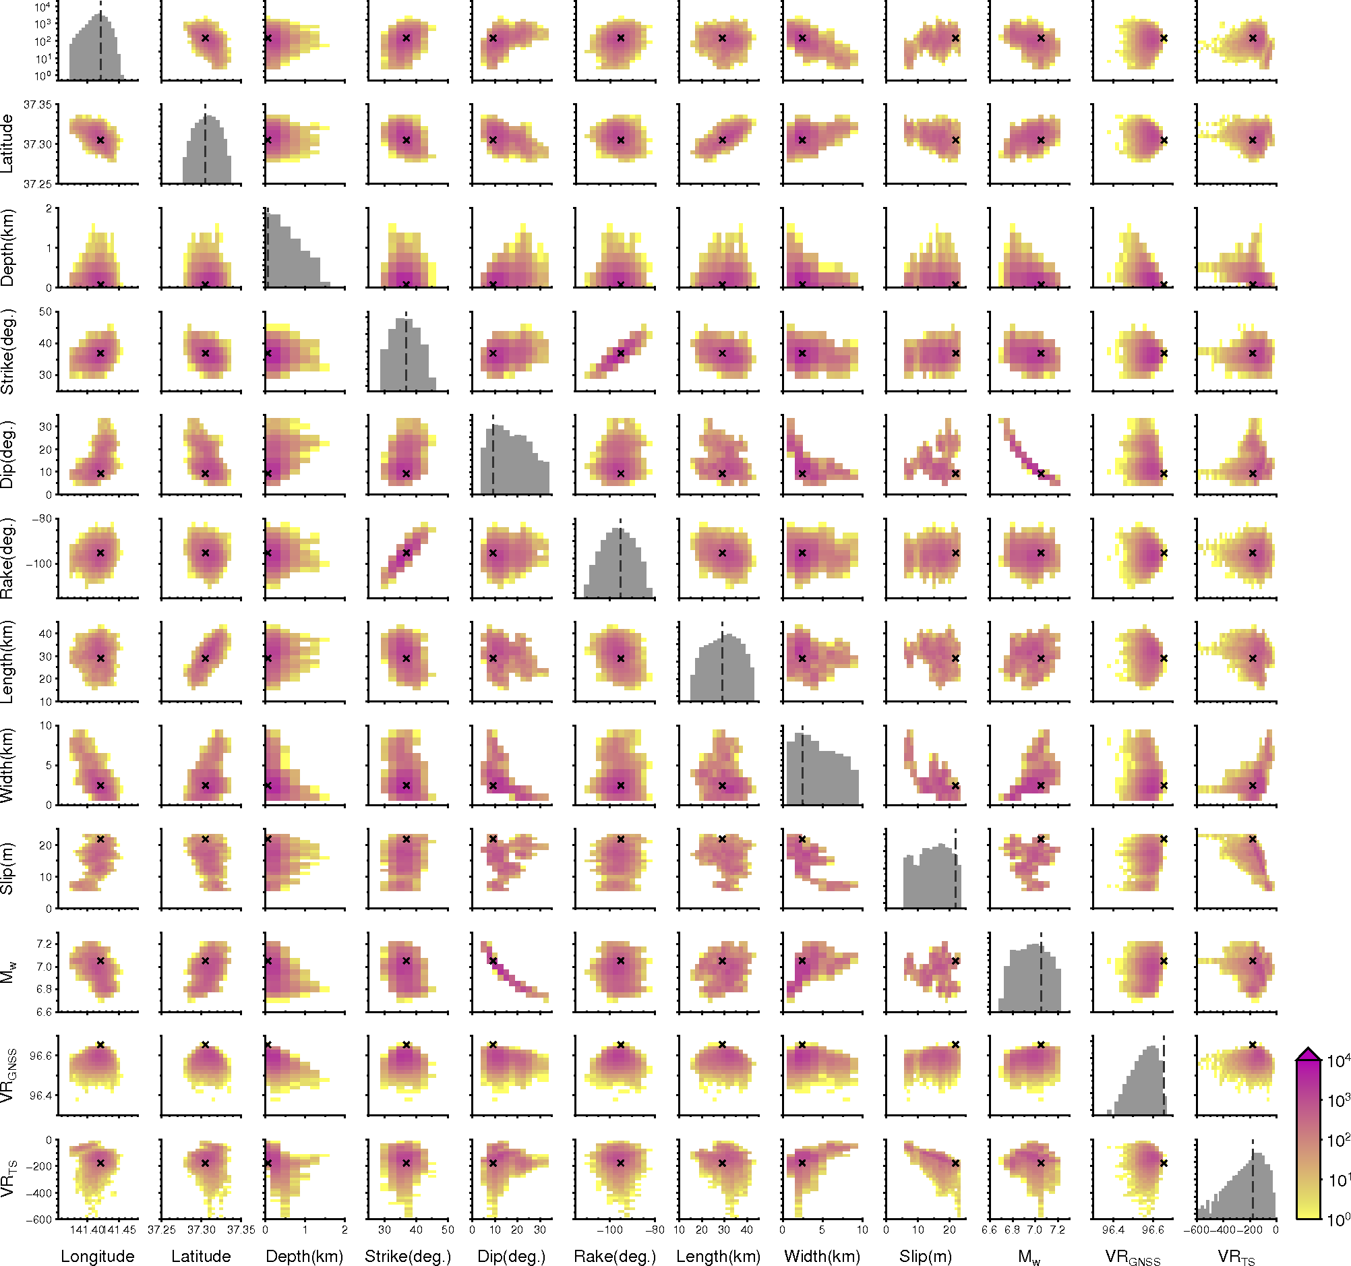
Figure S1
Relationship of fault-parameter ensembles in the GNSS inversion with heat maps of fault parameters and histograms of each fault parameter. The cross in the heatmaps and the dashed line in the histograms indicate fault parameters of the optimal solution having the maximum poster probability among solution ensembles. M_{w}, VR_{GNSS}, and VR_{TS} were not included in model parameters, but were calculated from the model parameter values for each ensemble.

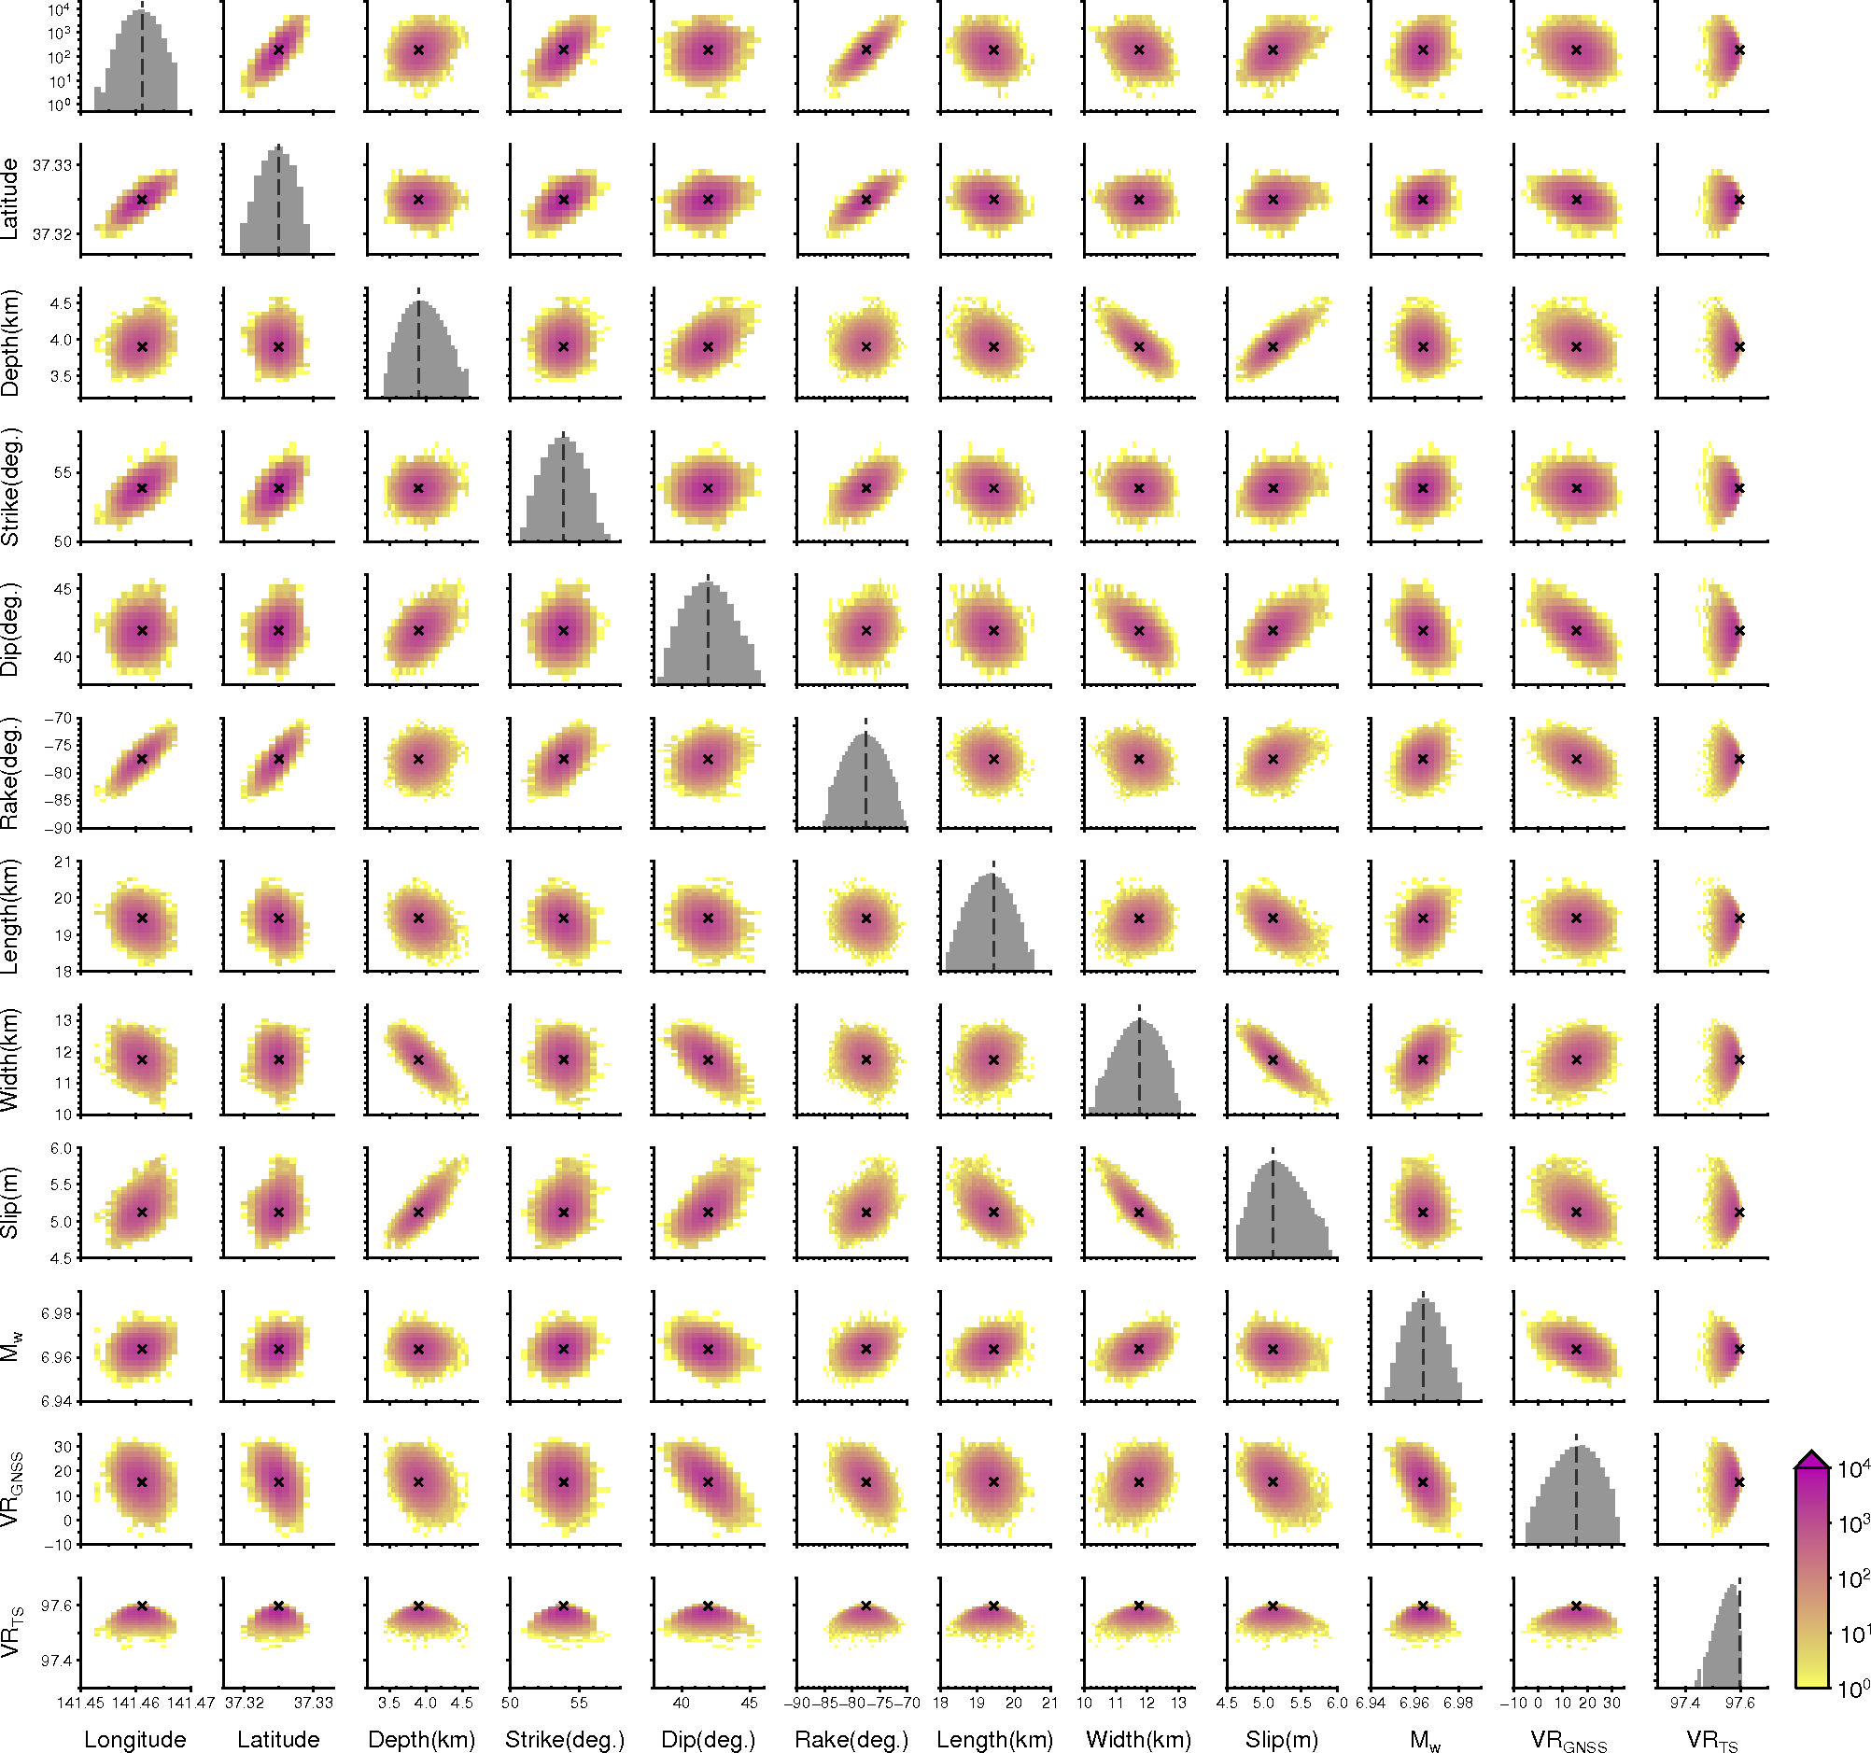
Fig. A2
Relationship of fault-parameter ensembles in the tsunami-source inversion with heat maps of fault parameters and histograms of each fault parameter. The cross in the heatmaps and the dashed line in the histograms indicate fault parameters of the optimal solution having the maximum poster probability among solution ensembles. M_{w}, VR_{GNSS}, and VR_{TS} were not included in model parameters, but were calculated from the model parameter values for each ensemble.

