Inverse Design of Multi-Foci Metalens for Generating Polarization-Dependent Images with Uniform Intensity Distributions：Supplementary Materials
Binbin Lu¹, Xiaofei Zang^{1,*}, Bowen Sun¹, Yiwen Zhou¹, Haoxiang Chi¹, Yiming Zhu^{1,*}, and Songlin Zhuang¹
¹Terahertz Technology Innovation Research Institute, Terahertz Spectrum and Imaging Technology Cooperative Innovation Center, Shanghai Key Lab of Modern Optical System, University of shanghai for Science and Technology, Shanghai 200093, China.
* Correspondence: xfzang@usst.edu.cn; ymzhu@usst.edu.cn

Section 1. The Stokes parameters and polarization states
The inversely designed metalens with multiple focal spots can form polarization-dependent images of Chinese characters or letters. The polarization of these Chinese characters or letters can be identified/calculated from the ellipticity that is decided by the Stokes parameters expressed as follows:
$$S_{0}={\left|t_{x}\right|}^{2}+{\left|t_{y}\right|}^{2} \\ S_{1}={\left|t_{x}\right|}^{2}-{\left|t_{y}\right|}^{2} \\ S_{2}=2\left|t_{x}\right|\left|t_{y}\right|\cos{(}φ_{d}) \\ S_{3}=2\left|t_{x}\right|\left|t_{y}\right|\sin{(}φ_{d})$$
in which $t_{x}$ and $t_{y}$ are transmission coefficients of the x-polarized and y-polarized components. S₀ is the field intensity of output THz waves. The linearly-polarized component along the x-axis is expressed by S₁ while the linearly-polarized component in the diagonal direction is expressed by S₂. S₃ is the circularly polarized component. $φ_{d}(=φ_{E_{y}}-φ_{E_{x}})$ is the phase difference between two orthogonal components (e.g. electric fields of $E_{y}$ and $E_{x}$). A focal spot with the corresponding ellipticity is governed by $χ=S_{3}/S_{0}$. For $χ=1$, an LCP focal spot is generated, while an RCP focal spot is generated for $χ=-1$. When $χ=0$, it is a LP focal spot. According to the value of parameter $χ$, one can easily identify the polarization of a focal spot.

Section 2. The polarization distributions of the metalens for generating CP-based images.
Fig. S₁. The schematic and polarization distributions ($χ$) of the metalens for generating CP-based images. (a) The schematic for the numbered Chinese characters for the words “wide” and “big”. (b), (c) and (d) The polarization distributions of Chinese characters for the words “wide”, “big” and both “wide” and “big”, respectively. The Chinese character for the word “wide” consists of six RCP ($χ≈-1$) focal spots while the Chinese character for the word “big” consists of eight LCP ($χ≈1$) focal spots.

Section 3. The polarization distributions of the metalens for generating LP-based images.
Fig. S₂. The schematic and polarization distributions ($χ$) of the metalens for generating CP-based images. (a) The schematic for the numbered letters “V” and “H”. (b), (c) and (d) The polarization distributions of letters “V”, “H” and both “V” and “H”, respectively. The letter “V” consists of seven LP ($χ≈0$) focal spots while the letter “H” consists of ten LP ($χ≈0$) focal spots.

Section 4. The polarization distributions of the metalens for generating images with multiple polarization states.
Fig. S₃. The schematic and polarization distributions ($χ$) of the metalens for generating images with multiple polarization states. (a) The schematic for the numbered letter “W”. (b), (c) and (d) The polarization distributions of letters “V”, “N” and “W”, respectively. The letter “V” (b) consists of seven RCP ($χ≈-1$) focal spots while the letter “N” (c) consists of ten LCP ($χ≈1$) focal spots. The letter “W” (d) consists of thirteen focal spots, which contains three RCP focal spots, four LP focal spot, and six LCP focal spots.

Section 5. The schematic of the near-field scanning terahertz microscopy.
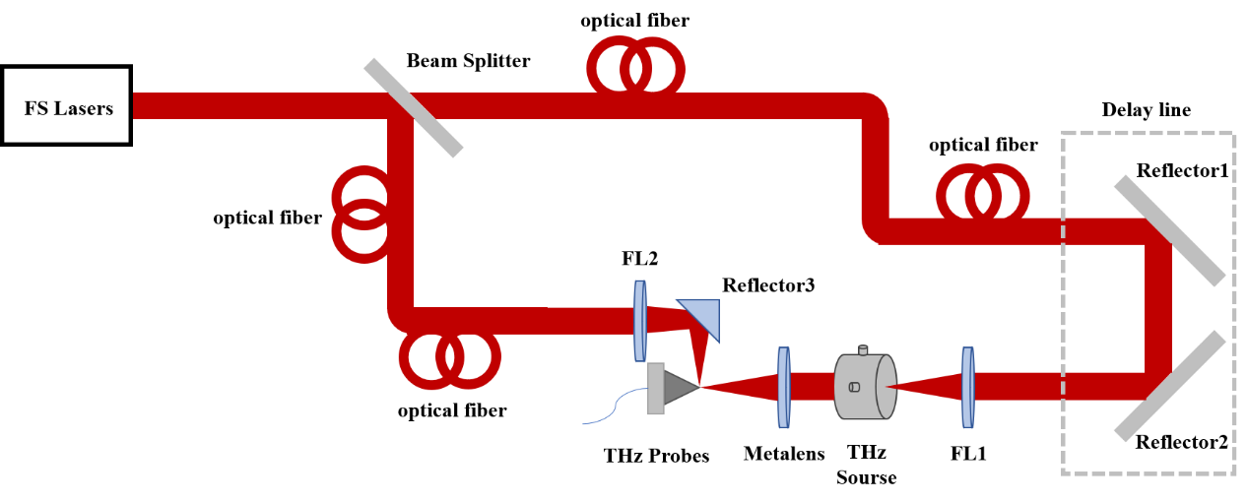
Fig. S₄. The schematic of the near-field scanning terahertz microscopy.

Table 1. The amplitude (A_{k}) of each focal spot for the word “wide”.
k | 1 | 2 | 3 | 4 | 5 | 6
A_{k} | 0.969748 | 0.941179 | 0.788249 | 0.950181 | 0.855601 | 1.11594

Table 2. The amplitude (A_{k}) of each focal spot for the word “big”.
k | 7 | 8 | 9 | 10 | 11 | 12 | 13 | 14
A_{k} | 1.01026 | 0.901397 | 1.05559 | 1.26868 | 1.1511 | 1.22945 | 1.16707 | 1.19832

Table 3. The amplitude (A_{k}) of each focal spot for the letter "V".
k | 11 | 12 | 13 | 14 | 15 | 16 | 17
A_{k} | 1.58341 | 1.74075 | 1.98526 | 1.8795 | 1.51458 | 1.55645 | 1.91181

Table 4 The amplitude (A_{k}) of each focal spot for the letter "H".
k | 1 | 2 | 3 | 4 | 5 | 6 | 7 | 8 | 9 | 10
A_{k} | 0.555637 | 0.608244 | 0.505186 | 0.557665 | 0.627095 | 0.563331 | 0.575564 | 1.4965 | 1.27351 | 1.27366

Table 5. The amplitude (A_{k}) of each focal spot for the letter "V".
k | 1 | 2 | 3 | 4 | 5 | 6 | 7
A_{k} | 1.28348 | 1.36193 | 1.1404 | 0.726593 | 0.867863 | 0.737092 | 0.75123

Table 6. The amplitude (A_{k}) of each focal spot for the letter "N".
k | 4 | 5 | 6 | 7 | 8 | 9 | 10 | 11 | 12 | 13
A_{k} | 0.726593 | 0.867863 | 0.737092 | 0.75123 | 1.15245 | 1.29373 | 1.14511 | 1.23483 | 1.28097 | 1.35036

