Controllable synthesis of iron-introduced cobalt-iron bimetallic MOFs for rapid removal of tetracycline hydrochloride in water

Hu Junhao, He Yuting, Shu Tingting, Wang Yingxi, Li Ling*
Ministry-of-Education Key Laboratory for the Synthesis and Application of Organic Function Molecules, Hubei University, 430062, People’s Republic of China

Characterization
The superficial morphology of the was determined using a JSM6510LV scanning electron microscopy(SEM, JEOL, Japan). The crystal constructions of aforesaid samples were detected by a D8 Advance X-ray diffraction (XRD, Bruker, Germany), equipped with copper anode material (40 mA, 40 kV). Fourier transform infrared spectra (FTIR, PerkinElmer, USA) of the 400-4000 cm⁻¹ region was measured by means of the KBr tableting technology. The oxidation states of Co and Fe in the fresh and used Co/Fe-MOFs were recorded by X-ray photoelectron spectroscopy (XPS, Thermo, USA). The intermediates of TC degradation were detected by Liquid Chromatography-Mass Spectroscopy(LC-MS, Agilent, USA).
Chemicals and materials
Tetracycline Hydrochloride (TC), Doxorubicin hydrochloride (DOX), Ferric chloride hexahydrate (FeCl₃•6H₂O), Cobalt chloride hexahydrate (CoCl₂•6H₂O), potassium dihydrogen phosphate (NaH₂PO₄), potassium peroxymonosulfate (PMS, 42%-46% KHSO₅ basis), sodium persulfate (PDS, Na₂S₂O₈) and 4,4’-Biphenyldicarboxylic (H₂BPDC) were sourced from Shanghai Macklin Co., Ltd. (Shanghai, China). Rhodamine B (RhB), sodium sulfate (Na₂SO₄, ≥99%), solid sodium hydroxide (NaOH, ≥96%), Methylene blue (MB), hydrochloric acid (HCl, 36%-38%) , N, N-Dimethylformamide (DMF), potassium chloride (KCl, ≥99.5%), tertiary butanol (TBA), anhydrous ethanol and methanol were acquired from Sinopharm Chemical Reagent Co., Ltd. (Shanghai, China).
Table S1. The detailed synthetic parameters of all samples

Sample | CoCl₂·6H₂O (mmol) | FeCl₃·6H₂O  (mmol) | H₂BPDC  (mmol) | Temperature(°C) | Time(h)
Co_{0.25}Fe_{0.75}-MOFs | 0.375 | 0.125 | 0.25 | 130 | 24
Co_{0.5}Fe_{0.5}-MOFs | 0.25 | 0.25 | 0.25 | 130 | 24
Co_{0.75}Fe_{0.25}-MOFs | 0.125 | 0.375 | 0.25 | 130 | 24
Co-MOFs | 0.5 | 0.00 | 0.25 | 130 | 24
Fe-MOFs | 0.00 | 0.5 | 0.25 | 130 | 24

Fig. S1. XRD comparison patterns of Co/Fe-MOFs and Co-MOFs.

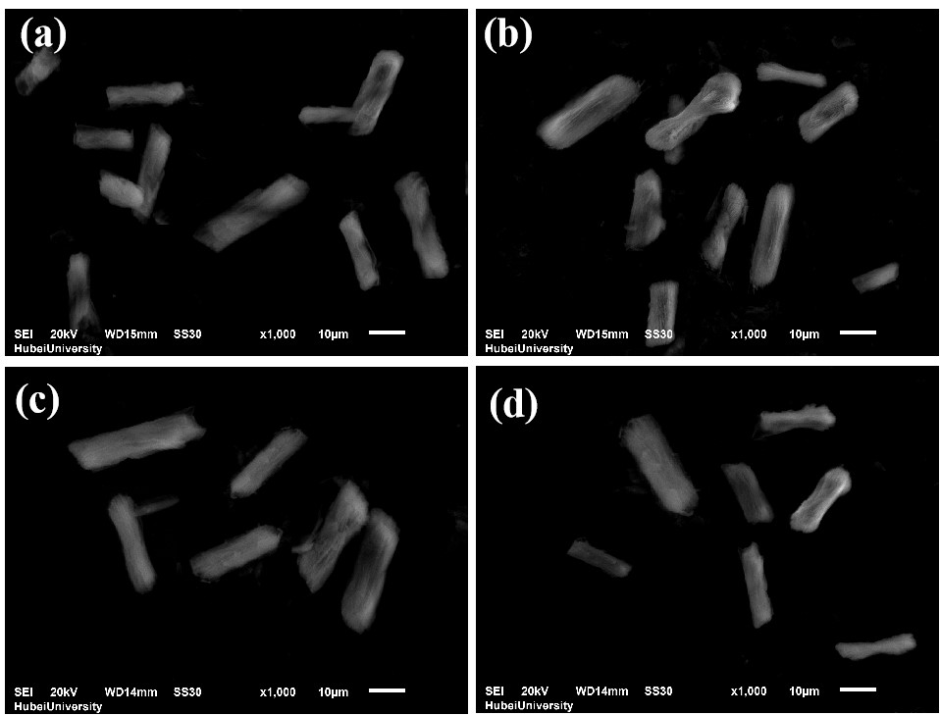

Fig. S2. SEM images of (a) Co-MOFs, (b) Fe_{0.25}Co_{0.75}-MOFs, (c) Fe_{0.5}Co_{0.5}-MOFs

Fig. S3. The pseudo-first-order kinetics analysis of (a) different systems, (b) different PMS concentration and (c) different catalyst dosage.

Fig. S4. EIS measurement of Fe-MOFs, Co-MOFs, Co/Fe-MOFs

Fig. S5. Effect of coexisting anion concentrations on the TC•HCl removal, (a) Cl⁻, (b) SO₄²⁻, (c) NO₃⁻ and (d) H₂PO₄⁻.

Fig S6. LC-MS analysis of TC intermediates in the degradation reaction with Co/Fe-MOFs/PMS.

Fig S7. (a) FTIR spectra and (b) XRD patterns of Co/Ni-MOF before and after use.

Fig S8. (a) Degradation effect and (b) the pseudo primary kinetic analysis of various pollutants.

* Corresponding authors.E-mail address: lingli@hubu.edu.cn (L.Li)

