Appendix S1: Species invasion alters fish mercury biomagnification rates

Table S1. Results of analysis comparing relationships of Cisco Hg (ug/g wet weight) with body size (total length, mm) between historic and contemporary time periods among lakes. Where a test for heterogeneity of slopes was found to be insignificant, ANCOVA was performed. Where ANCOVA was insignificant, a regression considering both time periods together was performed.

Category | Lake | Test for Homogeneity of slopes | ANCOVA | Regression
Altered | Gull Lake | F_{1,28}= 0.23,  P= 0.6 | F_{1,29}= 12.6,  P= 0.0014  (1995 > 2006)
 | Twelve Mile Lake¹ | F_{1,23}= 8.2,  P= 0.009  (+1995, -2006)
 | Lake Simcoe² | F_{1,70}= 3.49,  P= 0.066  (-1983, +2006) | F_{1,71}= 30.9,  P< 0.0001  (1983 > 2006)
Reference | Harp Lake³ | F_{1,49}= 0.19,  P= 0.67 | F_{1,50}= 8.4,  P= 0.006  (1995 > 2006)
 | Lake Rosseau | F_{1,56}= 2.5,  P= 0.12 | F_{1,57}= 0.7,  P= 0.4 | F_{1,58}= 89,  P< 0.0001  (Positive slope)
 | Lake Simcoe² | F_{1,71}= 2.1,  P= 0.15 | F_{1,72}= 79.0,  P< 0.00001  (2006 > 2009)
¹Limited range of sizes in analysis for 2006. Violates assumption of overlap in covariate (length). If examined separately, only 1995 relationship significant (F_{1,9}=38, p<0.0001).
²Lake Simcoe appears under two categories due to the relation of timing of sampling with the time of Bythotrephes invasion. See text for details.
³If examined separately, relationship only significant in 2006 (F_{1,19}= 8.6, P= 0.008).

Table S2. Results of analysis comparing relationships of Cisco δ¹⁵N isotopic values (‰) with body size (total length, mm) between historic and contemporary time periods among lakes. Where a test for heterogeneity of slopes was found to be insignificant, ANCOVA was performed. Where ANCOVA was insignificant, a regression considering both time periods together was performed.

Category | Lake | Test for Homogeneity of slopes | ANCOVA | Regression
Altered | Gull Lake | F_{1,28}= 20.6,  P< 0.0001  (+1995, -2006)
 | Twelve Mile Lake¹ | F_{1,23}=0.4,  P= 0.5 | F_{1,24}=9.8,  P= 0.005  (1995 < 2006)
 | Lake Simcoe² | F_{1,70}= 0.0002,  P= 0.99 | F_{1,71}= 164.2,  P< 0.0001  (1983 > 2006)
Reference | Harp Lake | F_{1,49}= 0.63,  P= 0.43 | F_{1,50}= 7.6,  P= 0.008  (1995 > 2006)
 | Lake Rosseau³ | F_{1,56}= 0.65,  P= 0.4 | F_{1,57}= 0.64,  P= 0.4 | F_{1,58}=7.3,  P= 0.009  (Positive slope)
 | Lake Simcoe^{2,4} | F_{1,71}= 2.1,  P= 0.0007
¹Limited range of sizes in analysis for 2006. Violates assumption of overlap in covariate (length). ²Lake Simcoe appears under two categories due to the relation of timing of sampling with the time of Bythotrephes invasion. See text for details.
³If examined separately, significant relationship in 2006 only (F_{1,28}= 5.8, P= 0.02).
⁴Slope for 2009 greater than for 2006, but 2006 δ¹⁵N greater than 2009 at all sizes < 400 mm.

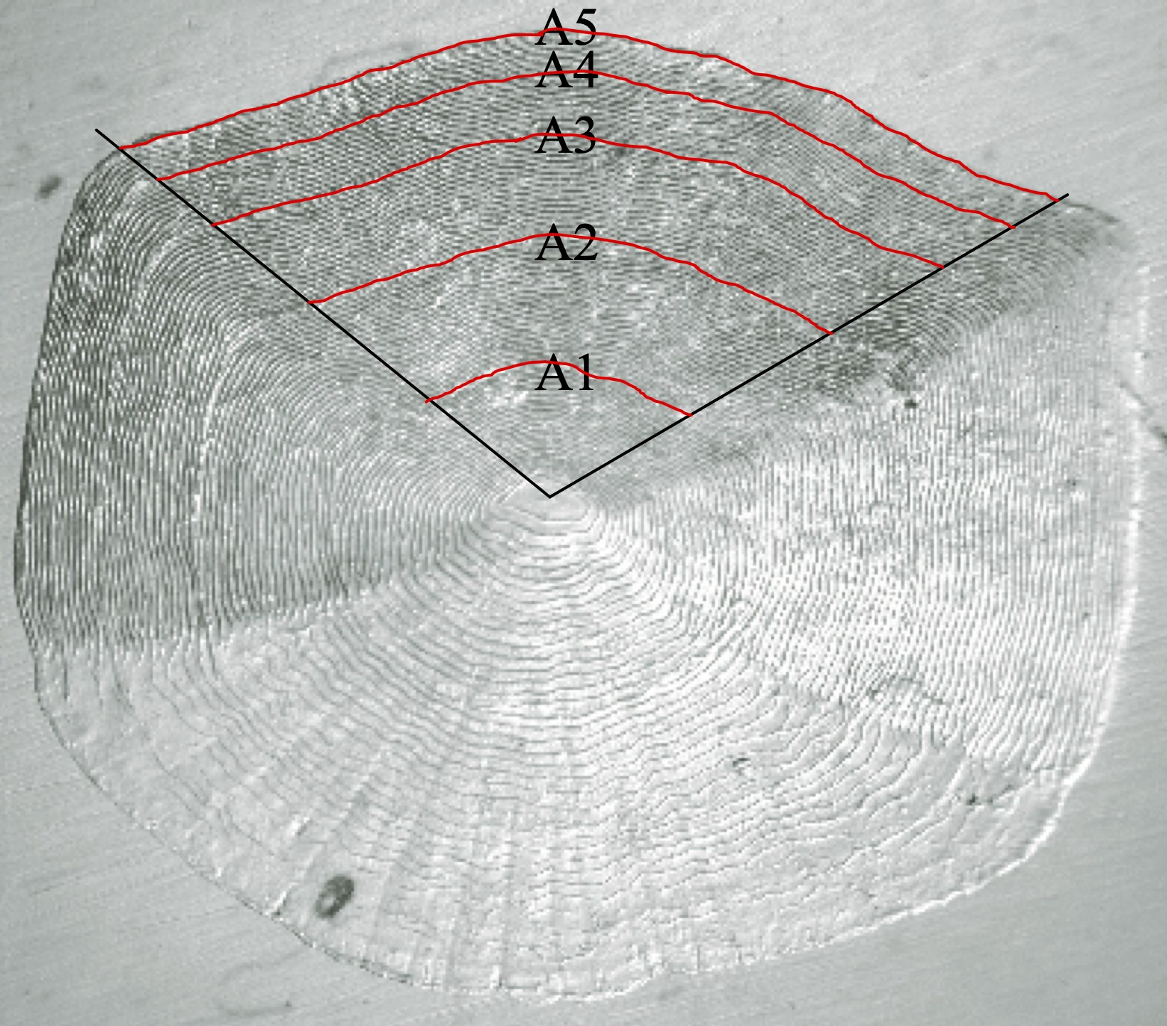

Figure S1. Sample image demonstrating the assignment of annuli to Cisco scales collected during the course of the study. Image was interpreted to be age 5. The annuli are traced across the 120° sector used to assess scale size and growth.

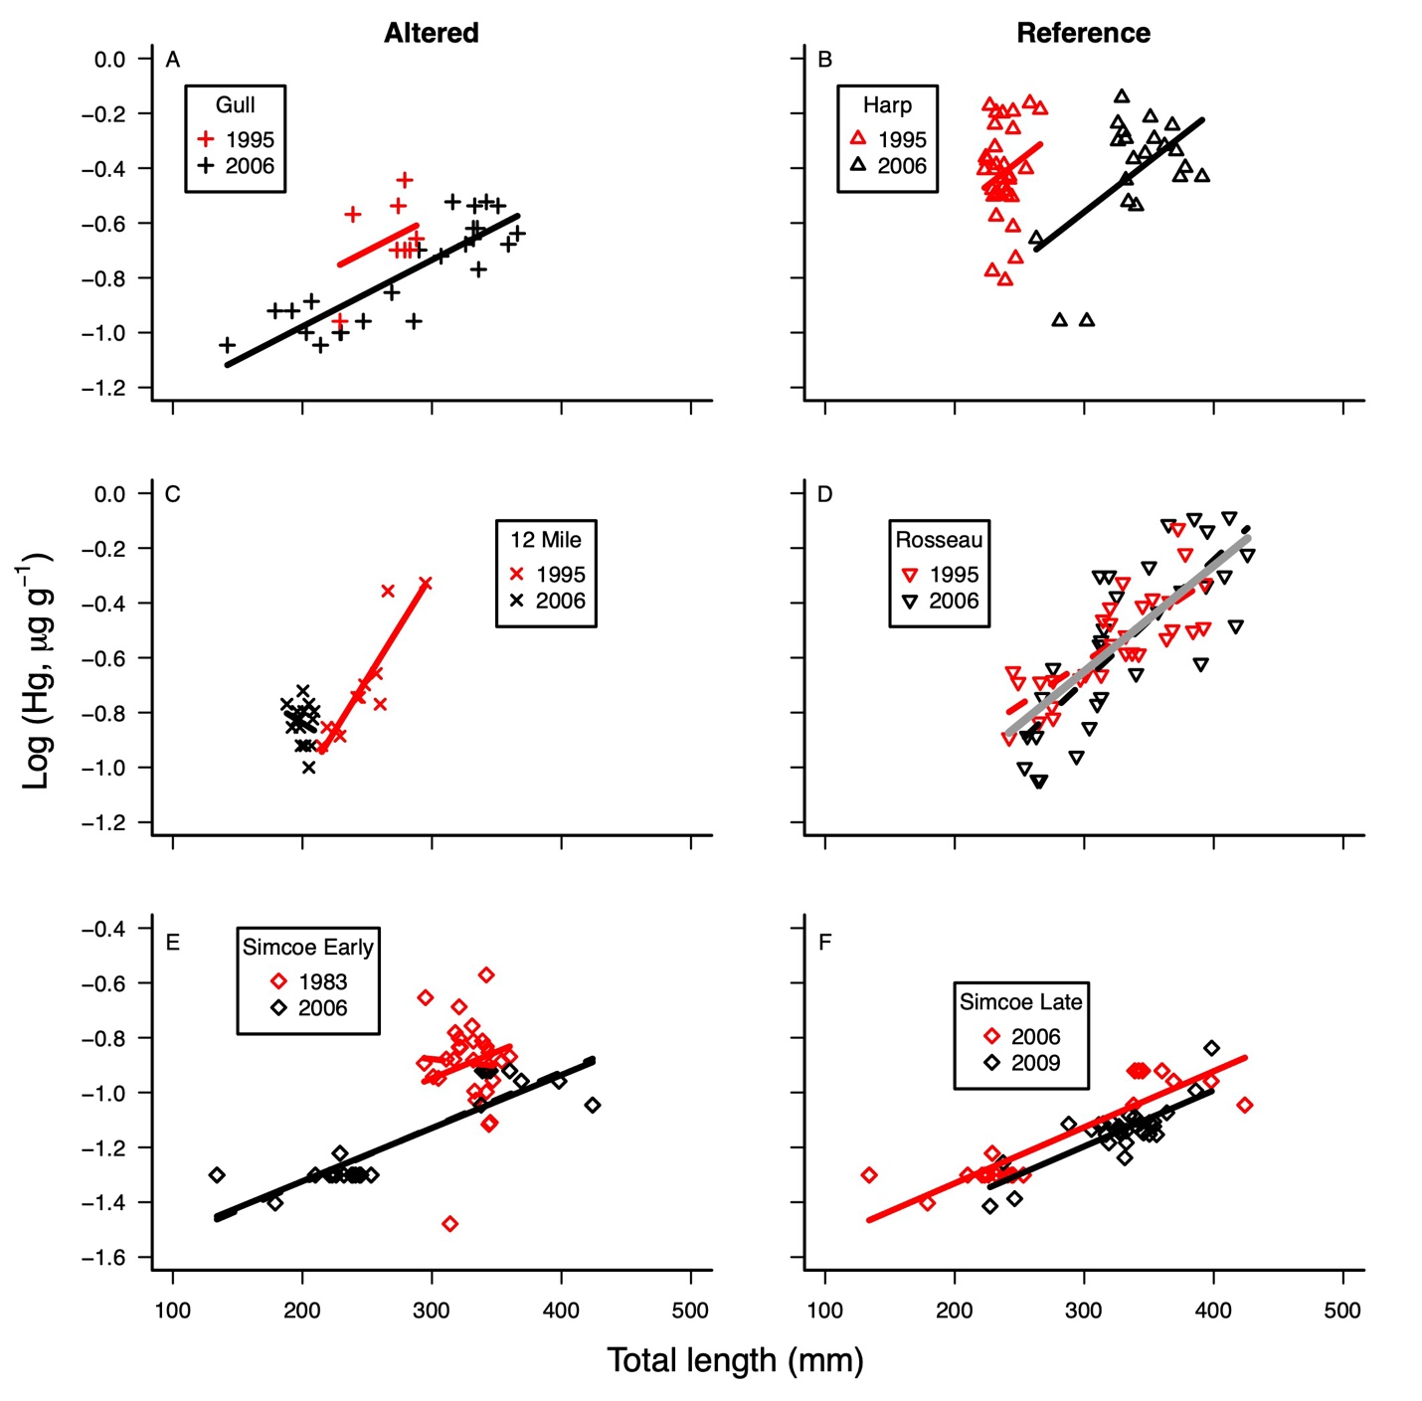

Figure S2. Cisco Hg concentrations (μg/g wet weight) with body size in altered (those invaded by Bythotrephes between historic and contemporary sampling) and reference lakes (those where Bythotrephes were present in both time periods). Models evaluated are presented in Table S2. Dashed lines in Panel D show results for relationships in each time period; solid grey line shows common relationship among both years (See Table S1). Dashed lines in Panel E show results for heterogeneous slope model (See Table S1).

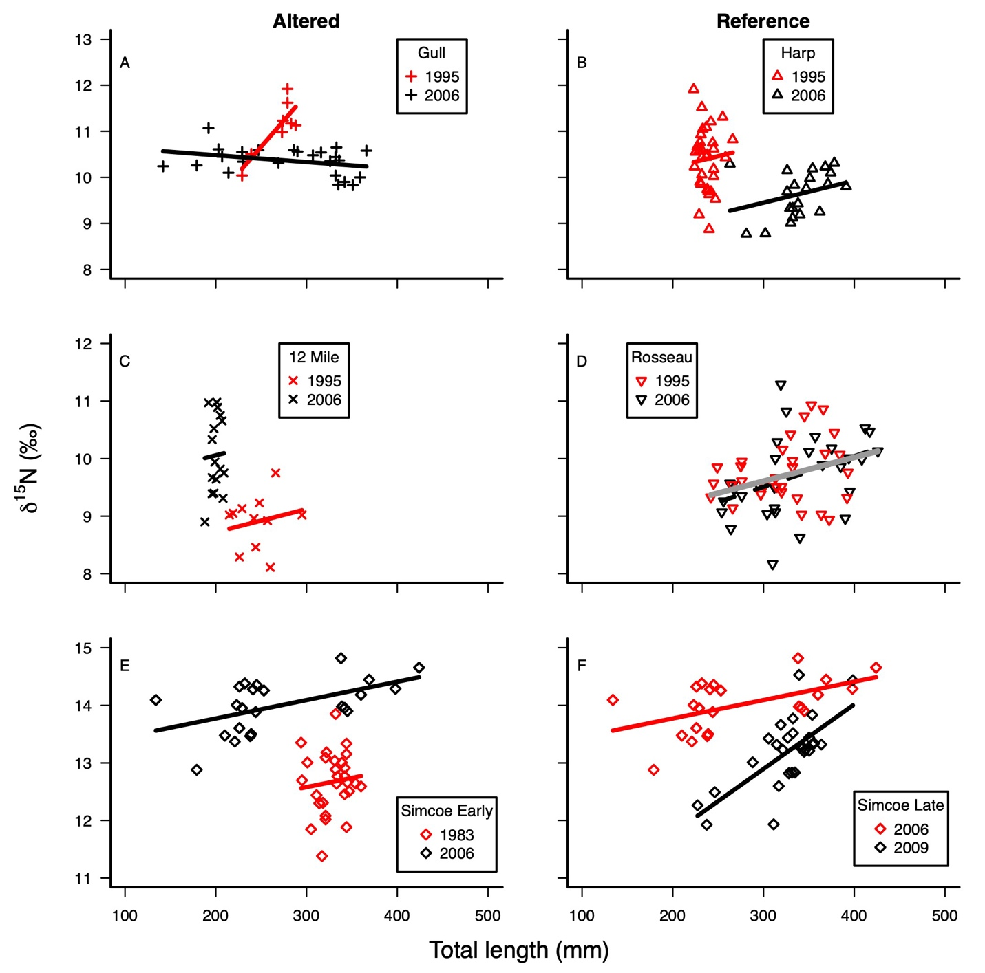
Figure S3. Cisco δ¹⁵N isotopic values (‰) with body size in altered (those invaded by Bythotrephes between historic and contemporary sampling) and reference lakes (those where Bythotrephes were present in both time periods). Models evaluated are presented in Table S3. Dashed lines in Panel D show results for relationships in each time period; solid grey line shows common relationship among both years (See Table S2).

Bythotrephes sampling- 2007
Lake sampling was conducted over 1-3 days, and occurred in each lake twice during the summer of 2007, starting in mid-June and ending in mid-August. second in mid July (See James 2010 for full details). Pelagic macroinvertebrate communities were sampled in the evening in each of the 11 study lakes using a vertically-hauled conical net (0.5 m diameter opening, 2 m long, 400 µm mesh) deployed from 3 m above the lake bottom to the surface. Five replicate hauls at 5 m intervals along a sampling transect were conducted, starting at the deepest part of the lake and moving towards shore, ensuring all samples were taken at depths over 10 m. Samples were immediately preserved using a 10% sugar buffered formalin solution. Bythotrephes abundance was estimated by counting the number of individuals encountered in each sample and was averaged across all samples taken in a lake.

Estimation of planktivore relative abundance- 2007
Fish collected using the NORDIC method (see Methods) were used to estimate the relative abundance of Cisco, as well as of the entire planktivore fish community (defined as the sum of all Cisco, Lake Whitefish, Rainbow Smelt, and Yellow Perch captured in survey nets). Average abundance and biomass over the summer period of both Cisco and the total planktivore community were estimated and standardized for effort (e.g. number of fish per net during a 12 hour set) to provide relative fish abundance and biomass. Linear regression was used to investigate relationships between cisco and planktivore relative abundance with Bythotrephes density. Total planktivore abundance and biomass were log transformed in order to conform to linearity. While no relationship was observed between Bythotrephes density with either cisco abundance (F_{1,9}= 0.4, P= 0.6) or biomass (F_{1,9}= 0.2, P= 0.7), significant relationships were observed with log-transformed total planktivore abundance (F_{1,9}= 9.1, P= 0.015, Figure S4) and with log-transformed total planktivore biomass (F_{1,9}= 8.9, P= 0.015). As Bythotrephes densities increased, the total abundance and biomass of the planktivore community declines (Figure S4).

Cisco diet analysis- 2007 samples
Cisco gastrointestinal tracts (stomach and foregut) were removed immediately after processing and were frozen for stomach content analysis. Stomach contents of at least 10 Cisco from each of the two sampling periods (no fewer than 20 stomachs per lake) were selected at random. Entire stomachs contents were weighed (fresh weight) and stomach contents were identified using a Leica dissecting microscope, enumerated and weighed individually (fresh weight). Prey types were classified into 5 groups: Mysis relicta, Chaoborus spp., Bythotrephes, zooplankton (i.e. those taxa that did not belong to any of the previous categories), and ‘other’ (typically fish eggs). The native macroinvertebrate, Leptodora kindtii was not observed in stomachs of cisco in any of the study lakes. The mean proportional biomass of each prey group was averaged among sampling periods to generate a summer average estimate. Linear regression was used to evaluate the relationship between the abundance of Bythotrephes in the environment and their proportional representation in the stomachs of Cisco. This analysis revealed that as density of Bythotrephes in the environment increased, so too did their proportional representation in the diets of Cisco (F_{1,6}= 28.8, P= 0.0017, Figure S5).

References

James, L.A.H. 2010. The effect of the invasive macroinvertebrate, Bythotrephes longimanus, on the growth of Cisco (Coregonus artedii) in Ontario shield lakes. Queen’s University, Kingston, ON.

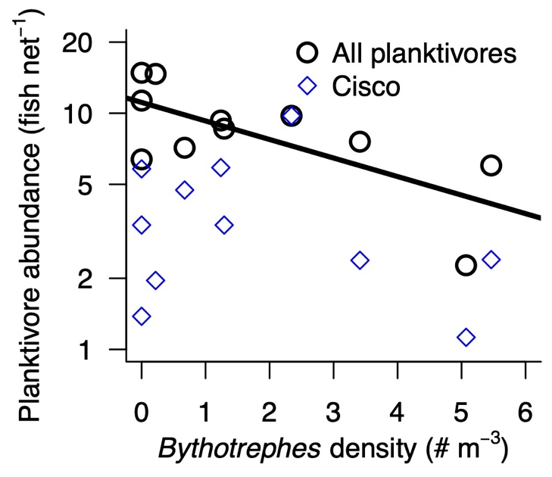
Figure S4. Mean relative abundance (Catch Per Unit Effort, CPUE) of Cisco (blue diamonds) and the total planktivore community (sum of Cisco, Lake Whitefish, Yellow Perch and Rainbow Smelt). Black line shows significant decline in total planktivore mean relative abundance with increasing mean Bythotrephes density.

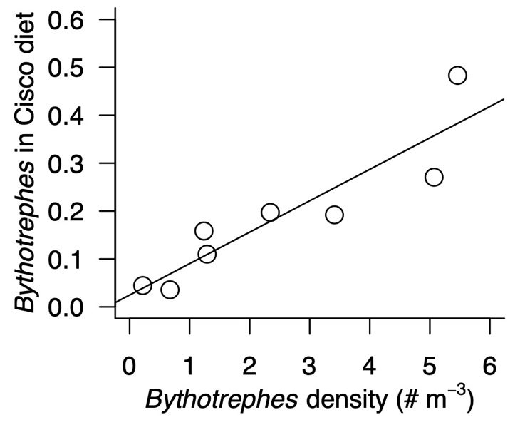
Figure S5. Mean proportion of Bythotrephes in Cisco guts increases significantly with Bythotrephes density in the environment. Each datapoint represents a lake-wide mean across all sampling periods.

