Table 2. Top 10 Zinc compounds along with SAM, S-Adenosyl-L-Cysteine, and Sinefungin are
arranged in descending order with the combined score. Their hydrogen binding residues were also listed in the table.

S.No. | Tittle | Structure | CombinedScore | Hydrogenbindingresidues
1 | ZINC000257261703 | 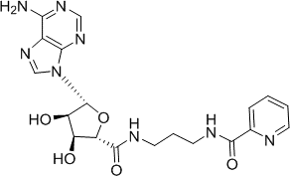 | 2.325 | Lys220,His170,Thr143,Asn214,Phe145,  Tyr146,Trp103
2 | ZINC000012405780 | 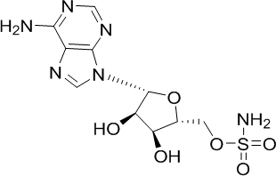 | 2.181 | Lys220,His170,Thr143,Asn214,Phe145,  Asn169
3 | ZINC000013509104 | 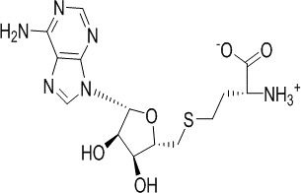 | 2.026 | Lys220,His170,Thr143,Asn144,Phe145,Tyr146, Trp103, Asn214
4 | ZINC001258104334 | 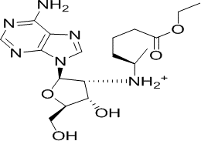 | 1.967 | Lys220,His170,Thr143,Asn144,Tyr146,  Trp103
5 | ZINC001204332484 | 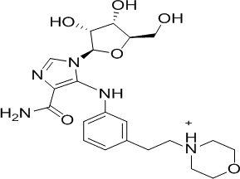 | 1.867 | Lys220,His170,Tyr207,Thr143,Gln100
6 | ZINC001581027904 | 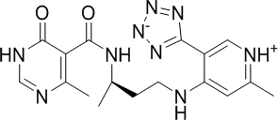 | 1.844 | Lys220,His170,Met168,Tyr146,Asn144

7 | ZINC001218564560 | 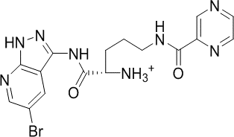 | 1.83 | Trp103,His170,Asn169,Tyr146
8 | ZINC001246208984 | 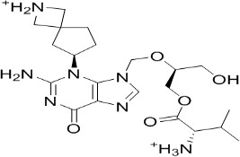 | 1.765 | Lys220,His170,Asn169,Asn214,Val218,  Phe145
9 | ZINC001246211171 | 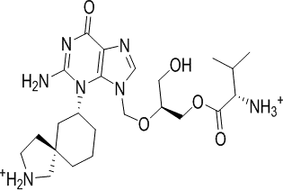 | 1.749 | Lys220, His170, Asn169, Arg101, Trp103,Asn144, Phe145, Asn214, Val218
10 | ZINC001150482938 | 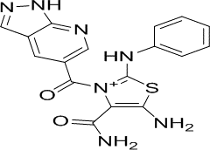 | 1.743 | Lys220,His170,Asn144,Phe145,Trp103,  Arg101
11 | SAM | 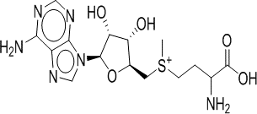 | Reference | Arg101,Trp103,Thr143,Tyr146,Phe145,  Asn214
12 | Sinefungin |  | Activeset | Lys220,Trp103,Phe145,Tyr146,Asn169,  His170,Asn214

