Target Validation and Structure-Based Virtual Screening to Discover Potential Lead Molecules against the oncogenic NSD1 histone methyltransferase

Zahid Rafiq Bhat¹, Anuj Gahlawat², Navneet Kumar², Nisha Sharma¹, Prabha Garg², Kulbhushan Tikoo^{*1}

^{SUPPLEMENTARY INFORMATION}
¹ Laboratory of Epigenetics and Diseases, Department of Pharmacology and Toxicology,
National Institute of Pharmaceutical Education and Research (NIPER) S.A.S. Nagar, India

² Department of Pharmacoinformatics, National Institute of Pharmaceutical Education and Research (NIPER), S.A.S. Nagar 160062, Punjab, India;

*Corresponding author: Prof. Kulbhushan Tikoo, Department of Pharmacology and Toxicology,
National Institute of Pharmaceutical Education and Research (NIPER) S.A.S. Nagar, India, Tel.9779199966; Fax: +91-172-2214692 Email: tikoo.k@gmail.com

This work was supported by grants from the National Institute of Pharmaceutical Education and Research, S.A.S. Nagar, India

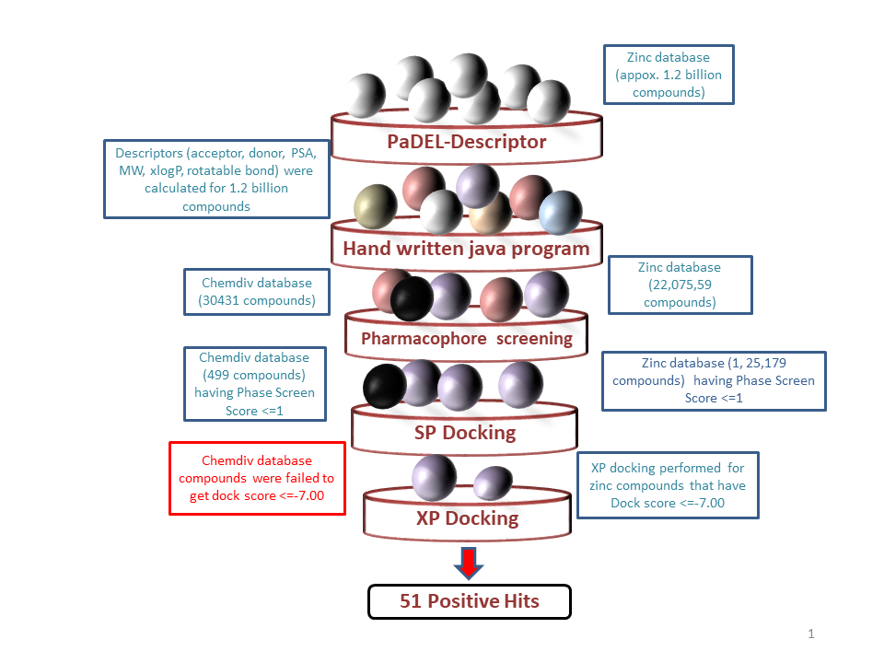
Figure S1. Staged process of high throughput virtual screening

Table S1. Sequence of primers used for mRNA quantitation by RT-PCR.
S.No | GENE NAME | PRIMER SEQUENCE
1. | NSD1 | Fwd: CAAGGAAGCGAAAACGACAGAGG  Rev: CCGTCCTGTGAGGCATTAGTTC
2. | 18S rRNA | Fwd: GCAATTATTCCCCATGAACG  Rev: AGGGCCTCACTAAACCATCC

S.No. | SAM inhibitors | Target | PubChem ID/Database
1 | S-Adenosyl-L-Ethionine | PKMT | Selleckchem.com
2 | S-Adenosyl-L-Cysteine | PKMT | Selleckchem.com
3 | Sinefungin | NSDs | 24595546
4 | Nahuoic acid | SETD2 | 23272941
5 | BRD9539 | EHMT2 | 22536950
6 | DC-L115 | DOT1L | 26914852
7 | EPZ004777 | DOT1L | 31790636
8 | DA3003-1 | NSD2 | 29945974
9 | TC_LPA5 4 | NSD2 | 29945974
10 | PF-03882845 | NSD2 | 29945974
11 | CPD4 | DOT1L | 21936531
12 | CPD5 | DOT1L | 21936531
13 | CPD6 | DOT1L | 21936531
14 | Pinometostat | DOT1L | 31790636
15 | BRD-4770 | EHMT2 | 22536950
16 | EZH6438 | EZH2 | Selleckchem.com
17 | UNC-1999 | EZH2 | Selleckchem.com
18 | NOVARTIS-EL1 | EZH2 | Selleckchem.com
19 | EPZ005687 | EZH2 | Selleckchem.com
20 | GSK-343 | EZH2 | Selleckchem.com
21 | GSK-126 | EZH2 | Selleckchem.com
22 | ABT-199 | NSD2 | 29945974
23 | BIX-01338 | EHMT2 | 22536950
24 | Suramin | Non-specific DNA binding protein | 24595546
25 | Chaetocin | HMT | 24595546, 29945974
Table S2. List of 25 SAM competitive / SET domain inhibitors of different PKMT targets collected from the literature and databases.

Table S3. Active dataset compounds having docking score < -9 were selected after the docking of 25 literature collected inhibitors.
Inhibitor | Docking score | Glide Gscore | Glide Emodel
S-Adenosyl-L-Ethionine | -12.9 | -13.1 | -152.3
Sinefungin | -12.2 | -12.2 | -140.2
CPD4 | -11.8 | -11.8 | -128.0
S-Adenosyl-L-Cysteine | -11.5 | -11.6 | -124.0
EPZ5676 | -9.4 | -10.8 | -81.6
Pinometostat | -9.4 | -10.8 | -81.6

Table S4. Minimum and maximum value used for descriptor based Zinc15 database screening.
Descriptors | Min | Max
nHA | 9 | 13
nHD | 3 | 6
TopoPSA | 150 | 220
MW | 330 | 570
XLogP | -4 | 5
Rotatable bond | 4 | 12

Table S5. Top 51 compounds screened after XP docking are arranged by combine score in descending order. Data also given for SAM, Sinefungin, and S-Adenosyl-L-Cysteine.
S.No | Title | Docking score | PhaseScreenScore | XP GScore | MMGBSA dG Bind | Combined Score
1 | 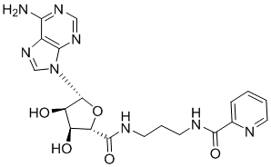 | -14.304 | 1.532 | -14.304 | -97.18 | 2.325
1 | ZINC000257261703
2 | 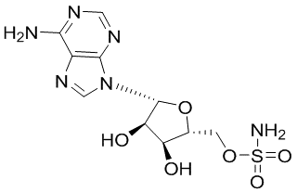 | -13.496 | 1.676 | -13.573 | -95.91 | 2.181
2 | ZINC000012405780
3 | 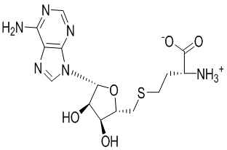 | -13.742 | 1.152 | -13.77 | -92.82 | 2.026
3 | ZINC000013509104
4 | 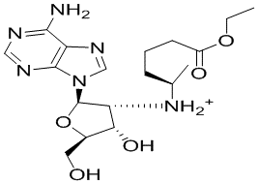 | -10.378 | 1.242 | -11.075 | -98.64 | 1.967
4 | ZINC001258104334
5 | 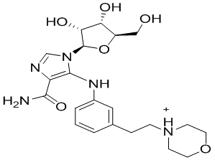 | -9.4 | 1.568 | -11.152 | -92.14 | 1.867
5 | ZINC001204332484
6 | 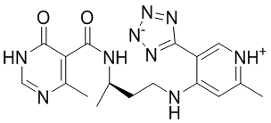 | -9.758 | 1.554 | -10.095 | -97.56 | 1.844
6 | ZINC001581027904
7 | 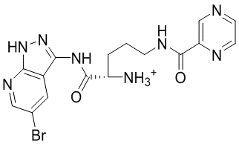 | -9.687 | 1.472 | -10.801 | -91.82 | 1.83
7 | ZINC001218564560
8 | 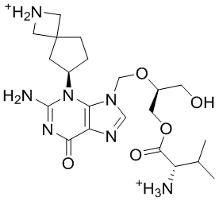 | -9.967 | 1.443 | -11.287 | -92.75 | 1.765
8 | ZINC001246208984
9 | 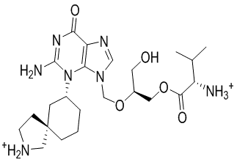 | -10.162 | 1.472 | -11.481 | -91.9 | 1.749
9 | ZINC001246211171
10 | 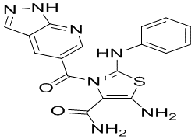 | -11.843 | 1.304 | -11.909 | -99.5 | 1.743
10 | ZINC001150482938
11 | 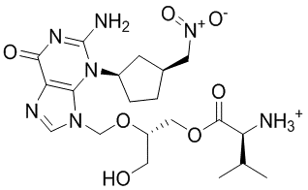 | -11.016 | 1.46 | -12.336 | -92.7 | 1.705
11 | ZINC001168975547
12 | 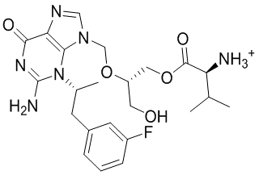 | -10.075 | 1.505 | -11.394 | -93.05 | 1.691
12 | ZINC001168459570
13 | 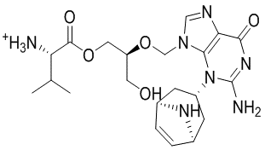 | -10.256 | 1.665 | -12.549 | -95.32 | 1.685
13 | ZINC001246213329
14 | 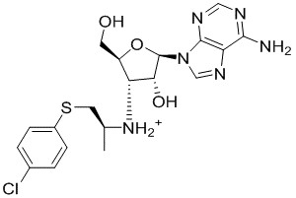 | -8.847 | 1.448 | -10.024 | -99.76 | 1.666
14 | ZINC001172873942
15 | 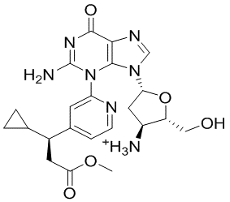 | -9.905 | 1.232 | -10.216 | -91.9 | 1.638
15 | ZINC001161485277
16 | 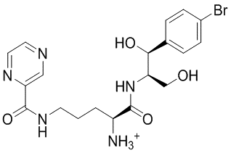 | -9.017 | 1.252 | -9.987 | -92.52 | 1.619
16 | ZINC001219580330
17 |  | -11.993 | 1.064 | -12.05 | -100.3 | 1.567
  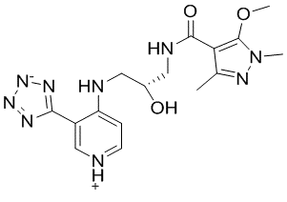
17 | ZINC001579871121
18 | 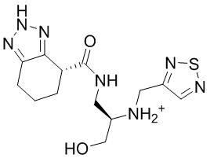 | -9.862 | 1.353 | -11.219 | -91.59 | 1.567
18 | ZINC001507226656
19 | 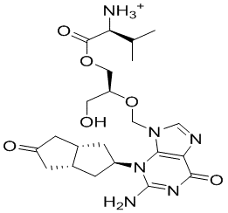 | -10.201 | 1.537 | -11.52 | -93.28 | 1.561
19 | ZINC001254925029
20 | 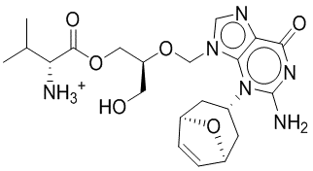 | -10.818 | 1.346 | -12.137 | -91.73 | 1.496
20 | ZINC001172228777
21 | 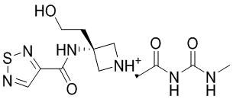 | -9.356 | 1.576 | -10.725 | -93.4 | 1.48
21 | ZINC001381643697
22 | 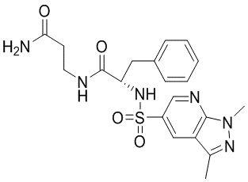 | -11.568 | 1.162 | -11.573 | -96.31 | 1.453
22 | ZINC000472741557
23 | 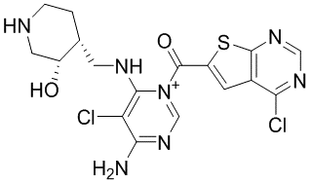 | -8.288 | 1.615 | -10.678 | -93.23 | 1.444
23 | ZINC001218780736
24 | 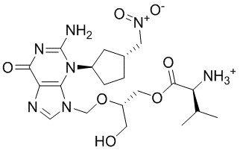 | -9.911 | 1.234 | -11.23 | -92.09 | 1.417
24 | ZINC001168975539
25 | 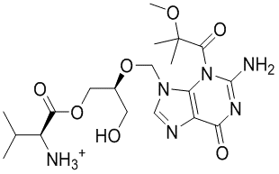 | -10.018 | 1.272 | -11.585 | -92.21 | 1.416
25 | ZINC001143330057
26 | 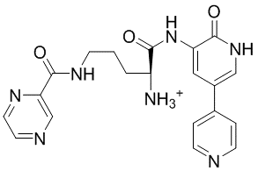 | -9.364 | 1.126 | -10.735 | -98.4 | 1.387
26 | ZINC001218603467
27 | 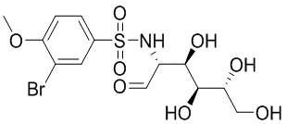 | -9.367 | 1.046 | -9.984 | -95.32 | 1.385
27 | ZINC001261041557
28 | 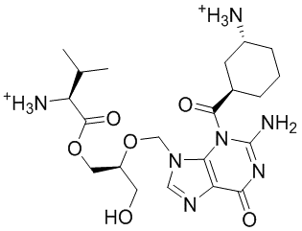 | -9.902 | 1.29 | -11.674 | -95.94 | 1.361
28 | ZINC001220123026
29 | 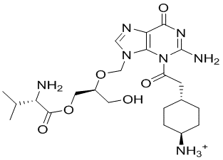 | -11.23 | 1.295 | -11.652 | -94.63 | 1.358
29 | ZINC001220121987
30 | 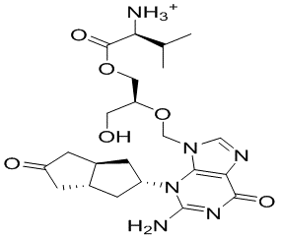 | -10.308 | 1.552 | -11.627 | -93.1 | 1.356
30 | ZINC001254925027
31 | 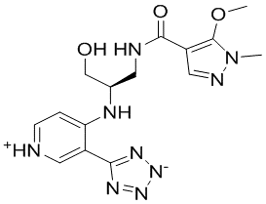 | -10.045 | 1.025 | -10.102 | -91.57 | 1.354
31 | ZINC001579871115
32 | 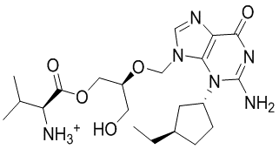 | -10.25 | 1.452 | -11.57 | -93.08 | 1.33
32 | ZINC001173262287
33 | 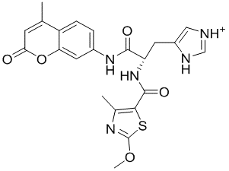 | -7.732 | 1.049 | -10.08 | -110.12 | 1.326
33 | ZINC001193502131
34 | 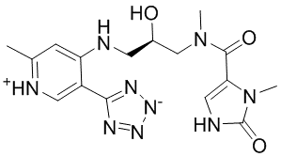 | -11.17 | 1.118 | -11.182 | -96.52 | 1.312
34 | ZINC001581014708
35 | 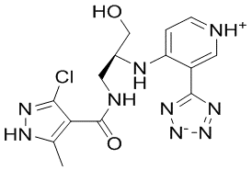 | -10.413 | 1.054 | -10.881 | -104.85 | 1.286
35 | ZINC001581401413
36 | 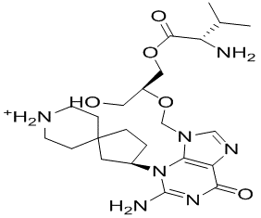 | -11.837 | 1.14 | -11.905 | -96.6 | 1.267
36 | ZINC001246206813
37 | 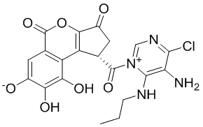 | -9.11 | 1.296 | -10.319 | -97.13 | 1.265
37 | ZINC001185541974
38 | 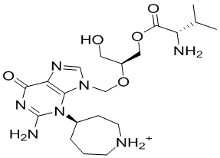 | -11.774 | 1.115 | -11.846 | -93.56 | 1.257
38 | ZINC001246208260
39 | 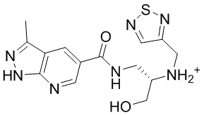 | -10.186 | 1.073 | -11.229 | -92.25 | 1.224
39 | ZINC001725548981
40 | 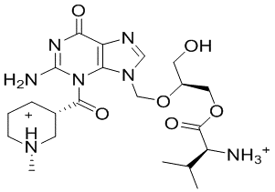 | -9.602 | 1.187 | -11.76 | -93.78 | 1.221
40 | ZINC001186361626
41 | 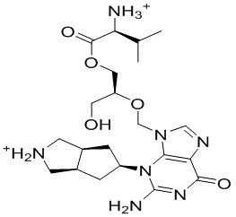 | -9.635 | 1.064 | -10.954 | -92.73 | 1.215
41 | ZINC001246211254
42 | 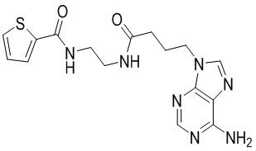 | -11.038 | 1.068 | -11.038 | -95.94 | 1.156
42 | ZINC001151031566
43 | 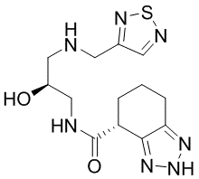 | -10.78 | 1.196 | -11.367 | -93.72 | 1.155
43 | ZINC001401567825
44 | 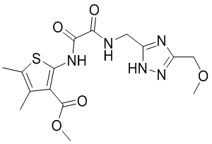 | -9.772 | 1.079 | -10.09 | -97.22 | 1.132
44 | ZINC000595133153
45 | 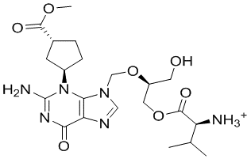 | -10.157 | 1.171 | -11.476 | -95.07 | 1.107
45 | ZINC001170509718
46 | 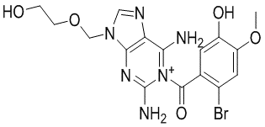 | -9.463 | 1.066 | -10.136 | -96.68 | 1.057
46 | ZINC001149056654
47 | 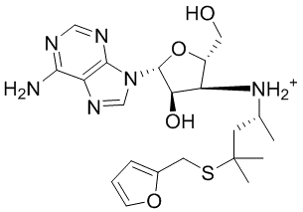 | -10.326 | 1.282 | -10.973 | -93.74 | 0.93
47 | ZINC001258305359
48 | 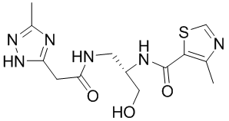 | -10.893 | 1.017 | -11.479 | -98.35 | 0.858
48 | ZINC001395728418
49 | 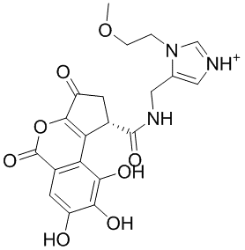 | -7.945 | 1.27 | -10.419 | -96.36 | 0.848
49 | ZINC001185553111
50 | 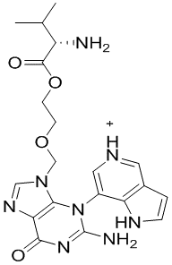 | -8.547 | 1.041 | -10.23 | -93 | 0.54
50 | ZINC001169981368
51 | 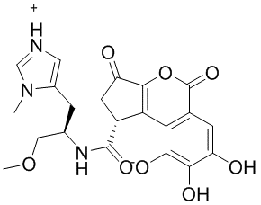 | -8.718 | 1.049 | -10.423 | -92.97 | 0.318
51 | ZINC001185558640
52 | 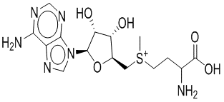 | -13.069 | Cofactor | -13.241 | -97.83 | Cofactor
52 | SAM
53 |  | -11.684 | Active dataset | -13.539 | -91.24 | Active dataset
53 | SINEFUNGIN
54 |  | -13.099 | Active dataset | 13.225 | -87.88 | Active dataset
54 | S-Adenosyl-L-Cysteine

Table S6.
Compounds | Average RMSD | Average Rg
3ooi_apo | 4.4±0.6 | 19.5±0.26
Sinefungin | 3.7±1.1 | 19.4±0.13
ZINC000257261703 | 3.3±0.5 | 19.4±0.17
ZINC000012405780 | 3.5±0.5 | 19.4±0.22
ZINC000013509104 | 3.2±0.5 | 19.7±0.15

Figure S2. Top panel shows the total number of specific contacts the NSD1makes with the A) Sinefungin, B) ZINC000257261703, C) ZINC000012405780, and d) ZINC000013509104 over the course of the trajectory and the bottom panel shows the interaction of particular residues with the ligands in each trajectory frame.

Supplementary Information:
Analysis of Clinical data samples
TCGA gene expression data analysis of NSD1 in various clinical cancer datasets was performed using the UALCAN¹ (http://ualcan.path.uab.edu/index.html). TCGA data based survival analysis was carried out using the GEPIA² (http://gepia2.cancer-pku.cn/#survival).The TCGA cancer datasets used in the analysis include LIHC (hepatocellular carcinoma), PRAD (Prostate adenocarcinoma), CESC (cervical squamous carcinoma), and COAD (colorectal adenocarcinoma).

Cell Culture
A549 cells, RWPE1 (normal prostate epithelial cells) and PCS-480-011 (primary cervical epithelial cells) were obtained from ATCC (Manassas, VA, USA). DU-145, HepG2, L132, Hela, and Siha cells were obtained from NCCS Pune, India. Cells were grown under standard conditions of 5% CO₂ and 37⁰C temperature in controlled humidified incubator. They were cultured in Dulbecco’s Modified Eagle’s Medium/DMEM (HepG2, Hela, and Siha), MEM (L132 cells), and RPMI-1640 (DU-145) cells (Sigma Aldrich) supplemented with 10% FBS (GIBCO, U.S.A.) and 1% penicillin streptomycin. RWPE1 were cultured in Keratinocyte Serum Free Media (KSFM) supplemented with 50 mg/L BPE, 5μg/L EGF, and 1% penicillin-streptomycin obtained from ATCC (Manassas, VA, USA). PCS were cultured in Cervical Epithelial Cell Basal Medium along with the Cervical Epithelial Cell Growth Kit (ATCC). All the cells were used prior to passage 20. Cells were routinely passage using 0.25% trypsin/0.1% EDTA. All the other chemicals were purchased from Sigma (St. Louis, MO, USA), unless otherwise mentioned.

Total RNA isolation
Briefly, TRIZOL reagent (Invitrogen, CA, USA) was used for total RNA extraction from cells followed by purification according to the manufacturer’s protocol using an RNeasy kit (AuPrep RNeasy Mini Kit; Life Technologies Pvt. Ltd., India). Nanodrop spectrophotometer (ND-1000) was used to evaluate the RNA quality and integrity of each sample by A260/280 absorbance ratio and agarose gel electrophoresis respectively.³

Reverse transcription and RT-PCR
In order to evaluate the mRNA (transcript) levels of NSD1 gene in various cell line samples, verso cDNA synthesis kit was used for cDNA synthesis from RNA and then quantitative RT-PCR was performed using 2 μL of total RNA template (5ng/μL), 2 μL of 5X reaction buffer, 1 μL of enzyme mix and finally adjusted to 10 μL reaction volume using nuclease free water. Process of Reverse transcription was performed at 42ºC for 60 minutes, followed by inactivation at 95ºC for 5 minutes. For RT-PCR, 20 μL reactions were prepared in the following proportions: 10 μL of SYBR Green master mix, 2 μL of primer mix, and 8 μL of cDNA template (1:80 dilution of the synthesized cDNA in nuclease free water). RT-PCR was conducted at 95ºC for 10 minutes, followed by 40 cycles of 95ºC for 10 seconds/60ºC for 1 minute using a Light Cycler 2.0 (Roche Diagnostics, USA).³
After amplification, melting curve analysis to verify the specificity of the reaction was carried out. Relative changes in NSD1 mRNA expression was assessed using the comparative Ct (ΔCt) method and normalization was done using 18S rRNA as a reference gene. The list of forward and reverse primer sequence of NSD1 and 18S rRNA genes used for mRNA quantification through quantitative RTPCR is given in Supplementary Table 1.

Isolation of total proteins and western blotting
Briefly, cells were seeded and allowed to grow till 70-80 % confluency in 8 cell culture dishes (2 x 10⁶ cells per plate) in their respective media having 10% FBS and antibiotics (penicillin, 100 IU/ml and streptomycin, 100 μg/ml) under controlled and standard conditions of 5% CO₂ and 37ºC in a well humidified atmosphere of incubator. Afterwards, washing of cells with ice-cold PBS followed by cell lysis in modified low salt buffer (LSB; 10 mM Tris–HCl, pH 7.4, 150 mM EDTA, 1 mM sodium orthovanadate, 10 mM sodium fluoride, 10 mM sodium pyrophosphate, 1 mM phenylmethylsulfonyl fluoride, 10 μg/ml aprotinin, 1 mM sodium butyrate and 0.05% NP-40). It was followed by sonication first and then centrifuged at 12000 g to separate supernatant for the estimation of total cellular proteins and then reduced by using 1X laemmli's sample buffer according to a method described by Tikoo et al.³ Equal amount of samples were run on SDS PAGE and then transferred onto nitrocellulose membrane electrophoretically using semi-dry transfer apparatus (Bio-Rad). Depending on the molecular weight of desired proteins, samples were resolved using sodium dodecyl sulphate-polyacrylamide gels. The membrane transferred proteins were blocked in 3% BSA for 2 to 3 hours. Further, the membrane was probed with primary and secondary antibodies, developed using HRP chemiluminiscent substrate solution and developed/fixed onto X-ray film. Immunoblotting was performed using anti-NSD1and anti-tubulin antibody (rabbit, 1:1000, Santa Cruz Biotechnology, CA, USA). Incubation of the membrane with horseradish peroxidase (HRP)-coupled secondary antibodies (Santa Cruz Biotechnology, CA, USA) used to help in detecting antigen-primary antibody complexes. Densitometry scanning was employed to quantify by using NIH Image J software.

(1) Chandrashekar, D. S.; Bashel, B.; Balasubramanya, S. A. H.; Creighton, C. J.; Ponce-Rodriguez, I.; Chakravarthi, B. V. S. K.; Varambally, S. UALCAN: A Portal for Facilitating Tumor Subgroup Gene Expression and Survival Analyses. Neoplasia 2017, 19 (8), 649–658.
(2) Tang, Z.; Li, C.; Kang, B.; Gao, G.; Li, C.; Zhang, Z. GEPIA: A Web Server for Cancer and Normal Gene Expression Profiling and Interactive Analyses. Nucleic Acids Res. 2017, 45 (W1), W98–W102.
(3) Surapaneni, S. K.; Bhat, Z. R.; Tikoo, K. MicroRNA-941 Regulates the Proliferation of Breast Cancer Cells by Altering Histone H3 Ser 10 Phosphorylation. Sci. Rep. 2020, 10 (1), 1–17.

