Graphical steps for preparing the ground olive leaves

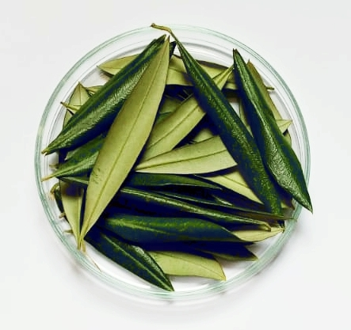
Step 1:
Collecting the fresh olive leaves and washing them with distilled water
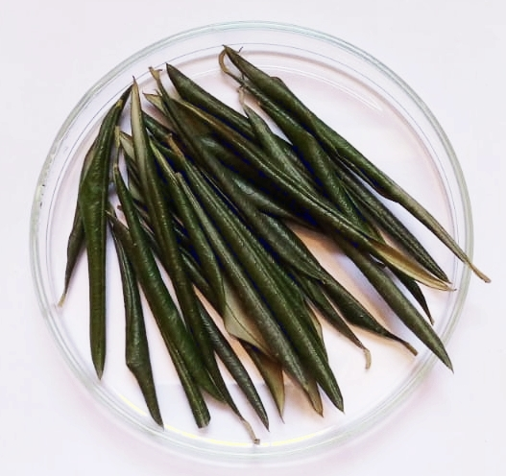
Step 2:
Drying the leaves at room temperature without exposing them to sunlight
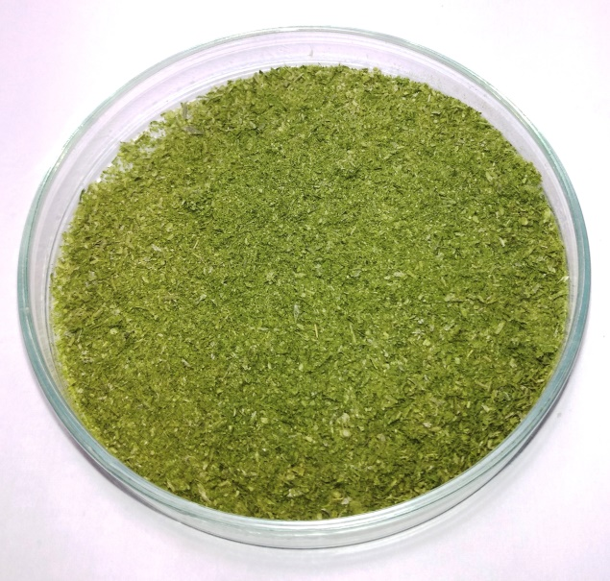
Step 3:
Grounding the olive leaves

Graphical steps for preparing the olive leaves extract

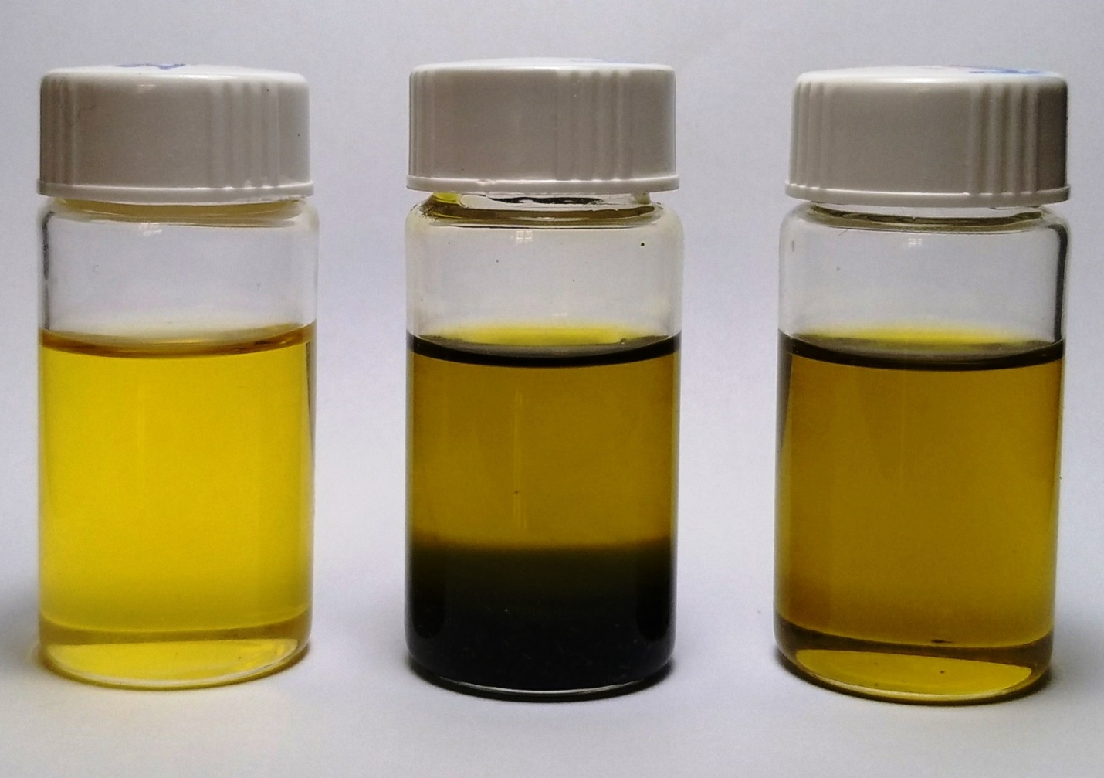

Step 1:
Prepare the Extra Verging Olive Oil (EVOO) as shown in left bottle
Step 2:
Add the ground olive leaves to the Extra Verging Olive Oil as shown in middle bottle
Step 3:
Purify the mixture in the middle bottle using centrifugation as shown in the right bottle

Note that the bottles shown in this graph are only for demonstrations; where the previous steps were carried out in DARK bottles
Preparing the bovine bone samples at the required dimensions
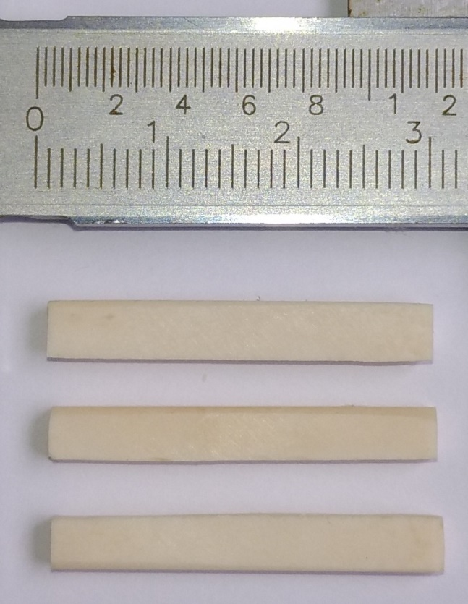
Soaking the bone samples in the olive leaves extract
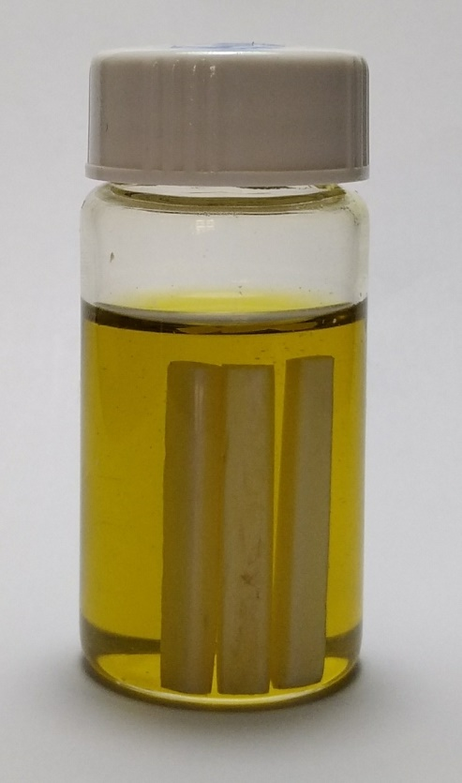
DMA measuring technique
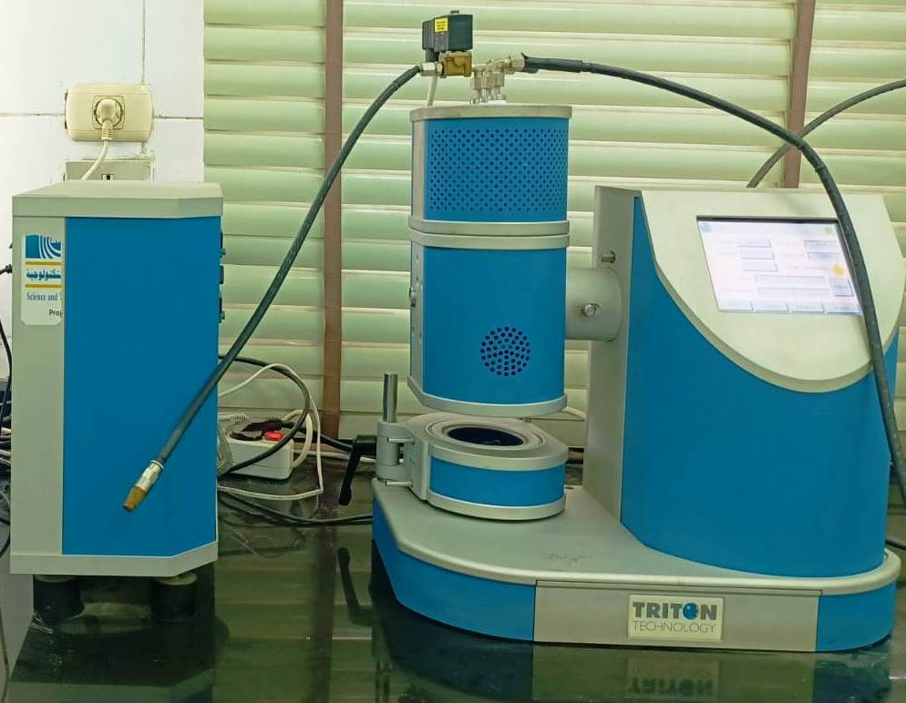
Placement of the bone sample in DMA measuring module
