Table S1 List of QTPP, CQAs & CPPs

Sr no | QTPP (Quality target product profile) | (CQA)  Critical quality attributes | (CPP)  Critical process parameters
1 | Mobile phase (org) composition | Resolution | Linearity
2 | Type of organic phase | Tailing | Specificity
3 | Stressor concentration | Retention time | LOD
4 | Buffer pH | Peak purity | LOQ
5 | Flow rate | Theoretical plates | Accuracy
6 | Column type | Fronting | Precision
7 | Injection volume | Area of peak
8 | Column temperature | HETP
10 | Column length
12 | Peak shape
13 | Peak purity
14 | Peak modifier

Table S2 Chromatographic factors and response variables for Plackett Burman Screening Design

Factor | Name | Type | Low (-1) | High (+1)
A | MP* (org) concentration | Numerical | 30 | 60
B | pH | Numerical | 3.5 | 4.0
C | FR* | Numerical | 0.8 mL/min | 1.0 mL/min
D | Column Temp | Numerical | 10°C | 30°C
E | Degradation sample | Numerical | 8 Hrs | 12 Hrs
F | Buffer type | Categoric | Ammonium formate (AF) | Ammonium Acetate (AA)
G | Wavelength | Numerical | 200 nm | 250 nm
H | Column length | Numerical | 150 mm | 250 mm
I | Organic phase | Categoric | Acetonitrile | Methanol
J | Column type | Categoric | C8 | C18
*MP = Mobile phase composition; FR = flow rate of mobile phase

Table S3 Response variable ANOVA result

Response | Model | R² | Adjusted R² | Polynomial equation | P value
RS I | Quadratic | 0.747 | 0.654 | Y = +3.91 -1.72*A- 0.1910*B - 2.07*B² | < 0.00270
RS II | Quadratic | 0.872 | 0.806 | Y = + 2.27 - 2.39*C + 4.42*C² | < 0.0300
RS III | Quadratic | 0.00 | 0.00 | Not significant | 0.4210
RS IV | Quadratic | 0.821 | 0.758 | Y = -0.1052 + 0.2389*D +0.8211*BD +1.63*D² | < 0.0391

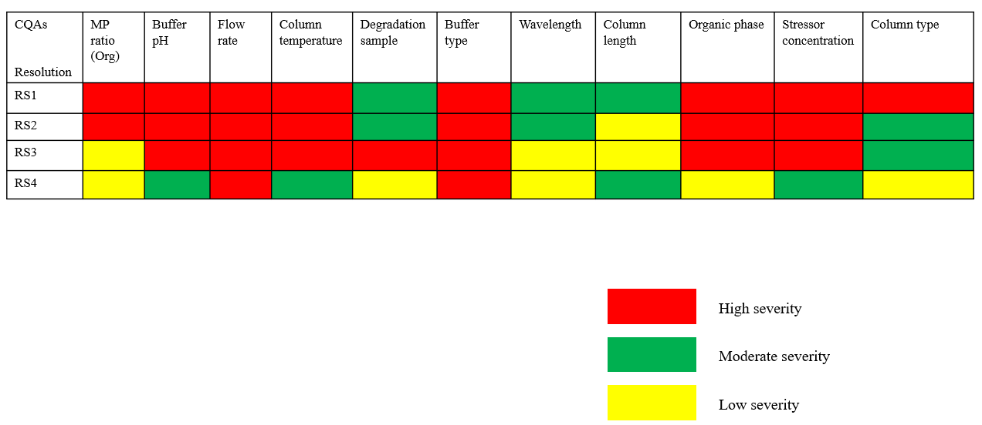
Figure S1 Risk assessment for stability method of Lenvatinib

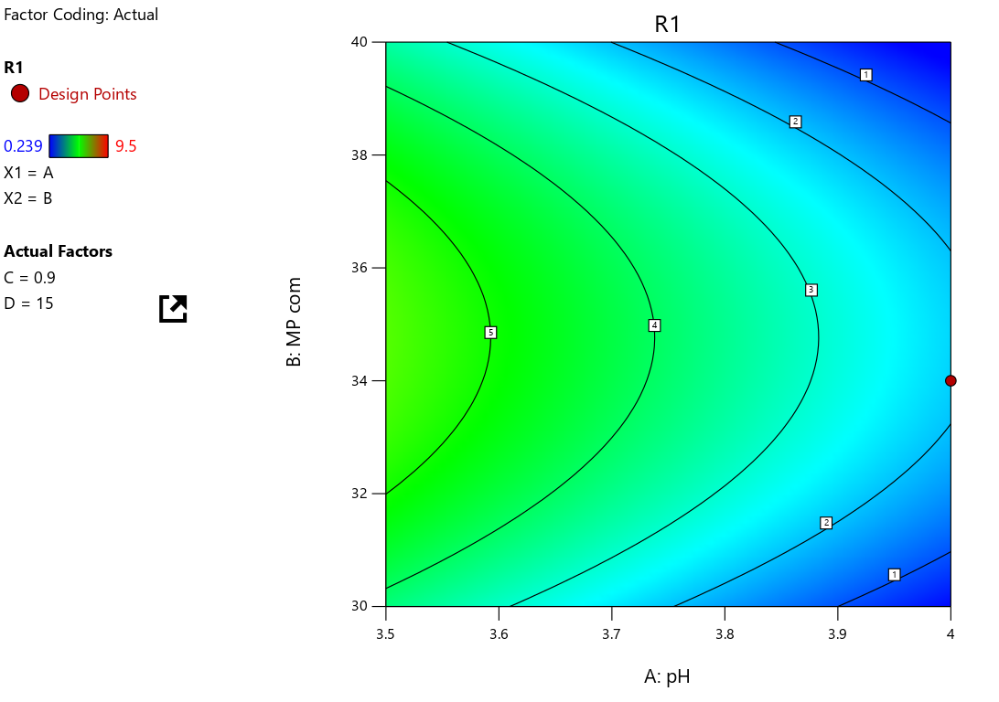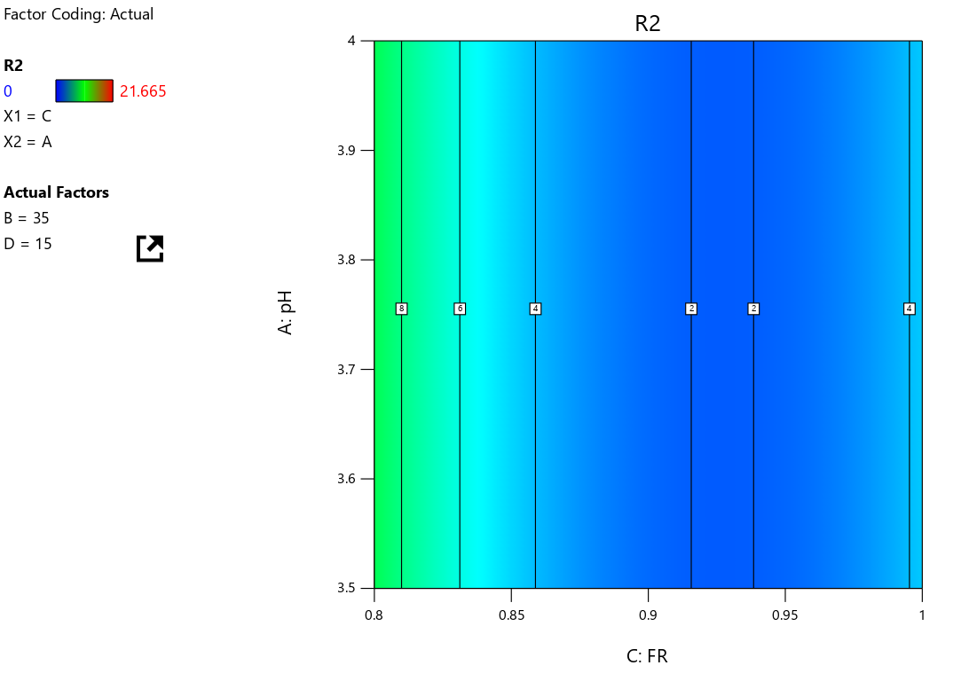
(i) (ii)

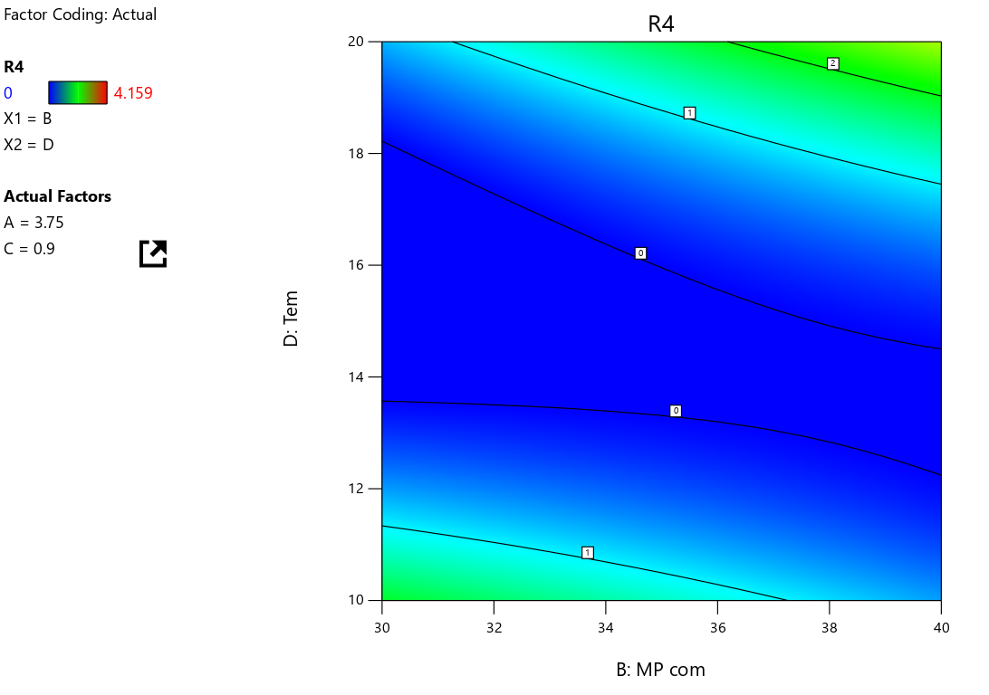
(iii)

Figure S2 2D Contour plots for (i) RS I, (ii) RS II, (iii) RS IV

