Supplementary Document

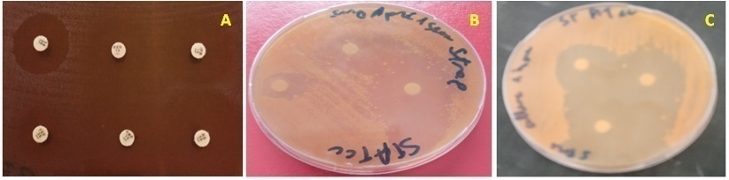
A
B

Supplementary 1: A: Zone of inhibition of an antibiotic. B: Antibacterial activity of cell-free supernatants of S. thermophilus isolates against Staphylococcus aureus (ATCC29213) after 1-week incubation. C: Antibacterial activity of bacterial suspension of S. thermophilus isolates against Staphylococcus aureus (ATCC29213) after 24hr incubation.

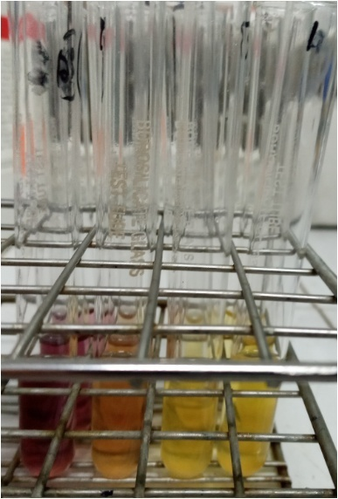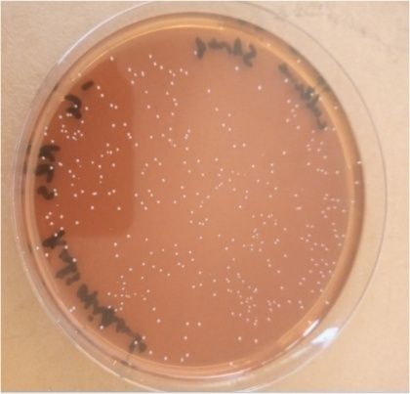
A
B
Supplementary 2: A: Antioxidant activity B: enumeration of S. thermophilus colonies during bile salt-resistance test.

