SUPPLEMENTARY MATERIAL
Carbon balance shift in mountain peatlands along a gradient of grazing disturbance in the tropical Andes (Colombia)
Violeta Martínez-Amigo^{1*}and Juan C. Benavides¹
¹ Department of Ecology and Territory, Pontificia Universidad Javeriana, Bogotá D.C., Colombia.
*Corresponding author: martinez_v@javeriana.edu.co
Appendix 1 – Methods
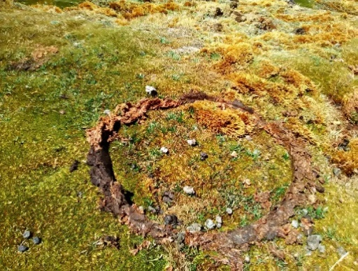
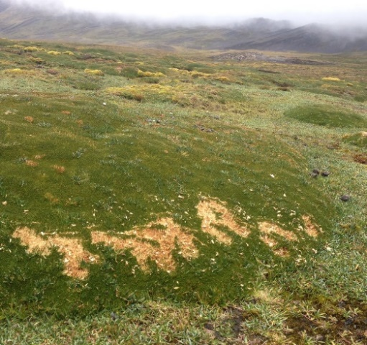
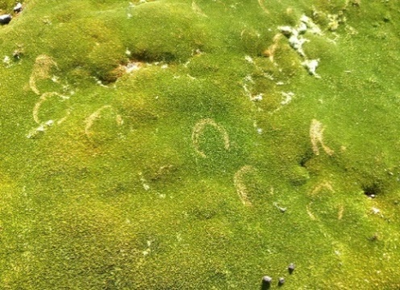
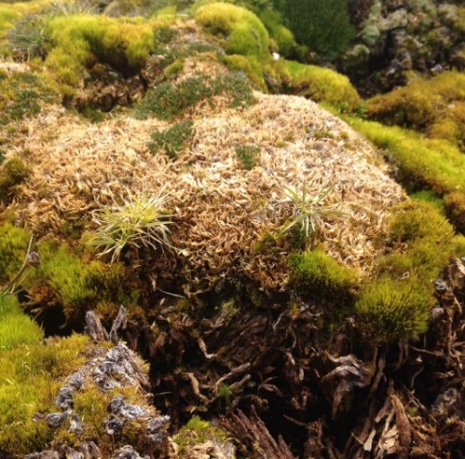
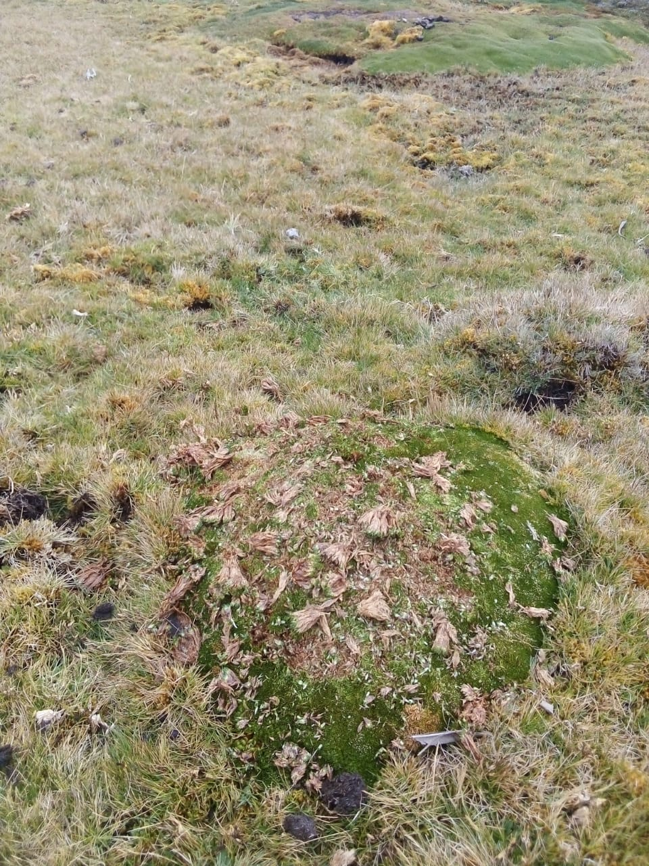
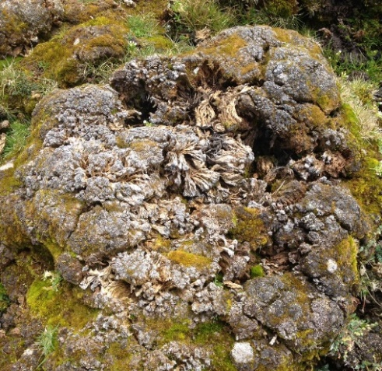
Fig. S1 Classification of the types of grazing disturbance of the plots. Each assigned value was classified according to the intensity scale of disturbance from 1 to 6: 1) presence of excrement; 2) trample; 3) chewed vegetation; 4) strongly grazed; 5) trampled and chewed plots; 6) completely disaggregated exposed soil.
1
2
3
4
5
6

Appendix 2 – Results
Table S1 List of plant species and families identified for each sampled peatland of El Cocuy National Park. The x marks the presence of the species for each study site.
Specie | Family | Chapetona | Curial | Curial alto | Corral grande
Agrostis breviculmis | Poaceae | x | x | x | x
Asteraceae 1 | Asteraceae | x |  | x | x
Asteraceae 2 | Asteraceae |  |  |  | x
Bartsia sp. | Orobanchaceae | x | x | x
Breutelia brittoniae | Bartramiaceae |  | x |  | x
Breutelia crysea | Bartramiaceae |  |  |  | x
Breutelia polygastrica | Bartramiaceae | x | x | x | x
Breutelia sp. | Bartramiaceae | x |  | x | x
Bryum argenteum | Bryaceae | x | x | x
Campylopus sp.1 | Leucobryaceae | x | x | x | x
Camylopus sp2. | Leucobryaceae | x | x | x
Carex sp. | Cyperaceae | x | x | x | x
Castilleja integrifolia | Orobanchaceae |  |  | x
Castratella piloselloides | Melastomataceae |  |  |  | x
Cotula mexicana | Asteraceae |  |  | x | x
Cyperaceae 1 | Cyperaceae | x | x | x | x
Distichia muscoides | Juncaceae | x | x | x | x
Gentiana sedifolia | Gentianaceae | x | x |  | x
Geranium multiceps | Geraniaceae | x |  | x | x
Geranium sibbaldioides | Geraniaceae | x |  |  | x
Geranium tomentoso | Geraniaceae |  |  | x
Halenia insignis | Gentianaceae | x | x |  | x
Hepatica | Hepaticophyta | x | x
Hypochaeris sessiliflora | Asteraceae | x | x |  | x
Lachemilla aphanoides | Rosaceae | x |  | x | x
Lachemilla killipii | Rosaceae |  |  |  | x
Lachemilla nivalis | Rosaceae |  | x | x | x
Lachemilla pinnata | Rosaceae | x |  | x | x
Lysipomia lacinata | Asteraceae |  |  | x
Macromitrium sp. | Orthotrichaceae | x |  |  | x
Merchantia sp. | Marchantiaceae | x
Oritrophium limnophilum | Asteraceae | x | x
Plantago rigida | Plantaginaceae |  |  |  | x
Pleurocarpico 1 | Bryophyta |  | x |  | x
Poaceae 1 | Poaceae |  |  |  | x
Poaceae 2 | Poaceae |  | x
Polytrichum juniperum | Polytrichaceae |  |  |  | x
Pylloscirpus sp. | Cyperaceae | x |  |  | x
Rhacocarpus purpurascens | Rhacocarpaceae | x
Thuidium peruvianum | Thuidiaceae | x
Warnstorfia exannulata | Calliergonaceae |  | x
Werneria nubigena | Asteraceae |  | x |  | x
Werneria pygmaea | Asteraceae | x | x | x | x

Fig. S2 Average and SD of the water table fluctuation throughout the year 2019-2020 for the sampled peatlands of El Cocuy National Park.
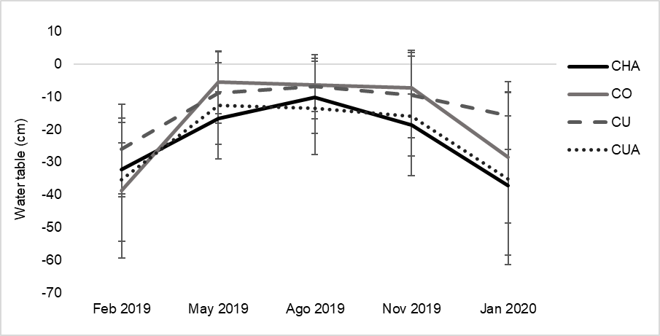
Fig. S3 Principal Components Analysis with all the response variables measured.
