Supplementary Figures

Bovine milk-derived exosomes attenuate NLRP3 inflammasome and NF-κB signaling in the lung during neonatal necrotizing enterocolitis
Rachel Filler, Mina Yeganeh, Bo Li, Carol Lee, Mashriq Alganabi, Alison Hock, George Biouss, Felicia Balsamo, Dorothy Lee, Hiromu Miyake, Agostino Pierro*
Division of General and Thoracic Surgery, Translational Medicine Program, The Hospital for Sick Children, Toronto, Ontario, Canada
*corresponding author:
Email: agostino.pierro@sickkids.ca (AP)

Submission to: Pediatric Surgery International

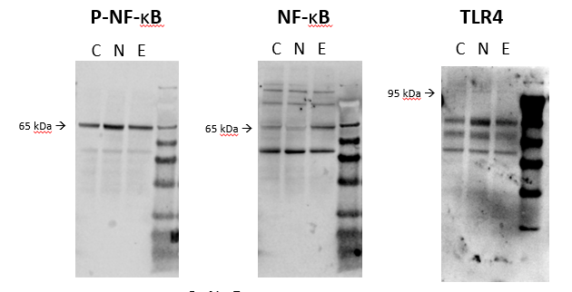
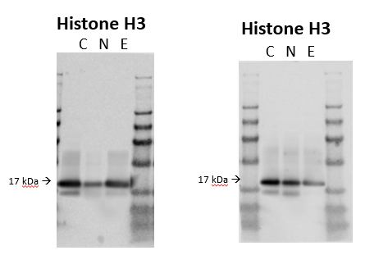
A)
B)
C)
D)
E)

Fig S1 Full length western blot images used for relative protein expression. (a) p-NF-κB, (b) NF-κB, (c) TLR4, (d) Histone H3 control for (a&b), (e) Histone H3 control for (c). Images were analyzed using an Odyssey scanner (LI-COR Biosciences) and protein expression was normalized using histone H3. (loading control)

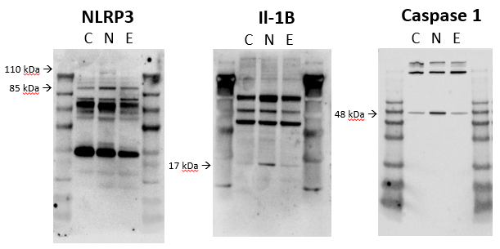
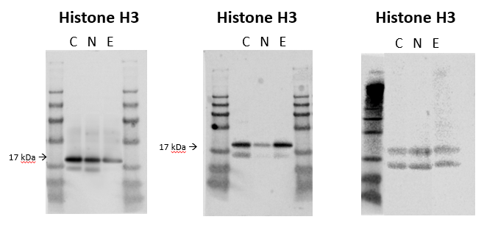
A)
B)
C)
D)
E)
F)

Fig S2 Full length western blot images used for relative protein expression. (a) NLRP3, (b) Il-1β, (c) Caspase 1, (d-f) Histone H3 controls for NLRP3, Il-1β, and Caspase 1, respectively. Images were analyzed using an Odyssey scanner (LI-COR Biosciences) and protein expression was normalized using histone H3 (loading control)

