Supporting Information

Aggregate suitability and Geo-chemical evaluation of limestone for construction industries in Pakistan: An approach for economic development

Asad Kamran¹ · Liaqat Ali¹ · Waqas Ahmed¹ · Sobia Zoreen² · Shah Jehan^{*1}

¹National Centre of Excellence in Geology, University of Peshawar 25130, Pakistan
²Institute of Chemical Sciences, University of Peshawar 25120, Pakistan

*Correspondence: jehanshah72@yahoo.com

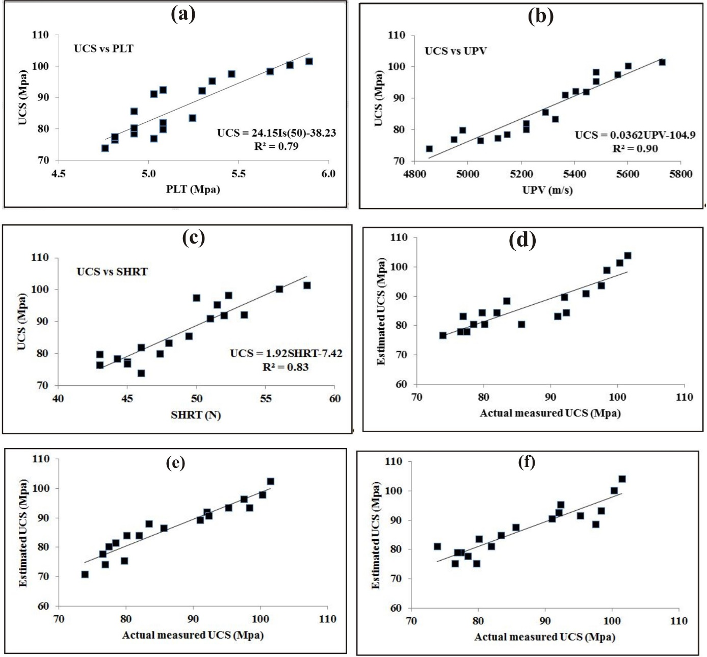
Fig. S1 Correlation between UCS and PLT (a), UCS and UPV (b), UCS and SHRT (c), actual measured UCS vs estimated UCS for Eq.1 (d), actual measured UCS vs estimated UCS for Eq.2 (e), actual measured UCS vs estimated UCS for Eq.3 (f),

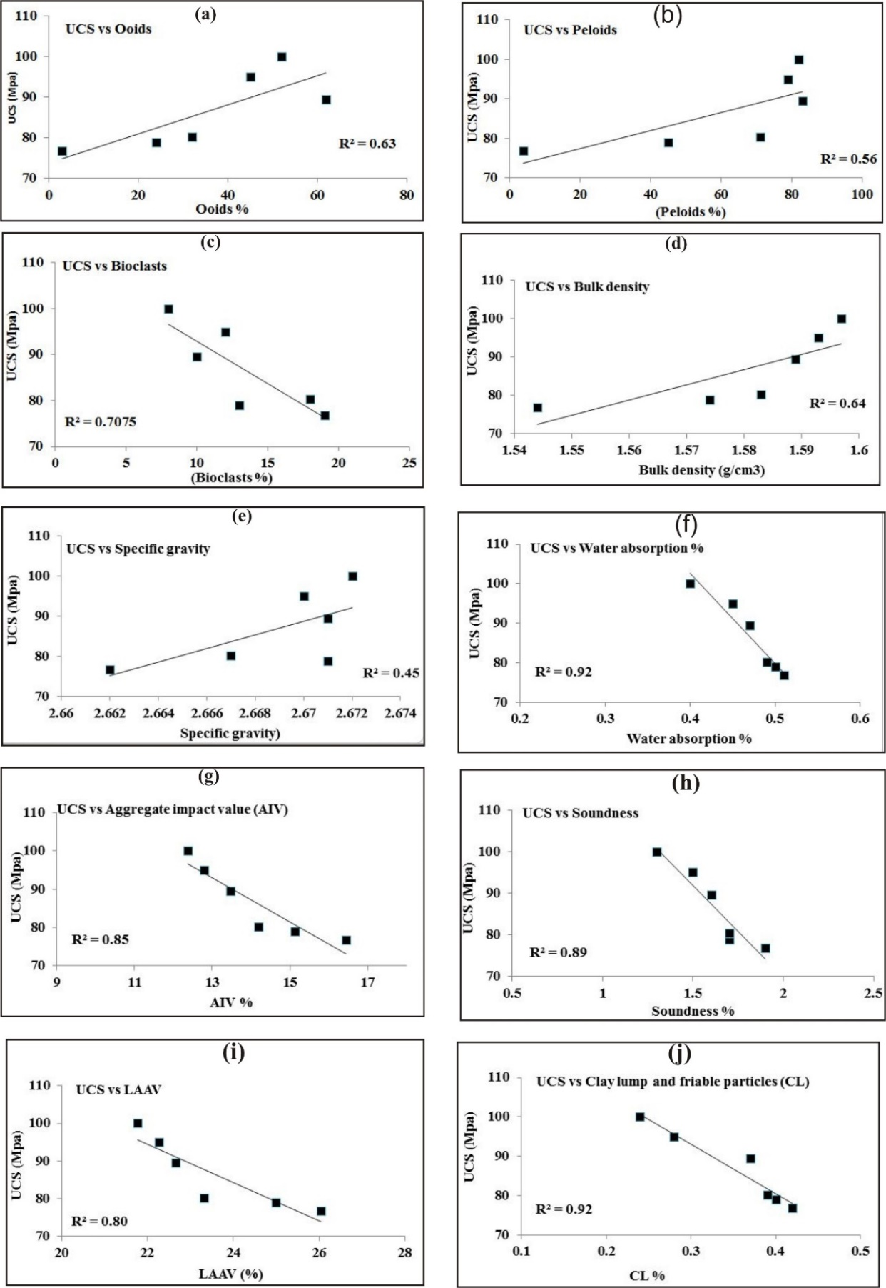
Fig. S2 Regression analysis of UCS vs ooids (a), peloids (b), bioclasts (c), BD (d) SG (e), WA (f), AIV (g), soundness (h), LAAV (i) and CL (j) in the LS of SSF.

