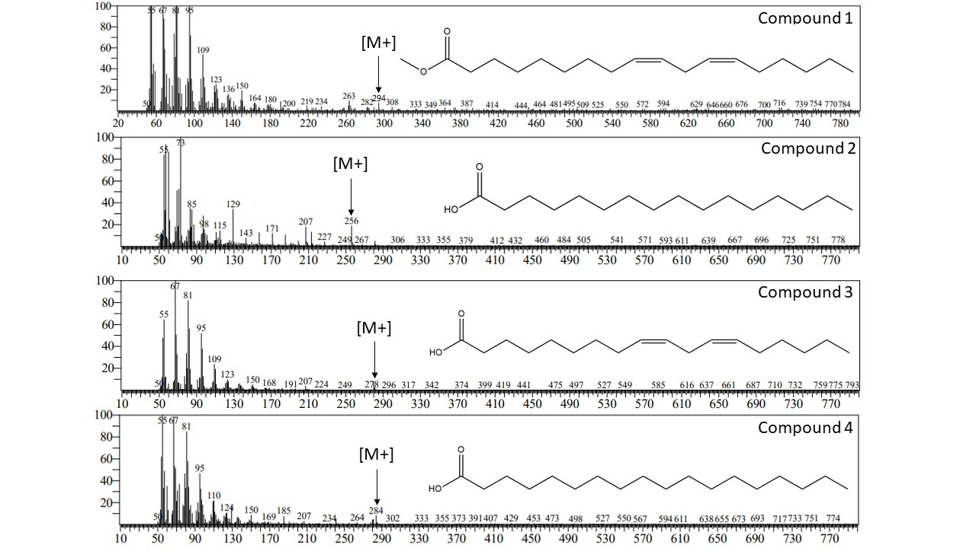
Figure S1. Mass Spectra of Lipid Extracts from GC-MS

