Table S1. Association Between LDL-C Levels and composite cardiovascular outcomes
Hazard ratio (95% CI) p-value
LDL quartile | Model1 | Model2 | Model3
Q1 | Ref | Ref | Ref
Q2 | 0.77 (0.62, 0.97) 0.0262 | 0.86 (0.68, 1.07) 0.1778 | 0.92 (0.73, 1.16) 0.4778
Q3 | 0.62 (0.49, 0.79) <0.0001 | 0.78 (0.61, 1.00) 0.0488 | 0.87 (0.67, 1.12) 0.2676
Q4 | 0.82 (0.66, 1.02) 0.0776 | 1.13 (0.89, 1.42) 0.3154 | 1.29 (1.00, 1.66) 0.0510

HR, hazard ratio; CI, confidence interval. Model1: adjusted for none. Model2: adjusted for age, female, race, education. Model3: adjusted for age, female, race, education, BMI; baseline systolic blood pressure; heart rate; smoking status; alcoholic drinking status; glucose; triglycerides; HDL; statin use; aspirin use.

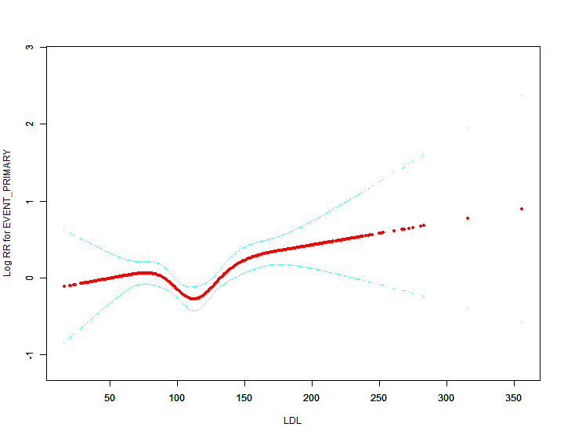
Figure S1：A U-shaped association links LDL-C (low-density lipoprotein cholesterol) and the risk of cardiovascular events in patients with hypertension. The red line is the trend line and the blue line is the 95% confidence interval.

Table S2: Results of two-piecewise linear-regression model
 | Male | Female | Total
One linear-regression model | 1.00 (1.00, 1.01) 0.0035 | 1.00 (0.99, 1.00) 0.7112 | 1.00 (1.00, 1.01) 0.0356
Inflection point (K) | 112 | 112 | 112
<K Effect size β (95%CI) | 1.00 (0.99, 1.01) 0.6845 | 0.98 (0.97, 0.99) 0.0012 | 0.99 (0.99, 1.00) 0.0623
>K Effect size β (95%CI) | 1.01 (1.00, 1.01) 0.0002 | 1.01 (1.00, 1.01) 0.0291 | 1.01 (1.00, 1.01) <0.0001
Log likelihood ratio test | 0.028 | 0.001 | 0.001

Two-piecewise linear-regression model was used to calculate the threshold effect of the HDL levels. If the log likelihood ratio test >0.05, it means the two-piecewise linear regression model is not superior to the single-line linear regression model.

