Supplementary Information

Intelligent Motion Detector: Compositing Reversibly-Crosslinkable Polymer Films with Encapsulated Electrodes and Cognitive Convolutional Neural Networks

Su Bin Choi,^{1,†} Hyun Sik Shin,^{1,†} and Jong-Woong Kim^{1,2,*}
¹ Department of Smart Fab Technology, Sungkyunkwan University, Suwon 16419, Republic of Korea
² School of Mechanical Engineering, Sungkyunkwan University, Suwon 16419, Republic of Korea
† These authors equally contributed to this work.
* Correspondence: Phone: +82 31 290 7441, E-mail: wyjd@skku.edu (J.-W. Kim)

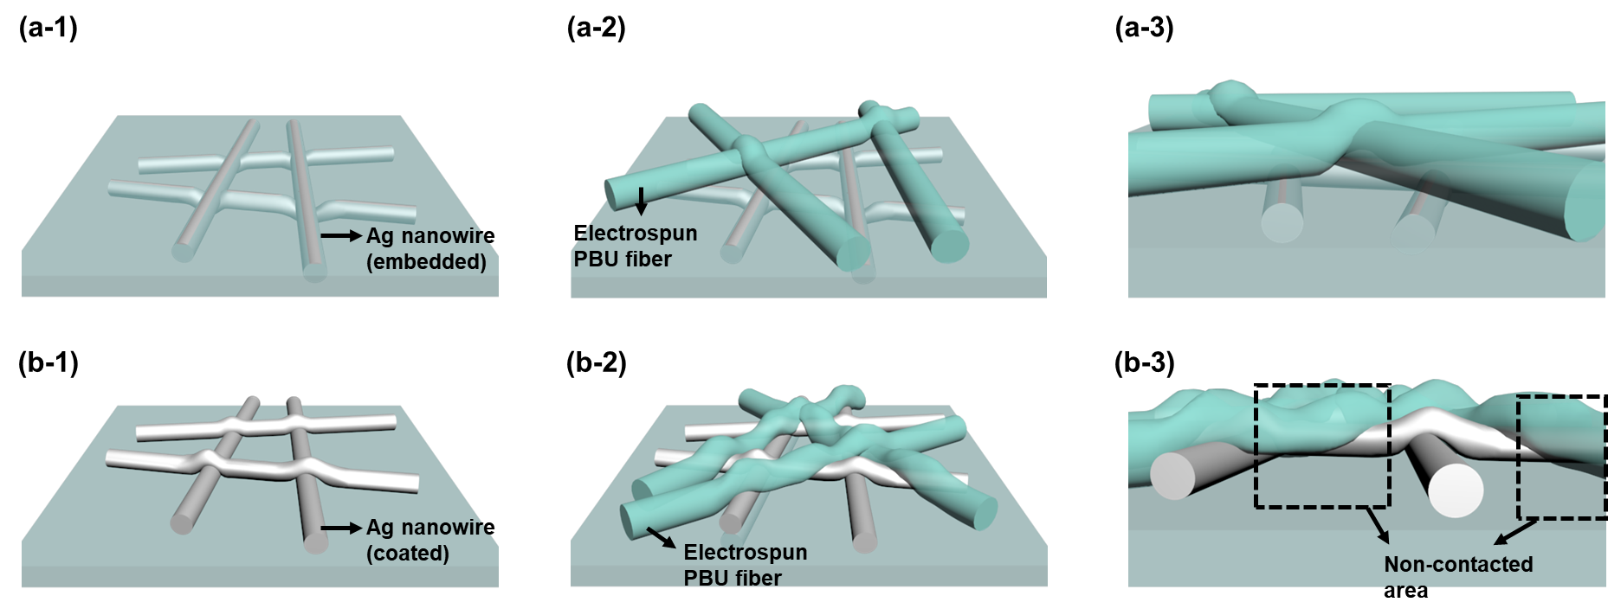
Figure S1. The diagram illustrating the morphology of electrospun PBU fibers upon the AgNW/PBU electrode, featuring (a) a flat surface and (b) a rough surface. The flat surface was achieved by incorporating AgNWs underneath the PBU surface, whereas the rough surface was facilitated by the deposition of AgNW dispersion upon the PBU surface.

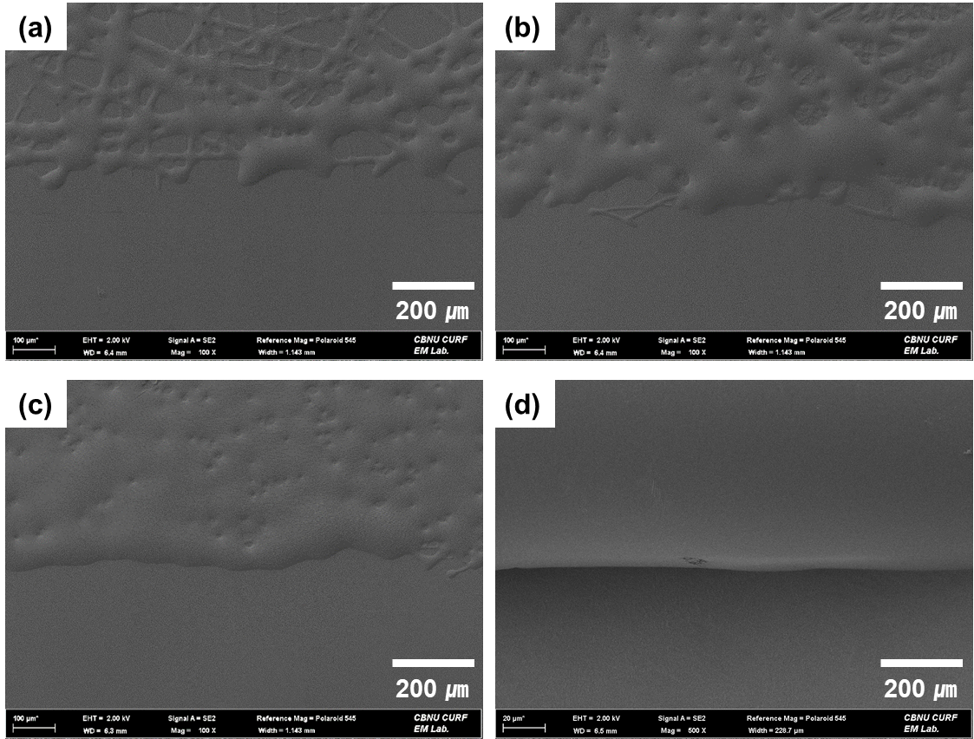
Figure S2. FESEM images of PBU fibers, electrospun onto the AgNW/PBU film over varying durations: (a) 1 min, (b) 3 min, (c) 5 min, and (d) 10 min.

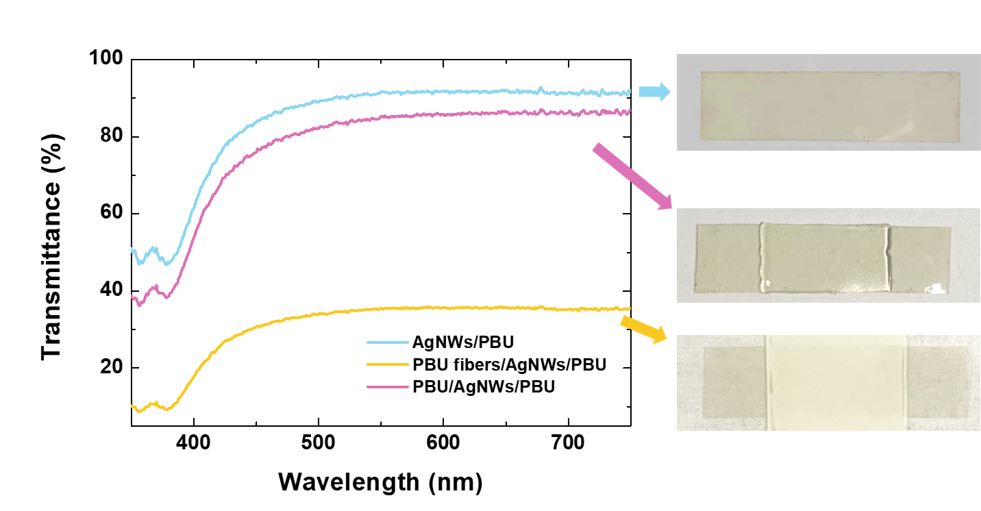
Figure S3. Depiction of optical transmittance properties alongside digital representations of AgNWs/PBU, PBU fibers/AgNWs/PBU, and PBU/AgNWs/PBU.

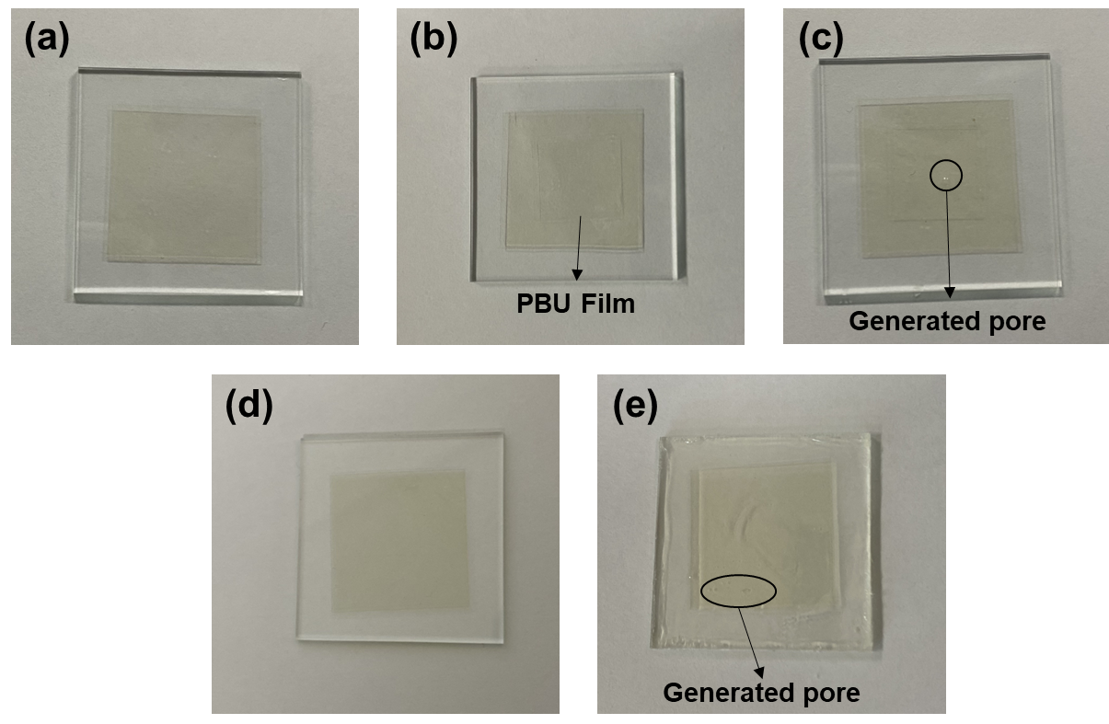
Figure S4. Sequential digital images of the lamination and polymer coating processes, respectively. Panels (a) to (c) present the process of lamination, with (a) showing the initial PBU/AgNW/PBU, (b) exhibiting the stage prior to lamination, and (c) the final stage post-lamination with a pressure of 10 kPa and heat treatment. Panel (d) shows the initial PBU/AgNW/PBU and panel (e) showcases the AgNW/PBU electrode post the application of the PBU solution, followed by a heat treatment process. Note that all heat treatments were conducted at a temperature of 120°C for a duration of 10 min.

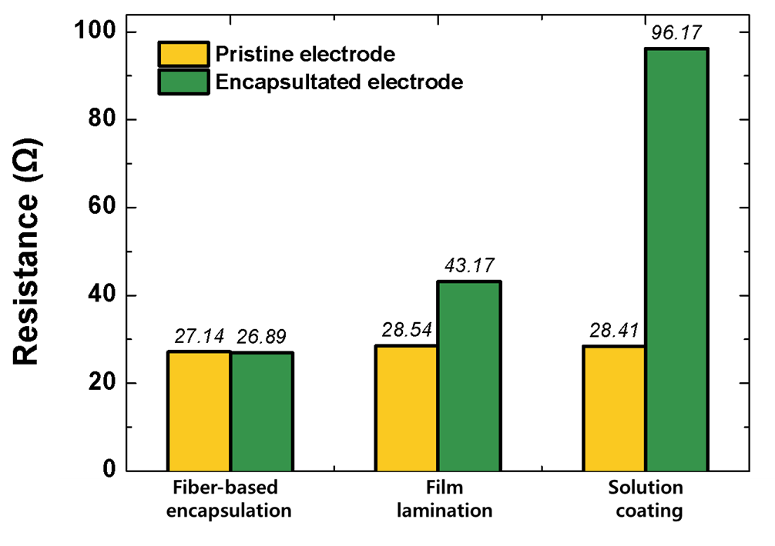
Figure S5. Resistance changes before and after each encapsulation process.

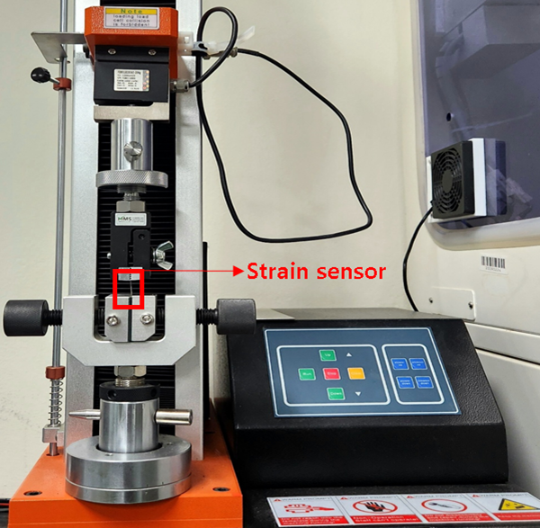
Figure S6. Photograph of the tensile testing of a strain sensor.

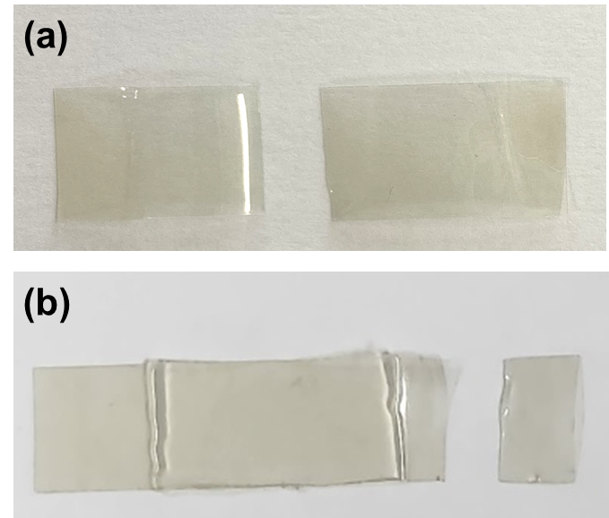
Figure S7. Photographs of the fractured (a) APS and (b) PAPS samples after tensile testing.

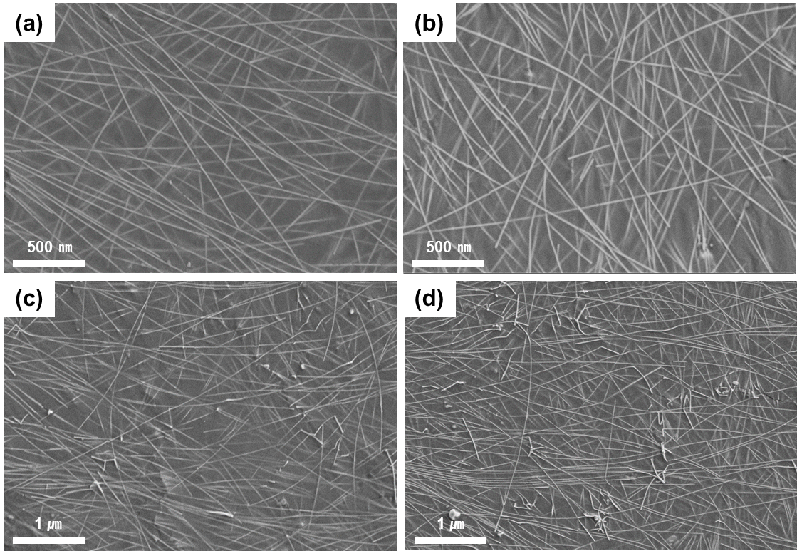
Figure S8. Microscopic examination of the APS surface following a series of stretch-and-release tests, conducted up to 10 cycles. The tests were performed with variable levels of strain: (a) 5%, (b) 10%, (c) 20%, and (d) 30%.

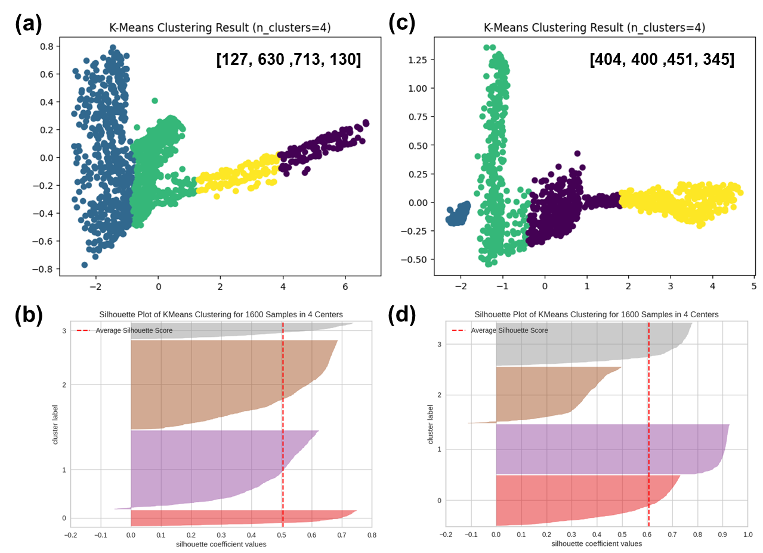
Figure S9. Results derived from the application of K-means clustering to two different types of stretching strain data: (a) Scatter plot illustration and (b) silhouette coefficient representation for APS; (c) scatter plot depiction and (d) silhouette coefficient portrayal for PAPS.

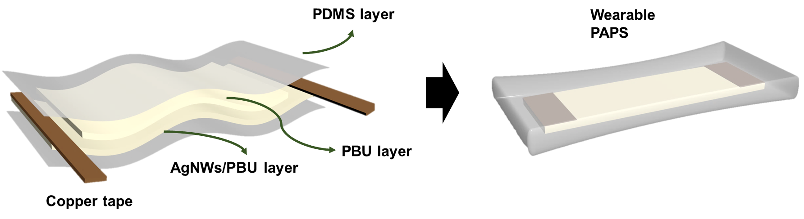
Figure S10. PAPS prepared for body attachment testing, safeguarded by PDMS films.

Figure S11. Bar graph illustrating the training, validation, and testing accuracy achieved with the application of various deep learning models.

