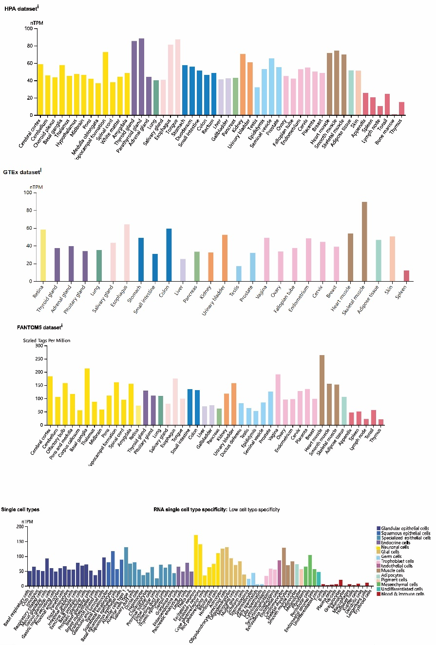

Supplementary Figure 1. NCKAP1 expression status in different normal tissues. (a-c) NCKAP1 tissue expression based on datasets of the HPA (Human protein atlas), GTEx, and FANTOM5 (Function annotation of the mammalian genome 5). (d) NCKAP1 expression in various cell types.

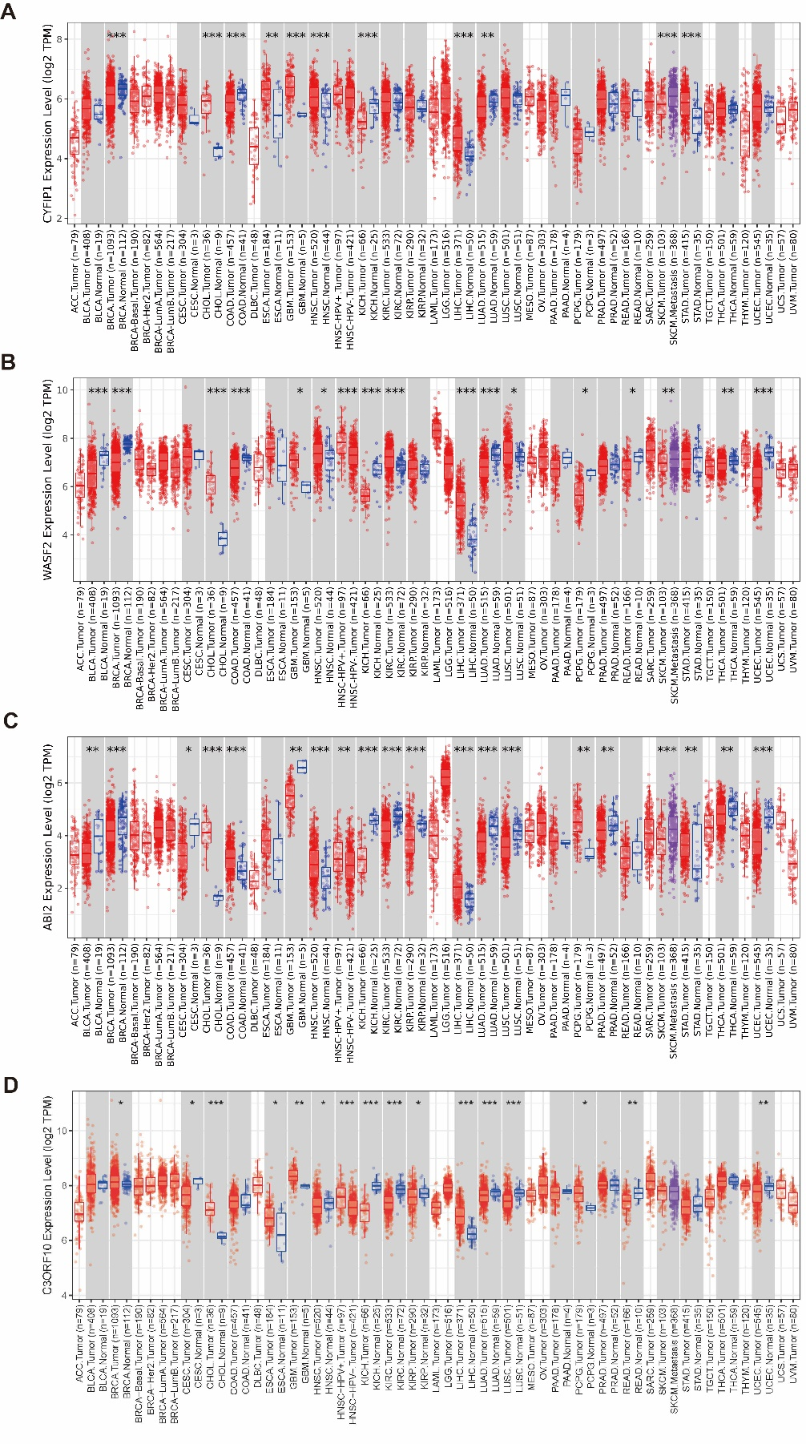
Supplementary Figure 2. CYFIP1, WASF2, ABI2 and C3ORF10 (BRK1) expression status in different normal tissues. (A-C) The expression status of CYFIP1, WASF2, ABI2 and BRK1 in different tumor types was visualized by TIMER2. * P < .05; ** P < .01; *** P < .001.

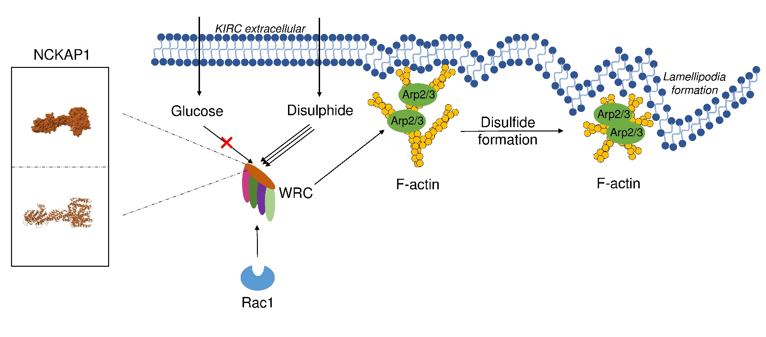
Supplement Figure 3. Working model depicting how glucose and disulphide coordinately regulate the disulfide formation of the actin cytoskeleton formatting lamellipodia via WRC including NCKAP1 and other subunits in KIRC cell.

