Table 2. Four limit conditions and the zero-gravity condition of the smart bed adjustment.
Conditions | Angles | Icons
Original condition | A0 (0°, 0°)
Back board in the highest position | A3 (60°, 0°) | 
Back and leg boards in the highest position | B2 (60°, 40°) | 
Leg board in the highest position | C3 (0°, 40°) | 
Officially recognised as zero-gravity condition | E (35°, 25°) | 

Table 3. Typical conditions of a smart bed
 | BPDM | SCE |  | BPDM | SCE |  | BPDM | SCE |  | BPDM | SCE
A0 | √ | √ | A3 | √ | √ |  | √ | - |  | √ | -
 | √ | - | 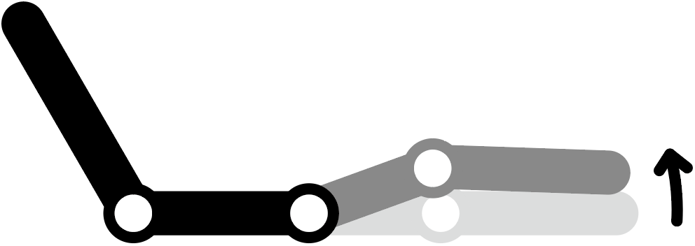 | √ | - | C1  | √ | √ | D1  | √ | √
A1  | √ | √ | B1  | √ | √ |  | √ | - |  | √ | -
 | √ | - | 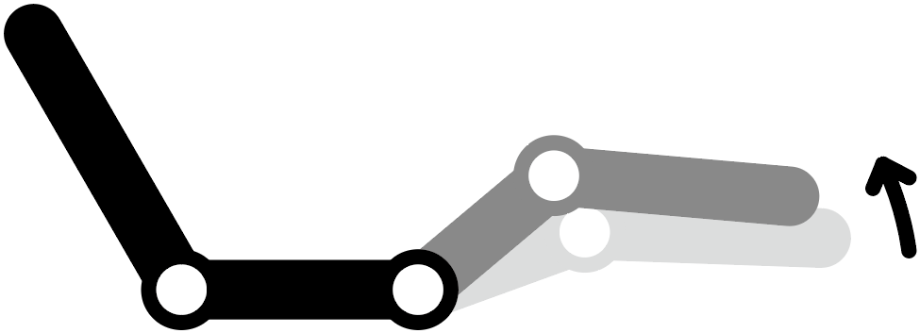 | √ | - | C2  | √ | √ | D2 | √ | √
A2  | √ | √ | B2 | √ | √ |  | √ | - | 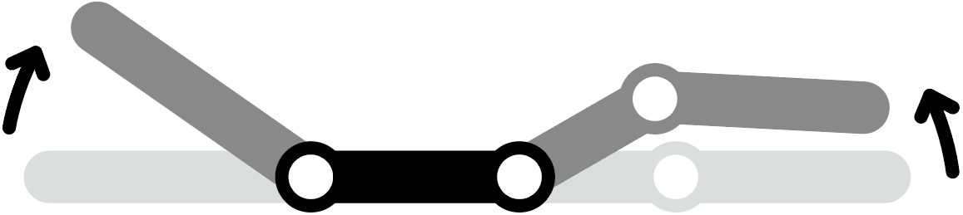 | √ | -
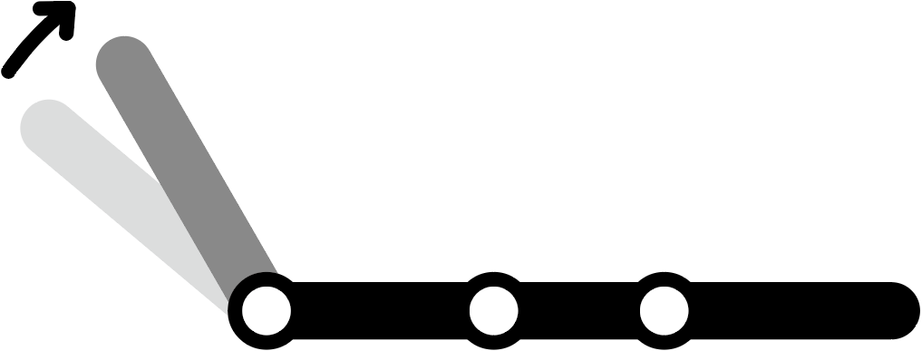 | √ | - |  |  |  | C3 | √ | √ | E | √ | √
* BPDM = body pressure distribution measurement; SCE = subjective comfort evaluation.

Table 4. Subjective comfort evaluation questionnaire.
Perceived comfort | Rating
Overall comfort | 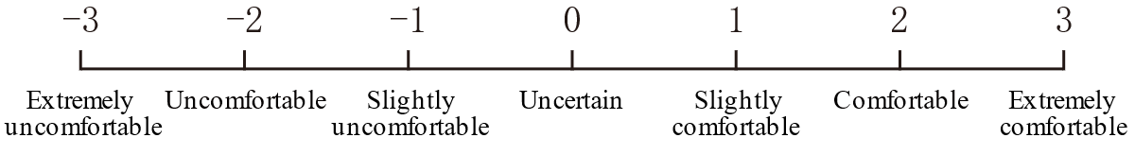
Comfort at the upper back area
Comfort at the lower back area
Comfort at the buttocks and thigh area
Comfort at the shank area

