Supporting Information

Mechanically robust room-temperature self-healing waterborne polyurethane with antimicrobial properties constructed through multiple dynamic bonds

YuanWang ¹, Liang Chen ¹, Pingping Jiang ¹, Pingbo Zhang ^{1,*}, Yanmin Bao ², Xuewen Gao ², Jialiang Xia ²
¹ Key Laboratory of Synthetic and Biological Colloids, Ministry of Education, School of Chemical and Material Engineering, Jiangnan University, Wuxi 214122, P. R. China
² Jiangsu Caihua Packaging Group Company, Kunshan 215321, P. R. China
*Corresponding authors: Pingbo Zhang (E-mail: pingbozhang@126.com)

Fig. S2 ¹H-NMR of 2,6-diacetylpyridine dioxime.
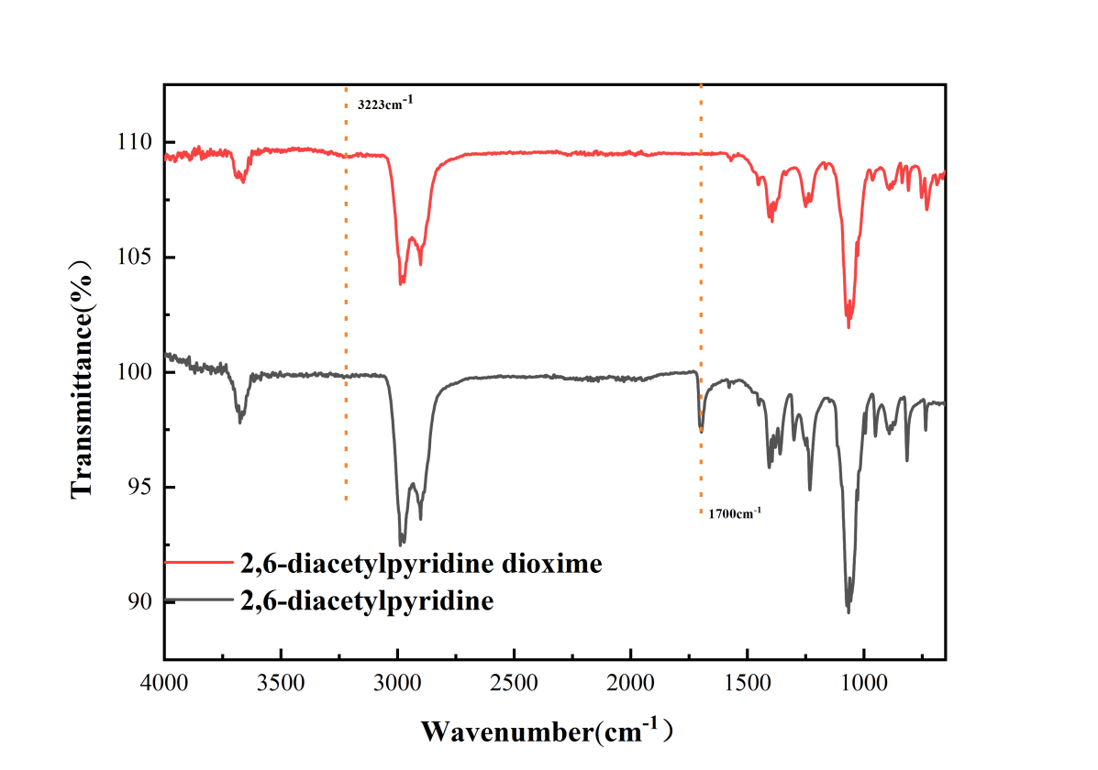
Fig.S1 Infrared spectra of 2,6-diacetylpyridine dioxime and 2,6-Diacetylpyridine.

Table. S1 Chemical constituents of polyurethane emulsion

Sample ª IPDI/g PTMG/g DMPA/g 2,6-DD^{b}/g TEA/g CuCl₂·2H₂O/g
DWPU 2.70 4.95 0.42 0.25 0.31 0
DWPU-Cu_{0.25} 2.70 4.95 0.42 0.25 0.31 0.06
DWPU-Cu_{0.5} 2.70 4.95 0.42 0.25 0.31 0.12
ª The molar ratios of CuCl₂⋅₂H₂O to 2,6-diacetylpyridine doxime were 0.25 and 0.5, respectively, and the corresponding samples were recorded as DWPU-Cu_{0.25} and DWPU-Cu_{0.5}
^{b} 2,6-diacetylpyridine dioxime is abbreviated as 2,6-DD

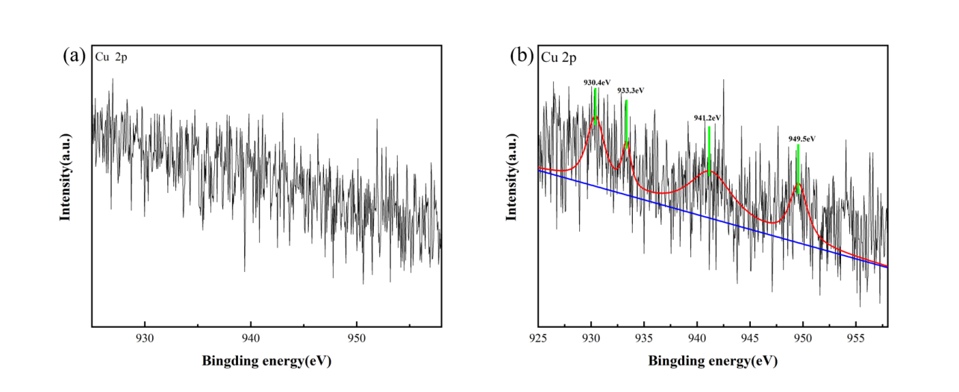
Fig. S3 Cu 2p high-resolution XPS spectra of DWPU (a) and DWPU-Cu_{0.25} (b).

