Roseobacter Weihaiensis sp. nov., an actinobacterium isolated from limpet collected from Golden Beach in Weihai, China.

Yu-Rui Li · Ming-Jing Zhang · Yan-Jun Yi · Xiao-Chen Wang · Dong-Mei San · Yan-Xia Zhou*
Marine College, Shandong University, Weihai 264209, China
*Correspondence:
Yan-Xia Zhou
Email: zhouyx@sdu.edu.cn

Table S1 ANI, dDDH, AAI values and DNA G+C contents between strain H9^{T} and the related type strains

Reference genome  (Accession no.) | ANI (%) | dDDH (%) | AAI (%) | DNA G+C content (mol%)
Roseobacter Weihaiensis H9^{T}  (MW407069) | 100 | 100 | 100 | 64.7
Roseobacter cerasinus AI77^{T}  (LC501444) | 78.8 | 17.7 | 74.0 | 61.0ª
Roseobacter ponti MM-7^{T}  (KX756455) | 78.1 | 16.6 | 73.5 | 61.5^{b}
Roseobacter denitrificans OCh 114^{T} (M59063) | 78.5 | 19.7 | 76.8 | 59.6^{c}
Roseobacter litoralis ATCC 49566^{T} (X78312) | 78.1 | 18.8 | 76.7 | 56-58.8^{d}
Phaeobacter gallaeciensis BS107^{T} (Y13244) | 76.2 | 13.4 | 64.3 | 57.6-58.0e
Marinovum algicola NBRC 16653^{T} (AB289592) | 76.7 | 13.6 | 63.4 | 60.0^{f}
*Strains in bold letters indicate type species of each genus.
ª Data from (Muramatsu S et al. 2020)
^{b} Data from (Jung et al. 1999)
^{c} Data from (Shiba 1991)
^{d} Data from (Shiba 1991)
^{e} Data from (Ruiz-Ponte C et al. 1998)
^{f} Data from (Lafay et al. 1995)

Table S2 General features of strain H9^{T} genome

Size (bp) | 5351685
G+C content | 59.8%
Gene number | 5452
Average Gene length (bp) | 869
tRNAs | 39
rRNAs | 3
sRNAs | 2
Type III secretion system | 149
Secondary metabolite | 4
Terpene gene number | 41
NRPS-like gene number | 41
Genomic islands | 12
Average length of gene islands (bp) | 14897

Table S3 Antibiotic resistant genes from CARD database
Antibiotic resistance | Antibiotic gene cluster
Fluoroquinolone | Mfd
Tetracycline | tetB(P), tet34
Rifamycin | rphB, rphA,Staphylococcus aureus rpoB
Aminoglycoside | Escherichia coli CpxR, Pseudomonas aeruginosa CpxR, baeR, adeR, vanRA, vanRL, arlR, basR, vanRM, vanRI, vanRC, vanRD, vanRE, vanRF, vanRG, mtrA, kdpE, smeR, vanRN, vanRB, vanRI, kdpE, vanRM, vanRO,
Glycopeptide | Escherichia coli CpxR, Pseudomonas aeruginosa CpxR, baeR, adeR, vanRA, vanRL, arlR, basR, vanRM, vanRI, vanRC, vanRD, vanRE, vanRF, vanRG, mtrA, kdpE, smeR, vanRN, vanRB, vanRM, vanRO, vanRL, vanHB, vanHA, vanHF, vanHD, vanHO, vanHM,
Macrolide | clbC, clbB, clbA, cipA, cfrA, cfrC
Phenicol | clbC, clbB, clbA, cipA, cfrA, cfrC

Table S4 The negative result for the utilization as sole carbon and energy sources of the isolated strain H9^{T}
Characteristic | H9^{T}
- arginine, L-glutamic acid, D-fucose,  - D-galactose, D-fructose | –

Fig. S1 Maximum-likelihood phylogenetic tree based on 16S rRNA gene sequences showing the position of H9^{T} (in bold) among the members of the genus Roseobacter. Bootstrap support values (1000 replications) above 50% are shown at nodes. The filled circles indicate that the corresponding node is also restored in the maximum likelihood tree. Hydrogenophilus thermoluteolus NBRC 14978^{T} was used as an outgroup. Bar, 0.02 substitutions per nucleotide position.
Roseobacter weihaiensis H9^{T} (MW407069)
Roseobacter cerasinus AI77^{T} (LC501444)
Roseobacter ponti MM-7^{T} (KX756455)
Roseobacter denitrificans OCh 114^{T} (M59063)
Roseobacter litoralis ATCC 49566^{T} (X78312)
Tateyamaria pelophila SAM 4^{T} (AJ968651)
Phaeobacter gallaeciensis BS107^{T} (Y13244)
Marinovum algicola NBRC 16653^{T} (AB289592)
Octadecabacter arcticus 238^{T} (U73725)
Octadecabacter antarcticus 307^{T} (U14583)
Dinoroseobacter shibae DFL-12^{T} (AJ534211)
Hydrogenophilus thermoluteolus NBRC 14978^{T} (AB680730)
100
99
99
95
69
91
60
66
97
0.020

Fig. S2 Phylogenomic tree based on TYGS results showing the relationship between the strain H9^{T} with related type strains.

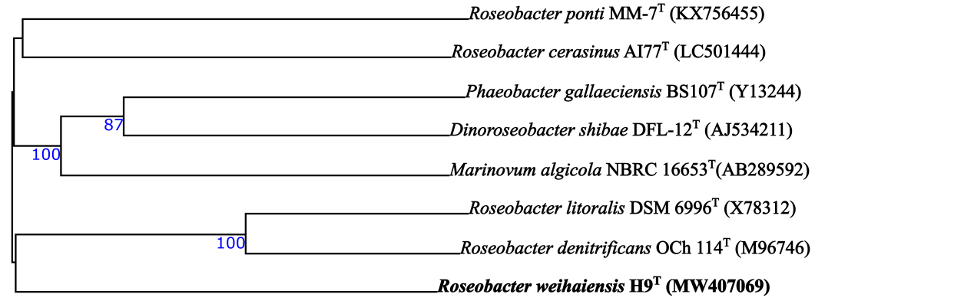

Fig. S3 Predicted gene length profiles
Gene number

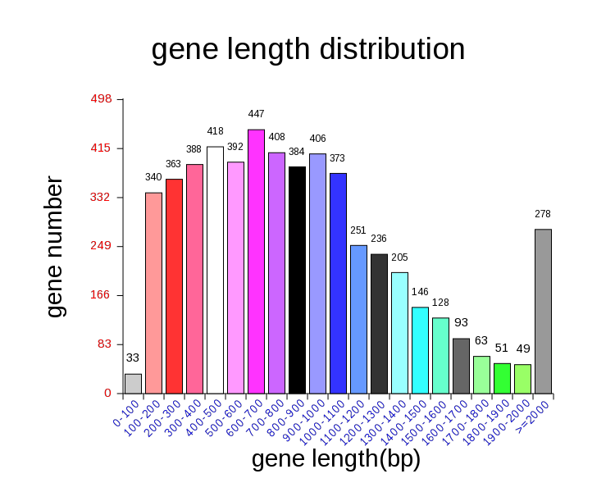
Gene length (bp)

Fig. S4 TCDB annotation of the genome of the strain H9^{T} .

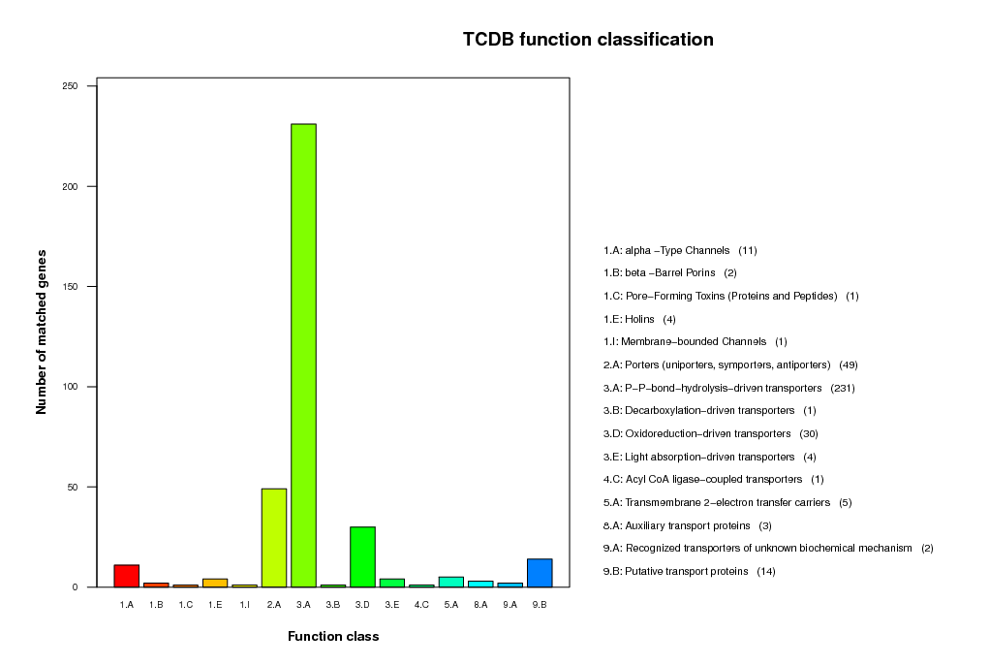

Fig. S5 Statistical chart of COG classification
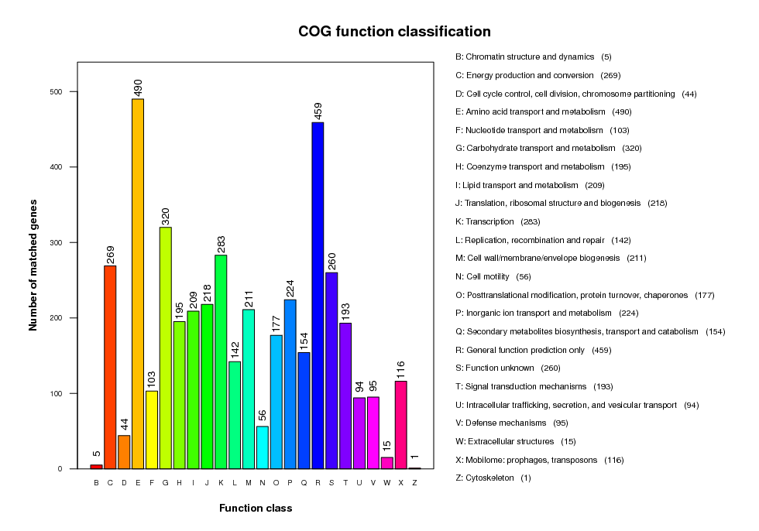

Fig. S6 Transmission electron micrograph showing the cell morphology of the novel strain H9^{T} after three days grown on MA medium at 28 °C. Bar, 500 nm.
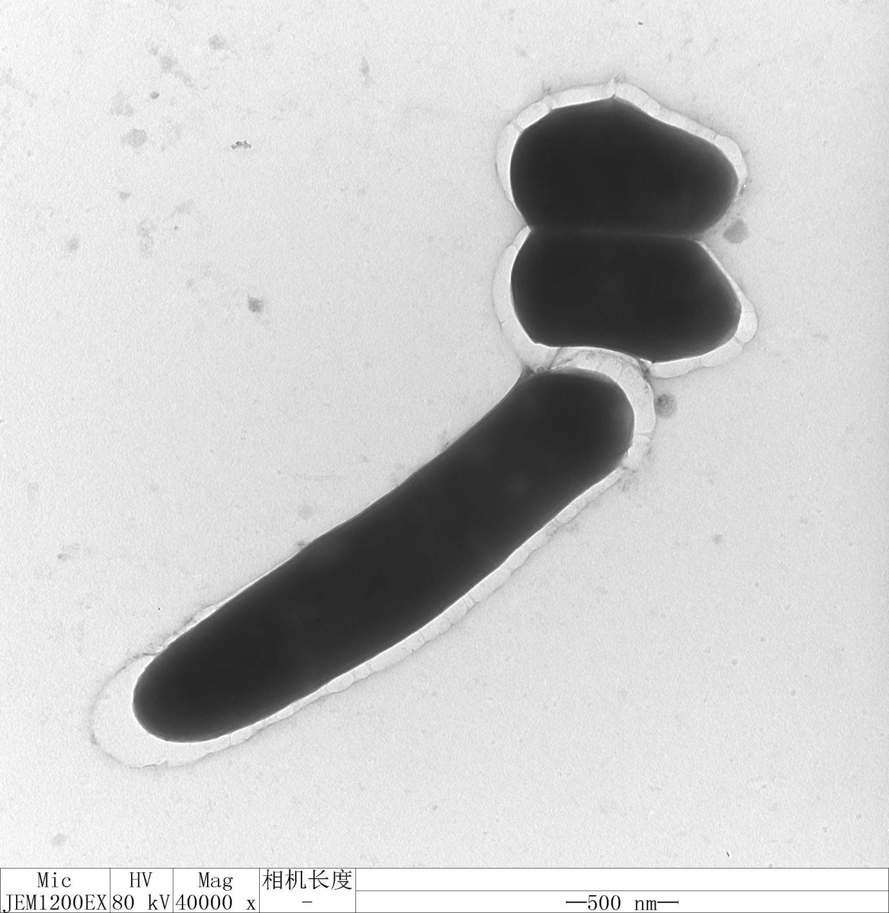
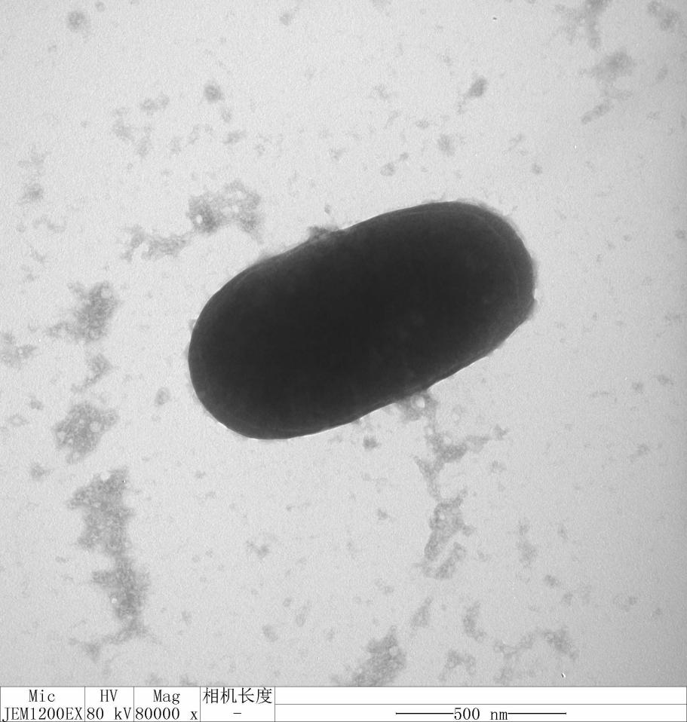

Fig. S7 Two-dimensional thin layer chromatograms of polarlipids for strain H9^{T} by staining with 5% ethanolic molybdophosphoric acid for total lipids(a), ninhydrin (b), phospholipid reagent(c) and ethanol sulfate (d).
L, unidentified lipid; PG, phosphatidylglycerol; DPG, diphos-phatidylglycerol; PC, phosphatidylcholine; PL, phospholipid.

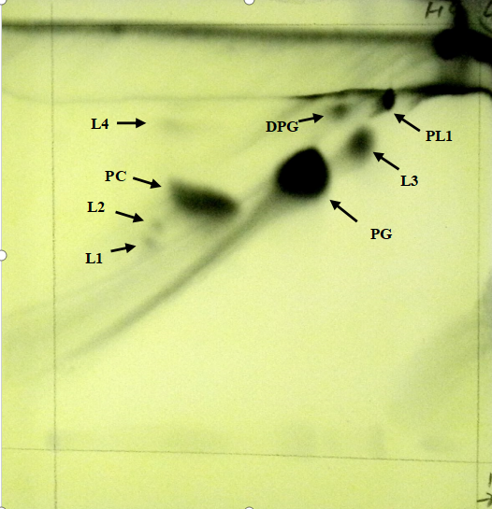
First dimension

Second dimension

First dimension

b
a
Second dimension

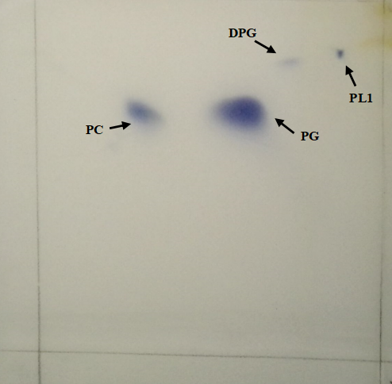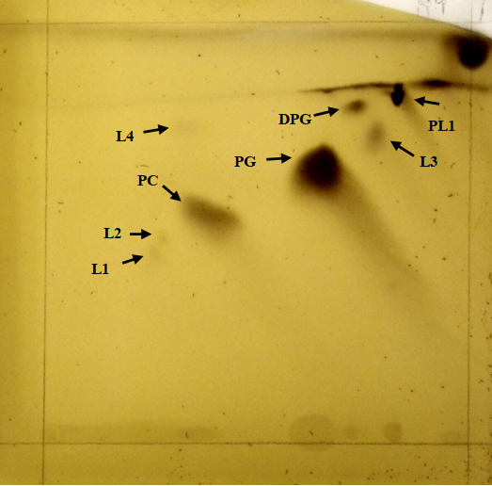
d
c
First dimension

Second dimension

First dimension

Second dimension

