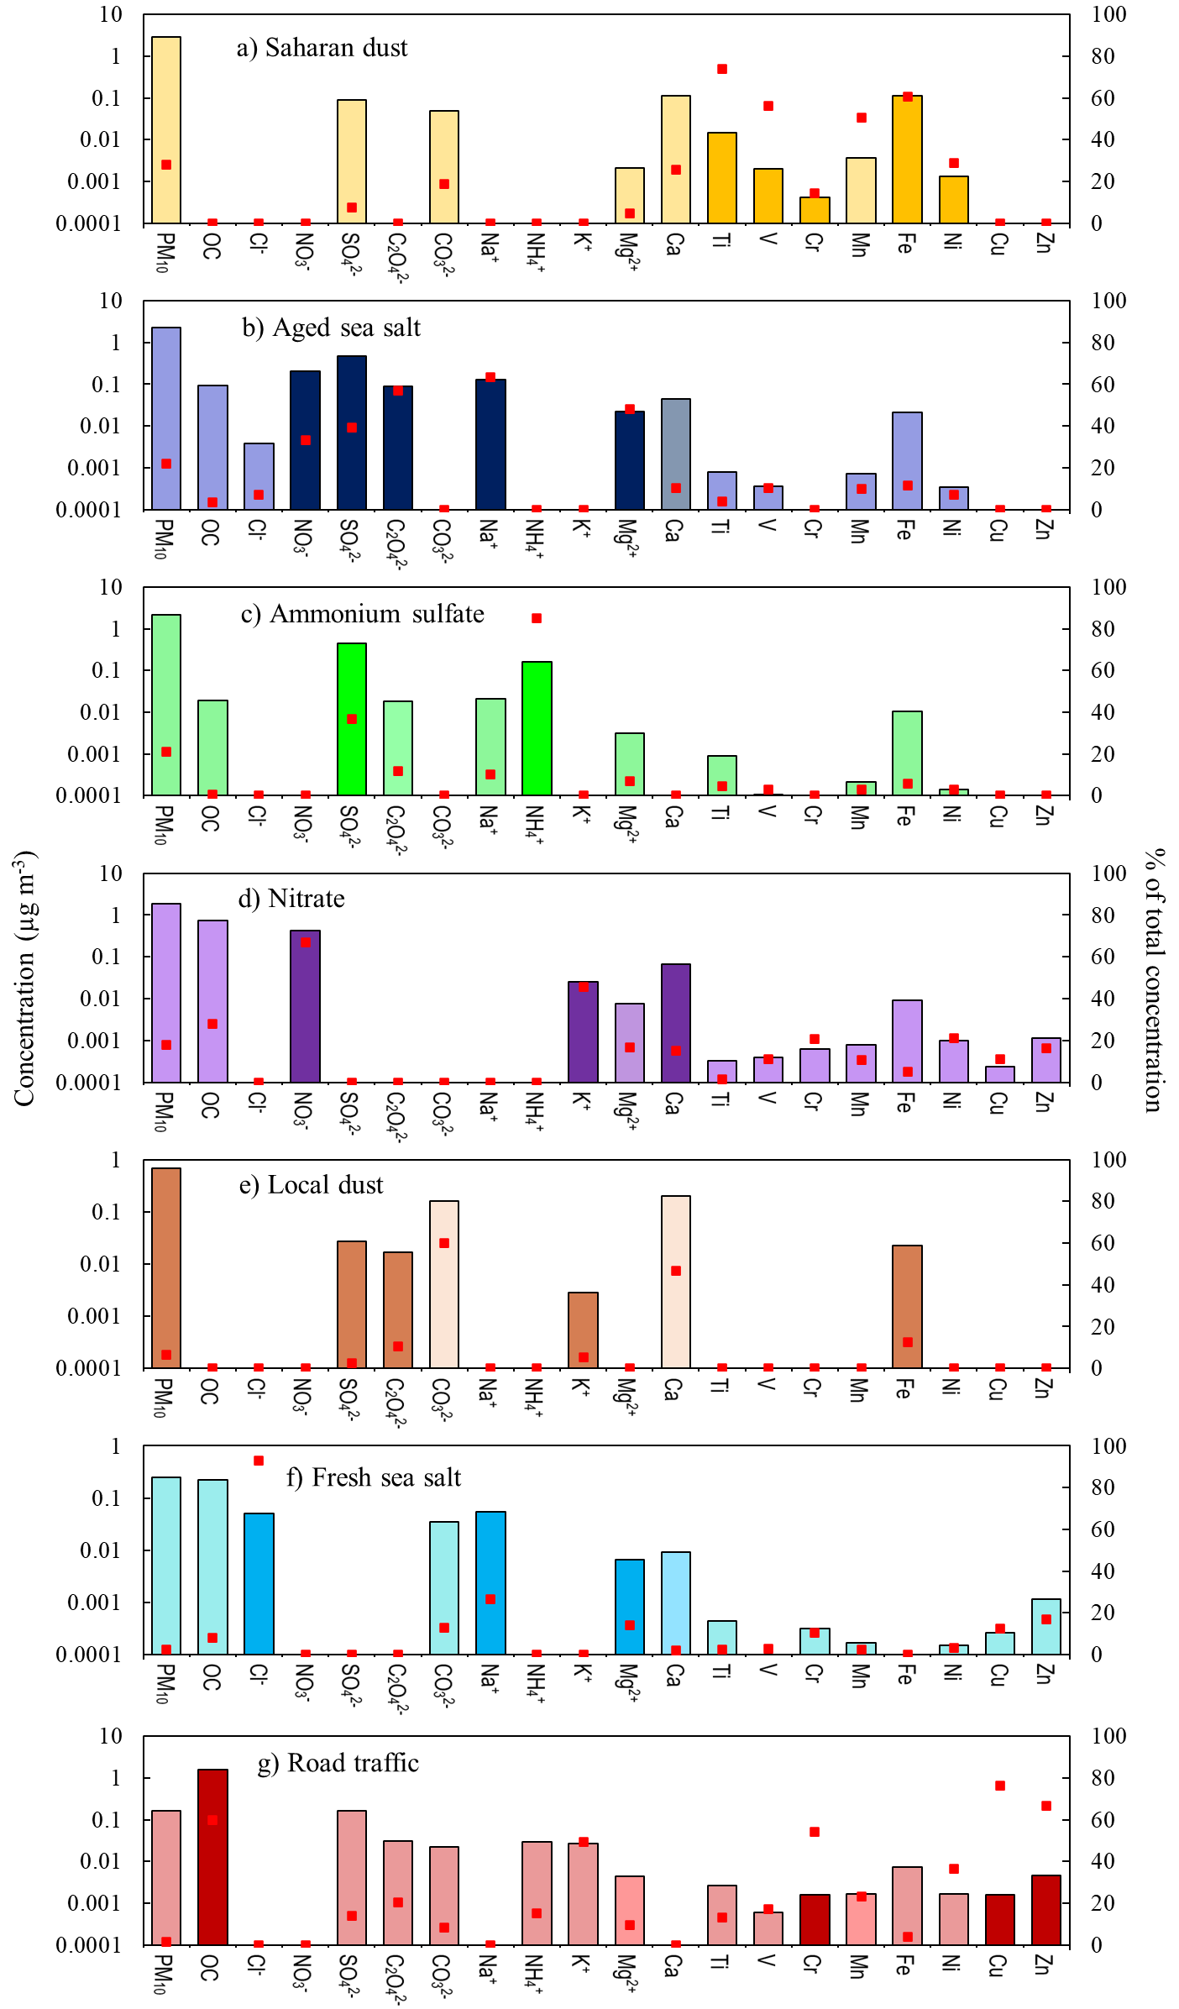
Figure S1. Chemical profiles of the PMF factors at the regional background station.
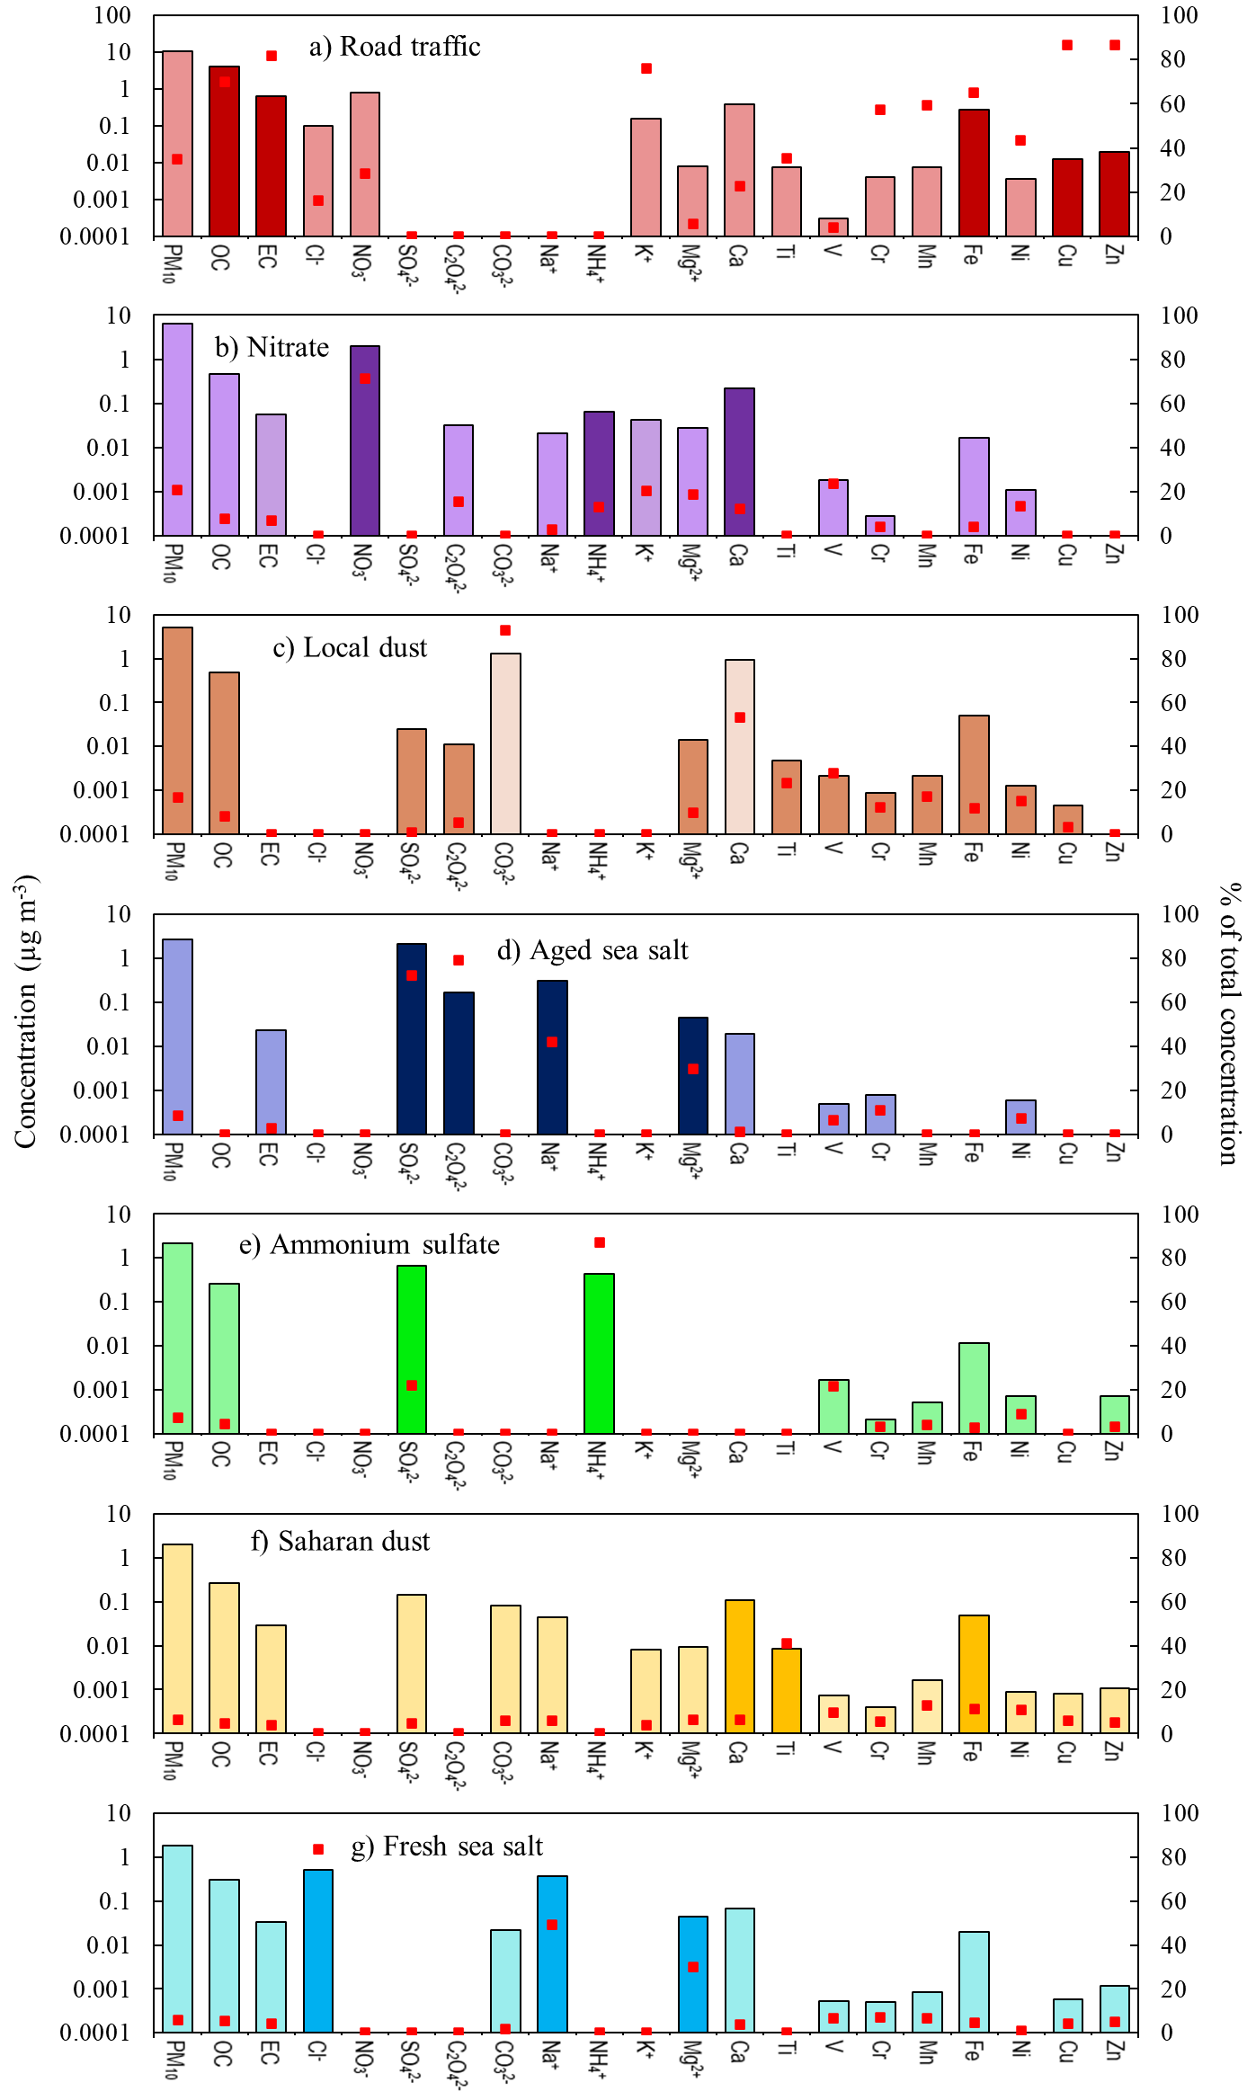
Figure S2. Chemical profiles of the PMF factors at the urban background site.
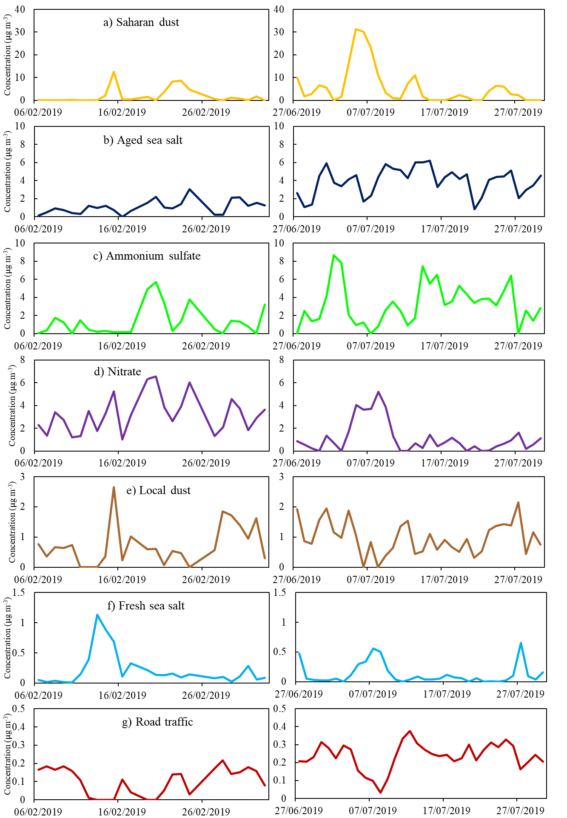
Figure S3. Temporal variations of the PMF factors at the regional background station.
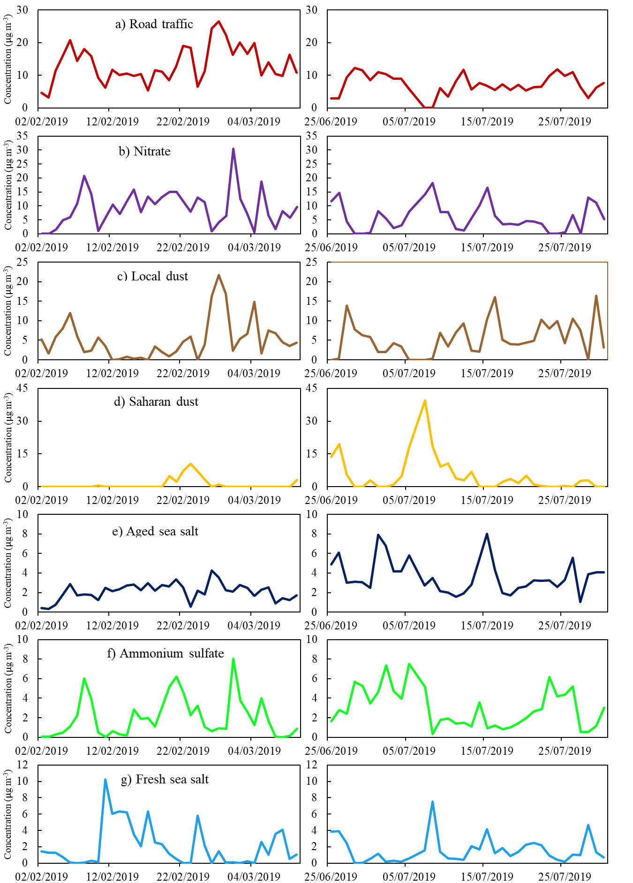
Figure S4. Temporal variations of the PMF factors at the urban site.

