Supplementary Material
A quantitative assessment of crop vulnerability to tephra hazard at Tungurahua volcano, Ecuador: understanding the effect of volcanic and biological factors
Ligot Noa^{1,*}, Viera William², Peñaherrera Diego², Bernard Benjamin³, Bogaert Patrick¹, Delmelle Pierre¹
¹Environmental Sciences, Earth and Life Institute, UCLouvain, Louvain-la-Neuve, Belgium
²Instituto Nacional de Investigaciones Agropecuarias, Quito, Ecuador
³Instituto Geofísico, Escuela Politécnica Nacional, Quito, Ecuador

*corresponding author
Email: noa.ligot@uclouvain.be
Tel.: +32 (0)10 473 638
NL ORCID: 0000-0003-1416-3663

Table S1: Tephra sampling date, tephra sampling site and site coordinates corresponding to the tephra specimens from Tungurahua volcano used for grain size distribution analysis (GSD). For the August 16–17, 2006 eruptive period, Eychenne et al. (2012) analysed 22 tephra samples collected within 7 and 20 km west of the volcano and determined their GSD between 1 µm and 31.5 mm. For the October–November 2015 eruptive period, the Instituto Nacional de Investigaciones Agropecuarias (IG-EPN) merged two tephra sample sets. The GSD of the first one, a four-day time series collected 6 km west of the volcano, was analysed between 0.244 µm and 4 mm. The second set was a 14-site spatial series collected within 4 and 18 km west of the volcano, which was dry sieved between 63 µm and 4 mm. A six-day time series was also obtained 6 km west of the volcano by the IG-EPN between late February and early March 2016 and its GSD was determined between 0.244 µm and 4 mm.

Table S2: Size of the tephra impact dataset obtained for each crop type. Crop occurrence, dataset with information on crop yield loss and crop phenological stage and dataset with the 28 factors used in the statistical analyses performed to assess the best-fit models of crop yield loss (Table 2). The data were obtained in 2019 by interviewing Tungurahua’s farmers.
Table S3: Volcanic and non-volcanic factors (codes and types) included in the best-fit linear model analysis performed to explain crop yield loss in corn, potato and legumes in the Tungurahua area affected by tephra fall (Table 2). For the categorical factors, the number of levels (corresponding to farmers’ answers in the interviews) before and after data processing are indicated as well as the level names.
Table S4: Crop types, crop type occurrence and surface area allocated to each crop type, local crop varieties (in Spanish) or species for fodders and the variety/species occurrence. The mean and standard deviation (sd) values are shown. The data were obtained in 2019 by interviewing Tungurahua’s farmers. NA stands for no answer.
Table S5: Frequency of use of different fertilisers and pesticides (absence, organic, chemical, organic and chemical) for each crop type. The data were obtained in 2019 by interviewing Tungurahua’s farmers.

Table S6: Summary best-fit models of the yield loss for corn, potato and legumes as evaluated by the Akaike information criterion (backward direction) and based on farmers’ estimates of crop yield loss after the August 16–17, 2006, October–November 2015 and February–March 2016 eruptive periods of Tungurahua volcano. For each level of the factors selected in the model, the table gives the coefficient estimates and the critical probability (i.e., the p-value, Pr(>|t|)) of the Student test when compared to the mean yield loss (i.e., “sum to zero” contrasts implemented with the contr.sum function in R). The levels for each factor are presented in Table S3, with 1, 2, 3 and 4 corresponding to the first, second, third and fourth level, respectively. The p-value of the last level of each categorical factor is not calculated by the software.
Table S6: continued
Table S7: R² of the one-way ANOVA that relates the continuous (rows) and categorial (columns) factors included in the analyses for the best-fit linear model for crop yield loss in the Tungurahua area surveyed in 2019. Low R² values indicate weak correlation between factors. A description of each factor is provided in Table S3.

Table S8: Cramer’s V coefficient to analyse the relationship between categorical factors included in the analyses for the best-fit linear model for crop yield loss in the Tungurahua area affected by tephra fall. Empty cells correspond to pairs of factors of which statistics could not be calculated due to lack of data. Low values for the Cramer’s V coefficient indicate weak correlation between factors. A description of each factor is provided in Table S3.

Table S9: Summary table for the multicollinearity analyses between factors included in the crop yield loss best-fit models for corn, potato and legumes (GVIF: generalized variation inflation factor, df: degree of freedom of the factor, GVIF^(1/(2*df)), which is an adjustment of GVIF for allowing comparison between factors with different df). Significant multicollinearity issues corresponding to GVIF>10 and GVIF^(1/(2*df))>2 (Fox and Monette 1992; O’brien 2007) are noted for the models obtained for corn and legume plants.

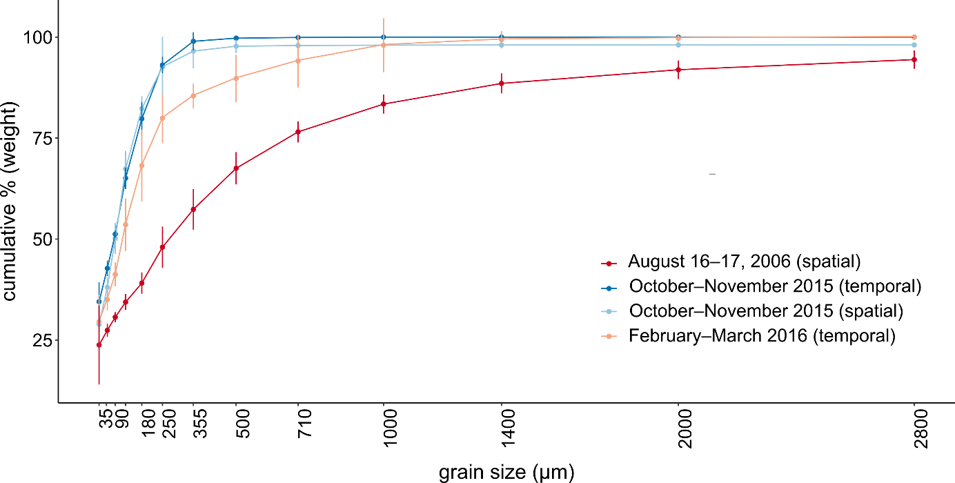

Figure S1: Cumulative grain size distributions of the tephra samples from the three eruptive periods included in the study: August 16–17, 2006, October–November 2015 and February–March 2016. Further details on the sampling and analysis methods appear in Table S1.

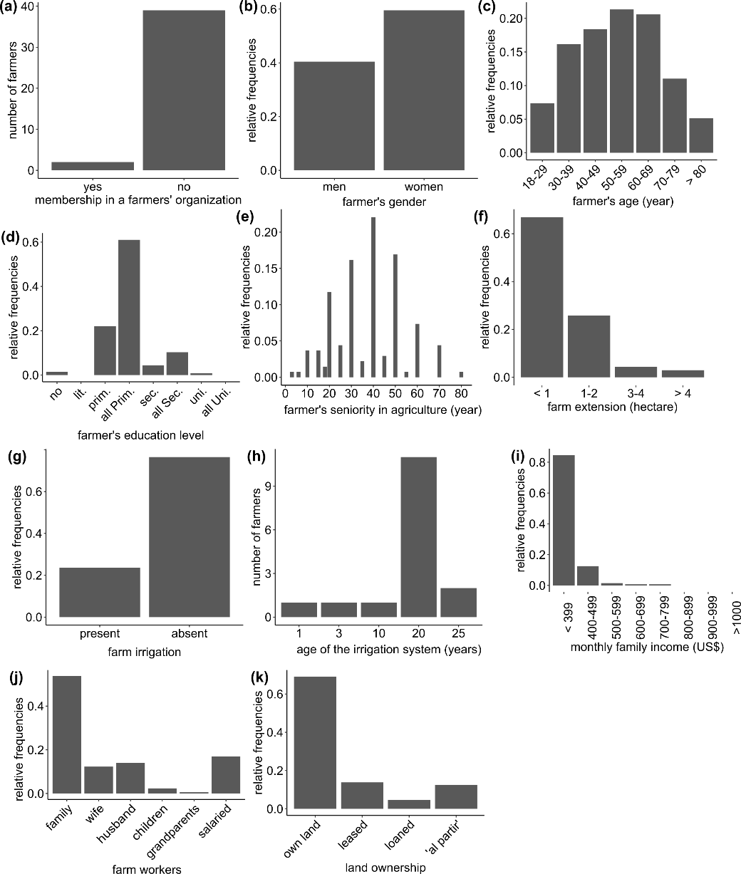
Figure S2: Profile of Tungurahua’s farmers interviewed in 2019: membership in a farmer’s organisation (a), gender (b), age (c), education level (lit.: literacy program, prim.: primary school, sec.: secondary school, uni.: university) (d), seniority in agriculture (e), and farm characteristics: farm extension (f), presence of an irrigation system (g), age of the irrigation system (h), monthly family income (i), farm workers (j) and land ownership (k).

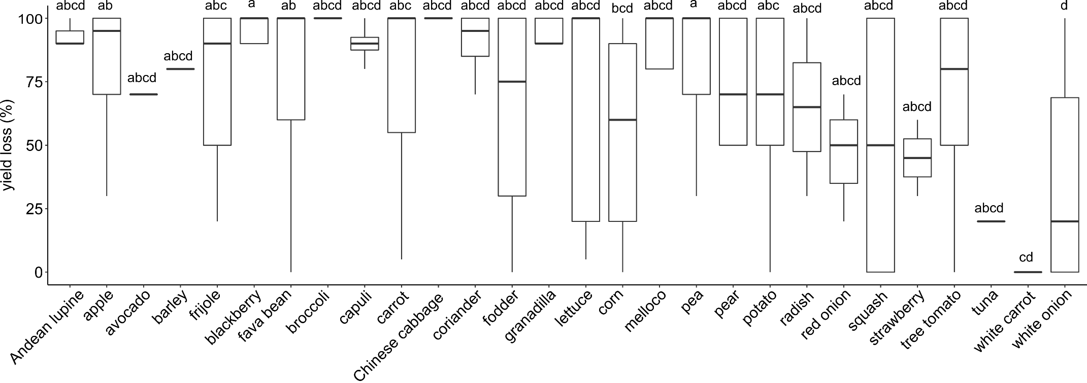
Figure S3: Boxplots of the yield loss for each crop type after the August 16–17, 2006, October–November 2015 and February–March 2016 eruptive periods of Tungurahua volcano. The estimates are those reported by Tungurahua’s farmers. Similar letters indicate that the average crop yield loss values are not significantly different (Tukey HSD test, Honest Significant Difference, 95% family wise confidence level).
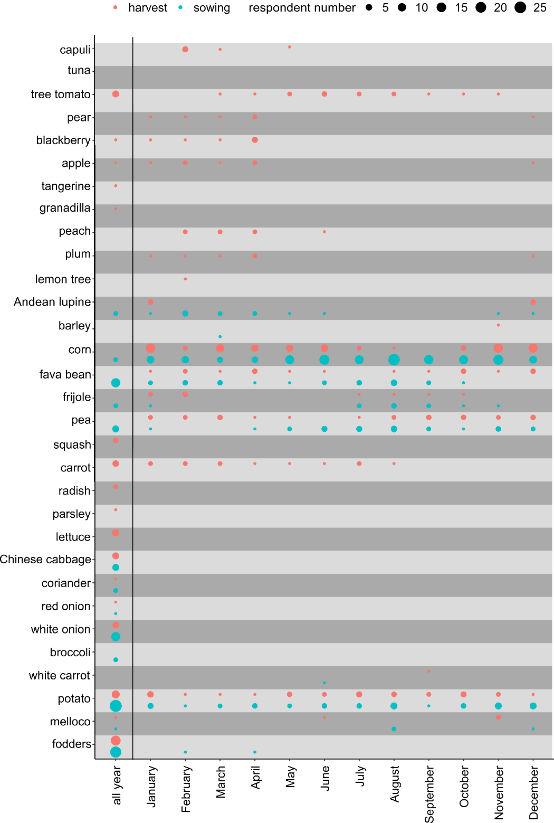
Figure S4: Crop-specific calendar created based on the information provided by Tungurahua’s farmers. It shows the sowing (annual plants) and harvesting months for 31 of the primary crops cultivated in an 800-km² area near Tungurahua volcano.
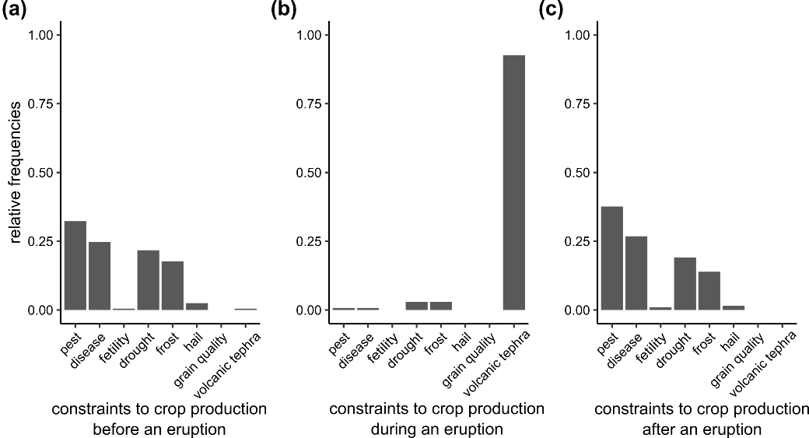
Figure S5: Constraints on crop production as estimated by Tungurahua’s farmers at different times during an eruptive period: before (a), during (b), and after (c) an eruption.
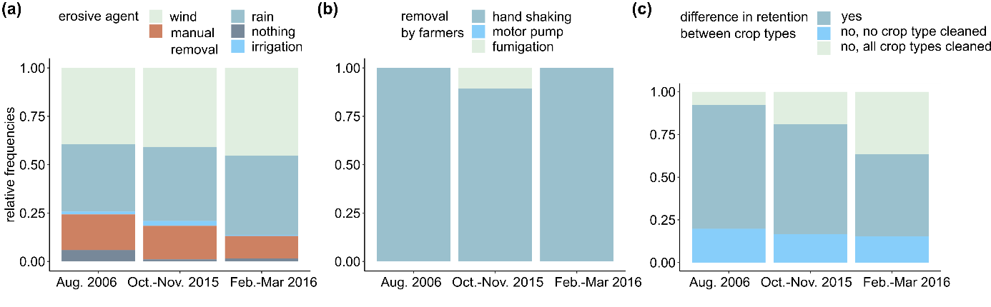
Figure S6: Type of tephra erosive agent (a), method used by farmers for removing tephra from plants (b) and difference in tephra retention between crop types as reported by Tungurahua’s farmers (c). The information is provided for the August 16–17, 2006, October–November 2015 and February–March 2016 eruptive periods.

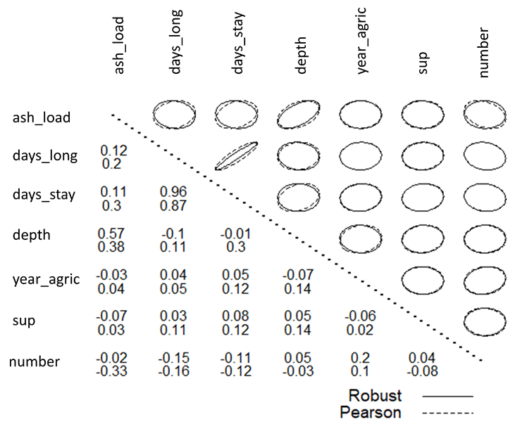
Figure S7: Pearson’s coefficient of the correlation analysis for continuous factors included in the best-fit linear model for crop yield loss in the Tungurahua area affected by tephra fall. Except between days_long and days_stay (see text for explanations, section 3.7), low values of the Pearson’s coefficient are obtained, indicating weak correlation between factors. A description of each factor is provided in Table S3.
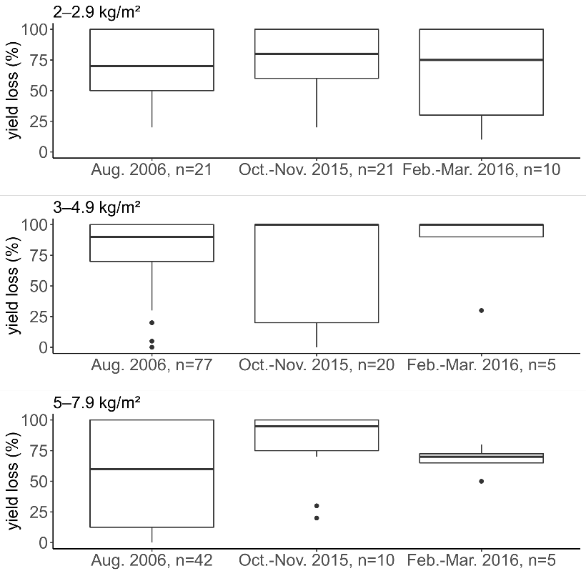
Figure S8: Boxplots of the crop yield loss as estimated by farmers after the August 16–17, 2006, October–November 2015 and February–March 2016 eruptive periods of Tungurahua volcano. The yield loss estimates are reported for three tephra mass load classes: 2–2.9 kg m⁻² (a), 3–4.9 kg m⁻² (b) and 5–7.9 kg m⁻² (c). For each tephra mass load class, the median crop yield loss values for the three eruptive periods are not significantly different.

References
Eychenne, J., Le Pennec, J.-L., Troncoso, L., Gouhier, M., and Nedelec, J.-M.: Causes and consequences of bimodal grain-size distribution of tephra fall deposited during the August 2006 Tungurahua eruption (Ecuador), Bull. Volcanol., 74, 187-205, doi: 10.1007/s00445-011-0517-5, 2012.
Fox, J. and Monette, G.: Generalized collinearity diagnostics, J. Am. Stat. Assoc., 87, 178-183, doi: 10.2307/2290467, 1992.
O’brien, R. M.: A caution regarding rules of thumb for variance inflation factors, Qual. Quan., 41, 673-690, doi: 10.1007/s11135-006-9018-6, 2007.

