Supplementary figures
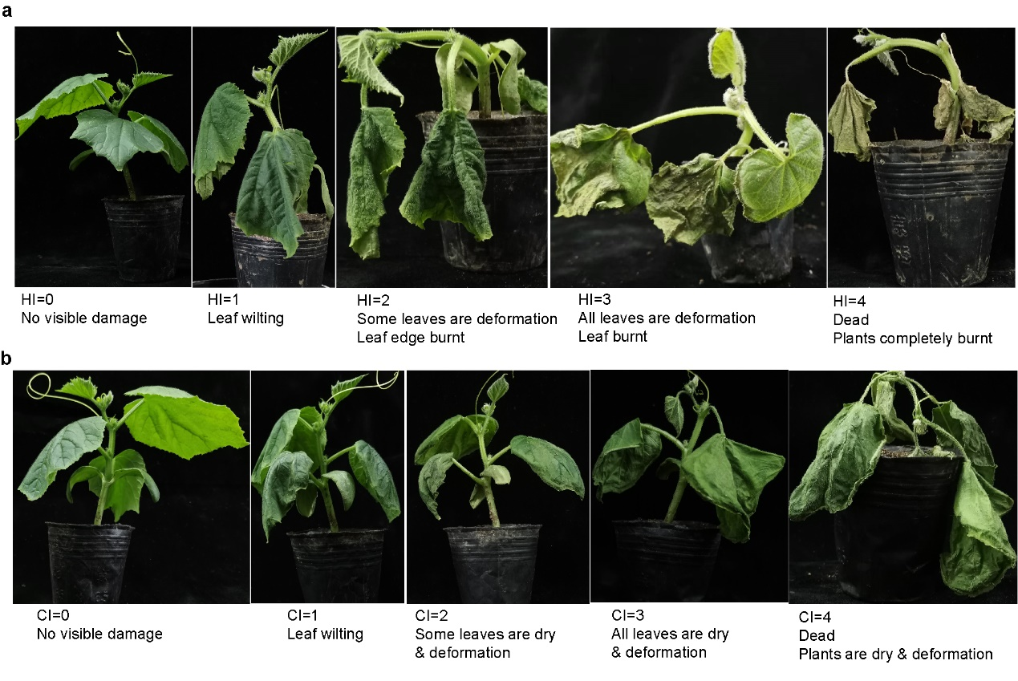
Fig. S1 The standards to evaluate injury index in temperature-stress treatment. a High temperature treatment. b Low temperature treatment.

Fig. S2 Distribution of Euclidean distance (ED), ΔSNP-index, or ΔInDel-index in bulked segregant analysis (BSA) of heat tolerance of seedling. A larger value of ED/ΔSNP-index/ΔInDel-index indicates a stronger linkage of the SNP site to target trait. In ED distribution, red dashed line represents linkage threshold. In ΔSNP-index and ΔInDel-index, the red, blue and green lines indicate linkage threshold at 99%, 95% and 90% of confidence interval respectively; Δindex=(cold-R bulk)-(cold-S bulk).
Fig. S3 Distribution of Euclidean distance (ED), ΔSNP-index, or ΔInDel-index in bulked segregant analysis (BSA) of cold tolerance of seedling. A larger value of ED/ΔSNP-index/ΔInDel-index indicates a stronger linkage of the SNP site to target trait. In ED distribution, red dashed line represents linkage threshold. In ΔSNP-index and ΔInDel-index, the red, blue and green lines indicate linkage threshold at 99%, 95% and 90% of confidence interval respectively; Δindex=(cold-R bulk)-(cold-S bulk).
Fig. S4 Expression profile of DEGs on QTL LTT6.1 during the cold treatment. Expression level is quantified by qRT-PCR. Both CL and EA35 are East Asian cucumbers, and both XIS77 and XIS49 are XIS cucumbers.
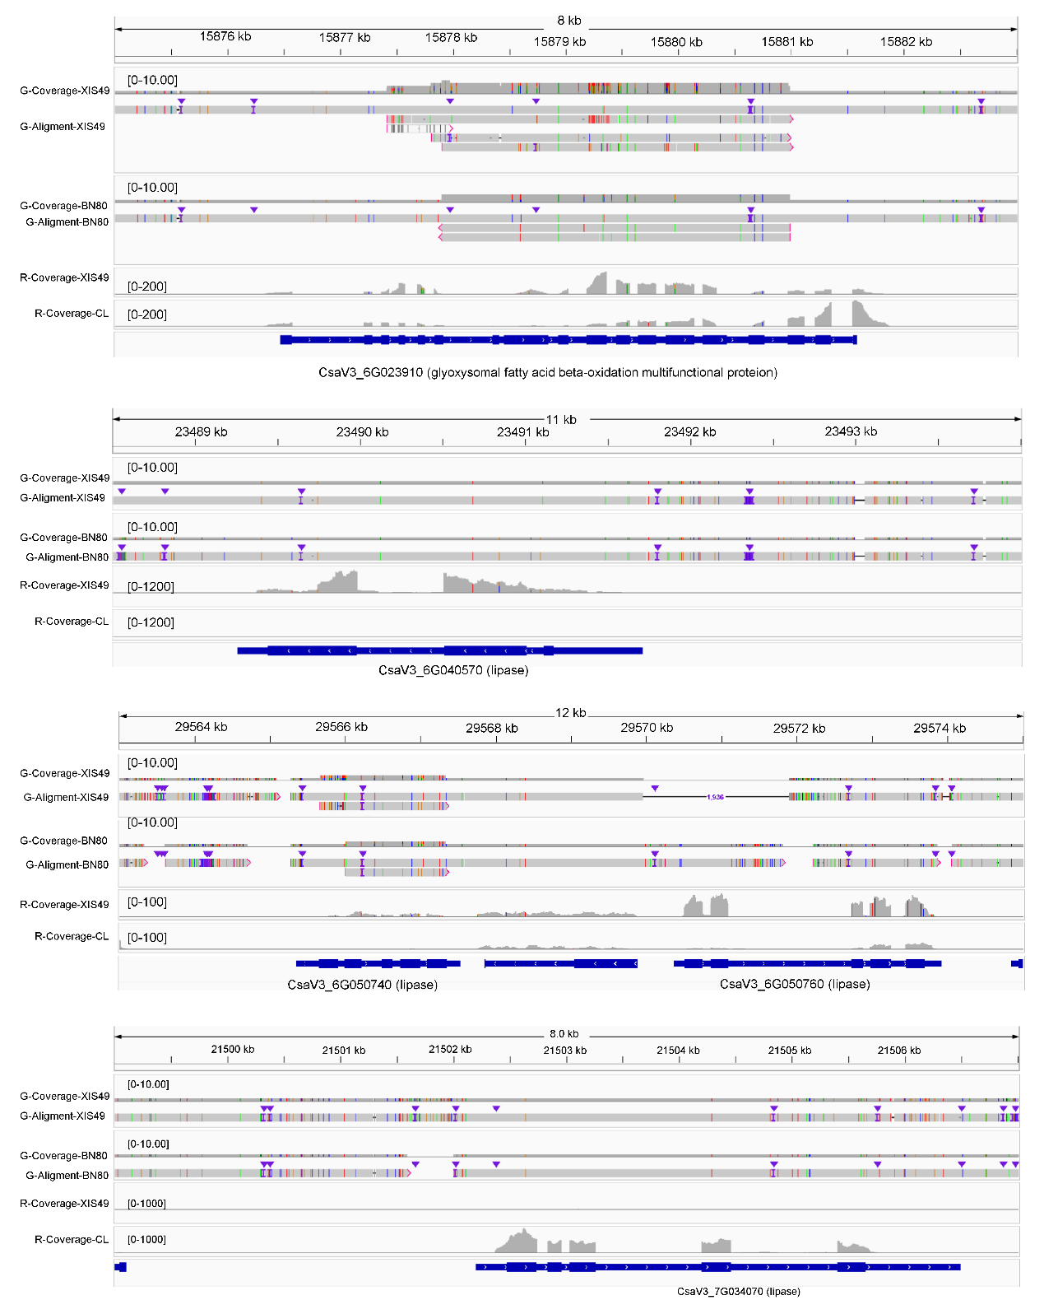
Fig. S5 Domestication SV (dSV) regulate lipid metabolism genes. The difference in gene transcription is associated with SVs as demonstrated. SV and transcription level were vitalized by integrative genomics viewer (IGV).
