Coating of SnO₂-NiO nanoparticles with ultrathin graphite nanosheets as a high-performance anode material for lithium-ion batteries
Wenbin Ye, Jinxuan Lei, Chaokui Jiang, Zuyong Feng *, Deping Xiong, Miao He
School of Physics and Optoelectronic Engineering, Guangdong University of Technology, Guangzhou, Guangdong 510006, PRC.
*Corresponding author. E-mail address: fengzuyong@foxmail.com (Zuyong Feng)

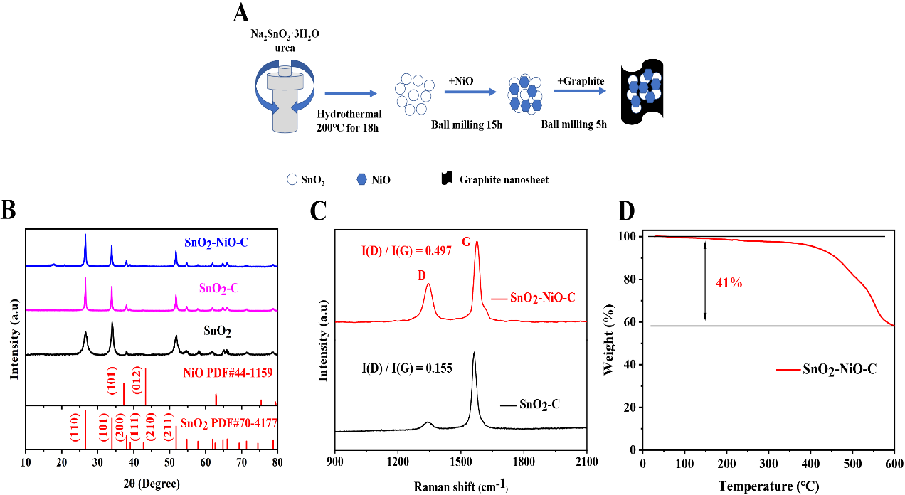
Fig. 1. (A) Diagrammatic representation of the SnO₂-NiO-C synthesis. (B) XRD graphs of the SnO₂-NiO-C as well as two other comparison materials. (C) Raman images of the SnO₂-NiO-C. (D) TGA test pattern of the SnO₂-NiO-C.

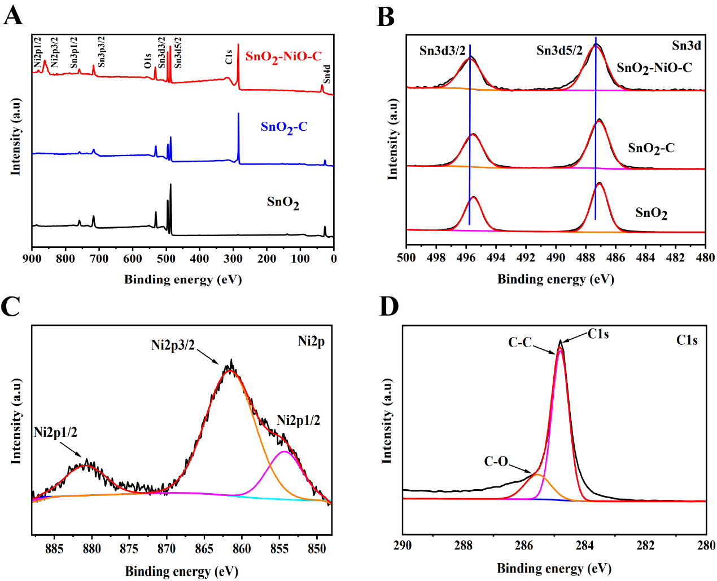
Fig. 2. (A) Complete XPS emissions of the SnO₂-NiO-C as well as two other comparison materials. (B) Sn3d XPS emissions of the SnO₂-NiO-C as well as two other comparison materials. (C) Ni2p XPS emissions for the SnO₂-NiO-C. (D) C1s XPS emissions for the SnO₂-NiO-C.

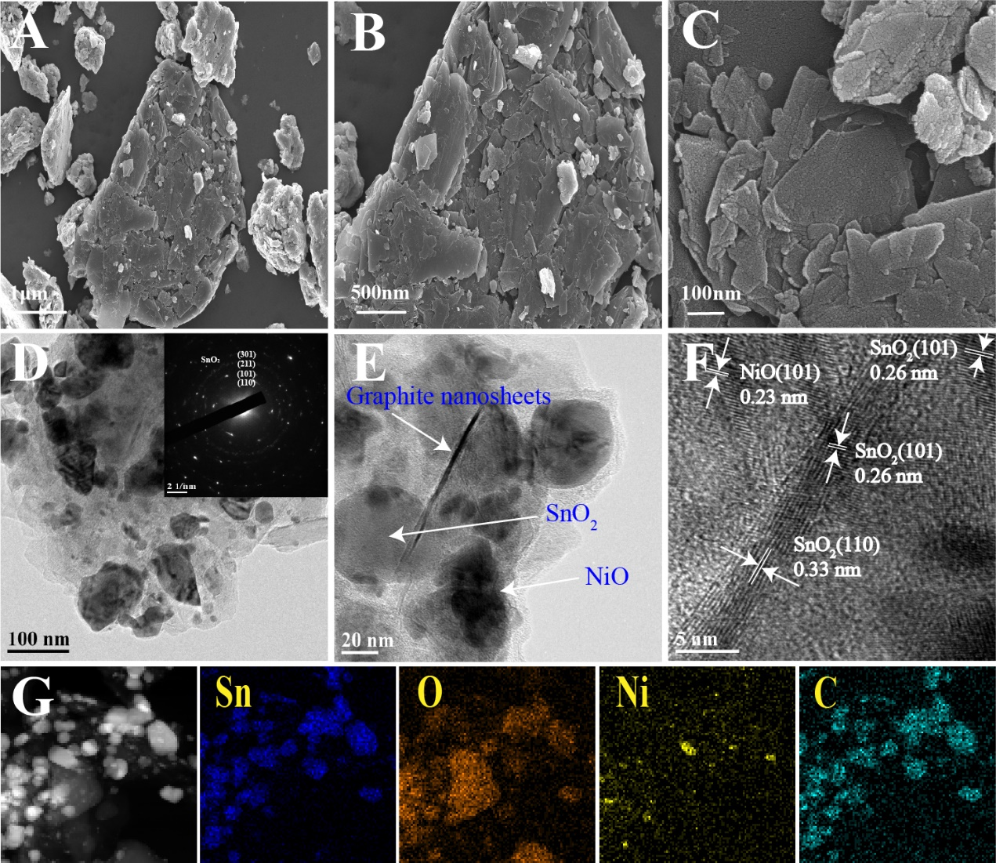
Fig. 3. The SnO₂-NiO-C composite: (A), (B) SEM pictures. (C) Hi-res SEM picture. (D) TEM picture. (E), (F) Hi-res TEM pictures. (G) Mappings of EDS element. Also, SEAD layout (plug in a portion of Fig. 3D)

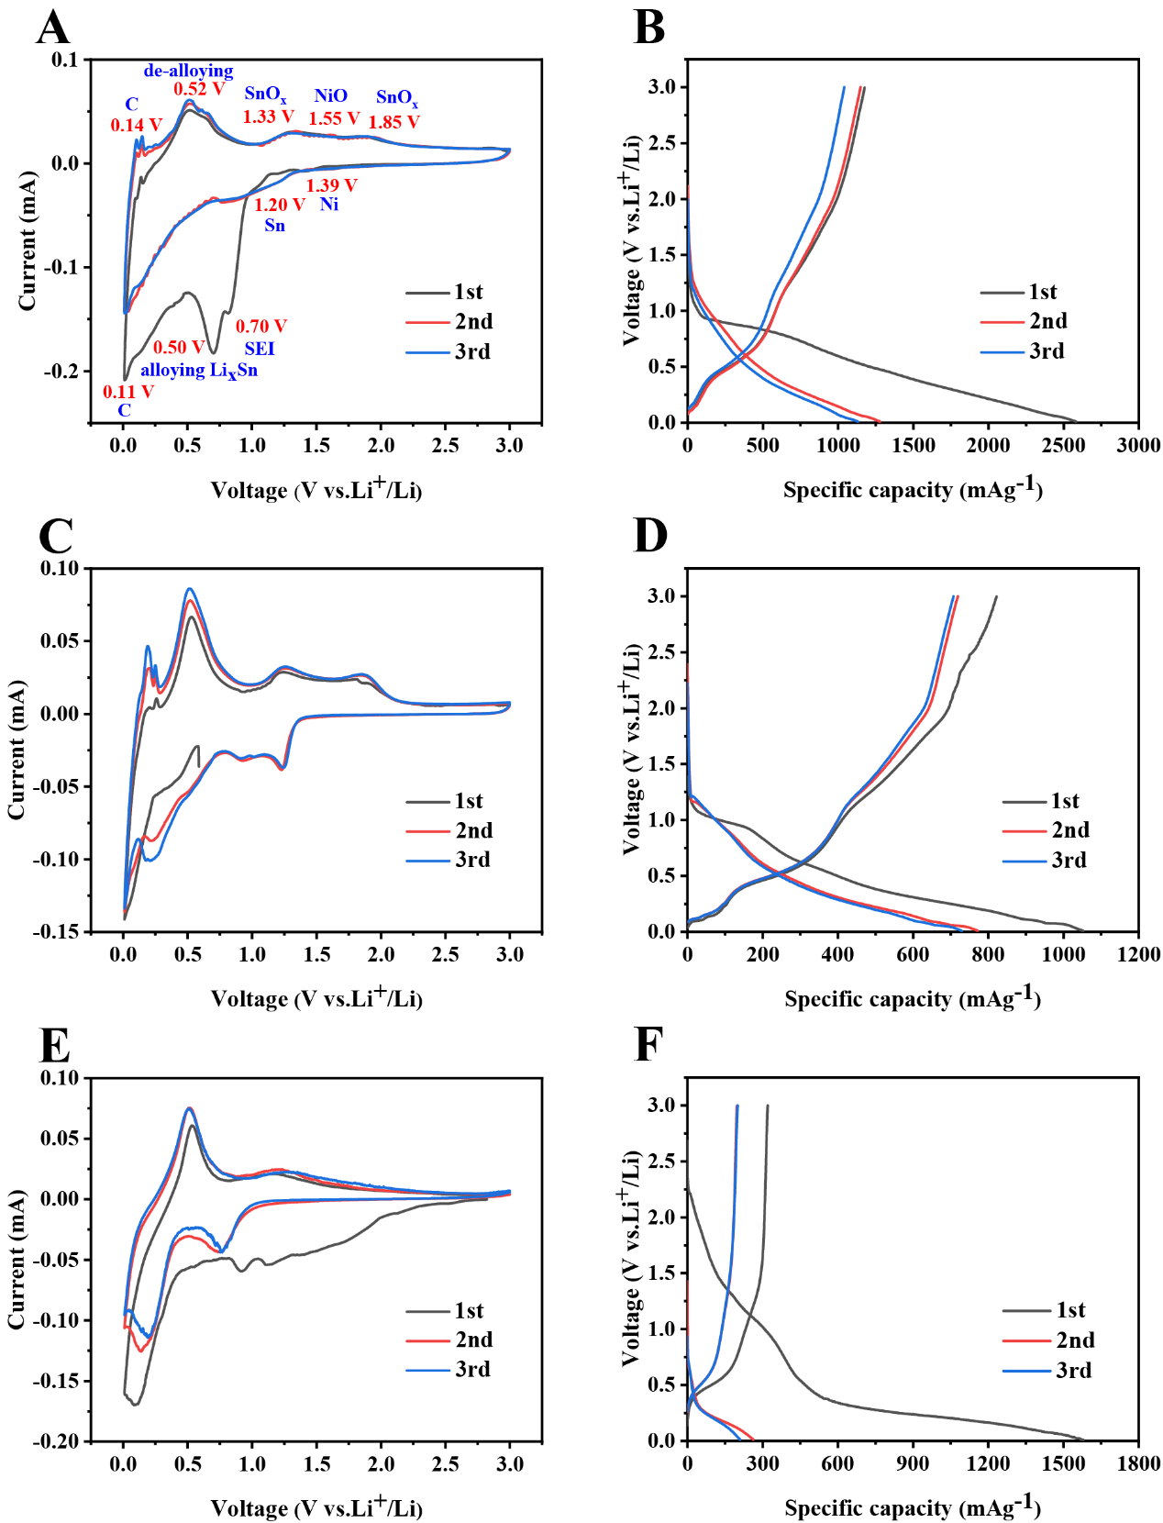
Fig. 4. (A), (C), (E) Cyclic voltammetry curves of the SnO₂-NiO-C as well as two other comparison materials. (B), (D), (F) Charging and discharging diagram of the SnO₂-NiO-C as well as two other comparison materials.

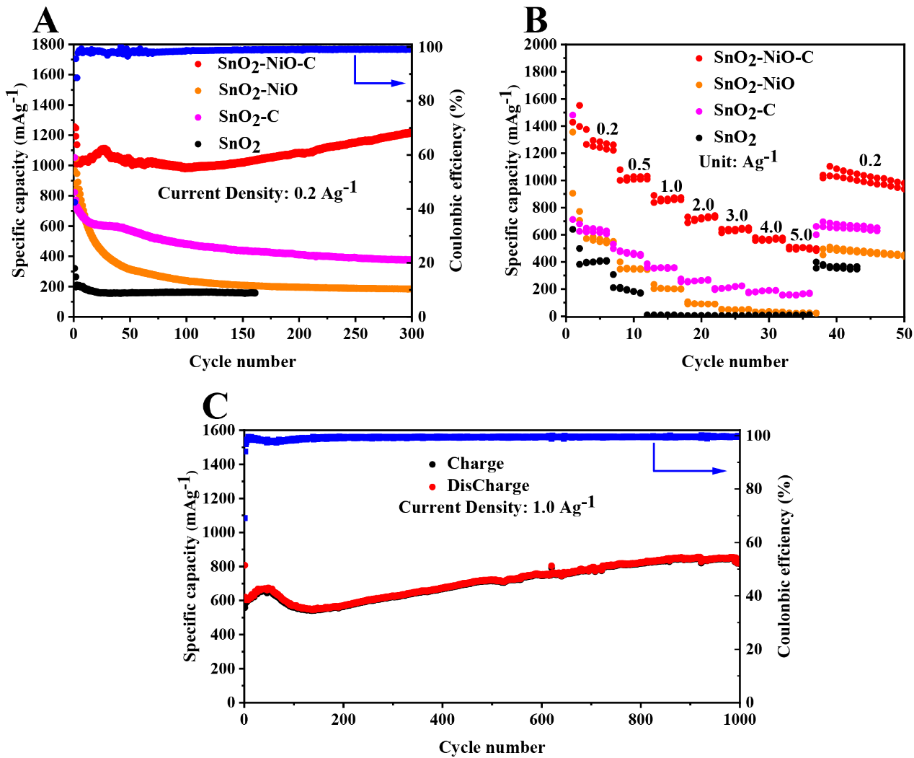
Fig. 5. (A) Cycling properties (after 300 cycles) of the SnO₂-NiO-C sample and the other three comparison materials (at 0.2 A g⁻¹). (B) Rate properties of the SnO₂-NiO-C sample and the other three comparison materials (between 0.2-5.0 A g⁻¹). (C) After 1000 cycles, long-cycle property of the SnO₂-NiO-C sample at 1.0 A g⁻¹.
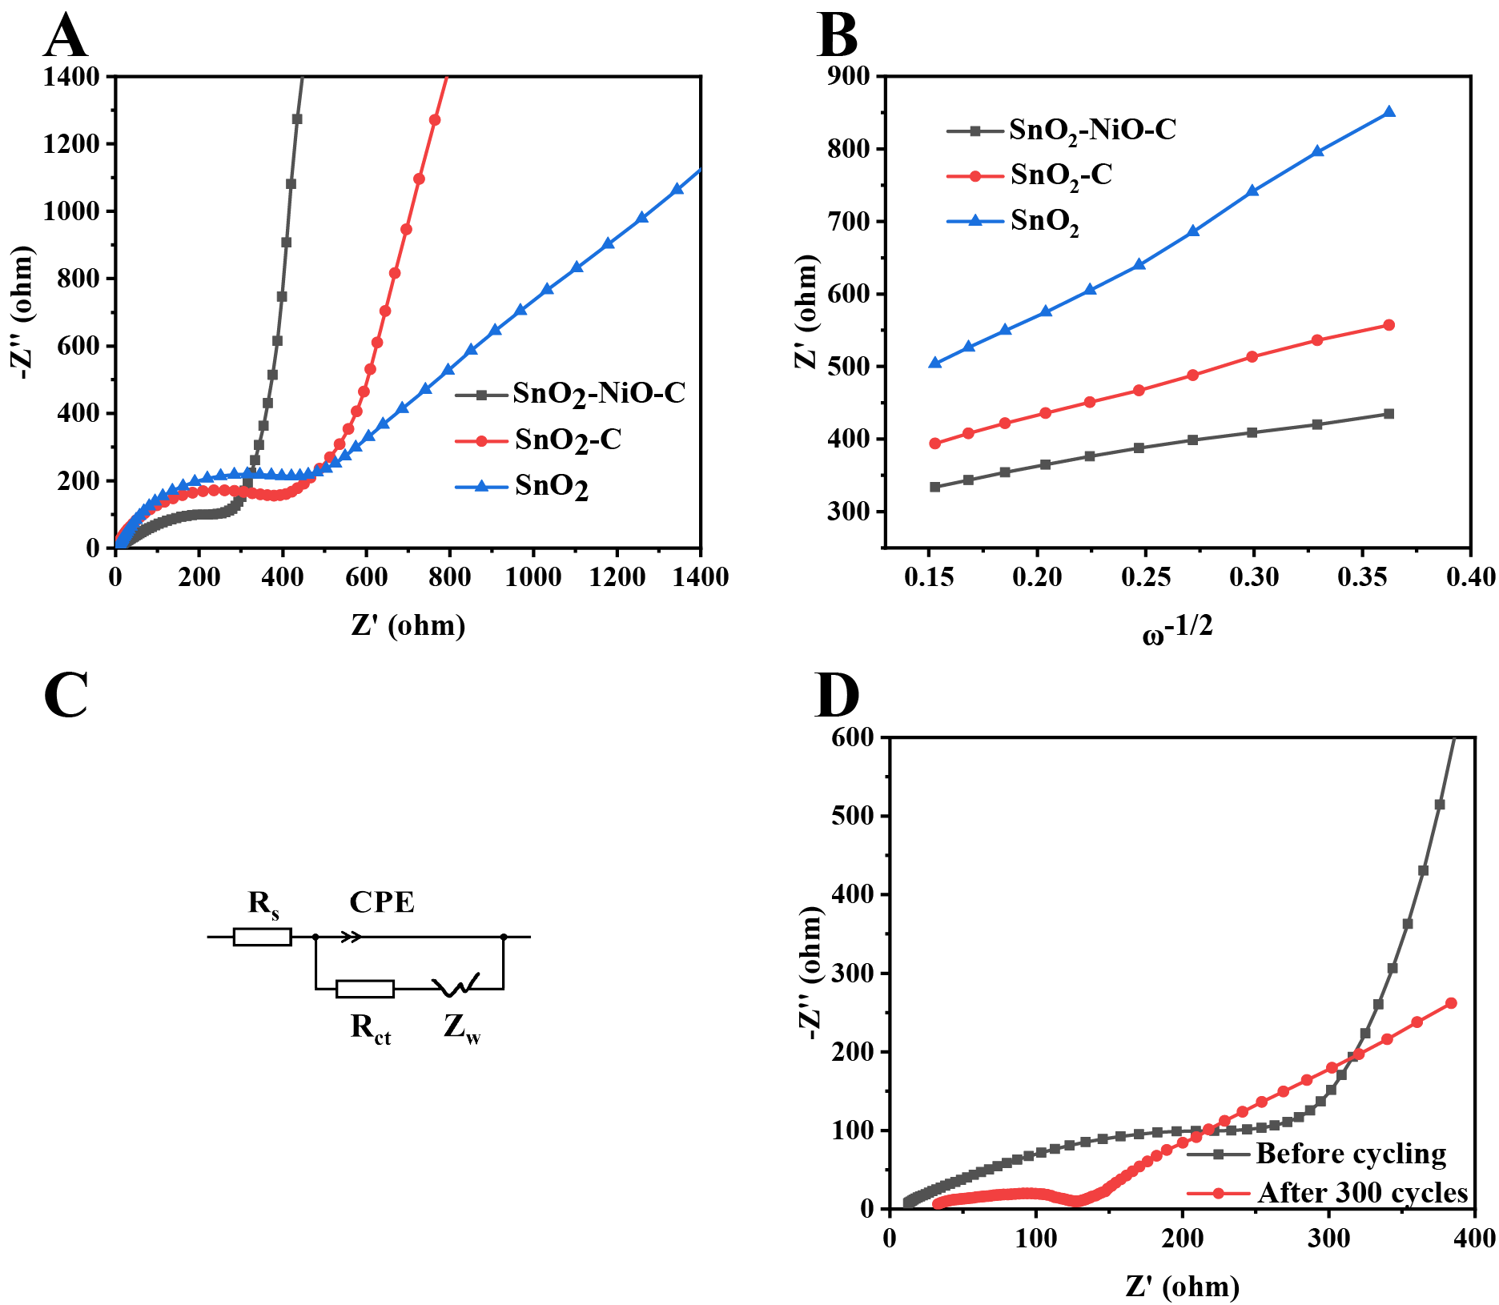
Fig. 6. (A) EIS patterns of the new SnO₂-NiO-C and other comparison materials. (B) EIS patterns of the fresh SnO₂-NiO-C and after 300 cycles at 0.2 A g⁻¹.
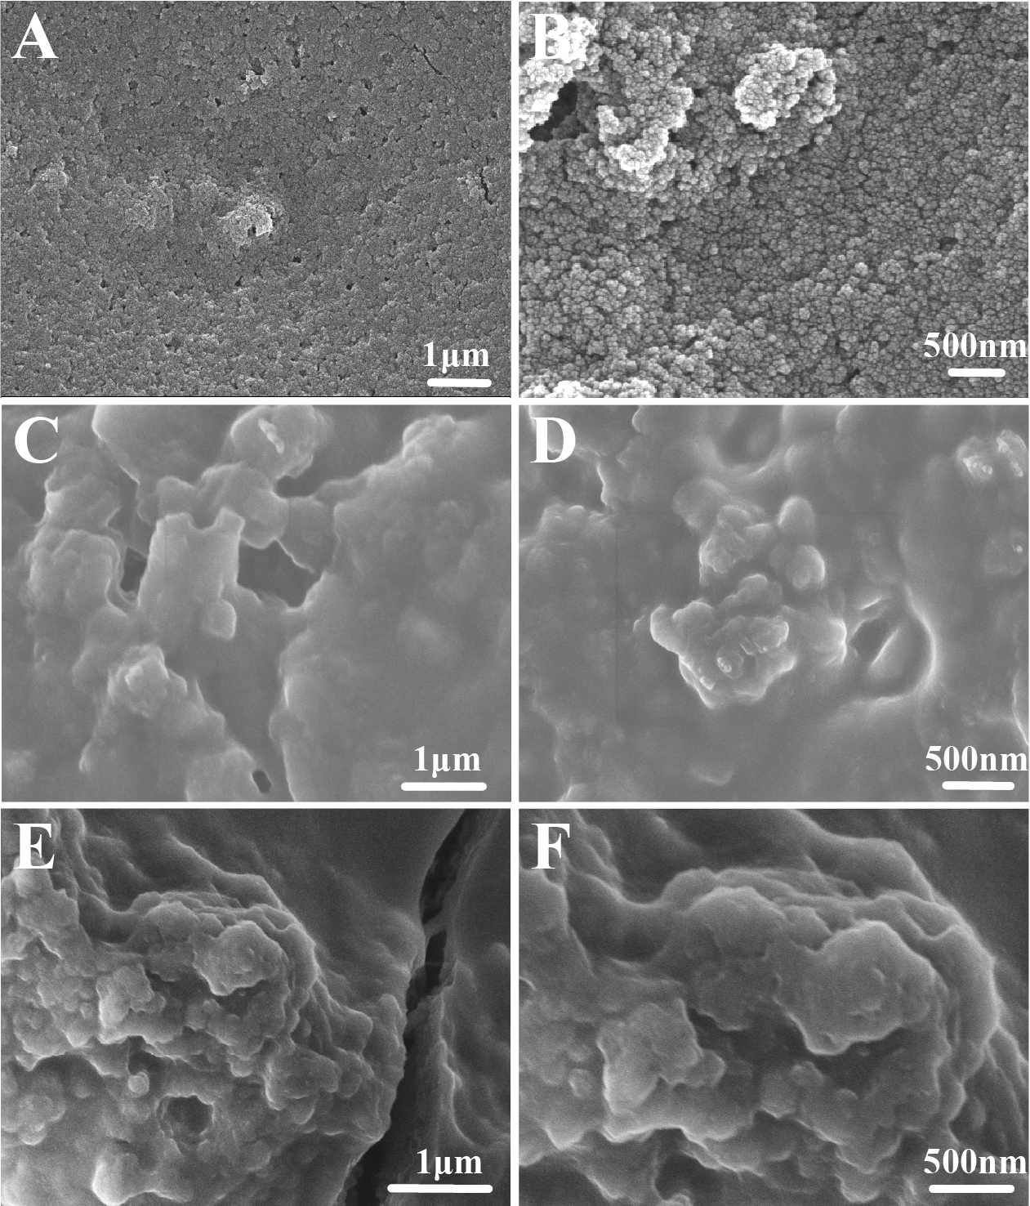
Fig. 7. SEM diagrams for (A) (B) SnO₂-NiO-C, (C) (D) SnO₂-C (E) (F) SnO₂ after 400 cycles at 0.2 A g⁻¹.
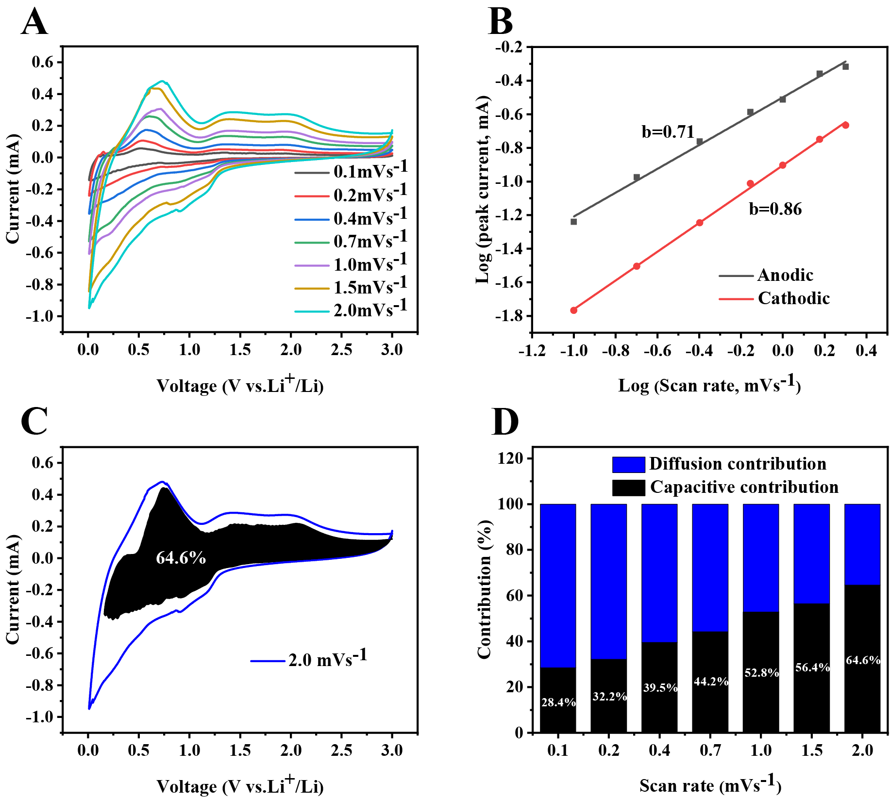
Fig. 8. (A) CV curves at various scanning speeds. (B) Scanning speeds and peak current processed by linear fitting to obtain b values. (C) The capacitance contribution. (D) The capacitance contribution rates obtained at various scanning speeds from 0.1 to 2.0 mV s⁻¹.

