Supplementary information for

SnO₂-NiO nanoparticles anchored in ultrathin graphite nanosheets as a high-performance anode material for lithium-ion batteries
Wenbin Ye, Jinxuan Lei, Chaokui Jiang, Zuyong Feng *, Deping Xiong, Miao He
School of Physics and Optoelectronic Engineering, Guangdong University of Technology, Guangzhou, Guangdong 510006, PRC.
*Corresponding author. E-mail address: fengzuyong@foxmail.com (Zuyong Feng)

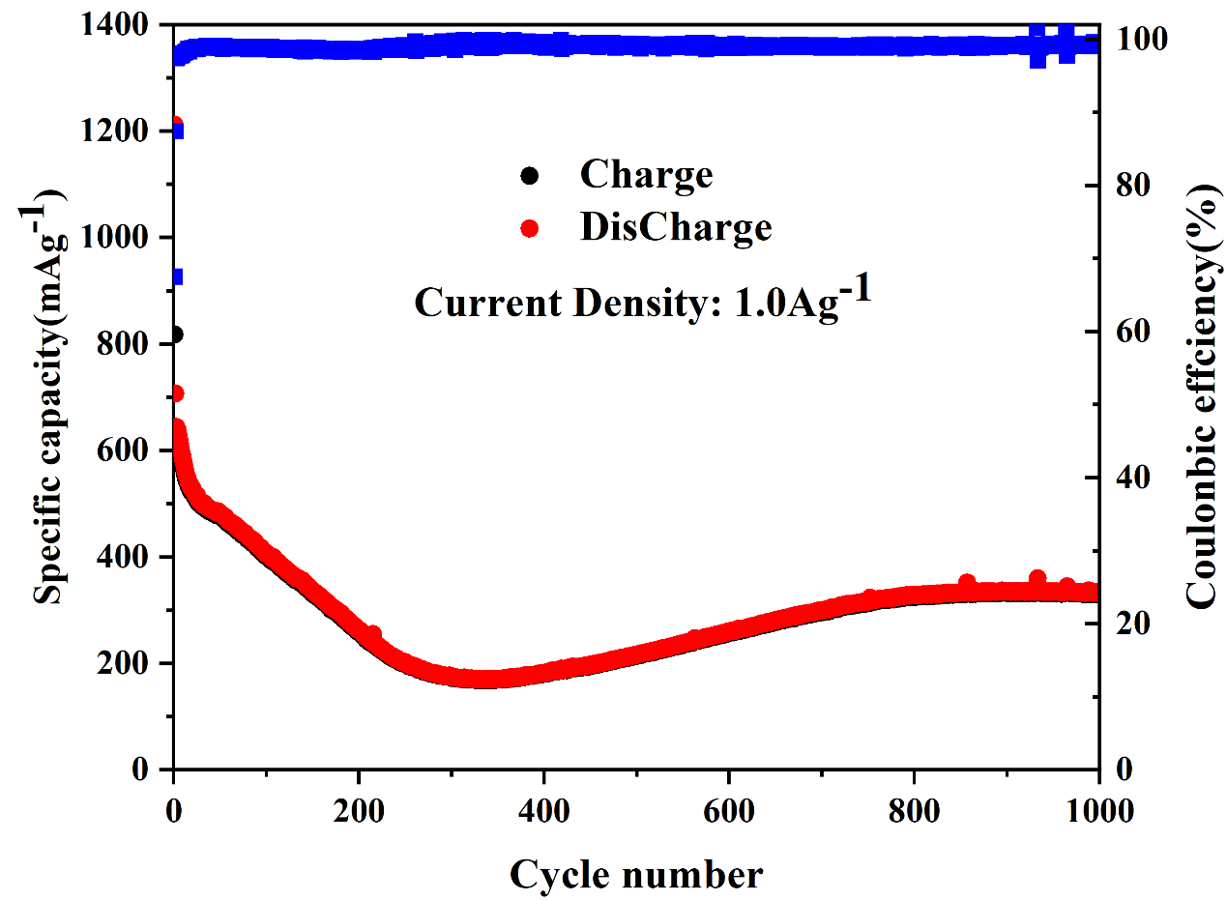
Fig. S1. Long-term cycling performance of the SnO₂-C composite at 1.0 A g⁻¹.

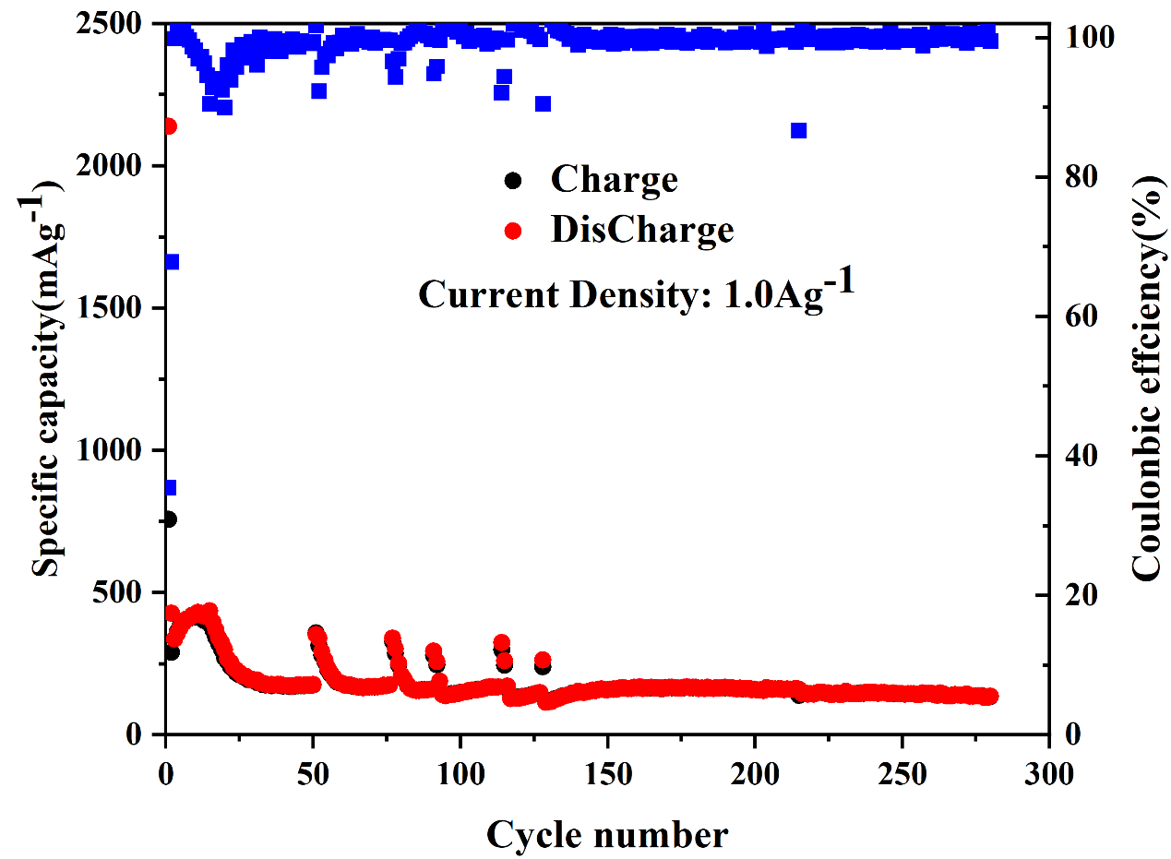
Fig. S2. Long-term cycling performance of SnO₂ at 1.0 A g⁻¹.
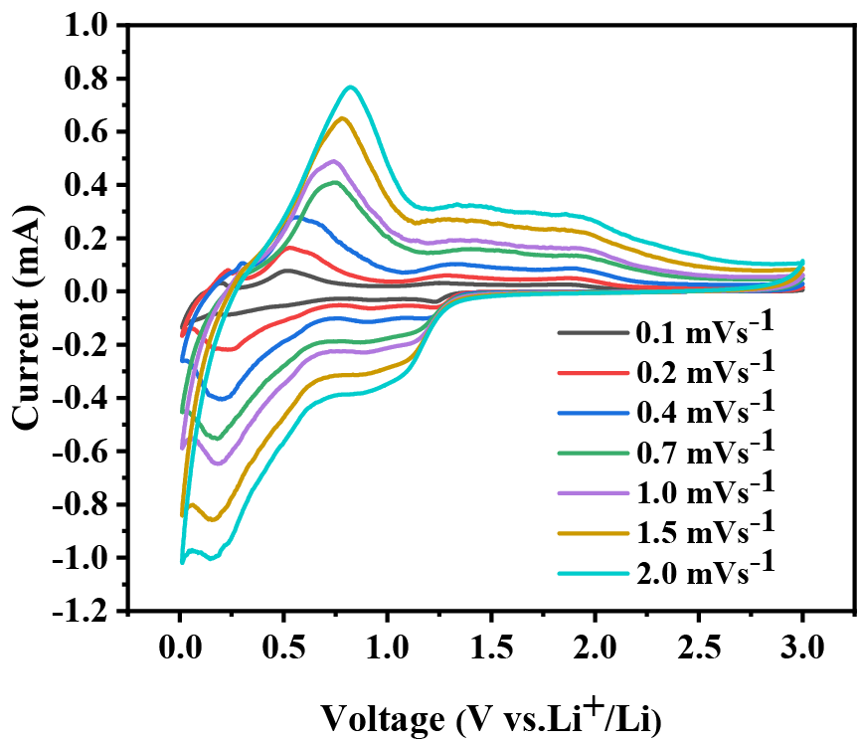
Fig. S3. CV curves of the SnO₂-C composite at various scanning rates.

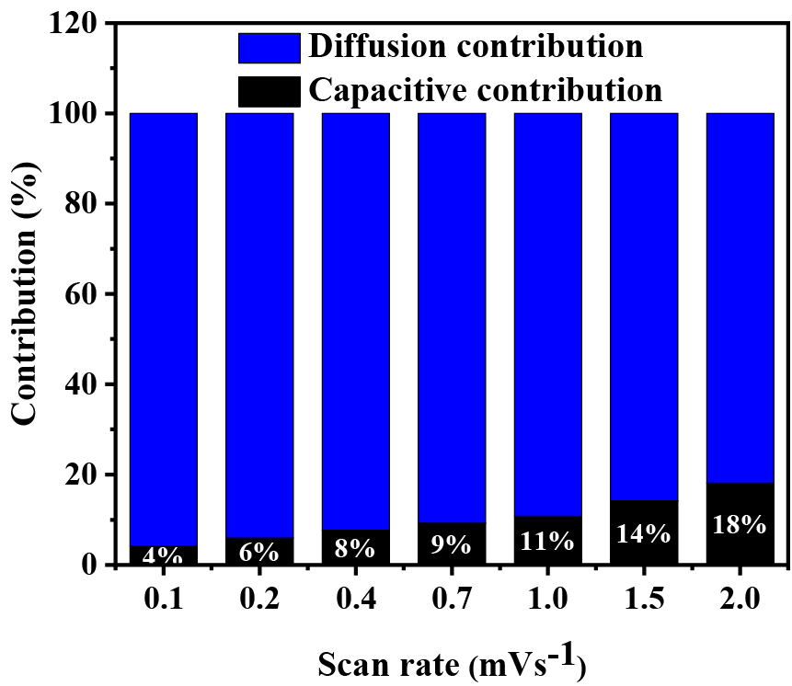
Fig. S4. The capacitance contribution rates of the SnO₂-C composite obtained at various scanning rates from 0.1 to 2.0 mV s⁻¹.

Table S1. Comparison of the specific capacities of previously reported SnO₂-based anode materials.
Samples | Cycling performance Capacity (mAh g⁻¹) /Number (n) /Rate (A g⁻¹) | Rate performance Capacity (mAh g⁻¹) / Rate (A g⁻¹) | Ref
SnO₂@TiO₂ | 472.7/800/2.0  518.2/500/0.8 | 388.9/5.0 | [S1]
bowl-like SnO₂@carbon | 963.0/100/0.4 | 850.0/1.6 | [28]
Sandwich-like SnO₂/Cu@Carbon | 348.0/1000/1.0 | 289.0/2.0 | [29]
SnO₂/MoS₂(1:3)@ CMK-9 | 1245.0/300/0.1  823.0/1000/1.0 | 740.0/2.0 | [30]
W-SnO₂-C | 1148.8/500/0.2  1229.5/800/1.0 | 312.3/5.0 | [31]
NiO-SnO₂/graphene | 826.0/500/1.0 | 721.0/5.0 | [33]
Sn@SnO₂@C@MoS₂ | 841.0/400/1.0 | 458.3/10.0 | [S2]
Sn/SnO_{x}@Ti3C₂ | 594.2/200/0.05 | 194.5/5.0 | [44]
Sn/SnO₂@Carbon | 986.3/2000/1.0 | 508.2/5.0 | [56]
V₂O₅-C-SnO₂ | 800.0/100/0.2 | 620.0/0.8 | [S3]
CNTs@SnO₂/SnO/Sn | 394.0/50/0.1 | 200/2.0 | [S4]
SnO₂/GN | 757.0/500/1.0 | 708.0/1.0  609.0/2.0 | [S5]
SnO₂-CuO-G | 561.2/150/0.1 | 440.0/1.0 | [S6]
SnO₂-NiO-C | 1224.3/300/0.2  820.1/1000/1.0 | 507.1/5.0 | This work

Table S2. Impedance parameters obtained from equivalent circuit model (Fig. 6C) for SnO₂-NiO-C, SnO₂-C and SnO₂ anode materials before cycling.
Materials | SnO₂-NiO-C | SnO₂-C | SnO₂
R_{Ω}/Ω | 1.024 | 2.314 | 4.586
R_{ct}/Ω | 271.8 | 407.8 | 551.4

References
[1] Q. Tian, Y. Tian, W. Zhang, J. Huang, Z. Zhang, L. Yang, Impressive lithium storage of SnO₂@TiO₂ nanospheres with a yolk-like core derived from self-assembled SnO₂ nanoparticles, Journal of Alloys and Compounds, 702 (2017) 99-105.
[2] Y.G. Huang, Q.C. Pan, H.Q. Wang, C. Ji, X.M. Wu, Z.Q. He, Q.Y. Li, Preparation of a Sn@SnO₂@C@MoS₂ composite as a high-performance anode material for lithium-ion batteries, J. Mater. Chem. A 4 (2016) 7185.
[3] L. Zhang, M. Yang, S. Zhang, Z. Wu, A. Amini, Y. Zhang, D. Wang, S. Bao, Z. Lu, N. Wang, C. Cheng, V₂O₅-C-SnO₂ Hybrid Nanobelts as High Performance Anodes for Lithium-ion Batteries, Scientific Reports, 6 (2016).
[4] J. Zhang, Z.S. Ma, W.J. Jiang, Y.L. Zou, Y. Wang, C.S. Lu, Sandwich-like CNTs@SnO₂/SnO/Sn anodes on three-dimensional Ni foam substrate for lithium ion batteries, Journal of Electroanalytical Chemistry, 767 (2016) 49-55.
[5] L. Zhan, X.S. Zhou, J. Luo, X.M. Ning, Binder-free multilayered SnO₂/graphene on Ni foam as a high-performance lithium ion batteries anode, Ceramics International, 45 (2019) 6931-6936.
[6] B. Lu, H. Wang, R.Z. Hu, L.C. Yang, J. Liu, J.W. Liu, M. Zhu, Enhanced cyclic performance of SnO2-CuO-graphitenano-sheetsas anode for Li-ion battery, Mater.Lett. 185 (2016) 9–12.

