Supplementary Figure
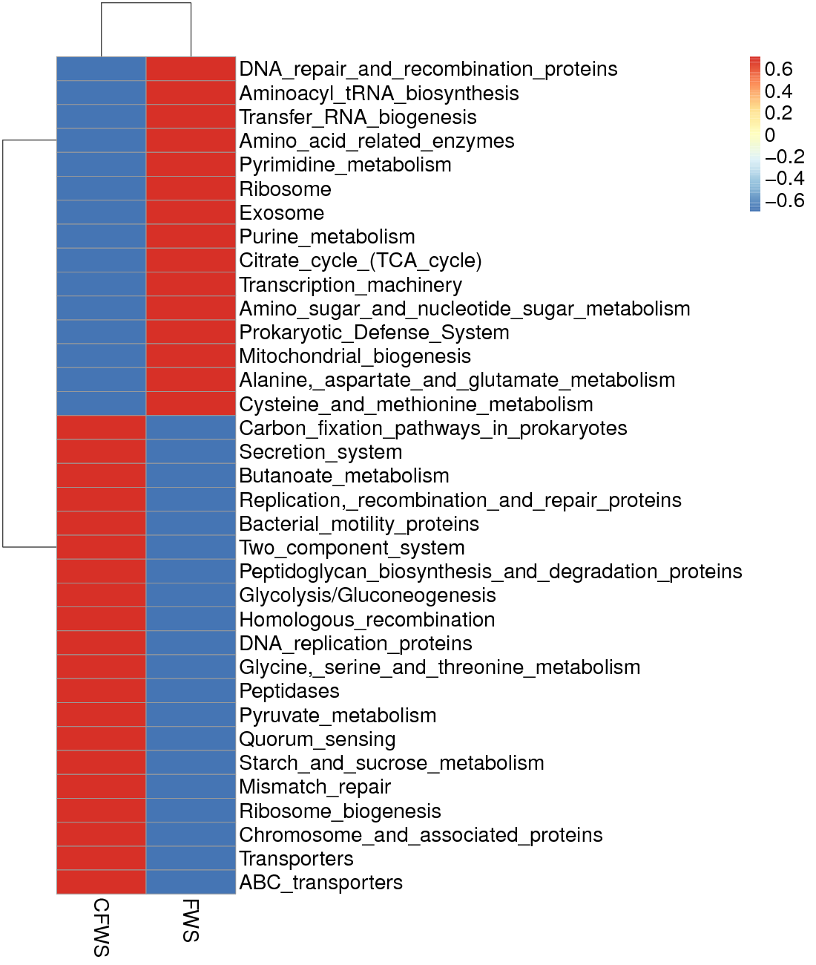

Supplementary Figure 1 FunGuild shows the predicted relative abundance of all KEGG signaling pathways between the two group of the fecal microbes (Level 3 Kos, > 1%).

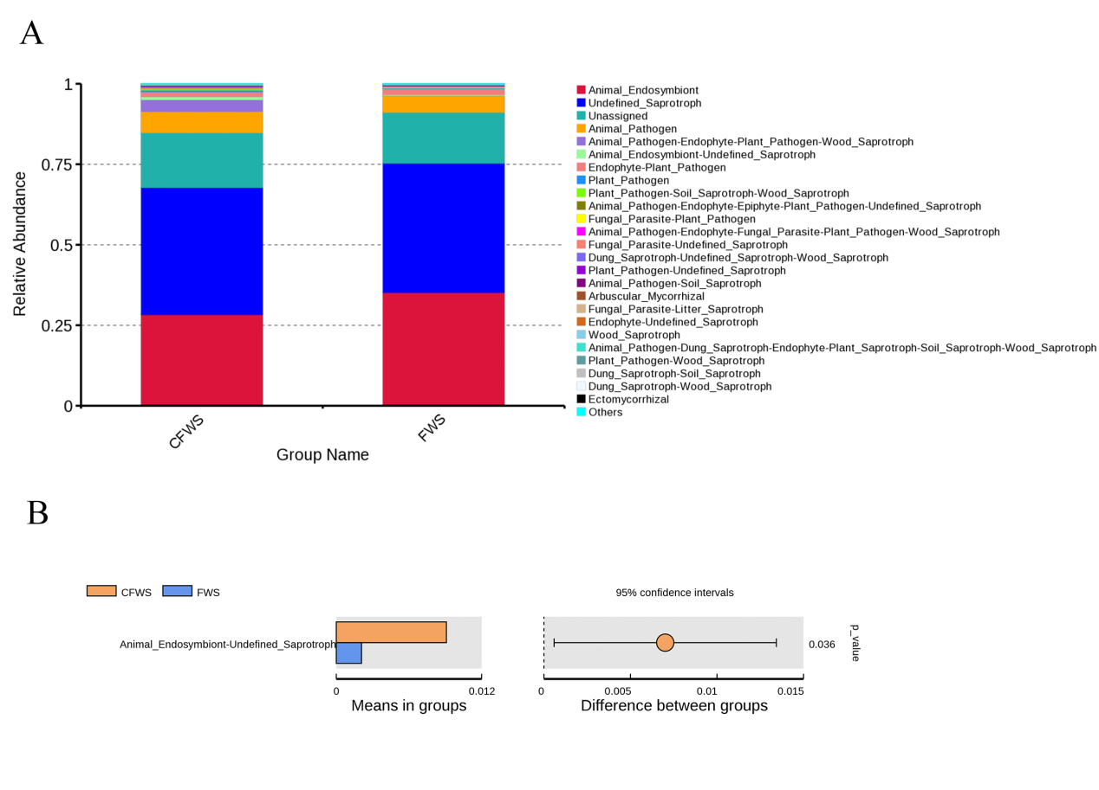
Supplementary Figure 2 (A) FunGuild function annotated relative abundance bar chart. (B) The differential analysis of T_test based on FunGuild function annotated.

