Supplementary Table 1. Human Phenotype Ontology (HPO) terms for patient with a VUS in the PTCHD1 gene (NM_173495 c.2489T>G (p.Ile830Arg)].).
HPO term | Description
HP:0000729 | Autistic behavior
HP:0000343 | Long philtrum
HP:0000278 | Retrognathia
HP:0000463 | Anteverted nares
HP:0000276 | Long face
HP:0030799 | Scaphocephaly
HP:0008070 | Sparse hair
HP:0000954 | Single transverse palmar crease
HP:0001263 | Global developmental delay
HP:0012330 | Pyelonephritis NOT
HP:0001250 | Seizures NOT
HP:0011398 | Central hypotonia
HP:0001317 | Abnormality of the cerebellum NOT
HP:0000666 | Horizontal Nystagmus
HP:0002194 | Delayed gross motor development
HP:0001252 | Muscular hypotonia

Supplementary Figure 1. 2D representations of the PTCHD1_trunc clone primary protein structure as predicted by deepTHMM and visualised in Protter. Both clones were predicted to produce a premature stop codon, disrupting the final transmembrane domain. a PTCHD1_trunc 1 NM_173495.2(PTCHD1_i001):p.(Leu827Alafs*4) b
PTCHD1_trunc 2 NM_173495.2(PTCHD1_i001):p.(Leu823Glyfs*5)
a
b

Supplementary Figure 2. Box plots of voom transformed PTCHD1 expression grouped by PTCHD1 clone and cell type. Differential gene expression analysis determined no significant differences in PTCHD1 expression between PTCHD1_WT, PTCHD1_SNV, and PTCHD1_trunc cells at both the iPSC and NPC level.
Supplementary Figure 3 Principal component analysis a. PTCHD1_WT, PTCHD1_SNV, and PTCHD1_trunc showed clear separation of iPSCs and NPCs. b. iPSCs. c. NPCs
a.
b.
c.
Supplementary Figure 4. Hierarchical clustering of samples by PTCHD1 genotype and cell type.

Supplementary Figure 5. Gene sets enriched during differentiation from the c5 Ontologies collection (GO and HPO)
Supplementary Figure 6. Principle component analysis of experimentally generated NPCs to wild-type NPCs in the ARCHS4 database.
Supplementary Figure 7. Mean-difference plots of PTCHD1_SNV, trunc and WT iPSCs and NPCs and during differentiation.
Supplementary figure 8. EnrichGO analysis identified synaptic cellular components were enriched in the comparison of PTCHD1_WT to PTCHD1_SNV cells during differentiation.
Supplementary figure 9. Enriched disease ontology terms from the comparison of PTCHD1_WT to PTCHD1_SNV cells during differentiation.
Supplementary figure 10. Clusterprofiler biological theme comparison of PTCHD1_WT, PTCHD1_SNV, and PTCHD1_trunc cells during differentiation.
Supplementary figure 11. FACs gating strategy. 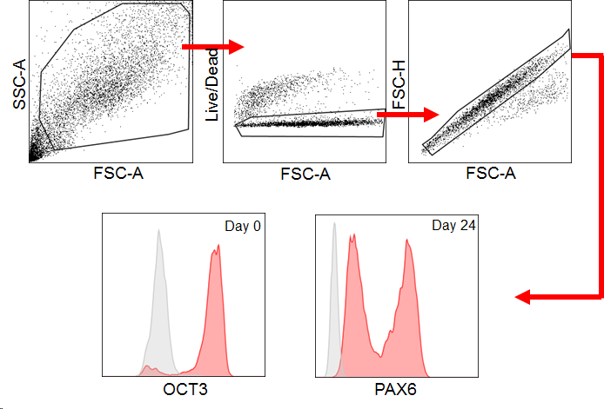
Supplementary figure 12. Karyotyping of KOLF2 cells containing PTCHD1_SNV determined a 46, XY karyotype. Cells were karyotyped in the Cytogenetics section, Diagnostic Genomics, PathWest.
Supplementary figure 13. Off-target PCR chromatograms for crRNA AA and crRNA Ax. No off-target effects were found. Primer/target information can be viewed in supplementary table 13.
