Supplementary Information for
Conformal fabrication of an electrospun nanofiber mat on a 3D ear cartilage-shaped hydrogel collector based on hydrogel-assisted electrospinning
Jin Yeong Song¹, Hyun Il Ryu¹, Jeong Myeong Lee¹, Seong Hwan Bae^{2,3}, Jae Woo Lee², Changryul Claud Yi^{2,3,**}, Sang Min Park^{1,*}
¹School of Mechanical Engineering, Pusan National University, 2, Busandaehak-ro 63 beon-gil, Geumjeong-gu, Busan, 46241, South Korea
²Department of Plastic and Reconstructive Surgery, Pusan National University School of Medicine, 179 Gudeok-ro, Seo-gu, Busan 49241, South Korea
³Biomedical Research Institute, Pusan National University Hospital, 179 Gudeok-ro, Seo-gu, Busan 49241, South Korea
Corresponding Author
* Prof. Sang Min Park
e-mail: sangmin.park@pusan.ac.kr
** Prof. Changryul Claud Yi
e-mail: fuffl0000@gmail.com

1. Numerical simulation of electric fields with three types of collectors
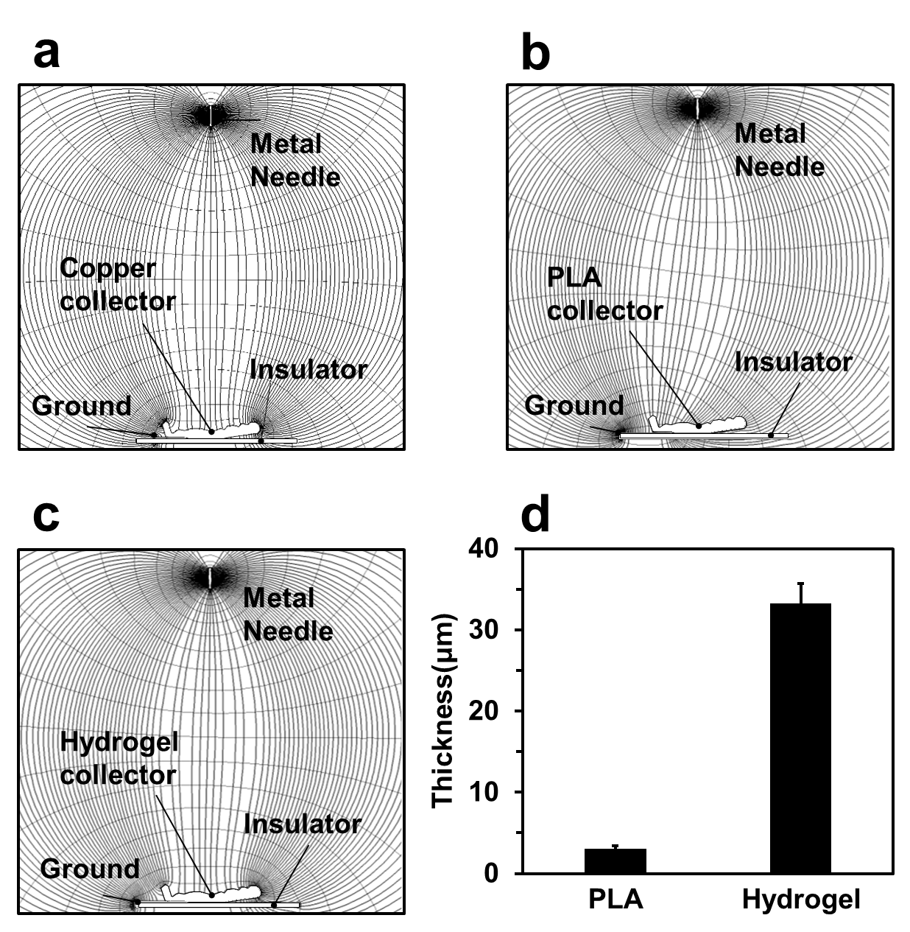
Figure S1. Simulation result of the electric field with a copper collector (a), a PLA collector (b), and an alginate-gelatin hydrogel collector (c). (d) The thicknesses of the electrospun nanofiber mat on the PLA collector and the alginate-gelatin hydrogel collector.

2. Fabricated 3D ear cartilage-shaped alginate-gelatin hydrogel collector
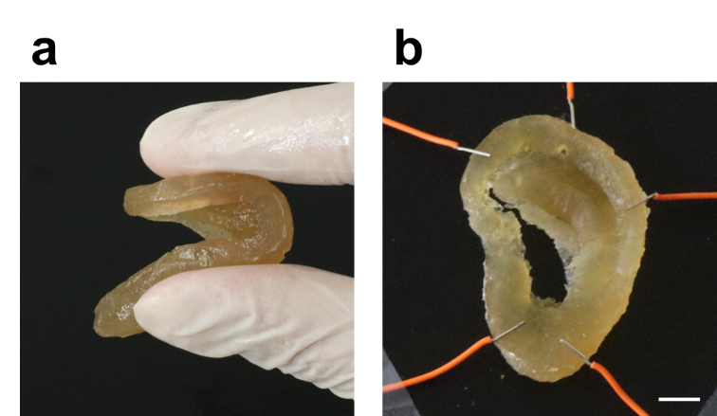
Figure S2. (a) Manual deformation of the 3D ear cartilage-shaped hydrogel collector. (b) The flattened 3D ear cartilage-shaped collector with metal fixtures. The scale bar is 1 cm.

