Supplementary Material

Tea Consumption and Ovarian Cancer Risk in European and East Asian Population: A Mendelian Randomization Study
Lili Wang^{1†}, Tongyu Xing^{1†}, Wei Liu¹, Jingjing Zhou¹, Wei Geng¹, Yanrui Zhao¹, Caiyun Huang¹, Ding Li², Kexin Chen¹, Hong Zheng^{1*}, Lian Li^{1*}
* Correspondence: Lian Li: lilian@tmu.edu.cn; Hong Zheng: zhengh64@aliyun.com

Supplementary Figures and Tables

Supplementary Figures
Supplementary Figure 1 Funnel plot of individual causal effect for tea consumption on ovarian cancer risk and its various histological subtypes in European. Causal effect for each instrumental variable (β_{IV}) is displayed by the black dots to assess potential asymmetry through the funnel plot. Each black dot represents a valid instrumental single nucleotide polymorphism (SNP). The vertical blue line represents the estimated causal effect using all instrumental SNPs from inverse variance-weighted method (light blue) and MR Egger method (dark blue). IV, instrumental variable; SE, standard error. HG, high grade; LG, low grade; LMP, low malignant potential.
Supplementary Figure 2 Funnel plot of individual causal effect for tea consumption on ovarian cancer risk and its various histological subtypes in East Asian. Causal effect for each instrumental variable (β_{IV}) is displayed by the black dots to assess potential asymmetry through the funnel plot. Each black dot represents a valid instrumental single nucleotide polymorphism (SNP). The vertical blue line represents the estimated causal effect using all instrumental SNPs from inverse variance-weighted method (light blue) and MR Egger method (dark blue). IV, instrumental variable; SE, standard error. HG, high grade; LG, low grade; LMP, low malignant potential.
Supplementary Figure 3 Funnel plot of individual causal effect for tea consumption on ovarian cancer risk and its various histological subtypes in Chinese. Causal effect for each instrumental variable (β_{IV}) is displayed by the black dots to assess potential asymmetry through the funnel plot. Each black dot represents a valid instrumental single nucleotide polymorphism (SNP). The vertical blue line represents the estimated causal effect using all instrumental SNPs from inverse variance-weighted method (light blue) and MR Egger method (dark blue). IV, instrumental variable; SE, standard error.
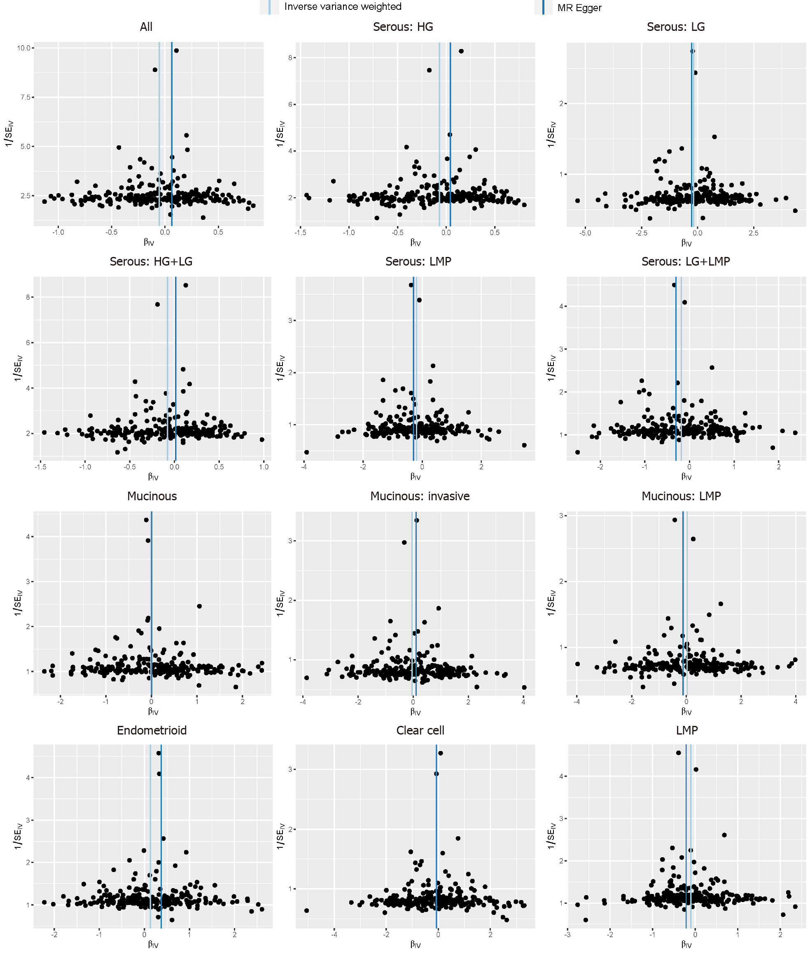
Supplementary Figure 1

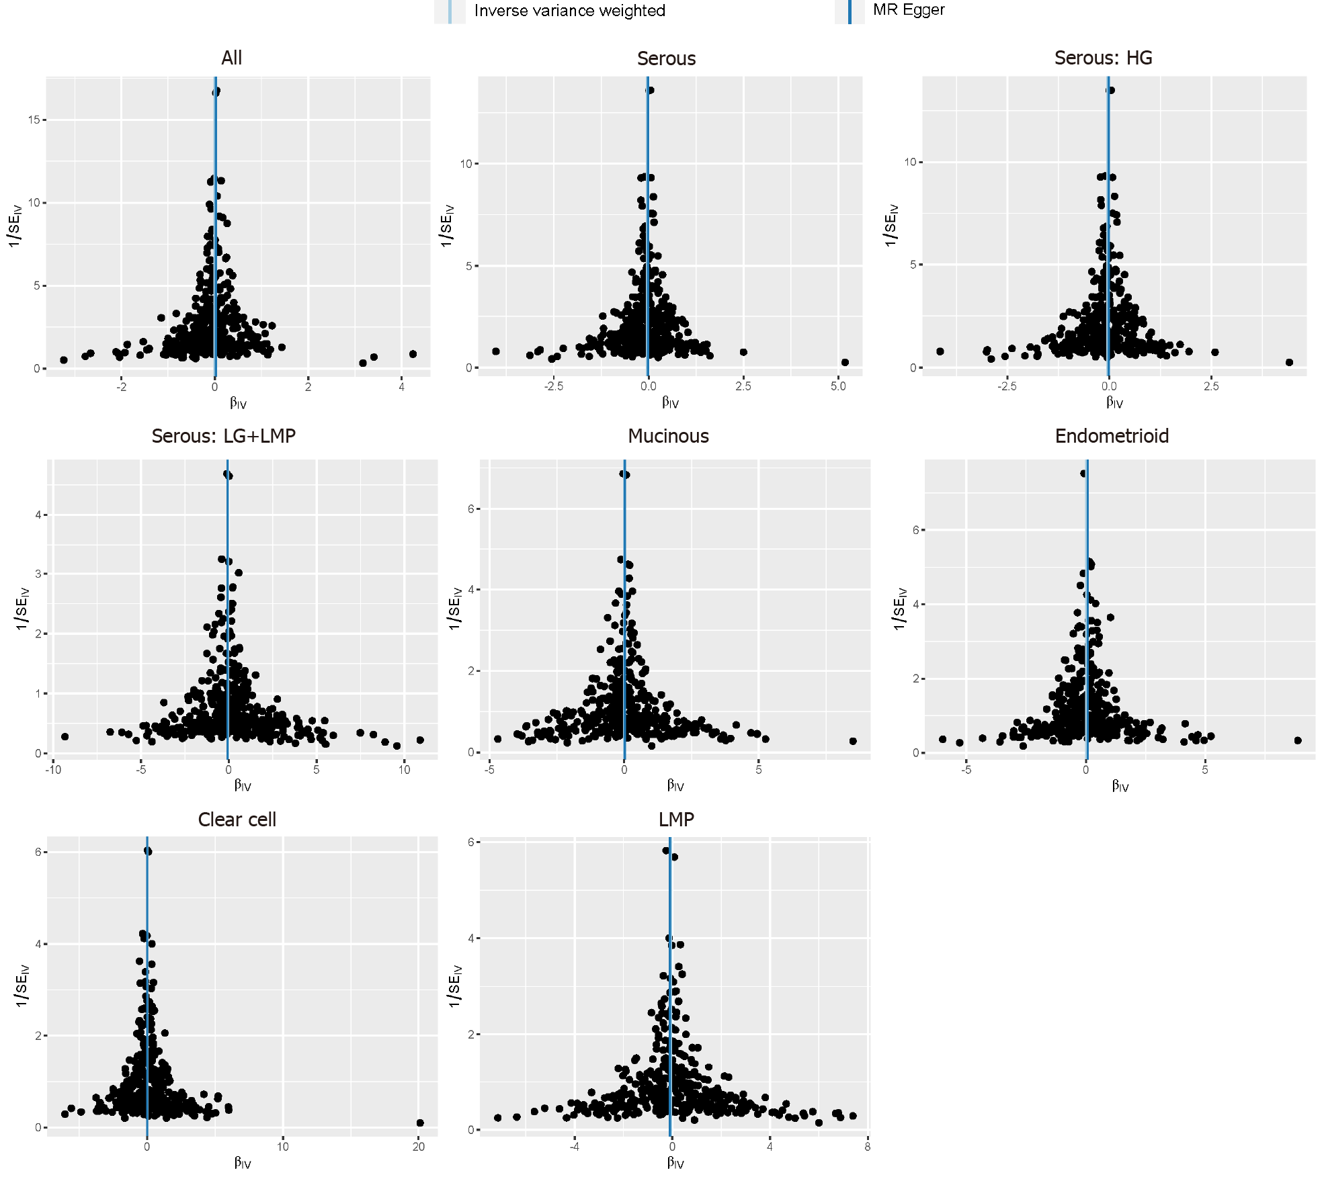
Supplementary Figure 2
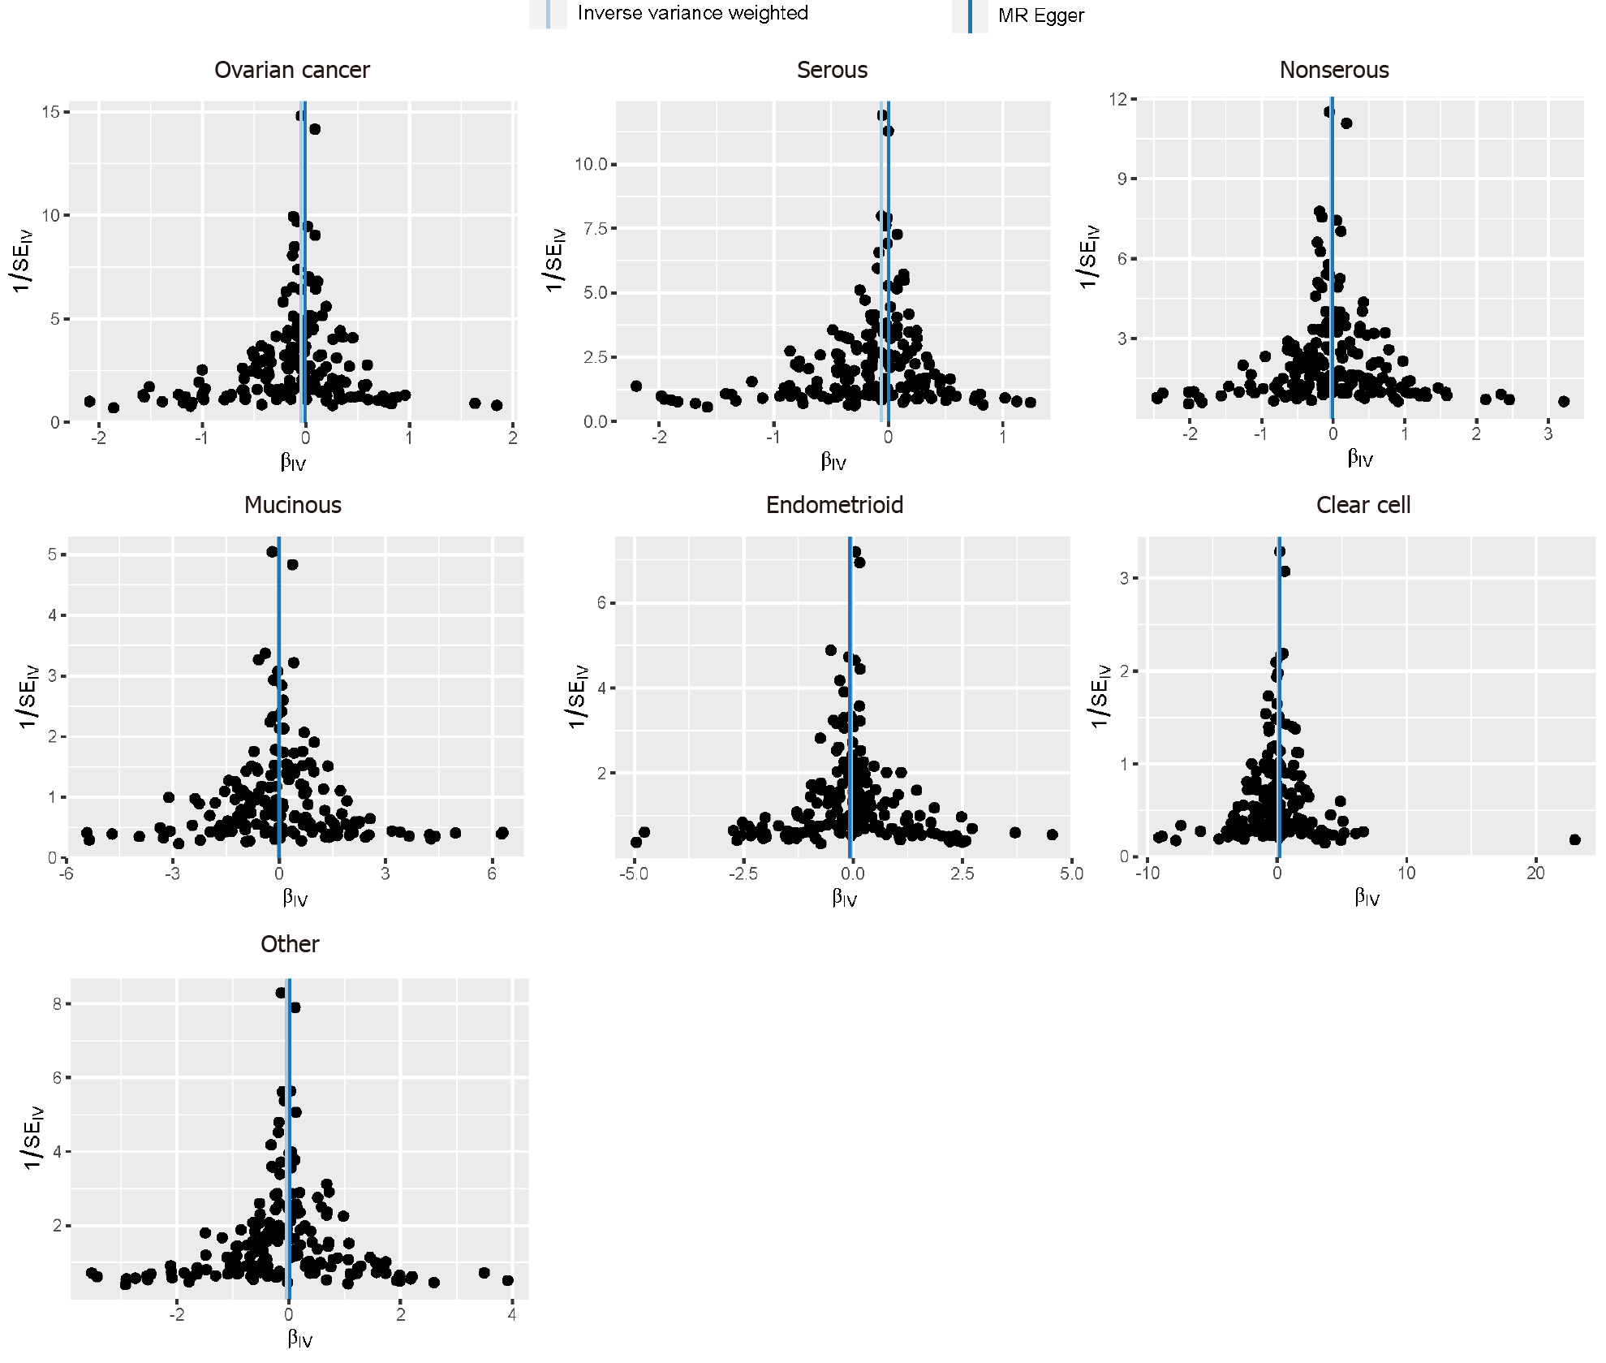
Supplementary Figure 3

Supplementary Tables
Supplementary Table 1 Summary statistics of SNPs information related to the frequency of drinking tea.
Ref. | Journal/Subject | Ethnicity | Sample size | Number of SNP* | Website
Watanabe, 2019 (Watanabe et al. 2019) | Nat Genet | European | 373,481 | 8,625 | —
Matoba, 2020  (Matoba et al. 2020) | Nat Hum Behav | East Asian | 152,653 | 525 | —
Furukawa, 2020 (Furukawa et al. 2020) | Nutrients | East Asian | 12,140 | 6 | —
ukb-e-1488_EAS, 2020 | IEU OpenGWAS project | East Asian | 2,524 | 232 | https://gwas.mrcieu.ac.uk/datasets/ukb-e-1488_EAS/
ukb-e-1488_CSA, 2020 | IEU OpenGWAS project | South Asian | 8,579 | 101 | https://gwas.mrcieu.ac.uk/datasets/ukb-e-1488_CSA/
ukb-e-100420_CSA, 2020 | IEU OpenGWAS project | South Asian | 1,469 | 1,036 | https://gwas.mrcieu.ac.uk/datasets/ukb-e-100420_CSA/
ukb-e-100440_CSA, 2020 | IEU OpenGWAS project | South Asian | 1,469 | 370 | https://gwas.mrcieu.ac.uk/datasets/ukb-e-100440_CSA/
ukb-e-100410_CSA, 2020 | IEU OpenGWAS project | South Asian | 1,469 | 4,097 | https://gwas.mrcieu.ac.uk/datasets/ukb-e-100410_CSA/
*Genome-wide association significance P < 1E-5. SNP, single nucleotide polymorphism.

Supplementary Table 5 Associations between genetically predicted tea-consumption and ovarian cancer by histotype in European, East Asian and Chinese populations. Results from Weighted median and MR-Egger methods were presented as odds ratios (OR) with 95% confidence intervals (95%CI).
Method | Overall |  |  | Serous |  |  | Mucinous |  |  | Endometrioid |  |  | Clear cell
Method | OR (95%CI) | P value |  | OR (95%CI) | P value |  | OR (95%CI) | P value |  | OR (95%CI) | P value |  | OR (95%CI) | P value
European
Weighted median | 0.98 (0.91-1.07) | 6.88E-01 |  | 0.97 (0.89-1.06) | 5.00E-01 |  | 1.05 (0.82-1.34) | 7.25E-01 |  | 1.20 (1.01-1.42) | 4.40E-02 |  | 1.02 (0.79-1.31) | 9.00E-01
MR-Egger | 1.07 (0.95-1.20) | 3.05E-01 |  | 1.01 (0.88-1.16) | 8.46E-01 |  | 1.11 (0.77-1.61) | 5.62E-01 |  | 1.45 (1.12-1.88) | 5.00E-03 |  | 0.93 (0.65-1.35) | 7.17E-01
East Asian
Weighted median | 1.00 (0.95-1.05) | 9.96E-01 |  | 0.96 (0.90-1.02) | 2.06E-01 |  | 1.06 (0.95-1.19) | 3.25E-01 |  | 0.98 (0.87-1.09) | 6.85E-01 |  | 1.02 (0.89-1.17) | 7.60E-01
MR-Egger | 1.02 (0.97-1.07) | 4.55E-01 |  | 0.98 (0.93-1.04) | 5.64E-01 |  | 1.04 (0.93-1.15) | 5.34E-01 |  | 1.08 (0.98-1.20) | 1.14E-01 |  | 1.01 (0.89-1.14) | 8.98E-01
Chinese
Weighted median | 0.96 (0.90-1.02) | 1.55E-01 |  | 0.98 (0.91-1.05) | 5.26E-01 |  | 0.99 (0.82-1.20) | 9.22E-01 |  | 1.04 (0.91-1.19) | 5.61E-01 |  | 1.11 (0.82-1.50) | 5.04E-01
MR-Egger | 1.00 (0.94-1.06) | 8.93E-01 |  | 1.00 (0.93-1.08) | 9.71E-01 |  | 0.99 (0.82-1.18) | 8.91E-01 |  | 0.93 (0.82-1.06) | 2.61E-01 |  | 1.18 (0.89-1.55) | 2.54E-01
IVW, Inverse variance weighted method; MR, Mendelian randomization; OR, Odd ratio; CI, Confidence interval.

Supplementary Table 6 Heterogeneity test results between the MR effect sizes obtained from each of the genetic variants used.
Outcome | Method | Q | Q_df | P value
European
Overall | IVW | 217.522 | 232 | 0.744
Overall | MR Egger | 213.182 | 231 | 0.794
Serous: HG | IVW | 202.331 | 232 | 0.921
Serous: HG | MR Egger | 199.419 | 231 | 0.935
Serous: LG | IVW | 233.448 | 232 | 0.461
Serous: LG | MR Egger | 233.266 | 231 | 0.446
Serous: HG+LG | IVW | 203.577 | 232 | 0.911
Serous: HG+LG | MR Egger | 201.527 | 231 | 0.920
Serous: LG+LMP | IVW | 207.037 | 232 | 0.879
Serous: LG+LMP | MR Egger | 206.109 | 231 | 0.879
Serous: LMP | IVW | 188.132 | 232 | 0.984
Serous: LMP | MR Egger | 187.674 | 231 | 0.983
Mucinous | IVW | 240.262 | 232 | 0.341
Mucinous | MR Egger | 240.243 | 231 | 0.324
Mucinous: Invasive | IVW | 244.651 | 232 | 0.272
Mucinous: Invasive | MR Egger | 243.817 | 231 | 0.269
Mucinous: LMP | IVW | 242.650 | 232 | 0.302
Mucinous: LMP | MR Egger | 241.974 | 231 | 0.297
Endometrioid | IVW | 220.594 | 232 | 0.694
Endometrioid | MR Egger | 216.695 | 231 | 0.742
Clear cell | IVW | 240.986 | 232 | 0.329
Clear cell | MR Egger | 240.983 | 231 | 0.312
LMP | IVW | 193.760 | 232 | 0.968
LMP | MR Egger | 192.952 | 231 | 0.968
East Asian
Overall | IVW | 404.944 | 381 | 0.191
Overall | MR Egger | 402.527 | 380 | 0.205
Serous | IVW | 338.570 | 381 | 0.942
Serous | MR Egger | 336.580 | 380 | 0.947
Serous: HG | IVW | 341.249 | 381 | 0.929
Serous: HG | MR Egger | 339.332 | 380 | 0.934
Serous: LG+LMP | IVW | 408.621 | 381 | 0.158
Serous: LG+LMP | MR Egger | 408.451 | 380 | 0.151
Mucinous | IVW | 385.829 | 381 | 0.421
Mucinous | MR Egger | 384.938 | 380 | 0.420
Endometrioid | IVW | 381.483 | 381 | 0.483
Endometrioid | MR Egger | 377.432 | 380 | 0.528
Clear cell | IVW | 381.994 | 381 | 0.476
Clear cell | MR Egger | 381.735 | 380 | 0.465
LMP | IVW | 429.990 | 381 | 0.042
LMP | MR Egger | 429.178 | 380 | 0.041
Chinese
Overall | IVW | 134.345 | 171 | 0.982
Overall | MR Egger | 131.678 | 170 | 0.987
Serous | IVW | 99.761 | 171 | 1.000
Serous | MR Egger | 95.695 | 170 | 1.000
Serous | MR Egger | 185.502 | 170 | 0.197
Mucinous | IVW | 174.648 | 171 | 0.408
Mucinous | MR Egger | 174.616 | 170 | 0.388
Endometrioid | IVW | 171.824 | 171 | 0.468
Endometrioid | MR Egger | 171.388 | 170 | 0.456
Clear cell | IVW | 164.248 | 171 | 0.631
Clear cell | MR Egger | 163.363 | 170 | 0.629
Clear cell | MR Egger | 174.241 | 170 | 0.396
Q, Cochran's Q heterogeneity statistic; df, the degree of freedom. IVW, inverse variance weighted; MR, Mendelian randomization; HG, high grade; LG, low grade; LMP, low malignant potential.

Supplementary Table 7 Aggregated directional pleiotropy results using the MR-PRESSO test.
Histological type | MR PRESSO results Global Test RSSobs | MR PRESSO results Global Test  P value
European
Overall | 220.270 | 0.818
Serous: HG | 206.456 | 0.941
Serous: LG | 238.317 | 0.486
Serous: HG+LG | 207.568 | 0.926
Serous: LMP | 194.903 | 0.983
Serous: LG+LMP | 213.976 | 0.872
Mucinous | 248.478 | 0.334
Mucinous: Invasive | 253.472 | 0.237
Mucinous: LMP | 246.759 | 0.356
Endometrioid | 229.516 | 0.656
Clear cell | 245.664 | 0.362
LMP | 197.781 | 0.978
East Asian
Overall | 407.843 | 0.235
Serous | 346.396 | 0.928
Serous: HG | 346.396 | 0.936
Serous: LG+LMP | 412.757 | 0.187
Mucinous | 389.603 | 0.453
Endometrioid | 385.754 | 0.506
Clear cell | 389.406 | 0.482
LMP | 432.641 | 0.036
Chinese
Overall | 136.155 | 0.987
Serous | 100.933 | 1.000
Mucinous | 177.928 | 0.431
Endometrioid | 175.240 | 0.467
Clear cell | 166.363 | 0.680
IVW, inverse variance weighted; HG, high grade; LG, low grade; LMP, low malignant potential.

Reference
Furukawa K, Igarashi M, Jia H, Nogawa S, Kawafune K, Hachiya T et al (2020) "A Genome-Wide Association Study Identifies the Association between the 12q24 Locus and Black Tea Consumption in Japanese Populations." Nutrients 12(10). https://doi.org/10.3390/nu12103182 (PubMed PMID: 33080986)
Matoba N, Akiyama M, Ishigaki K, Kanai M, Takahashi A, Momozawa Y et al (2020) "GWAS of 165,084 Japanese individuals identified nine loci associated with dietary habits." Nat Hum Behav 4(3): 308-316. https://doi.org/10.1038/s41562-019-0805-1 (PubMed PMID: 31959922)
Watanabe K, Stringer S, Frei O, Umicevic Mirkov M, de Leeuw C, Polderman TJC et al (2019) "A global overview of pleiotropy and genetic architecture in complex traits." Nat Genet 51(9): 1339-1348. https://doi.org/10.1038/s41588-019-0481-0 (PubMed PMID: 31427789)

