Supplementary Figures

Figure S1. Location of explored sites, Guerrero segment, Mexican subduction zone.

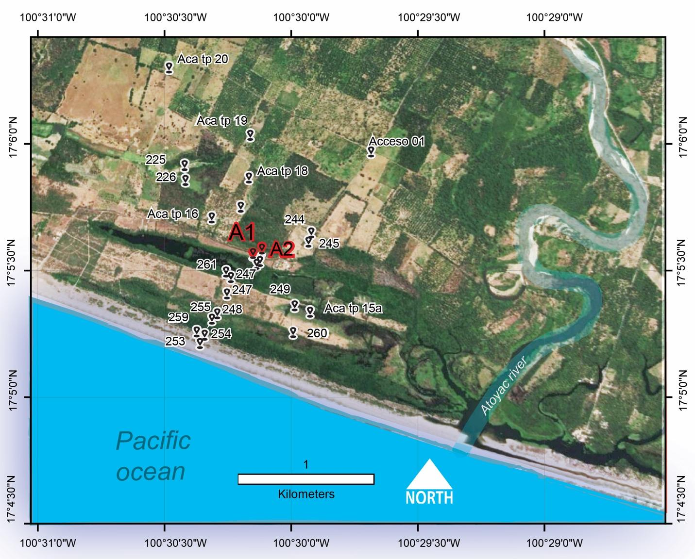

Figure S2. Grain size parameters at site A1. Mz -grain size and % of sand, silt, and clay fractions.
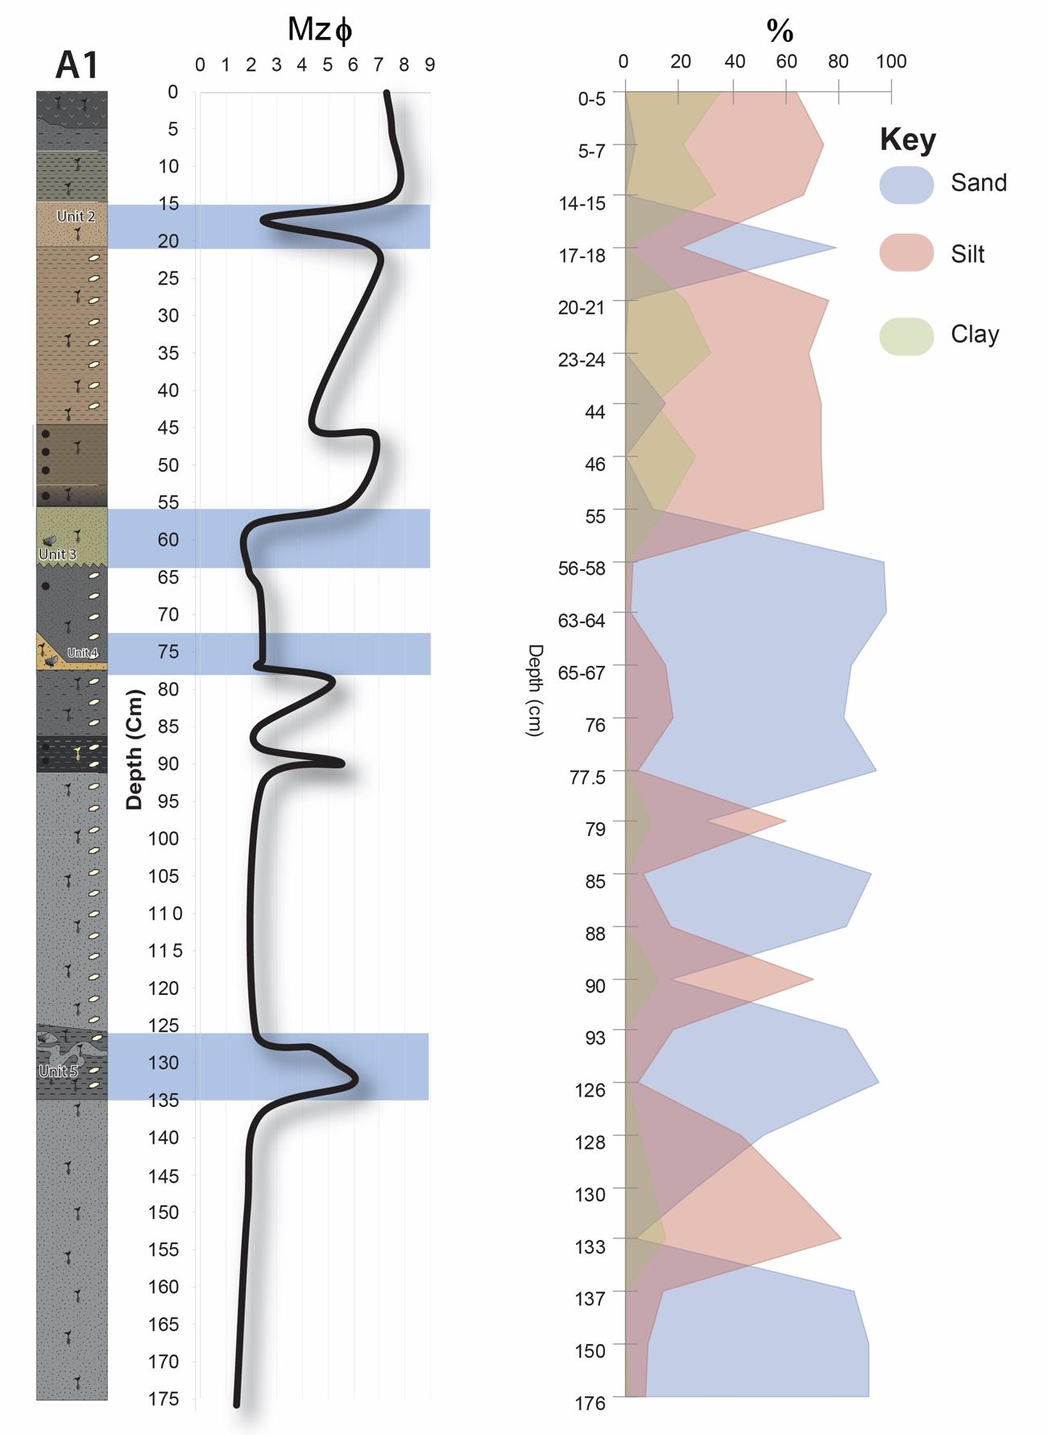

Figure S3. Elemental composition A1 site showing concentrations of Na, Mg, Ca, Br and Ba, suggesting marine influence, and a decrease in elements such as Ti, Fe, Al, and Cu indicative of heavy minerals and terrestrial source.

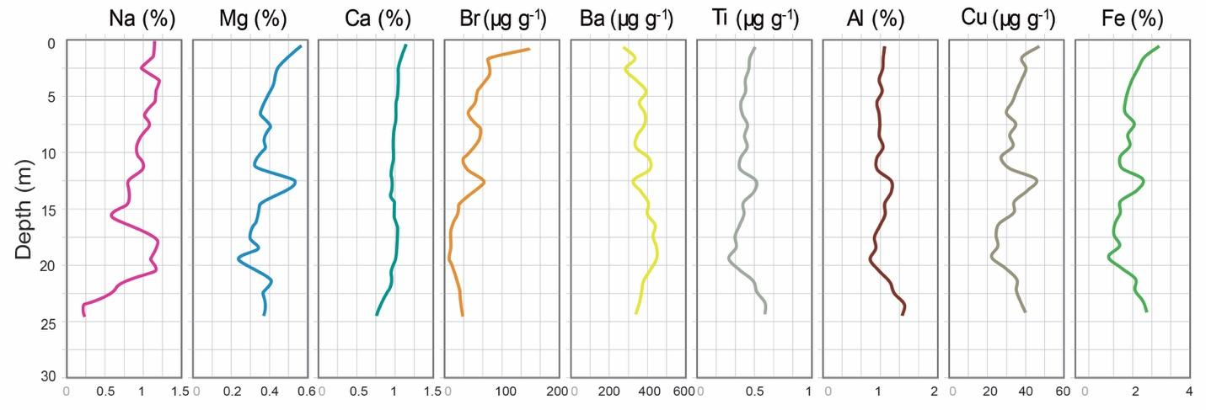

Figure S4. Detailed diatom content on modern coastal topography. Colors represent diatom environments. See Key in Figure 3.

