Supplementary Tables

Table S1.
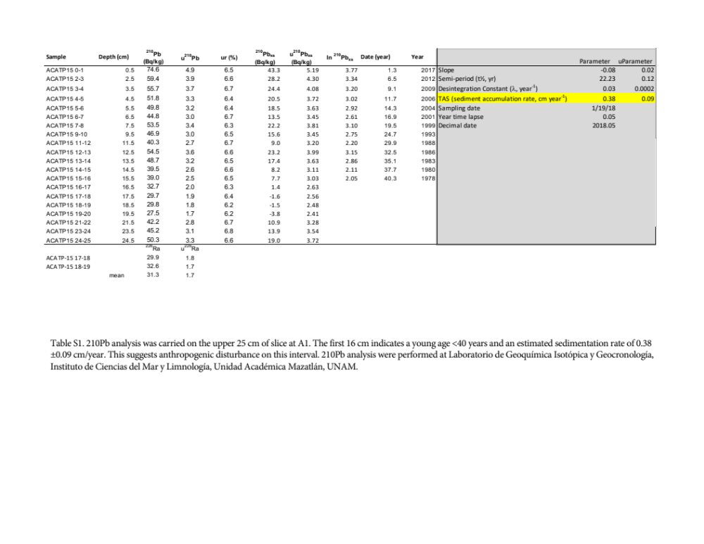

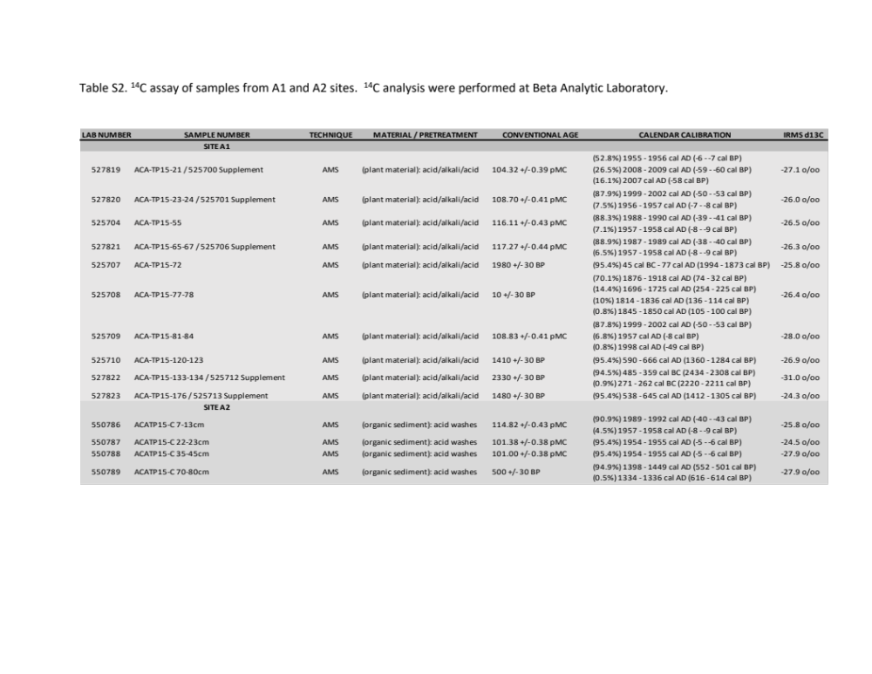

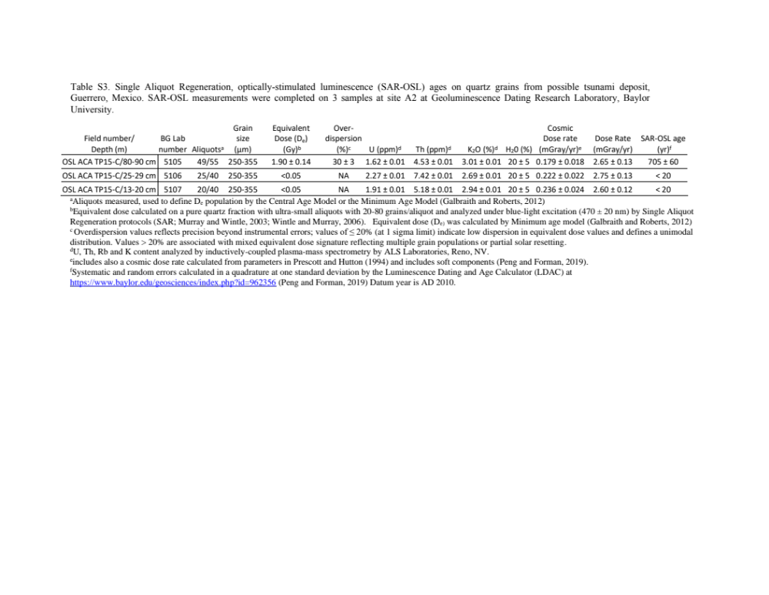

Table S4. Tsunami model inputs

Parameter | Values
Fault centroid longitude (m) | 326,351
Fault centroid latitude (m) | 1,865,740
Fault strike from north (deg) | 291
fault dip angle (deg) | 15
slip rake angle | 93
earthquake magnitude (Mw) | 8.4
maximum fault slip (m) | 8
centroid depth (m) | 20,000
Fault length (m) | 180,000
Fault width (m) | 90,000
shear modulus (Pa) | 4.5d+10

