Electronic Supplementary Information

ESM 1. ²¹⁰Pb and ¹³⁷Cs radioisotope trends from gamma spectroscopy analysis showing changes in activities with sediment depth for the Cache Lake core. The top and bottom X axes represent 210Pb and 137Cs activity scales, respectively.
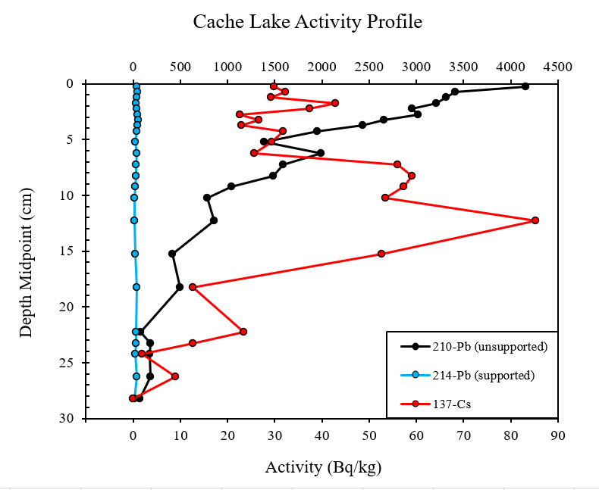

ESM 2. (A) Age-depth estimates determined by gamma spectrometry using the constant rate of supply (CRS) model, along with associated errors plotted against core depth. (B) Estimated sediment accumulation rates in Cache Lake using the CRS model, along with associated errors.
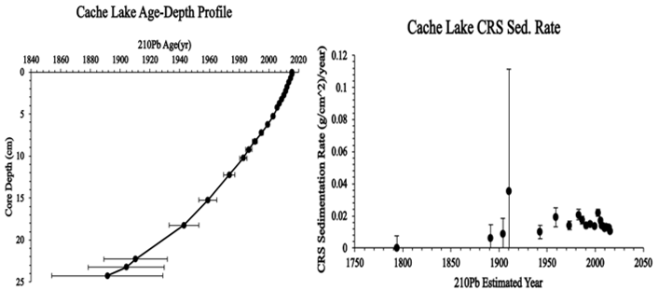

A
B

ESM 3. First Derivative of the fitted generalized additive model (GAM), modelling the rate of compositinoal change present in the ditaom data. Periods of significant compositinal change are determined by identifying years where the first deriviative (along with its associated confidence intervals), are non-zero.
