Disentangling the spatial and preferential aspects in the value realization of the spatially sensitive ecosystem service

Supplementary Materials

Data Sources
The data used in this paper are presented in Table SM1, where mobile signaling data (CDR) from China Unicom is used to as the source for demographic and human mobility records. China Unicom is one of the largest mobile operators in China, with 315.5 million customers in China as of September 2021. When a user enters the service area of a mobile base station or has a call/message, a record is generated by the nearest base station (Ratti, Frenchman, Pulselli, & Williams, 2006; Xu et al., 2015). Thus, by identifying the specific base station to which the mobile device is connected, we can locate the mobile user. The data covers the entire month of August 2019 and includes all trip records of China Unicom subscribers present in the study area, with a total of 702,169 records. Each record contains anonymized user ID, age, gender, and the time and location of the start and end of each trip. To ensure anonymity, and due to the limitations of cellular network location accuracy, all data were aggregated into a 250 * 250m resolution analysis grid.
The urban land use data were obtained from the 2017 global surface coverage map (fromglc10_2017 data) and the 2018 "Basic Urban Land Use Types" (EULUC) (Gong et al., 2020), both of which have a spatial resolution of 10 * 10m. We obtained the complete land use data for the study area by overlaying the EULUC-China-2018 data on top of the fromglc10_2017 data such that the land use status within urbanized areas were revealed in details. The land use map thus obtained covers 208,2841 plots, and has a total of 11 land use/land over types: residential, business, commercial, industrial, transportation, administrative, educational, healthcare, sports, park and greenspace, and other built-up area.
We obtained the sales prices of second-hand houses in September 2019 from the Anjuke website (https://nb.anjuke.com/) through a web crawler, which is a major online real property transaction platform in China. We used the data as a proxy for the socioeconomic characteristics of urban locations. The data has a total of 3950 transaction records, covering 2,687 analysis grids. For the rest of the grids, we used the Inverse Distance Weight Interpolation Method with a power of -2 to estimate the potential housing price.

Table SM1. Data Sources
Data | Source | Description | Spatial Resolution | Access Time
Areas of Interest (AOI) Data | https://map.baidu.com/ | Vectorized shapes of parks | 1m | Sep 2020
Mobile Signaling Data (CDR) | http://daas.smartsteps.com/ | User count at each grid with stay states of home, work, and visit | 250m | Sep 2019
Land Use / Land Cover Data | fromglc10_2017 data;  EULUC-China-2018 (http://data.ess.tsinghua.edu.cn/) | Land use (10 classes)  Land cover (10 classes) |  | 2017-2018
Housing Price Data | https://nb.anjuke.com/ | Second-hand house transaction records |  | Sep 2019

Departure Location Definition for Park Visitation Trips
Since the original geospatial data of the parks are vector shapes with ~1m resolution, while the spatial unit of analysis in this paper is a 250m * 250m grid system, there is a mismatch between the park boundary and the analysis grid when superimposing the two. The mismatch may cause errors when counting the visitation trips as some of the trip origins will fall in the grids that intersect with the park shape boundary.
Regarding whether the grids that intersect the park boundary should be counted as part of the park visitation trip departure locations, as described in the main text of the paper, there are two possible ways. If the grids that overlap with park boundaries are excluded from the departure location of visitation trips, the number of park visits may be underestimated (Figure SM1 c); otherwise, park visits may be overestimated (Figure SM1 d). In order to evaluate the magnitude of the error caused by both, we tried to chart the distance decay curves of park visitation under the two cases, and determine which method is better in error reduction terms.
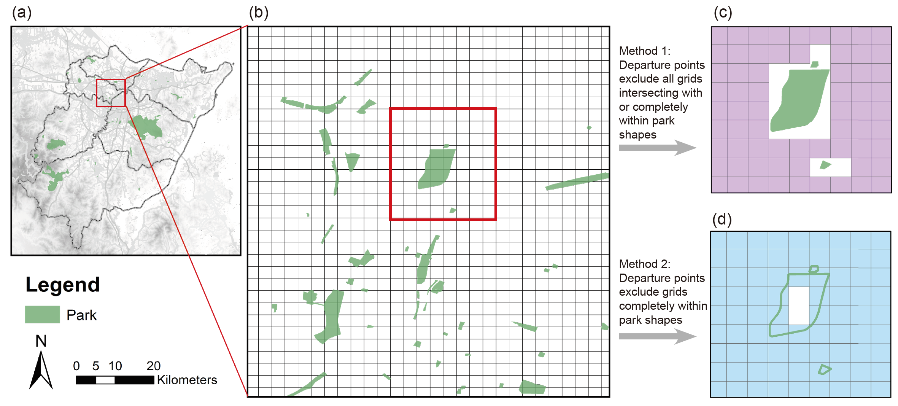
Figure SM1. Two methods for counting park visitation trips based on whether boundary grids are excluded from trip departure locations

The distance decay curves hence generated are shown in Figure SM2. It can be seen that for all types of parks, the first method does estimate park visitation counts lower than the second, and this is more pronounced in the distance circles closer to the park. Overall, we believe that the second method has two advantages over the first one. First, all park visitation distance decay curves estimated by the first method give a significant "downward" trend in the closest circle(s) to the park, which is physically unreasonable; especially for country parks, it is difficult to imagine any mechanism that would cause visits from the nearest 0-250m circle to be significantly lower than the next circle. Second, most of the parks in the study area are in fact very small, and in relative terms, the first method underestimates the number of visitation departures to a much greater extent than the second method overestimates it, as the small park patch to the bottom of Figure SM1 c/d shows. Therefore, we determine to use the second method in this paper.
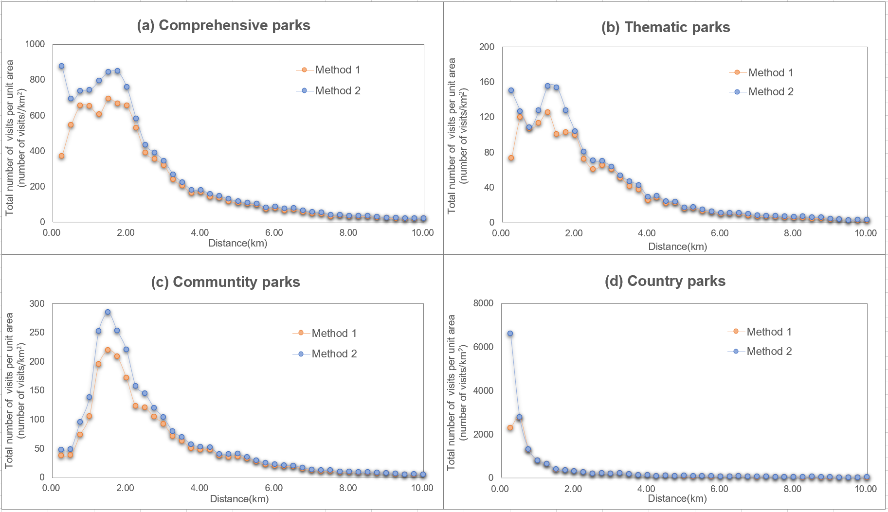

Figure SM2. Distance-decay curves as yielded by the two methods

Calculation of the Parks’ Accommodation Capacities
We use the maximum allowed visitors per day as the parks’ ES-providing capacity, which can be calculated by the directions of the Park Design Code (GB 51192-2016) and the Scenic Area Planning Code (GB50298-1999). The formula is:
$C=\frac{M}{m}*\frac{T}{t}$ ( 1 )
Where $C$ is the daily capacity of the park; $M$ is the visitable area of the park, and $m$ is the Code-designated per person area quota of the park, dependent on the type of the park; $T$ is the opening time length per day of the park, and $t$ is the average visiting time of tourists, both of which are also dependent on the type of the park and can be obtained from online tourist Apps. For ease of operation, $T/t$ is usually compounded into a visitation turnover rate factor. The specific designated values for the indicators are shown in Table SM2.

Table SM2 Designated capacity indicators for different park types
Park type | Per person park area (m²) | Opening time length (h) | Average visiting time (h)
Country park | 100-250 | 8-10 | 3-5
Comprehensive park | 30-60 | 8-10 | 1-3
Thematic park | 20-30 | 8-10 | 1-2
Community park | 20-30 | 24 | 0.5-2

In this paper, referring to the indicator values in Table SM2 and also considering the status quo of the study area, we took the per person park area quota of 200, 60, 30, and 20 m², respectively for country parks, comprehensive parks, thematic parks, and community parks. For the visitation turnover rate $T/t$, we took the value of 2, 4, 6, and 24, respectively.

Spatial Regression Model Specifications

Spatial Autocorrelation Diagnose
Based on the variable structure in Section 2.7 of the main text, we fitted a multiple linear regression model using the OLS method as the “baseline” model, and mapped the spatial distribution of the model residual terms, as shown in Figure SM3. It can be seen that the residuals are clearly spatially autocorrelated, and therefore a spatial econometric model is required to correct for the effect of spatial autocorrelation on the parameter estimates.

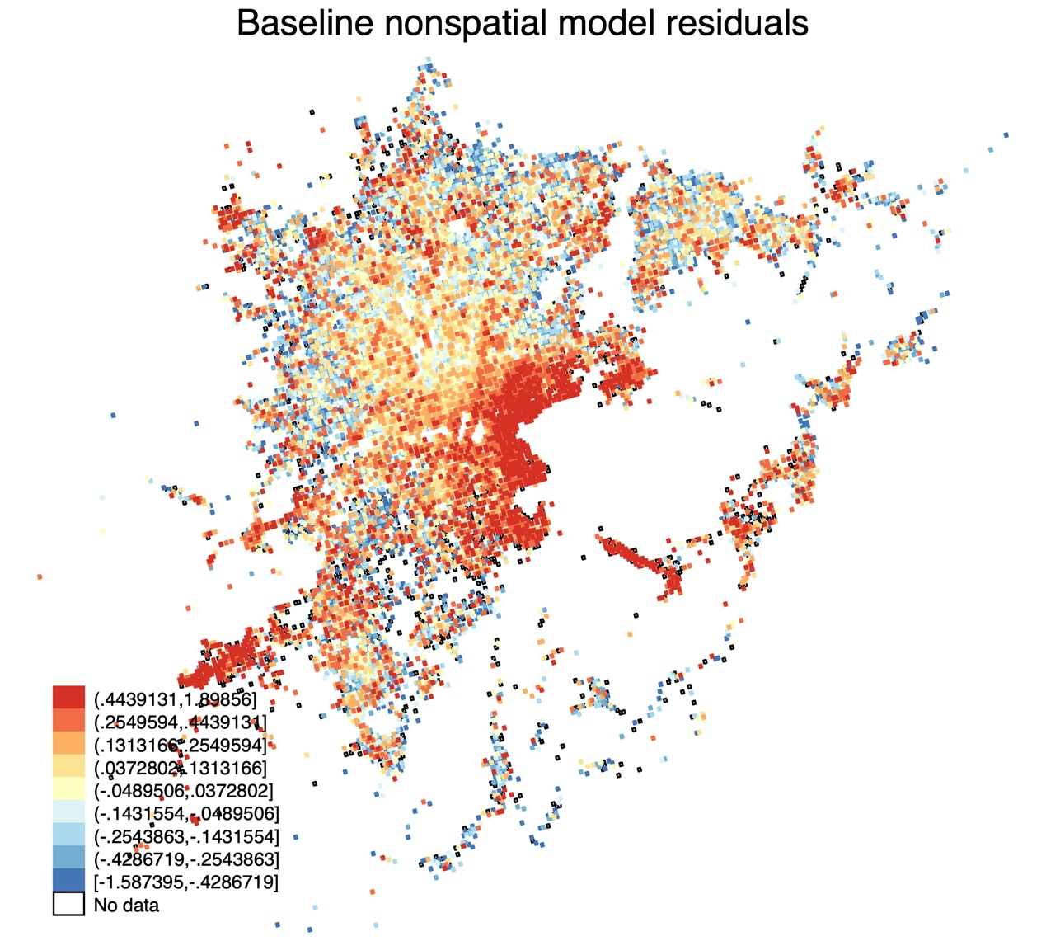
Figure SM3. Spatial distribution of the residual term of the “baseline” model

Forms of the Spatial Weighing Matrix
For the choice of the spatial weight matrix in the spatial measurement model, we tested the model with the 1-, 2- and 3-layer neighborhoods in both rook and queen shapes as the spatial weight matrix, and look into the respective Moran’s I’s for the dependent variable, OLS residual term, and SLM residual term for model choice criteria. The results are shown in Table SM3, which indicate that the 1-rook spatial weight matrix should be used for SLM and SEM modeling; the 1-rook spatial weight matrix should be used as the spatial lag term for SLM modeling; and the 2-queen spatial weight matrix should be used as the spatial error term for SAC modeling.

Table SM3. Spatial weight matrix choice in spatial econometrical modeling
Spatial weight matrix form | Moran’s I (dependent variable ) | Moran’s I (OLS residual term) | Moran’s I (SLM residual term)
1-queen | 0.640 | 0.261 | 0.111
2-queen | 0.597 | 0.249 | 0.140
3-queen | 0.567 | 0.234 | 0.139
1-rook | 0.656 | 0.271 | 0.047
2-rook | 0.626 | 0.262 | 0.126
3-rook | 0.599 | 0.253 | 0.136

Evaluation of the Selection Bias in the Cellular Signaling Data
To evaluate the selection bias of the mobile signaling data (CDR) on the demographic structure, we compared the CDR-based population records with the stay state of "home" with the resident population data from the 2020 Census, as shown in Table SM4. This comparison is appropriate because according to the home detection rule of the CDR data, each user only corresponds to one home location, thus avoiding the double counting problem in the other two stay states. Of course, the definition of resident population in the Census is not exactly the same as the home population in the CDR data, but the former is already the closest to the latter among all possible data sources.
The comparison shows that the sampling ratios of the CDR data are generally stable, with only one exception, among the jurisdictional districts covered in the research. The gender structure is also largely consistent in both data. However, for the age structure, although the two data are not directly comparable due to different age segmentation methods, it can still be seen that the CDR data has a strong selection for the population group of 30-44 years old, while the sampling ratios for minors and elderly are disproportionately low. This implies that we need to be cautious about the age structure factors reflected in the CDR data. Technically, we mitigate the error in the estimation of the model parameters as much as possible by including the age group with the highest population share (30-44 years old) as a base in the age dummy variables.

Table SM4. Comparison of key demographic structures as revealed in the CDR data and the 2020 Census
District | Population |  |  | Gender ratio |  | Age structure (ratio)
 | CDR (home population) | Census | CDR/  Census | CDR (home population) | Census | CDR 0-18 | Census 0-14 | CDR 19-29 | CDR 30-44 | CDR 45-59 | Census 15-59 | CDR >60 | Census >60
Beilun | 300403.63 | 829448.00 | 0.36 | 1.05 | 1.19 | 0.01 | 0.12 | 0.10 | 0.79 | 0.08 | 0.73 | 0.02 | 0.15
Fenghua | 404780.42 | 577505.00 | 0.70 | 1.08 | 1.09 | 0.02 | 0.11 | 0.10 | 0.70 | 0.14 | 0.66 | 0.05 | 0.23
Haishu | 318649.89 | 1041285.00 | 0.31 | 1.05 | 1.06 | 0.004 | 0.12 | 0.03 | 0.93 | 0.03 | 0.70 | 0.01 | 0.18
Jiangbei | 205749.67 | 488885.00 | 0.42 | 1.08 | 1.10 | 0.01 | 0.13 | 0.05 | 0.87 | 0.05 | 0.70 | 0.02 | 0.17
Yinzhou | 859581.07 | 1609555.00 | 0.53 | 1.07 | 1.04 | 0.01 | 0.13 | 0.09 | 0.79 | 0.09 | 0.71 | 0.03 | 0.16
Zhenhai | 195097.83 | 510462.00 | 0.38 | 1.09 | 1.14 | 0.01 | 0.13 | 0.07 | 0.84 | 0.06 | 0.72 | 0.02 | 0.15
Total | 2284262.52 | 5057140.00 | 0.45 | 1.07 | 1.09 | 0.01 | 0.13 | 0.08 | 0.80 | 0.08 | 0.70 | 0.03 | 0.17

6 An Evaluation of the Spatial Supply-Demand Relationship of Urban Parks
According to the analysis framework of this paper, if there is an undersupply or oversupply of ES in some parts of the city, there could be only three possible reasons: (1) an absolute mismatch between supply and demand, i.e., the overall ES supply is insufficient or the demand is too high; (2) the ESF decays rapidly due to excessive spatial resistance, which may be due to poor traffic accessibility, or other urban spatial structure features that hinder ESF transmission, resulting in the ES supply capacity not being effectively transmitted to the demand side; and (3) people's propensity for ES consumption is too high or too low, which may be the result of a combination of demographic, socio-economic, and cultural factors. Obviously, the three causes will require different responses. Therefore, following the above analysis framework, one can not only spatially explicitly and accurately identify the areas where the supply and demand of urban ES are mismatched, but also make accurate attributions to the causes of such mismatches, which has high practical significance for urban planning.
Again, we take the study area of this paper as a concrete example. First, the ESF distance decay patterns are highly consistent for the parks of the same category, and no notable outliers are found, indicating that there is generally no significant problem that hinders the ESF transmission process. Second, if we superimpose the potential ES provision and RVES, ES demand endowments and RVES, and potential ES provision and ES demand endowments of park recreation ES, and take the minimum values respectively (Figure SM4), it can be seen that in the first set of comparisons, the lower values for almost all grids are RVES (Figure SM4a), indicating that the potential ES provision for park recreation in the study area has not been fully converted into ESV; in the second set of comparisons, again the lower values for almost all grids are RVES (Figure SM4b), indicating that there seems to be a suppressed demand for park recreation ES among the population in the study area. Finally, in the third set of comparisons, it can be found that about 46% of the ES demand endowments are smaller than the potential ES supply, mainly in the urban fringe, while the other 54% are, on the contrary, mainly in urban centers (Figure SM4c). On balance, these seem to imply that in the urban centers, the constraints to the achievement of higher park recreation ESV are mainly on the supply side, while in the urban fringe they are mainly on the demand side. Accordingly, we can make the following policy and planning recommendations for the study area, namely, to increase the level of park ESV supply in the city centers through more and higher quality urban parks provisioning, and to enhance people’s willingness to use the parks in the urban fringe through, for example, information campaigns. The combination of the two strategies will help to obtain greater value realization of the park recreation ES.

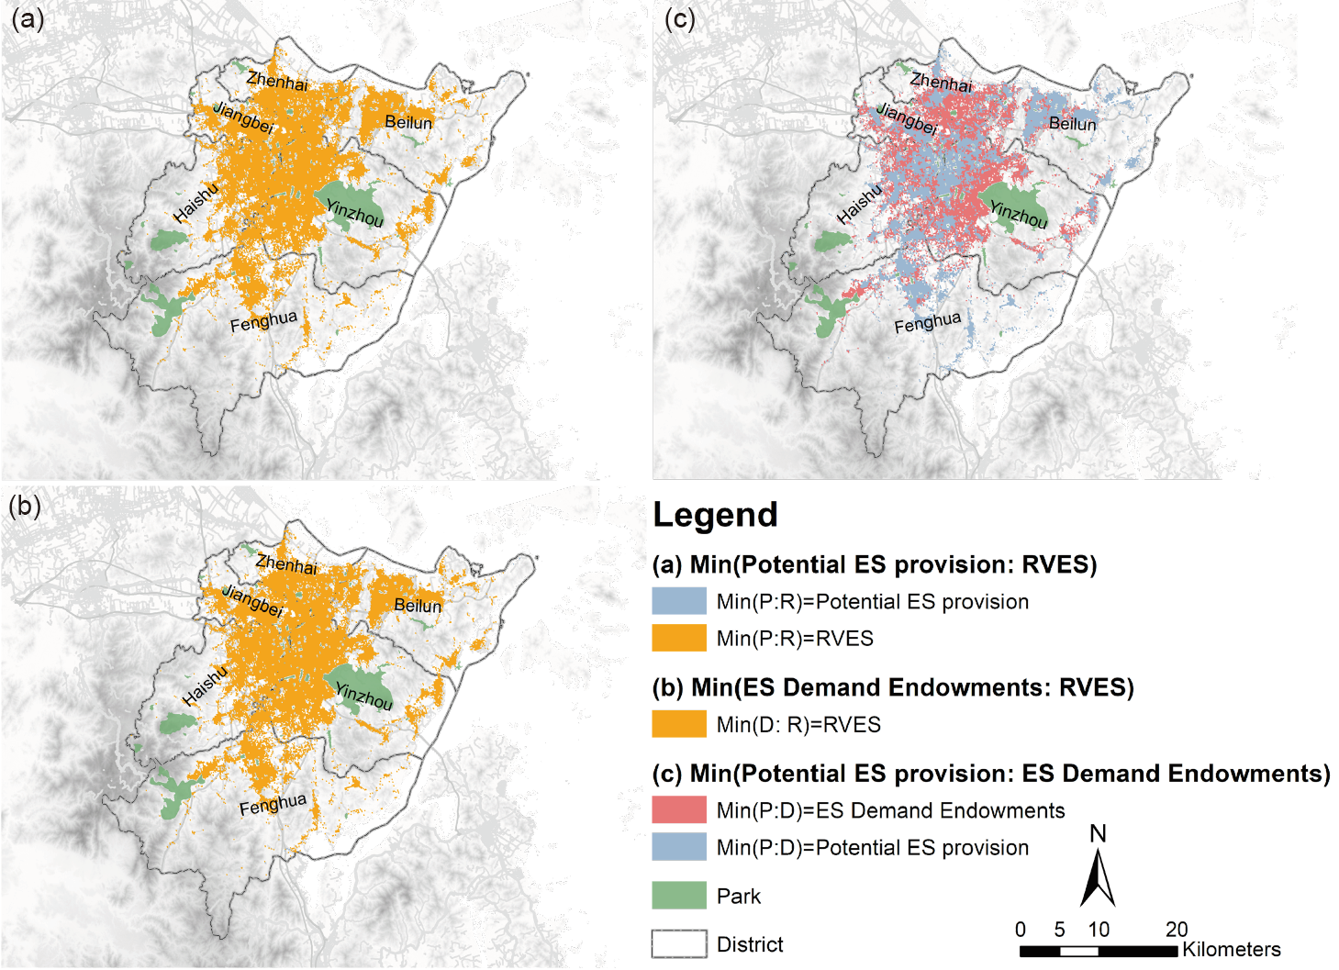
Figure SM4. Supple-demand relationships of recreational ES
(a) Comparison between potential ES provision and RVES; (b) Comparison between ES demand endowments and RVES; (c) Comparison between potential ES provision and ES demand endowments.

References
Gong, P., Chen, B., Li, X., Liu, H., Wang, J., Bai, Y., … Xu, B. (2020). Mapping essential urban land use categories in China (EULUC-China): preliminary results for 2018. Science Bulletin, 65(3), 182–187. https://doi.org/10.1016/j.scib.2019.12.007
Ratti, C., Frenchman, D., Pulselli, R. M., & Williams, S. (2006). Mobile landscapes: Using location data from cell phones for urban analysis. Environment and Planning B: Planning and Design, 33(5), 727–748. https://doi.org/10.1068/b32047
Xu, Y., Shaw, S.-L., Zhao, Z., Yin, L., Fang, Z., & Li, Q. (2015). Understanding aggregate human mobility patterns using passive mobile phone location data: a home-based approach. Transportation, 42(4), 625–646. https://doi.org/10.1007/s11116-015-9597-y

