Additional File 1: Additional Tables and Figures

Table 1. Further information on variables included in stepwise selection processes for weight generation and their handling

Variables | Details | Collection point
Index COVID Status | Assessed using UKHSA held data at the point of matching test-negatives and test-positives (Positive/Negative). | Matching
Age | Obtained from UKHSA at the point of matching test-negatives and test-positives, dichotomised as 11-14/15-17 on the basis of school years. | Matching
Sex | Obtained from UKHSA at the point of matching test-negatives and test-positives (Male/Female). | Matching
Region | Obtained from UKHSA at the point of matching test-negatives and test-positives (East Midlands; East of England; London; North East England; North West England; South East England; South West England; West Midlands; Yorkshire and the Humber). | Matching
IMD Decile | Derived using CYP’s lower super output area (i.e., small local area level-based geographic hierarchy) and classified into quintiles from most (1) to least (5) deprived [1]. | Matching
Ethnicity | Self-reported at enrolment, which can be 3-, 6-, or 12-months post-index PCR-test (Asian or Asian British; Black, African, or Caribbean; Mixed; White; Other; Prefer not to say). | 3, 6, 12
Current number of symptoms | Derived from 21 symptoms which were mostly assessed as present/absent [2]. | 3, 6, 12
Current health | Self-reported (I am not feeling quite right; I feel as healthy as normal). | 3, 6, 12
Quality of life/functioning (EQ-5D-Y) | This scale measures problems (No/Some/A lot of problems) with (a) mobility, (b) self-care, (c) doing usual activities, (d) having pain or discomfort, and (e) feeling worried, sad or unhappy [3]. | 3, 6, 12
UCLA Loneliness Scale | The final loneliness score was derived as the sum of the three items in the UCLA Loneliness Scale whereby a score of eight and above denoted loneliness [4, 5]. | 3, 6, 12
Current Loneliness | This is a direct measure of loneliness (“How often do you feel lonely”) which is scored 1-5 (Often/Always; Some of the time; Occasionally; Hardly Ever; Never) [4]. | 3, 6, 12
Strengths and Difficulties Questionnaire (SDQ) | Five subscales (25 items) measure: (i) emotional symptoms, (ii) conduct problems, (iii) hyperactivity, (iv) peer relationships, and (v) prosocial skills. Each item was scored from 0 to 2, meaning total scores per subscale ranged from 0-10. A total difficulties score (ranging from 0-40) was derived as the sum of all but the prosocial subscale. The impact of difficulties on CYP is specified by the impact subscale, with scores ranging from 0-10 (higher scores denoting a higher impact).  The following cut-off points were used: ≥18 (total difficulties); ≥4 (peer difficulties); ≥5 (conduct problems); ≥6 (emotional symptoms); ≥7 (hyperactivity); ≤5 (prosocial skills) and ≥2 for impact [6]. | 3, 6, 12
Short Warwick Edinburgh Mental Wellbeing Scale (SWEMWS) | Consists of seven items with a five-point scale (None of the time; Rarely; Some of the time; Often; All of the time) scored 1-5. Scores are summed to provide a mental wellbeing score ranging from 7-35. Poor wellbeing was characterised as a score of <19.6 [7] post-conversion to metric. | 3, 6, 12
Chronic Fatigue (Chalder Fatigue Scale; CFQ-11) | Eleven items on a four point scale (Less than usual; No more than usual; More than usual; Much more than usual) coded as 0, 0, 1, 1. These were summed with scores ranging from 0-11 and fatigue defined as a score of four and above [8, 9]. | 3, 6, 12
EuroQol Visual Analogue Scale (EQ-VAS) | 0% refers to the worst health imaginable and 100% to the best, scores went up in increments of 5 [10]. | 3, 6, 12
Vaccination status | Self-reported at time of questionnaire completion (Yes/No) | 3, 6, 12

Table 2. Tiredness prevalence 0 to 12-months post-index PCR-test weighted (trimmed and untrimmed) and unweighted

Timepoint | Unweighted  (previously published [11]) | Weighted to target population (untrimmed) | Weighted to target population (trimmed) | Weighted to general population  (untrimmed) | Weighted to general population  (trimmed)
Negatives
0 months | 3.6% | 5.5% | 3.4% | 5.0% | 3.6%
6 months | 25.1% | 23.9% | 23.9% | 24.0% | 23.2%
12 months | 33.5% | 32.4% | 31.9% | 32.3% | 31.4%
Positives
0 months | 27.2% | 25.1% | 25.6% | 24.3% | 25.1%
6 months | 38.6% | 41.2% | 38.6% | 39.4% | 38.3%
12 months | 45.9% | 46.3% | 45.1% | 45.4% | 44.7%

Table 3. Shortness of breath prevalence 0 to 12-months post-index PCR-test weighted (trimmed and untrimmed) and unweighted

Timepoint | Unweighted  (previously published [11]) | Weighted to target population (untrimmed) | Weighted to target population (trimmed) | Weighted to general population  (untrimmed) | Weighted to general population  (trimmed)
Negatives
0 months | 1.6% | 2.2% | 1.5% | 2.0% | 1.5%
6 months | 9.9% | 9.8% | 9.6% | 9.9% | 9.6%
12 months | 14.0% | 14.8% | 14.3% | 15.3% | 13.6%
Positives
0 months | 12.2% | 11.9% | 11.0% | 11.3% | 11.0%
6 months | 22.9% | 20.8% | 19.7% | 19.7% | 20.0%
12 months | 24.3% | 21.8% | 22.4% | 21.7% | 22.6%

Figure 1. Weighted (trimmed and untrimmed) and unweighted tiredness prevalences by time of first report

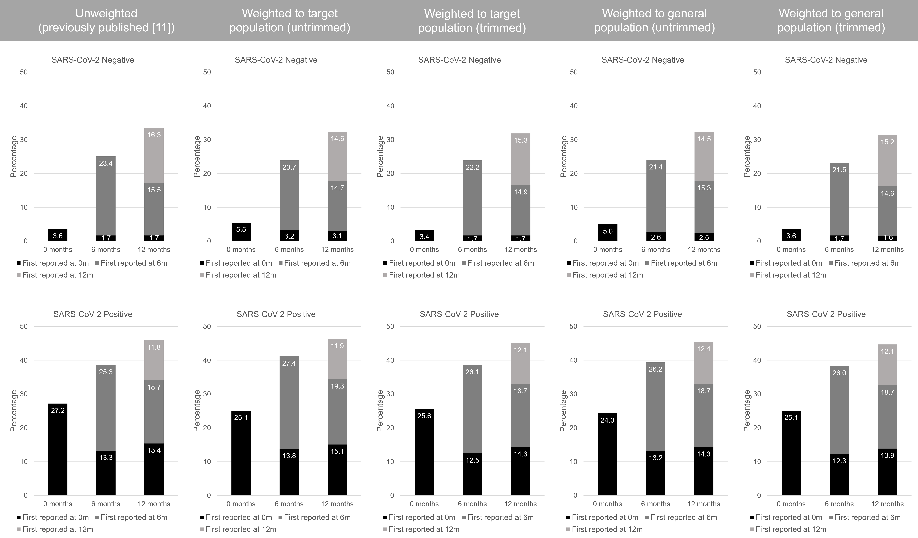
Figure 2. Weighted (trimmed and untrimmed) and unweighted shortness of breath prevalences by time of first report

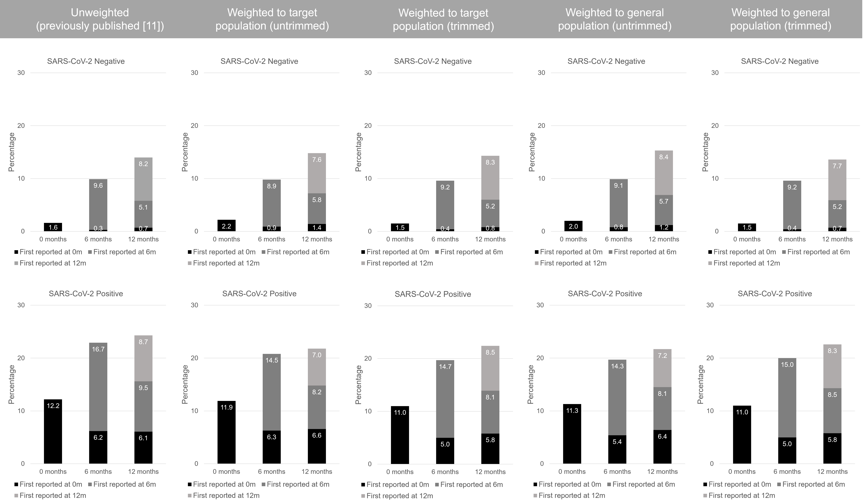
References

1. Ministry of Housing Communities & Local Government. English indices of deprivation 2015. 2015. https://www.gov.uk/government/statistics/english-indices-of-deprivation-2015. Accessed 25 April 2023.
2. Stephenson T, Pinto Pereira SM, Shafran R, de Stavola BL, Rojas N, McOwat K, et al. Physical and mental health 3 months after SARS-CoV-2 infection (long COVID) among adolescents in England (CLoCk): a national matched cohort study. The Lancet Child & Adolescent Health. 2022;6(4):230-9. doi:10.1016/S2352-4642(22)00022-0
3. Wille N, Badia X, Bonsel G, Burström K, Cavrini G, Devlin N, et al. Development of the EQ-5D-Y: a child-friendly version of the EQ-5D. Qual Life Res. 2010;19(6):875-86. doi:10.1007/s11136-010-9648-y
4. Office for National Statistics. Measuring loneliness: guidance for use of the national indicators on surveys. 2018. https://www.ons.gov.uk/peoplepopulationandcommunity/wellbeing/methodologies/measuringlonelinessguidanceforuseofthenationalindicatorsonsurveys#recommended-measures-for-children. Accessed 26 Sept 2022.
5. Klein EM, Zenger M, Tibubos AN, Ernst M, Reiner I, Schmalbach B, et al. Loneliness and its relation to mental health in the general population: Validation and norm values of a brief measure. Journal of Affective Disorders Reports. 2021;4:100120. doi:https://doi.org/10.1016/j.jadr.2021.100120
6. youthinmind. Information for researchers and professionals about the Strengths & Difficulties Questionnaires. 2022. https://www.sdqinfo.org/. Accessed 26 Sept 2022.
7. Ng Fat L, Scholes S, Boniface S, Mindell J, Stewart-Brown S. Evaluating and establishing national norms for mental wellbeing using the short Warwick-Edinburgh Mental Well-being Scale (SWEMWBS): findings from the Health Survey for England. Qual Life Res. 2017;26(5):1129-44. doi:10.1007/s11136-016-1454-8
8. Chalder T, Berelowitz G, Pawlikowska T, Watts L, Wessely S, Wright D, et al. Development of a fatigue scale. J Psychosom Res. 1993;37(2):147-53. doi:10.1016/0022-3999(93)90081-p
9. Loge JH, Ekeberg O, Kaasa S. Fatigue in the general Norwegian population: normative data and associations. J Psychosom Res. 1998;45(1):53-65. doi:10.1016/s0022-3999(97)00291-2
10. Feng Y, Parkin D, Devlin NJ. Assessing the performance of the EQ-VAS in the NHS PROMs programme. Qual Life Res. 2014;23(3):977-89. doi:10.1007/s11136-013-0537-z
11. Pinto Pereira SM, Shafran R, Nugawela MD, Panagi L, Hargreaves D, Ladhani SN, et al. Natural course of health and well-being in non-hospitalised children and young people after testing for SARS-CoV-2: A prospective follow-up study over 12 months. The Lancet Regional Health – Europe. 2022. doi:10.1016/j.lanepe.2022.100554

