Table S1. Description of the original dataset extracted from the TIER.Net
# | Variables | Data type | Number of records | % Missing records | Class (n, %)
1 | Gender | object | 30205 | 0 | Female (20878, 69%), Male (9327, 31%)
2 | Regiment schedule | object | 30205 | 0 | 3-Month (3032, 10%), 6-Month (7957, 26%), Regular (19216, 64%)
3 | Prior ART | object | 28725 | 5 | Missing (1480, 5%), Naive (25104, 83%), Non-naive (3621, 12%)
4 | Method into ART | object | 25025 | 17 | Missing (5180, 17%), New (20275, 67%), Transferred (4750, 16%)
8 | Last Pre-ART Stage | float64 | 17659 | 42 | Missing (12546, 42%), 1 (2539, 8%), 2 (2903, 10%), 3 (10662, 35%), 4 (1555, 5%)
9 | Stage at ART Start | float64 | 24590 | 19 | Missing (5615, 19%), 1 (5520, 18%), 2 (3319, 11%), 3 (13883, 46%), 4 (1868, 6%)
10 | TB Rx Started | object | 22612 | 25 | Missing (7593, 25%), No (19152, 63%), Yes (3460, 11%)
11 | TPT Outcome | object | 10669 | 65 | Missing (19536, 65%), Developed TB (20, 0%), Rx completed (9938, 33%), Rx interrupted (697, 2%), Transferred (14, 0%)
14 | Regimen At Baseline | object | 25038 | 17 | Missing (5167, 17%), 1A3E (382, 1%), 1A3L (357, 1%), 1A3N (9, 0%), 1A3O (6, 0%), 1A3R (1, 0%), 1A3V (1, 0%), 1S3 (5, 0%), 1S3A (3, 0%), 1S3E (437, 1%), 1S3L (99, 0%), 1S3N (3520, 12%), 1T3 (3, 0%), 1T3E (15759, 52%), 1T3L (86, 0%), 1T3N (587, 2%), 1T3O (392, 1%), 1T3V (15, 0%), 1TFE (136, 0%), 1Z3 (2, 0%), 1Z3A (5, 0%), 1Z3E (362, 1%), 1Z3L (50, 0%), 1Z3LT (2, 0%), 1Z3N (2748, 9%), 1Z3O (2, 0%), 1Z3V (1, 0%), 1ZE (1, 0%), 1ZN (1, 0%), 2A3L (18, 0%), 2A3O (1, 0%), 2T3L (14, 0%), 2T3O (8, 0%), 2T3V (1, 0%), 2Z3L (17, 0%), 2Z3O (1, 0%), 2Z3V (3, 0%), 3A3O (1, 0%), STOPPED (2, 0%)
15 | Last ART Prescription | object | 25058 | 17 | Missing (5147, 17%), 1A3E (424, 1%), 1A3L (314, 1%), 1A3N (19, 0%), 1A3O (10, 0%), 1A3V (5, 0%), 1S3E (172, 1%), 1S3L (29, 0%), 1S3N (962, 3%), 1T3E (17843, 59%), 1T3EO (42, 0%), 1T3L (55, 0%), 1T3N (199, 1%), 1T3NO (1, 0%), 1T3O (1131, 4%), 1T3V (22, 0%), 1TFE (46, 0%), 1Z3A (1, 0%), 1Z3E (324, 1%), 1Z3EO (1, 0%), 1Z3L (61, 0%), 1Z3LT (1, 0%), 1Z3N (1525, 5%), 1Z3NT (1, 0%), 1Z3O (12, 0%), 1Z3V (5, 0%), 2A3E (9, 0%), 2A3L (294, 1%), 2A3LT (2, 0%), 2A3O (18, 0%), 2A3V (62, 0%), 2AdL (1, 0%), 2T3E (7, 0%), 2T3L (389, 1%), 2T3LA (1, 0%), 2T3LO (1, 0%), 2T3LT (1, 0%), 2T3LZ (1, 0%), 2T3N (1, 0%), 2T3O (166, 1%), 2T3V (124, 0%), 2T3VA (1, 0%), 2TFE (1, 0%), 2Z3E (8, 0%), 2Z3L (525, 2%), 2Z3LT (3, 0%), 2Z3N (2, 0%), 2Z3O (68, 0%), 2Z3OT (2, 0%), 2Z3V (109, 0%), 2Z3VT (3, 0%), 2ZdN (1, 0%), 3A3O (4, 0%), 3A3V (1, 0%), 3T3E (1, 0%), 3T3O (38, 0%), 3T3OL (1, 0%), 3T3OU (1, 0%), 3T3VO (1, 0%), 3T3Z (1, 0%), 3Z3L (1, 0%), 3Z3LO (1, 0%), 3Z3O (3, 0%)
17 | Facility | object | 30205 | 0 | CMC Matam (10054, 33%), CS Gbessia port 1 (4274, 14%), CMC Flamboyants (3336, 11%), CS Tombolia (3306, 11%), CS Wanidara (3283, 11%), CMC Minière (3088, 10%), CMC Coléah (1850, 6%), CS Dabompa (1014, 3%)
18 | TB Status At Last Visit | object | 24596 | 19 | Missing (5609, 19%), No symptoms (15707, 52%), Not Screened (4812, 16%), Screening Unknown (2782, 9%), On TB Rx (1216, 4%), Symptoms (79, 0%)
19 | CPT at ART Start | object | 17786 | 41 | Missing (12419, 41%), Oui (13170, 44%), Non (4616, 15%)
5 | Baseline CD4 | float64 | 16102 | 47 | Mean: 298 Std: 266 Min: 0.0047 Max: 3000
6 | Last Pre-ART CD4 | float64 | 10287 | 66 | Mean: 276 Std: 250 Min: 0 Max: 3000
7 | Last ART CD4 | float64 | 18813 | 38 | Mean: 449 Std: 306 Min: 0.03 Max: 2992
12 | Age At ART Start | float64 | 25058 | 17 | Mean: 3 Std: 1 Min: 1 Max: 4
13 | Current Age | int64 | 30205 | 0 | Mean: 33 Std: 13 Min: 0 Max: 90
16 | Second Line Start Date | datetime64[ns] | 1939 | 94 | Oldest date: 4/16/2007, Earliest date: 8/31/2021, Most frequent date: 5/26/2017
20 | Duration on ART (months) | float64 | 29430 | 3 | Mean: 49 Std: 48 Min: 0 Max: 246
21 | Last ART VL Count | float64 | 14252 | 53 | Mean: 34025 Std: 277679 Min: 0 Max: 9147452

Table S2. Characteristics of the training and test sets
# | Variable | Data type | Training set |  |  | Test set
# | Variable | Data type | Number of records | % Missing values |  | Number of records | % Missing values
0 | Gender | object | 9470 | 0 |  | 4059 | 0
1 | Regiment schedule | object | 9470 | 0 |  | 4059 | 0
2 | Prior ART | object | 9470 | 0 |  | 4059 | 0
3 | Method into ART | object | 9470 | 0 |  | 4059 | 0
4 | Baseline CD4 | category | 6232 | 34 |  | 2583 | 36
5 | Last Pre-ART CD4 | category | 3911 | 59 |  | 1612 | 60
6 | Last ART CD4 | category | 7812 | 18 |  | 3336 | 18
7 | Last Pre-ART Stage | float64 | 4872 | 49 |  | 2030 | 50
8 | Stage at ART Start | float64 | 9399 | 1 |  | 4028 | 1
9 | TB Rx Started | object | 8561 | 10 |  | 3658 | 10
10 | TPT Outcome | object | 9470 | 0 |  | 4059 | 0
11 | Age At ART Start | category | 9362 | 1 |  | 4007 | 1
12 | Current Age | category | 9470 | 0 |  | 4059 | 0
13 | Regimen At Baseline | object | 9468 | 0 |  | 4059 | 0
14 | Last ART Prescription | object | 9470 | 0 |  | 4059 | 0
15 | Facility | object | 9470 | 0 |  | 4059 | 0
16 | TB Status At Last Visit | object | 9408 | 1 |  | 4033 | 1
17 | CPT at ART Start | object | 6829 | 28 |  | 2889 | 29
18 | Duration on ART (months) | category | 8561 | 10 |  | 3642 | 10
19 | Second Line Rx | object | 9470 | 0 |  | 4059 | 0
20 | VL Suppressed | object | 9470 | 0 |  | 4059 | 0

Table S3. Description of the pre-processing technics performed on independent and target variables
Variable |  | Description of the process
Independent variable |  | Grouping small categories
 | Last ART CD4, Last Pre-ART CD4, Baseline CD4 | Keep CD4 equals 100s, 200s, 300s, 400s, and 500s as is.  Recode any CD4 equal or above 600s as 600s.
 | TPT Outcome | Keep Rx completed, and No treatment as is.  Recode Rx interrupted, Patient transferred, and Developed TB as Other.
 | Regimen At Baseline | Keep 1T3E, 1S3N, 1Z3N, 1T3N, and 1S3E as is.  Recode any other regiment as Other.
 | Last ART Prescription Code | Keep 1T3E, 1T3O, 2Z3L, 1Z3N, and 2T3L as is.  Recode any other regiment as Other regiment.
 | TB Status At Last Visit | Recode No symptoms, Not Screened, and Screening Unknown as is.  Recode On TB treatment and Symptoms as Other.
 | Age At ART Start, and Current Age | Keepp age equals 20s, 25s, 30s, 35s, 40s, 45s, 50s, and 55s as is.  Recode any age equal or above 60s as 60s.
Target variable |  | Bootstrapping
 | VL Suppressed_Yes | Minority class: 'VL Suppressed_Yes' = 0; number of samples= 8392; random state = 05

Table S4. Characteristics of the final training and test sets
# | Variable | Data type | Number of records
# | Variable | Data type | Training set | Test set
1 | Gender_Male | int64 | 16793 | 4054
2 | Regiment schedule_3-Month | int64 | 16793 | 4054
3 | Regiment schedule_6-Month | int64 | 16793 | 4054
4 | Regiment schedule_Regular | int64 | 16793 | 4054
5 | Prior ART_Naive | int64 | 16793 | 4054
6 | Method into ART_New | int64 | 16793 | 4054
7 | TB Rx Started_Yes | int64 | 16793 | 4054
8 | TPT Outcome_No treatement | int64 | 16793 | 4054
9 | TPT Outcome_Other | int64 | 16793 | 4054
10 | TPT Outcome_Rx completed | int64 | 16793 | 4054
11 | Regimen At Baseline_1S3E | int64 | 16793 | 4054
12 | Regimen At Baseline_1S3N | int64 | 16793 | 4054
13 | Regimen At Baseline_1T3E | int64 | 16793 | 4054
14 | Regimen At Baseline_1T3N | int64 | 16793 | 4054
15 | Regimen At Baseline_1Z3N | int64 | 16793 | 4054
16 | Regimen At Baseline_Other | int64 | 16793 | 4054
17 | Last ART Prescription_1T3E | int64 | 16793 | 4054
18 | Last ART Prescription_1T3O | int64 | 16793 | 4054
19 | Last ART Prescription_1Z3N | int64 | 16793 | 4054
20 | Last ART Prescription_2T3L | int64 | 16793 | 4054
21 | Last ART Prescription_2Z3L | int64 | 16793 | 4054
22 | Last ART Prescription_Other | int64 | 16793 | 4054
23 | Facility_CMC Coléah | int64 | 16793 | 4054
24 | Facility_CMC Flamboyants | int64 | 16793 | 4054
25 | Facility_CMC Matam | int64 | 16793 | 4054
26 | Facility_CMC Minière | int64 | 16793 | 4054
27 | Facility_CS Dabompa | int64 | 16793 | 4054
28 | Facility_CS Gbessia port 1 | int64 | 16793 | 4054
29 | Facility_CS Tombolia | int64 | 16793 | 4054
30 | Facility_CS Wanidara | int64 | 16793 | 4054
31 | TB Status At Last Visit_No symptoms | int64 | 16793 | 4054
32 | TB Status At Last Visit_Not Screened | int64 | 16793 | 4054
33 | TB Status At Last Visit_Other | int64 | 16793 | 4054
34 | TB Status At Last Visit_Screening Unknown | int64 | 16793 | 4054
35 | CPT at ART Start_Yes | int64 | 16793 | 4054
36 | Second Line Rx_Yes | int64 | 16793 | 4054
37 | Baseline CD4 | int64 | 16793 | 4054
38 | Last Pre-ART CD4 | int64 | 16793 | 4054
39 | Last ART CD4 | int64 | 16793 | 4054
40 | Last Pre-ART Stage | int64 | 16793 | 4054
41 | Stage at ART Start | int64 | 16793 | 4054
42 | Age At ART Start | int64 | 16793 | 4054
43 | Current Age | int64 | 16793 | 4054
44 | Duration on ART (months) | int64 | 16793 | 4054
45 | VL Suppressed_Yes | int64 | 16793 | 4054

Table S5. Logistic regression summary
Variable | Coefficient | p-value
Gender_Male | -0.1012 | 0.0306 | *
Regiment schedule_3-Month | -1.5898 | nan
Regiment schedule_6-Month | -0.2433 | nan
Regiment schedule_Regular | -1.9183 | nan
Prior ART_Naive | -0.2283 | 0.0001 | *
Method into ART_New | 0.1733 | 0.0021 | *
TB Rx Started_Yes | 0.0238 | 0.7191
TPT Outcome_No treatement | 0.5098 | 1
TPT Outcome_Other | 0.5163 | 1
TPT Outcome_Rx completed | 0.6703 | 1
Regimen At Baseline_1S3E | -1.08 | nan
Regimen At Baseline_1S3N | -0.7463 | nan
Regimen At Baseline_1T3E | -0.8525 | nan
Regimen At Baseline_1T3N | -0.7002 | nan
Regimen At Baseline_1Z3N | -0.7882 | nan
Regimen At Baseline_Other | -0.245 | nan
Last ART Prescription_1T3E | 0.7008 | nan
Last ART Prescription_1T3O | 0.1611 | nan
Last ART Prescription_1Z3N | -0.2736 | nan
Last ART Prescription_2T3L | 0.4283 | nan
Last ART Prescription_2Z3L | -0.3393 | nan
Last ART Prescription_Other | 0.1671 | nan
Facility_CMC Coléah | -0.3092 | nan
Facility_CMC Flamboyants | 0.2141 | nan
Facility_CMC Matam | -0.4989 | nan
Facility_CMC Minière | 0.03 | nan
Facility_CS Dabompa | 0.1533 | nan
Facility_CS Gbessia port 1 | -0.5456 | nan
Facility_CS Tombolia | -0.1792 | nan
Facility_CS Wanidara | 0.5907 | nan
TB Status At Last Visit_No symptoms | -0.0543 | nan
TB Status At Last Visit_Not Screened | -0.0553 | nan
TB Status At Last Visit_Other | -0.5351 | nan
TB Status At Last Visit_Screening Unknown | -0.5532 | nan
CPT at ART Start_Yes | 0.1086 | 0.0125 | *
Second Line Rx_Yes | -1.3247 | 0 | *
Baseline CD4 | -0.0006 | 0.114
Last Pre-ART CD4 | 0.0008 | 0.0417 | *
Last ART CD4 | 0.0019 | 0 | *
Last Pre-ART Stage | -0.03 | 0.4455
Stage at ART Start | -0.0824 | 0.0107 | *
Age At ART Start | -0.0051 | 0.4874
Current Age | 0.0216 | 0.0036 | *
Duration on ART (months) | 0.0052 | 0 | *
(*) Significant at 0.05 level

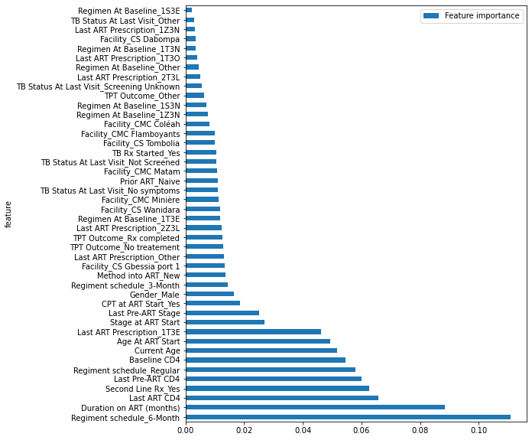
Figure S1. Feature importance based on random forest

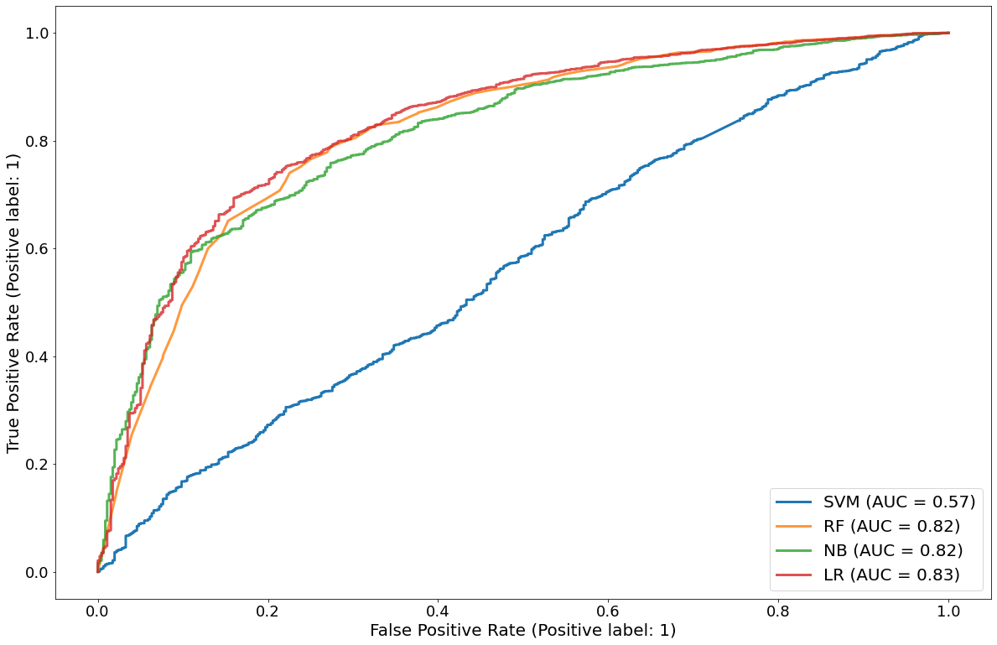
Figure S2. Areas under the curves of the four individual algorithms: SVM, RF, NB, LR

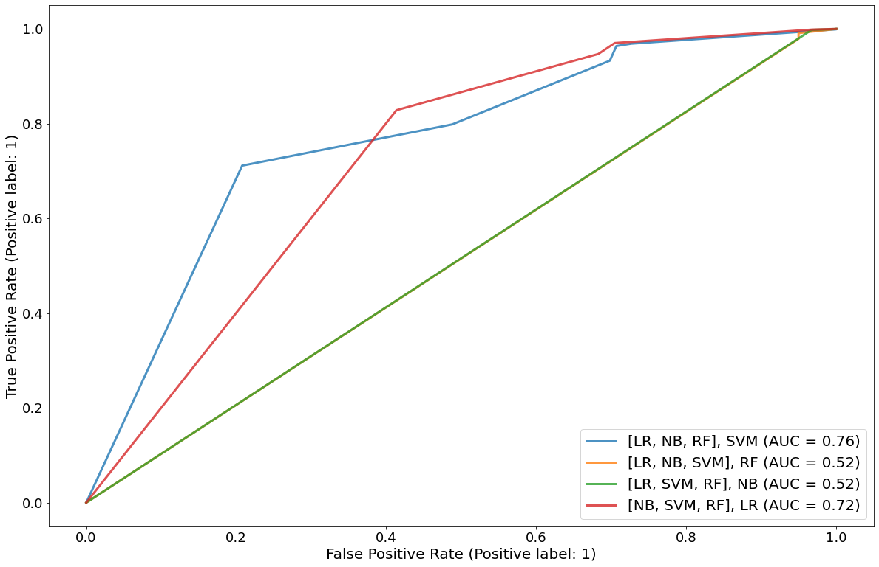
Figure S3. Areas under the curves of the four stacked algorithms: ([LR, NB, RF], SVM), ([LR, NB, SVM], RF), ([LR, SVM, RF], NB), ([NB, SVM, RF], LR)

