Appendix I: Assumption checking
Assumption checking for Pearson’s correlation coefficients
For each analysis of the Pearson’s correlation coefficient, the following assumptions, including (1) the variables are continuous, i.e., interval or ratio variables, (2) the relationship between the variables needs to be linear, (3) there are no outliers in the data, and (4) the variables are normally distributed, were examined (Field, 2013). The first assumption was satisfied as the composite scores of three variables, depression (measured as the total score of BDI-II), purpose in life (measured as the total score of PIL), and loneliness (measured as the total score of RULS), were ratio variables and continuous.
The second assumption was checked using scatter plots to determine if the two variables (e.g., depression and purpose of life) exhibited a linear relationship. The scatter plots were also used to examine the third assumption, to ensure there were no significant outliers. The scatter plots are presented in Supplementary figure s1,s2,s3. It appeared that there was a linear relationship between the three variables and there were no outliers. Hence Assumptions 2 and 3 of Pearson’s correlation coefficients were satisfied.
The fourth assumption was checked using skewness and kurtosis. As suggested by Kim (2013) and Mishra et al. (2019), an absolute skewness value ≤ 2 and an absolute kurtosis (excess) ≤ 4 for the data may be used as reference values for determining considerable normality. Since the values of skewness ranged from -0.52 to 0.73 and the values of kurtosis ranged from -0.51 to 2.19 (Table 6), it was concluded that the normality assumption was satisfied for Pearson’s correlation coefficients. As all assumptions were satisfied for Pearson’s correlation coefficients, it was appropriate to apply Pearson’s correlation coefficients to analyze the data.

Supplementary figure S 1; Scatter plot of depression and loneliness
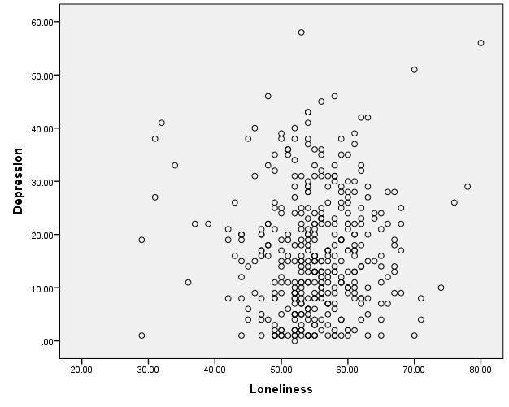
Supplementary figure S 2: Scatter plot of depression and purpose in life
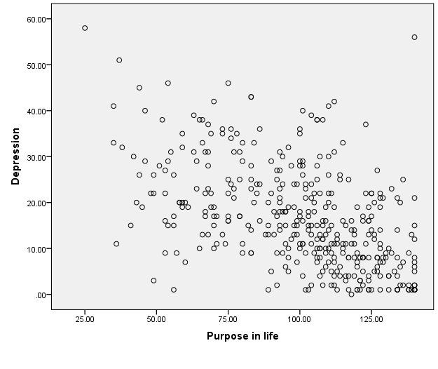
Supplementary figure S 3: Scatter plot of purpose in life and loneliness

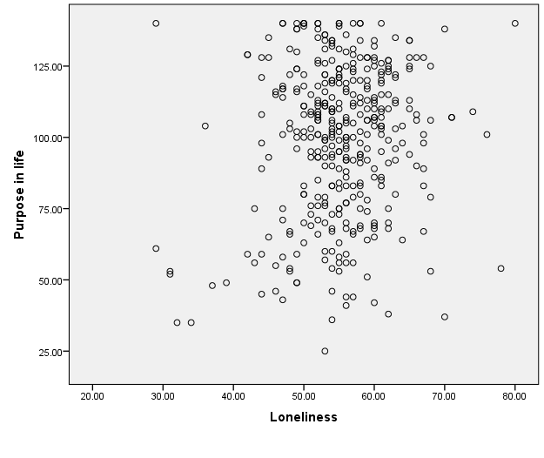

Supplementary figure S 4: Mean scores of depressions, purpose in life, and loneliness by gender

Supplementary figure S 5: Mean scores of depressions, purpose in life, and loneliness by marital status

Assumption checking for two-sample t-tests
The following three assumptions for two-sample t-tests were examined: a) independence of observations, b) the dependent variable should be approximately normally distributed, and c) there needs to be homogeneity of variances (Field, 2013). The independence assumption was satisfied as each patient was an independent individual and hence the observations were independent of one another.
The normality assumption was checked via skewness and kurtosis. As suggested by Kim (2013) and Mishra et al. (2019), an absolute skewness value ≤ 2 and an absolute kurtosis (excess) ≤ 4 for the data may be used as reference values for determining considerable normality. Since the values of skewness ranged from -0.55 to 0.74 for males and from -0.53 to 0.72 for females, and the values of kurtosis ranged from -0.60 to 1.95 for males and from -0.40 to 2.61 for females (Table 7), it was concluded that the normality assumption was satisfied for the two-sample t-tests.
The assumption of homogeneity of variances were examined using Levene’s test. Since the p-values for Levene’s tests were all greater than 0.05 (Table 7), it was concluded that the assumption of homogeneity of variances for two-sample t-tests was satisfied. As all assumptions were satisfied for two-sample t-tests, it was appropriate to apply two-sample t-tests to analyze the data.
Assumption checking for one-way ANOVAs
For ANOVAs, the following assumptions were checked: (a) independence of observations, (c) normality of the residuals, and (d) homoscedasticity (homogeneity of variances) (Neter et al., 1990; Keppel, 1991). The assumption of independence of observations means that that there was no relationship between the observations in each group or between the groups themselves. As participants of the study were independent individuals, the assumption of independence of observations was satisfied.
The assumption of normality of the residuals was checked using the skewness and kurtosis. As suggested by Kim (2013) and Mishra et al. (2019), an absolute skewness value ≤ 2 and an absolute kurtosis (excess) ≤ 4 for the data may be used as reference values for determining considerable normality. Since the values of skewness ranged from -0.53 to 0.73 and the values of kurtosis ranged from -0.49 to 2.23 (Table 8), it was concluded that the normality assumption was satisfied for the ANOVAs.
The assumption of homoscedasticity (homogeneity of variances) was checked via Levene’s test (Neter et al., 1990). Since the p-values for Levene’s tests were all greater than 0.05 (Table 8), it was concluded that the assumption of homogeneity of variances for ANOVAs was satisfied. As all assumptions were satisfied for ANOVAs, it was appropriate to apply ANOVAs to analyze the data.

References
Beck, A., Steer, R., & Brown, G. (1996). Manual for the Beck Depression Inventory-II. San Antonio, TX: Psychological Corporation.
Beck, A., Steer, R., Ball, R., & Ranieri, W. (1996). Comparison of Beck Depression Inventories-IA and-II in psychiatric outpatients. Journal of personality assessment, 67(3), 588-597.
Crumbaugh, J. C., & Maholick, L. T. (1964). An experimental study in existentialism: The psychometric approach to Frankl's concept of noogenic neurosis. Journal of clinical psychology, 20(2), 200-207.
Field, A. (2013). Discovering statistics using IBM SPSS statistics. Sage Publication Ltd.
Keppel, G. (1991). Design and analysis: A researcher's handbook. Englewood Cliffs, NJ: Prentice-Hall, Inc.
Kim, H. Y. (2013). Statistical notes for clinical researchers: Assessing normal distribution (2) using skewness and kurtosis. Restorative Dentistry & Endodontics, 38(1), 52.
Lodder, P. (2013). To impute or not impute: That’s the question. Advising on research methods: Selected topics, 1-7.
Mishra, P., Pandey, C., Singh, U., Gupta, A., Sahu, C., & Keshri, A. (2019). Descriptive statistics and normality tests for statistical data. Annals of Cardiac Anaesthesia, 22(1), 67.
Neter, J., Wasserman, W., & Kutner, M. (1990). Applied linear statistical models. Boston: Richard D. Irwin, Inc.
Russell, D., Peplau, L.A., & Cutrona, C.E. (1980). The revised UCLA Loneliness Scale: Concurrent and discriminant validity evidence. Journal of personality and social psychology, 39, 472-480.
Raaijmakers, Q. A. (1999). Effectiveness of different missing data treatments in surveys with Likert-type data: Introducing the relative mean substitution approach. Educational and Psychological Measurement, 59(5), 725-748.
Raymond, M. R. (1986). Missing data in evaluation research. Evaluation & the health professions, 9 (4), 395–420.
Tsikriktsis, N. (2005). A review of techniques for treating missing data in OM survey research. Journal of operations management, 24(1), 53-62.

