Supplementary Table 1: Summary of included studies.
Study ID | Site | Protocol registration | Surgical procedure | General anesthesia protocol | Ciprofol dose | Propofol dose | Muscle relaxant | Primary outcomes | Conclusion
Chen et al. 2022 | China | ChiCTR2100045211 | Elective gynecological surgery | Intravenous midazolam (0.03 mg/kg) and sufentanil (0.3 g/kg) | 0.4 mg/kg | 2 mg/kg | Rocuronium (0.6 mg/kg) | Percentage  of successful induction | Compared to propofol, ciprofol showed similar effectiveness for inducing general anesthesia in patients with gynecological surgery, and it was also linked with fewer side effects.
Liang et al. 2023 | China | NCT04511728 | Non-emergency, non-cardiothoracic, and non-brain elective surgeries | Intravenous midazolam (0.04 mg/kg) and sufentanil (0.3 g/kg) | 0.4 mg/kg | 2 mg/kg | Rocuronium (0.6 mg/kg) | Rate of anesthetic maintenance | Compared to propofol, ciprofol showed a non-inferior effectiveness profile and tolerability.
Qin et al. 2022 | China | ChiCTR2200058826 | Kidney transplantation under general anesthesia | Sufentanil (0.4-0.5 μg/kg) | 0.4 mg/kg | 2 mg/kg | Cisatracurium (0.2 mg/kg) | The success rate of sedation | The sedative impact of ciprofol was superior to propofol's, making it a preferable choice for anesthetic induction and maintenance after kidney transplantation.
Wang et al. 2022 | China | NCT03808844 | Elective surgeries under general anesthesia | Intravenous midazolam (0.04 mg/kg) and sufentanil (0.3 g/kg) | 0.4 mg/kg | 2 mg/kg | Rocuronium (0.6 mg/kg) | Percentage  of successful induction | For individuals having elective surgery, ciprofol has recently become a viable alternative to other drugs used to induce general anesthesia.
Zeng et al. 2022 | China | NCT03698617 | Elective surgeries under general anesthesia | Intravenous midazolam (0.04 mg/kg) and sufentanil (0.3 g/kg) | In the dose escalation trial: 0.4 mg/kg, 0.5 mg/kg, and 0.3 mg/kg  In the dose-expansion trial: 0.3 mg/kg and 0.5 mg/kg | In the dose escalation trial: 2 mg/kg and 2.5 2 mg/kg  In the dose-expansion trial: 2 mg/kg | Rocuronium (not reported dose) | Percentage  of successful induction | Inducing general anesthesia for patients undergoing selected surgery, a single bolus dosage of ciprofol was equally effective and safe as propofol.

Supplementary Figure 1: Change in mean arterial pressure (MAP) (mmHg)
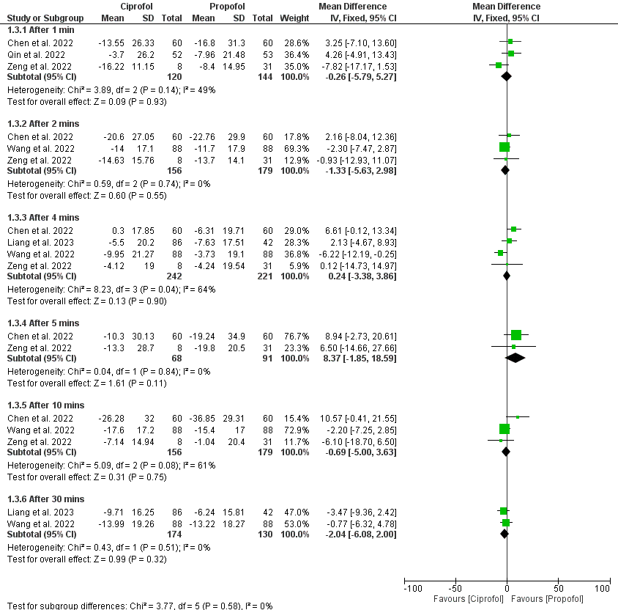
Supplementary Figure 2: Change in systolic blood pressure (SBP) (mmHg)
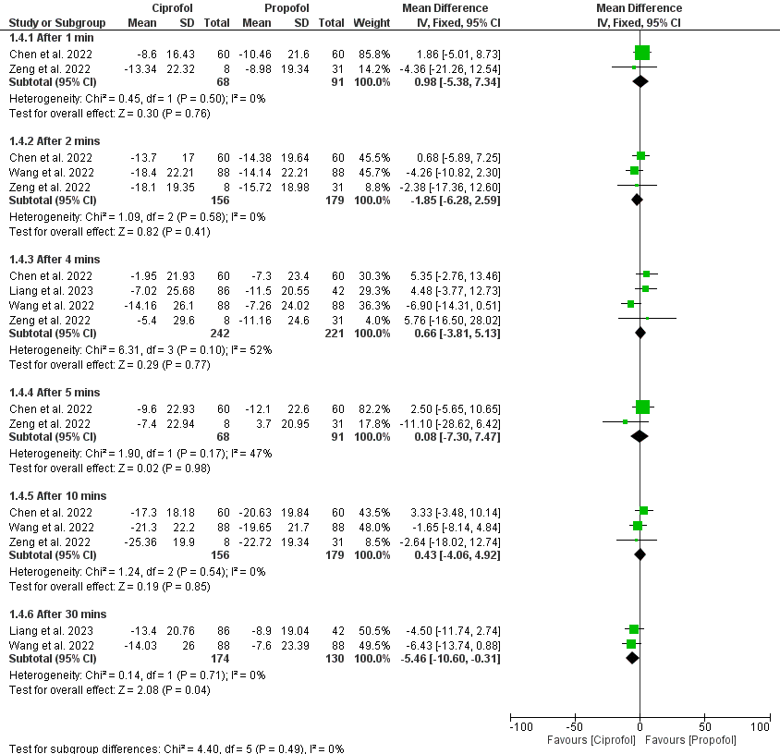

Supplementary Figure 3: Change in diastolic blood pressure (DBP) (mmHg)
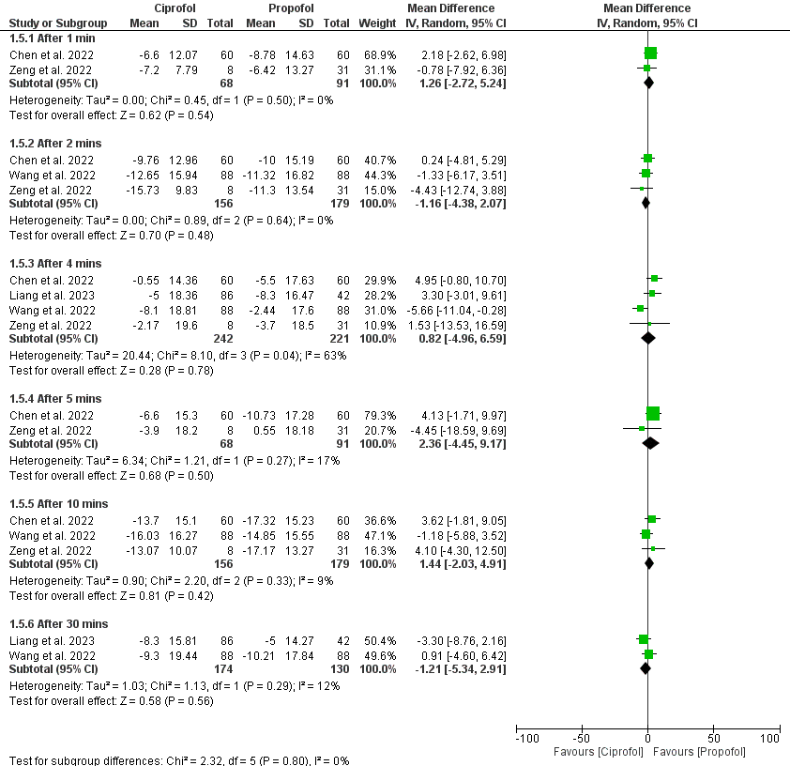

Supplementary Figure 4: Incidence of hypotension
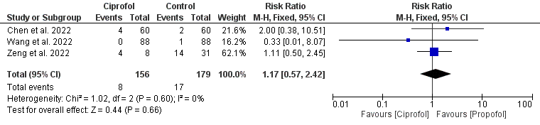
Supplementary Figure 5: Incidence of bradycardia
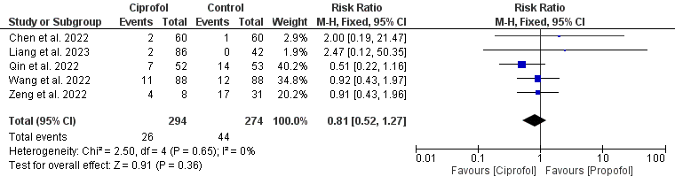

Supplementary Figure 6: Incidence of tachycardia
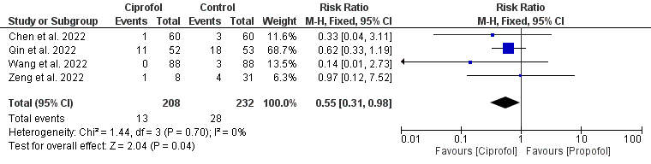
Supplementary Figure 7: Incidence of Injection-site pain
