Article title
The Influence of Academic Stress on College Students' Learning Motivation: The Mediating Role of Academic Environment Satisfaction and the Moderating Role of Learning Adaptability
Journal name
Advances in Health Sciences Education
Author names
Chen Liu^{a#}, Jiayi Tang^{b#}, Zhou Jiang^{b}, Xingya Zhan^{c}, Junjie Shen^{b}, Mengying Wang^{c}, Chao Shen^{c}, and Xin Liu^{e}*
ªSchool of international education, Xuzhou Medical University, Xuzhou, China
^{b}School of public health, Xuzhou Medical University, Xuzhou, China
^{c}Department of Epidemiology and Biostatistics, Key Laboratory of Infectious Diseases, School of Public Health, Nanjing Medical University, Nanjing, China
^{e}Center for Mental Health Education and Research, Xuzhou medical University, Xuzhou, China
Author Note
# These authors contributed equally to this work.
We have no known conflict of interest to disclose.
Correspondence concerning this article should be addressed to Xin Liu, Xuzhou medical University, Xuzhou, Jiangsu Province, China, Email: lx@xzhmu.edu.cn
Supplementary material
- Supplementary Tables
Supplementary Table1. Construct validity: Overall fit coefficient of the four scales
Scale | χ2/df | RMSEA | GFI | CFI | IFI | TLI
AESS | 7.965 | 0.066 | 0.976 | 0.990 | 0.990 | 0.985
LAS | 11.542 | 0.071 | 0.953 | 0.977 | 0.977 | 0.970
ASS | 7.049 | 0.061 | 0.953 | 0.981 | 0.981 | 0.975
LMS | 9.974 | 0.043 | 0.955 | 0.979 | 0.979 | 0.971
Note: AESS=Academic Environment Satisfaction Scale, LAS=Learning Adaptability Scale, ASS=Academic Stress Scale, LMS=Learning Motivation Scale.
Supplementary Table2. Convergent validity: Factor Loading for the four scales
Item | Scale | I | II | III | AVE | CR
AES 1 | AESS | 0.935 |  |  | 0.837 | 0.954
AES 2 | AESS | 0.904 |  |  | 0.837 | 0.954
AES 3 | AESS | 0.928 |  |  | 0.837 | 0.954
AES 4 | AESS | 0.892 |  |  | 0.837 | 0.954
AES 5 | AESS |  | 0.952 |  | 0.704 | 0.899
AES 6 | AESS |  | 0.916 |  | 0.704 | 0.899
AES 7 | AESS |  | 0.834 |  | 0.704 | 0.899
AES 8 | AESS |  | 0.445 |  | 0.704 | 0.899
LA 1 | LAS | 0.895 |  |  | 0.814 | 0.956
LA 2 | LAS | 0.854 |  |  | 0.814 | 0.956
LA 3 | LAS | 0.921 |  |  | 0.814 | 0.956
LA 4 | LAS | 0.929 |  |  | 0.814 | 0.956
LA 5 | LAS | 0.909 |  |  | 0.814 | 0.956
LA 6 | LAS |  | 0.798 |  | 0.738 | 0.933
LA 7 | LAS |  | 0.830 |  | 0.738 | 0.933
LA 8 | LAS |  | 0.852 |  | 0.738 | 0.933
LA 9 | LAS |  | 0.889 |  | 0.738 | 0.933
LA 10 | LAS |  | 0.924 |  | 0.738 | 0.933
AS 4 | ASS | 0.863 |  |  | 0.688 | 0.898
AS 3 | ASS | 0.904 |  |  | 0.688 | 0.898
AS 2 | ASS | 0.835 |  |  | 0.688 | 0.898
AS 1 | ASS | 0.703 |  |  | 0.688 | 0.898
AS 8 | ASS |  | 0.863 |  | 0.758 | 0.926
AS 7 | ASS |  | 0.904 |  | 0.758 | 0.926
AS 6 | ASS |  | 0.835 |  | 0.758 | 0.926
AS 5 | ASS |  | 0.703 |  | 0.758 | 0.926
AS 11 | ASS |  |  | 0.703 | 0.653 | 0.848
AS 10 | ASS |  |  | 0.795 | 0.653 | 0.848
AS 9 | ASS |  |  | 0.913 | 0.653 | 0.848
LM 4 | LMS | 0.909 |  |  | 0.687 | 0.897
LM 3 | LMS | 0.907 |  |  | 0.687 | 0.897
LM 2 | LMS | 0.751 |  |  | 0.687 | 0.897
LM 1 | LMS | 0.730 |  |  | 0.687 | 0.897
LM 8 | LMS |  | 0.940 |  | 0.857 | 0.960
LM 7 | LMS |  | 0.941 |  | 0.857 | 0.960
LM 6 | LMS |  | 0.901 |  | 0.857 | 0.960
LM 5 | LMS |  | 0.921 |  | 0.857 | 0.960
LM 11 | LMS |  |  | 0.861 | 0.789 | 0.912
LM 10 | LMS |  |  | 0.864 | 0.789 | 0.912
LM 9 | LMS |  |  | 0.937 | 0.789 | 0.912
Note：Bold = salient (> 3.0) loading.
Supplementary Table3. Discriminant validity: The square roots of AVE and correlation between the constructs
Scale |  | AESS |  | LAS |  | ASS |  |  | LMS
 |  | I | II | I | II | I | II | III | I | II | III
AESS | I | 0.837
AESS | II | 0.599*** | 0.704
LAS | I |  |  | 0.814
LAS | II |  |  | 0.171*** | 0.738
ASS | I |  |  |  |  | 0.688
ASS | II |  |  |  |  | 0.404*** | 0.758
ASS | III |  |  |  |  | 0.372*** | 0.595*** | 0.653
LMS | I |  |  |  |  |  |  |  | 0.687
LMS | II |  |  |  |  |  |  |  | 0.364*** | 0.857
LMS | III |  |  |  |  |  |  |  | 0.375*** | 0.551*** | 0.789
Square root of AVE |  | 0.915 | 0.839 | 0.902 | 0.859 | 0.830 | 0.871 | 0.808 | 0.829 | 0.926 | 0.888
Note：* P<0. 05，** P<0. 01，*** P<0. 001
Supplementary Table4. Testing the moderated mediating effect of academic stress on learning motivation
Variables | Equation 4  Outcome variable: LM
Variables | B | SE | t-value | 95%CI
Gender | -0.746 | 0.412 | -1.811 | [-1.554,0.062]
Major | 0.045 | 0.110 | 0.409 | [-0.170,0.260]
Economic condition | -0.472 | 0.457 | -1.033 | [-1.367,0.424]
Urban and rural origin | -0.020 | 0.360 | -0.055 | [-0.726,0.686]
Family atmosphere | -0.326 | 0.123 | -2.660** | [-0.567,-0.086]
AS | 0.235 | 0.025 | 9.247*** | [0.185,0.284]
LA | -0.060 | 0.035 | -1.734 | [-0.129,0.008]
AS*LA | -0.025 | 0.003 | -8.441*** | [-0.031,-0.019]
AES | 0.239 | 0.034 | 6.979*** | [0.172,0.307]
R-sq | 0.144
F | 29.750***
Note：* P<0. 05，** P<0. 01，*** P<0. 001. AES=academic environment satisfaction; LA= learning adaptability; AS=academic stress; LM=learning motivation.
- Supplementary Figures

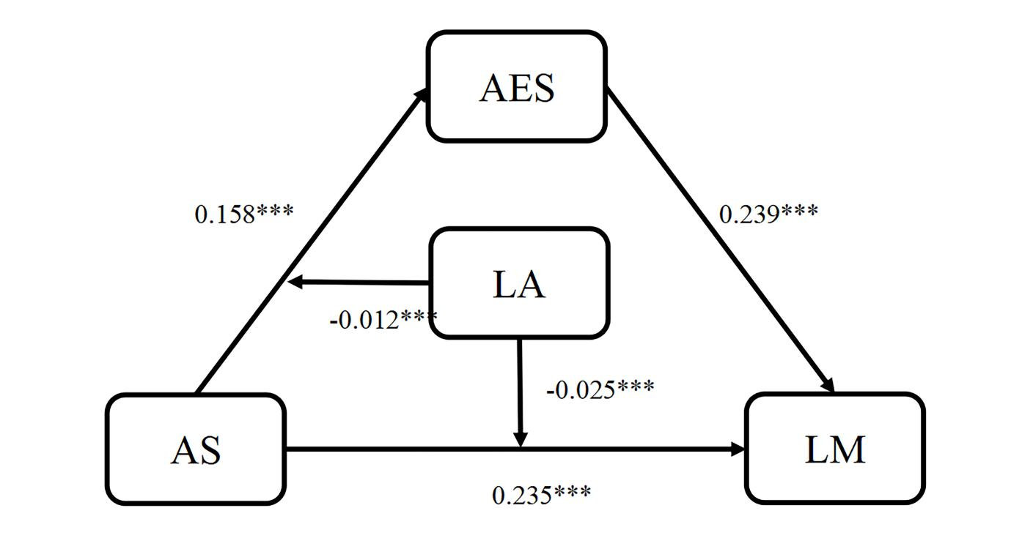
Supplementary Figure.1 Moderated mediation model
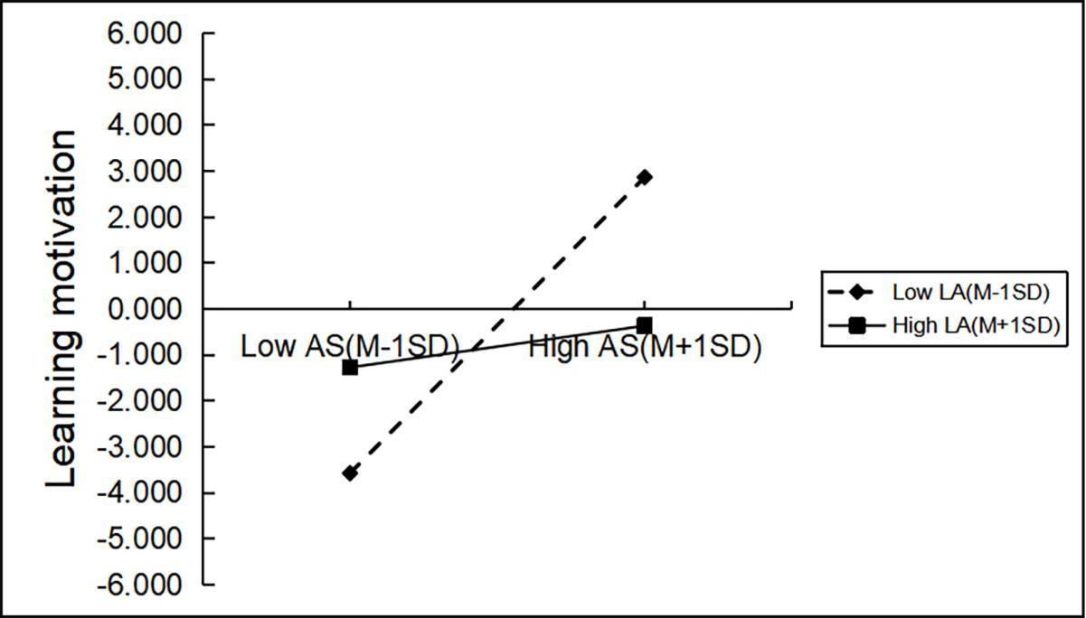
Supplementary Figure.2 The moderating role of learning adaptability in the relationship between academic stress and learning motivation

