Supporting Information
Enhancing the middle frequency X-band electromagnetic wave absorbing through porous defect engineering on MoC_{x} carbon hybrids and heat-insulating aerogel
Wenhuan Huang,^{1,*}() Jiamin Chen,¹ Wenming Gao,¹ Yifan Kang,¹ Chao Liu,¹ Tong Liu,² Zheng Yin,¹ Yuhao Yang,¹ and Fan Wu,^{3,*}()

¹ Key Laboratory of Chemical Additives for China National Light Industry, College of Chemistry and Chemical Engineering, Shaanxi University of Science and Technology, Xi’an 710021, China.
² College of New Energy, Xi’an Shiyou University. 710065, Xi'an, China.
³ School of Mechanical Engineering, Nanjing University of Science & Technology, Nanjing, 210094, China
* Corresponding author. huangwenhuan@sust.edu.cn

Supporting information to DOI 10.1007/s12274-****-****-* (automatically inserted by the publisher)
1 EXPERIMENTAL SECTION···············································································1
2 CHARACTERIZATIONS····················································································2
3 DATA ANALYSIS······························································································3
4 RESULTS AND DISCUSSIONS············································································5
5 REFERENCES································································································10

1. Experimental Section
1.1. Synthesis of Mo-POM@Co-ZIF precursor
In a facile synthetic process, firstly, 0.72 g of Co(NO₃)₂·6H₂O were mixed in 25 mL of methanol solution as solution A. The 1.63 g of 2-methylimizole were mixed in 25 mL of methanol solution as solution B. The 0.05 g of H₃PMo₁₂O₄₀·11H₂O were mixed in 10 mL of deionized water as solution C. Then solution B was quickly mixed with solution C, subsequently the resultant mixture ultrasoniced for 1 min and stirred for 0.5 h. Then, solution A was added quickly and similarly mixed with sonication for 1 min. The obtained solution was continued stirring for 2.5 h. The violet precipitates were centrifugally collected, and washed consecutively with deionized water and methanol for three times, and dried in an oven at 75 ℃ for 10 h.
1.2. Preparation of η-MoC/Co@NC polyhedrons
To gain nitrogen-droped η-MoC/Co@NC composite, the Mo-POM@Co-ZIF precursor was calcined at 700 ℃, 800 ℃ and 900 ℃ under nitrogen flow for 3 h with a heating rate of 5 ℃/min. The samples were labeled as η-MoC/Co@NC-700, η-MoC/Co@NC-800 and η-MoC/Co@NC-900, respectively.
1.3. Preparation of η-MoC/Co@NC-800 aerogel

First, the 0.5 g chitosan was dissolved in 50 mL acetic acid solution (1.0 vol%) under magnetic stirring at room temperature to obtain a homogenous solution. Afterward, 0.5 mg η-MoC/Co@NC-800 was added into above homogenous solution under magnetic stirring at room temperature for 2 h to acquire uniform η-MoC/Co@NC-800/ chitosan dispersion. Then, the sample was frozen in a refrigerator (-18 ℃) and freeze-dried in a lyophilizer (-67 ℃, 2 Pa) for 48 h to obtain η-MoC/Co@NC-800 aerogel.

2. Characterizations
D8 DAVANCI X-ray powder diffractometer equipped with graphite monochromatized Cu Kα radiation (λ = 0.1542 nm) was used to record powder X-ray diffraction (PXRD) patterns in the 2θ range of 5º-80º with a scanning rate of 1 º/min. The specific surface area was measured by nitrogen adsorption and desorption at 77 K by ASAP 2020 sorption system. Scanning electron microscopy (SEM) images were collected by a Hitachi S4800 apparatus with an acceleration voltage of 2 kV. The transmission electron microscopy (TEM) images were recorded on a JEM-2010HR apparatus working at an accelerating voltage of 200 kV. The surface area (BET) of the samples was measured by N₂ adsorption and desorption at 77 K using an ASAP 2020 sorption system. Raman spectroscopy of the samples was obtained by a Renishaw inVia Raman Microscope. The electromagnetic parameters were analyzed using a HP8753D vector network analyzer in the frequency range of 2~18 GHz. The measured samples were dispersed in paraffin homogeneously with a sample-to-paraffin weight ratio of 3:17, and then the mixture was pressed into a toroidal shape with an inner diameter of 3.04 mm and an outer diameter of 7.0 mm. The temperature change of the aerogels was explored with a thermal infrared imager (FOTRIC 618C).

3. Data analysis
The R2 value reflects the graphitization and the number of structural defects and assumes value higher than 0.5 for poorly organized structure and lower than 0.5 for a well-organized one, which can be calculated by the following formula (Eq. S1):
$$R2=\frac{I_{D1}}{I_{G}+I_{D1}+I_{D2}} (Equation S1)$$
The band intensity ratio can be used to determine the degree of the graphitization, which can be calculated according to equation S2:
$$\frac{I_{D1}}{I_{G}}=C^{'}(λ)d_{nc}^{-2} (Equation S2)$$
where C′ (514 nm) ≈ 0.0055 Å⁻².
The reflection loss (RL) values of the absorbers are calculated according to transmission line theory by the following equation S3-4:
$$R_{L}\left(dB\right)=20lg∣\frac{Z_{in}-Z_{0}}{Z_{in}+Z_{0}}∣ (Equation S3)$$
$$Z_{in}=Z_{0}\sqrt{\frac{μ_{r}}{ε_{r}}}\tanh\left[j\left(\frac{2πfd}{c}\right)\sqrt{μ_{r}ε_{r}}\right] (Equation S4)$$
Where Z₀ is the characteristic impedance of free space, Z_{in} is the normalized input impedance of absorber, and are the relative complex permittivity and permeability, d is the layer thickness, c is the speed of light in free space and f is the frequency.
Debye relaxation correction formula (Equation S5-6):
$$ε_{r}=ε_{r∞}+\frac{ε_{rs}-ε_{r∞}}{1+{\left(iωτ\right)}^{1-A}} \left(0<A<1\right) (Equation S5)$$
$$ε_{r}^{'}=ε_{r∞}+\left(ε_{rs}-ε_{r∞}\right)\frac{1+{\left(ωτ\right)}^{(1-A)}sin\frac{πA}{2}}{1+2{\left(ωτ\right)}^{1-A}sin\frac{πA}{2}+{\left(ωτ\right)}^{2\left(1-A\right)}} (Equation S6)$$
$ε_{p}^{''}$ and $ε_{c}^{''}$ are the dielectric loss contributed by polarization relaxation and charge transport, respectively, which can be obtained according to Debye theory (Equation S7-9).
$$ε"=\frac{ε_{s}-ε_{∞}}{1+{(2πf)}^{2}τ^{2}}ωτ+\frac{σ}{2πfε_{0}}=ε_{p}^{''}+ ε_{c}^{''} (Equation S7)$$
$$ε_{c}^{''}=\frac{σ}{2πfε_{0}} (Equation S8)$$
$$ε_{p}^{''}=\frac{ε_{s}-ε_{∞}}{1+{(2πf)}^{2}τ^{2}}ωτ=ε^{''}-ε_{c}^{''} (Equation S9)$$
Where $ε_{s}$ is the relative permittivity at static, and $ε_{∞}$ is the “infinite” high frequency. $σ$ is the conductivity, Conductivity is a parameter used to describe the difficulty of charge flow in matter.
It is generally recognized that the Cole-Cole semicircle can be explained by the relaxation process, and the relationship between ε′ and ε′′ can be expressed as (Equation S10):
$${(ε^{'}-\frac{ε_{s+}ε_{∞}}{2})}^{2}+{(ε'')}^{2}={(\frac{ε_{s-}ε_{∞}}{2})}^{2} (Equation S10)$$
Each semicircle in the ε′–ε″ curve stands for a polarization relaxation process. The ε_{s} and ε∞ represent the static dielectric constant, the dielectric constant at infinite frequency, respectively. The high number of semicircles means the strong dipole polarization process.
The eddy current effect factor (C₀), which were calculated by the following formula (Eq. S11)
$$C_{0}=μ^{"}(μ^{'})^{-2}f^{-1}=2πμ_{0}d^{2}σ (Equation S11)$$
The ability of microwave absorbers to attenuate electromagnetic wave energy is determined by the attenuation constant (α), which can be calculated by the following formula (Eq. S12):
$$α=\frac{\sqrt{2}πf}{C}\sqrt{\left(μ^{''}ε^{''}-μ^{'}ε^{'}\right)+\sqrt{{\left(μ^{''}ε^{''}-μ^{'}ε^{'}\right)}^{2}+{(μ^{'}ε^{''}+μ''ε')}^{2}}} (Equation S12)$$
$${SR}_{L}=\frac{{RL}_{min}}{Thickness×Loading} (Equation S13)$$

4. Results and discussions

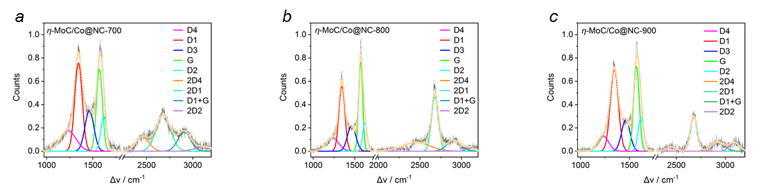 Figure S1 | a-c, Raman spectra deconvolution of η-MoC/Co@NC-700, η-MoC/Co@NC-800 and η-MoC/Co@NC-900.

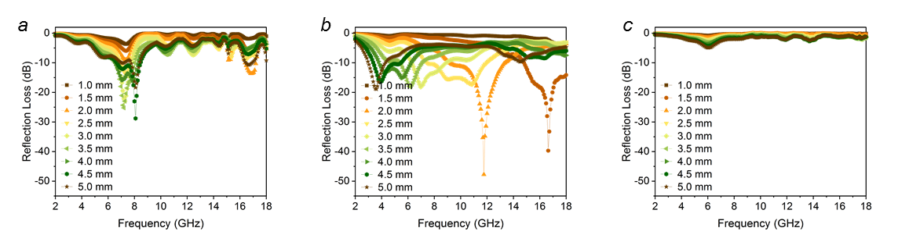
Figure S2 | a-c, RL plots of η-MoC/Co@NC-700, η-MoC/Co@NC-800 and η-MoC/Co@NC-900.

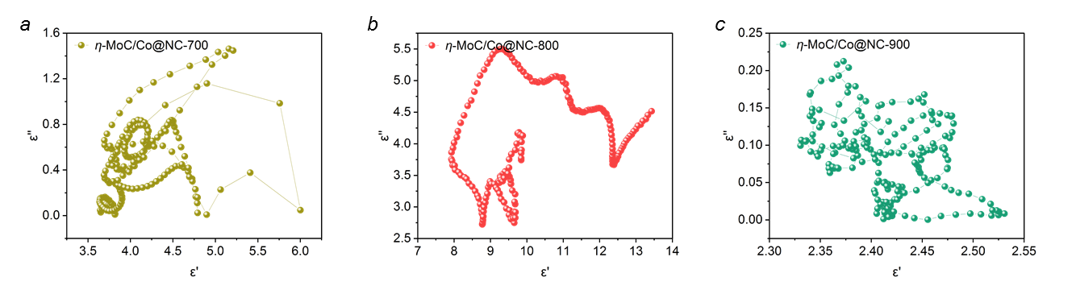
Figure S3 | The Cole-Cole curves.

Table S1. Raman parameters obtained from deconvolution spectra.
Sample | Raman
Sample | D1 | G | A_{D3} | I_{D1}/I_{G} | R2 | d_{nc} | 2D4 | 2D1 | A_{2D1} | D1+G | 2D2 | I_{2D1}/I_{D1}
Sample | cm⁻¹ | cm⁻¹ |  |  |  | nm | cm⁻¹ | cm⁻¹ |  | cm⁻¹ | cm⁻¹
η-MoC/Co@NC-700 | 1344 | 1571 | 42.1 | 0.96 | 0.43 | 1.32 | 2453 | 2681 | 60.7 | 2908 | 3117 | 0.41
η-MoC/Co@NC-800 | 1345 | 1570 | 27.7 | 0.76 | 0.36 | 1.18 | 2454 | 2681 | 49.0 | 2908 | 3103 | 0.84
η-MoC/Co@NC-900 | 1345 | 1571 | 29.0 | 0.84 | 0.40 | 1.24 | 2450 | 2679 | 26.8 | 2924 | 3084 | 0.44
All Raman spectra were fitted with four bands. The frequency of the two bands corresponding to D1 and G were allowed to vary between 1300 and 1400 cm⁻¹ and between 1550 and 1650 cm⁻¹, respectively. The frequency of the D3 band for amorphous carbon and D4 band tentatively assigned to polyenes or oligomers were fixed at 1500 cm⁻¹ and 1200 cm⁻¹, respectively.

Table S2. Comparison of microwave absorption performance of η-MoC/Co@NC-x with other MOFs-derived carbon absorbers.
Samples | Thickness  (mm) | Loading  (wt%) | RL_{min}  (dB) | EAB  (GHz) | SRL  (dB·mg⁻¹· mm⁻¹) | Ref.
H-Co/C-700 | 2.9 | 10 | -40.70 | 4.60 | -140.34 | S1
HMs-700 | 1.6 | 33 | -45.85 | 4.80 | -86.05 | S2
Ni@C-500 | 1.5 | 25 | -59.50 | 4.50 | -158.67 | S3
H-900 | 1.8 | 10 | -21.60 | 5.20 | -120.00 | S4
COCN@CNT-700 | 2.5 | 20 | -29.05 | 6.35 | -58.10 | S5
Ni/CN-700 | 2.7 | 40 | -86.80 | 2.14 | -80.37 | S6
CoNi-N/C-500 | 5.0 | 70 | -44.90 | 6.16 | -12.83 | S7
CF@C/Co-800 | 1.4 | 20 | -27.44 | 4.75 | -100.88 | S8
FC/RCs-700 | 2.2 | 50 | -21.20 | 7.40 | -19.27 | S9
η-MoC/Co@NC-800 | 1.5 | 15 | -39.687 | 3.20 | -176.39 | this work
η-MoC/Co@NC-800 | 2.0 | 15 | -47.72 | 4.16 | -159.07 | this work

5. References
[S1] L. Wang, B. Wen, X. Bai, C. Liu, H. Yang, Facile and green approach to the synthesis of zeolitic imidazolate framework nanosheet-derived 2D Co/C composites for a lightweight and highly efficient microwave absorber, J. Colloid Interface Sci. 540 (2019) 30-38.
[S2] Z. Gao, D. Lan, L. Zhang, H. Wu, Simultaneous Manipulation of Interfacial and Defects Polarization toward Zn/Co Phase and Ion Hybrids for Electromagnetic Wave Absorption, Advanced Functional Materials 31(50) (2021).
[S3] Z. Xiang, X. Zhang, Y. Shi, L. Cai, J. Cheng, H. Jiang, X. Zhu, Y. Dong, W. Lu, Efficient microwave absorption of MOFs derived laminated porous Ni@C nanocomposites with waterproof and infrared shielding versatility, Carbon 185 (2021) 477-490.
[S4] X. Xu, F. Ran, Z. Fan, Z. Cheng, T. Lv, L. Shao, Z. Xie, Y. Liu, Acidified bimetallic MOFs constructed Co/N co-doped low dimensional hybrid carbon networks for high-efficiency microwave absorption, Carbon 171 (2021) 211-220.
[S5] P. Yi, X. Zhang, L. Jin, P. Chen, J. Tao, J. Zhou, Z. Yao, Regulating pyrolysis strategy to construct CNTs-linked porous cubic Prussian blue analogue derivatives for lightweight and broadband microwave absorption, Chem Eng J 430 (2022).
[S6] Y. Qiu, H. Yang, B. Wen, L. Ma, Y. Lin, Facile synthesis of nickel/carbon nanotubes hybrid derived from metal organic framework as a lightweight, strong and efficient microwave absorber, J. Colloid Interface Sci. 590 (2021) 561-570.
[S7] P. Zhou, M. Wang, Z. Song, Y. Guan, L. Wang, Q. Zhang, Coral-like carbon-based composite derived from layered structure Co-MOF-71 with outstanding impedance matching and tunable microwave absorption performance, Journal of Materials Science & Technology 108 (2022) 10-17.
[S8] J. Tao, Z. Jiao, L. Xu, P. Yi, Z. Yao, F. Yang, C. Zhou, P. Chen, J. Zhou, Z. Li, Construction of MOF-Derived Co/C shell on carbon fiber surface to enhance multi-polarization effect towards efficient broadband electromagnetic wave absorption, Carbon 184 (2021) 571-582.
[S9] H. Wu, Z. Zhao, G. Wu, Facile synthesis of FeCo layered double oxide/raspberry-like carbon microspheres with hierarchical structure for electromagnetic wave absorption, J Colloid Interface Sci 566 (2020) 21-32.

