Supplementary Information

Supplementary Methods
Spectoscopic data of 2-Stearoxyphenethyl phosphocholine
¹H NMR (400 MHz, CD₃OD) δ 7.25–7.14 (m, 2H), 6.95–6.82 (m, 2H), 4.14–4.03 (m, 4H), 4.00 (t, J = 6.4 Hz, 2H), 3.54–3.48 (m, 2H), 3.19–3.13 (s, 9H), 2.98 (t, J = 6.8 Hz, 2H), 1.86–1.78 (m, 2H), 1.56–1.46 (m, 2H), 1.46–1.21 (m, 32H), 0.92 (t, J = 6.8 Hz, 3H); ¹³C NMR (100 MHz, CD₃OD) δ 158.5, 132.1, 128.9, 127.9, 121.3, 112.4, 69.1, 67.4, 66.4, 60.2, 54.7(3C), 33.1, 30.8(13C), 30.5(2C), 27.3, 23.8, 14.5.

Supplementary Figures
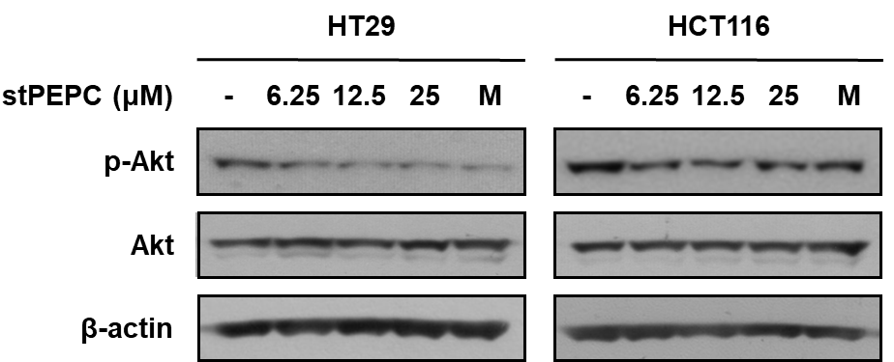

Supplementary Figure 1. Effect of stPEPC on the phosphorylation of AKT in HT29 and HCT116 cells. Cells were treated with stPEPC for 10 min and 5 min in HT29 and HCT116 cells, respectively. The phosphorylation levels of AKT were determined by western blot analysis. β-Actin was used as an internal control.

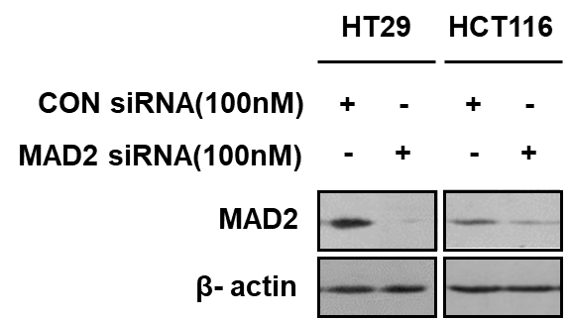
Supplementary Figure 2. Effect of stPEPC on the phosphorylation of AKT in HT29 and HCT116 cells. Cells were treated with stPEPC for 10 min and 5 min in HT29 and HCT116 cells, respectively. The phosphorylation levels of AKT were determined by western blot analysis. β-Actin was used as an internal control.

