Enhancing C. reinhardtii growth and metabolite biosynthesis using organic dyes as spectral convertors
Luveshan Ramannaª, Mahmoud Nasr^{b,c}, Ismail Rawatª, and Faizal Bux^{a,}*
ª Institute for Water and Wastewater Technology, Durban University of Technology, Durban 4000, South Africa
^{b} Environmental Engineering Department, Egypt-Japan University of Science and Technology (E-JUST), Alexandria 21934, Egypt
^{c} Sanitary Engineering Department, Faculty of Engineering, Alexandria University, Alexandria, 21544, Egypt
*Corresponding author: P.O. Box 1334, Durban 4000, South Africa. Email address: faizalb@dut.ac.za

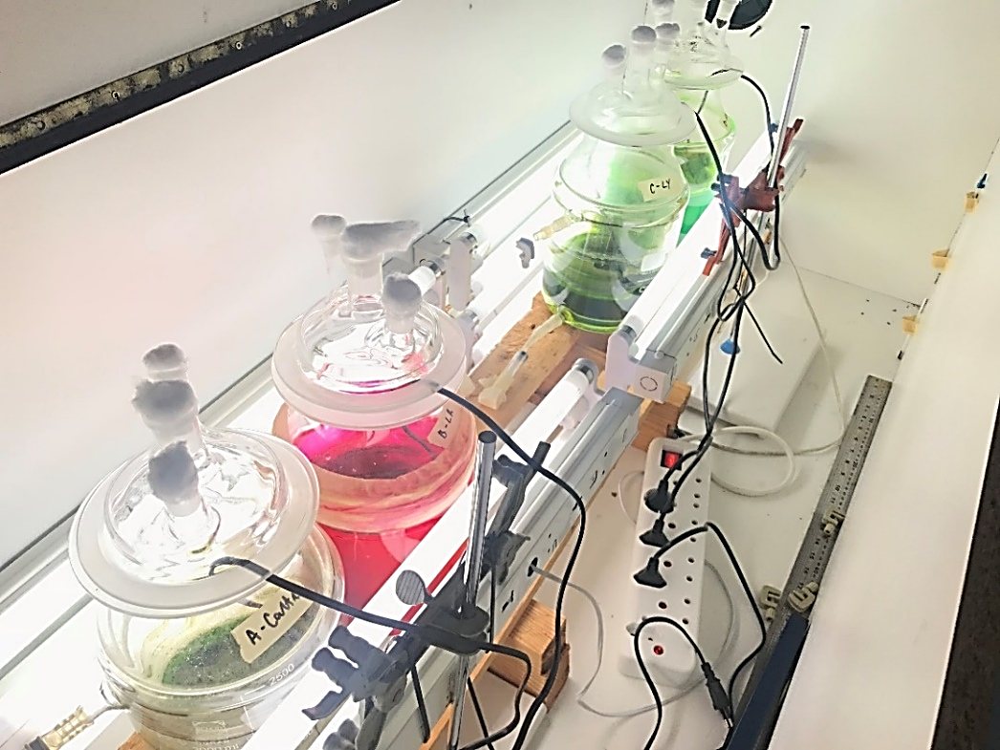

Supplementary Fig. S1. Photo-bioreactors and incubator. From left to right, PBRs contain the control, LR, LY, and R8G. Due to the light irradiance, the contrast on the images has been adjusted

Supplementary Fig. S2. The phylogenetic tree was inferred from 18S rRNA gene sequences. The tree was constructed using the Maximum Likelihood method based on the Kimura 2-parameter model. The Chlamydomonas isolate C1 had a sequence length of 741 base pairs (bps), the query coverage comparison to Chlamydomonas reinhardtii was 99% and the sequence similarity had a conﬁrmed identiﬁcation of 99.73%

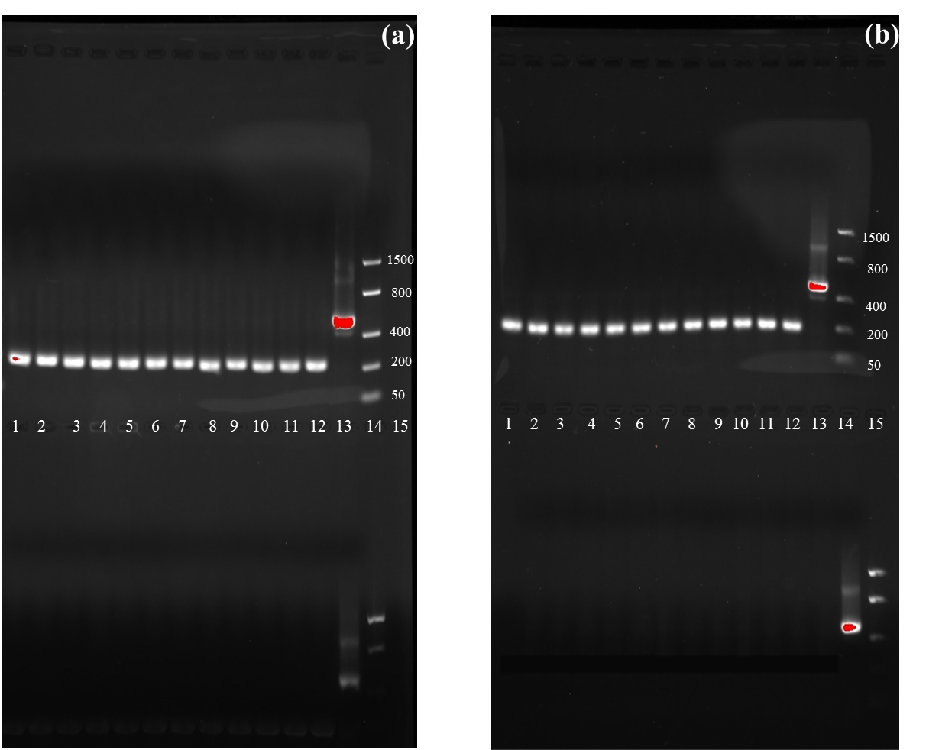

Supplementary Fig. S3. PCR showing (a) rbcL and (b) 18S amplicon verification. From left to right: Lane 1 – 12: rbcL amplicons (201 bp); Lane 13: control GAPDH amplicon (496 bp); Lane 14: DNA ladder (low range ≤ 1500 bp). The bottom gel from left to right: Lanes 1 – 6: NTC; Lanes 7 – 12: NRT; lane 13: control GAPDH amplicon (496 bp); Lane 14: DNA ladder (low range ≤ 1500 bp). (b) From left to right: Lanes 1 – 12: 18s amplicons (192 bp); Lane 13: control GAPDH amplicon (496 bp); Lane 14: DNA ladder (low range ≤ 1500 bp). The bottom gel from left to right: Lanes 1 – 6: NTC; Lanes 7-12: NRT; lane 13: control GAPDH amplicon (496 bp); Lane 14: DNA ladder (low range ≤ 1500 bp)

Supplementary Table S1. Primers used for gene expression studies

Gene | Primer Sequence | Amplicon size (bp) |  | Annealing Temp. (°C) | Reference
rbcL | (F) ATACCGTGTGGAGGACCTTG | 201 | 56 |  | (Giridhar Babu et al. 2017)
rbcL | (R) AGCCAGTTCCAGGTGAAGAA | 201 |  |  | (Giridhar Babu et al. 2017)
18s | (F) CCTGCGGCTTAATTTGACTC | 192 | 55 |  | (Giridhar Babu et al. 2017)
18s | (R) GCGAACCAACCGTGACTATT | 192 |  |  | (Giridhar Babu et al. 2017)
GAPDH | * | 496 | 58 |  | As per kit.

Bp- Base pairs; F- Forward; R- Reverse, *- not supplied with kit instructions.

Supplementary Table S2. Loadings of the principal component analysis of C. reinhardtii grown under dye-mediated irradiations

 | PC1 | PC2 | PC3
Dye fluorescence | 0.31 | 0.35 | 0.36
DCW | -0.31 | -0.38 | 0.36
Total carotenoids | 0.31 | 0.35 | 0.13
Total chlorophyll | 0.33 | 0.18 | 0.31
Protein | -0.31 | 0.40 | 0.18
Carbohydrate | 0.33 | 0.08 | -0.03
Lipid | 0.33 | 0.09 | -0.42
Y(II) | -0.30 | 0.46 | -0.11
Y(NPQ) | -0.32 | 0.26 | 0.40
Y(NO) | 0.31 | -0.35 | 0.50
Variance (%) | 89.52 | 8.11 | 2.37
Cumulative variance (%) | 89.52 | 97.63 | 100.00
Eigenvalue | 8.66 | 1.10 | 0.24

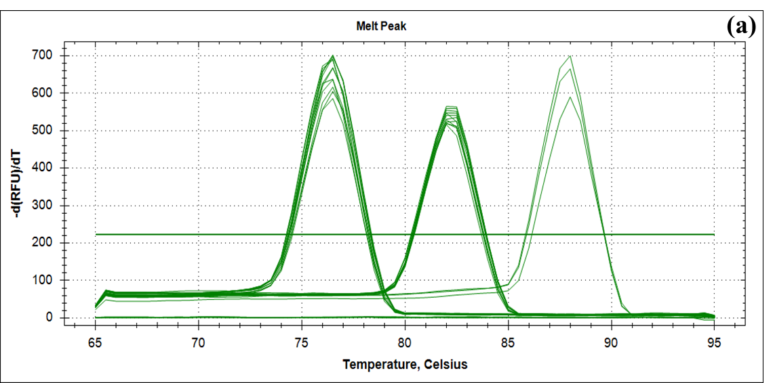
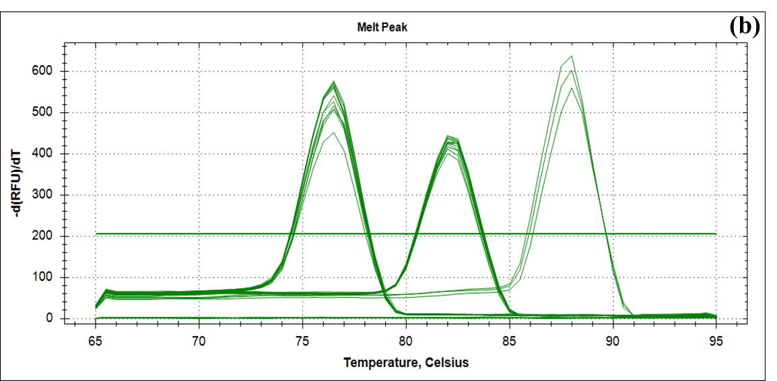

Supplementary Fig. S4. The melt curve data of the generated qPCR amplicons represent the gene expression on (a) day 4 and (b) day 8 of cultivation under control (Cont.), Lumogen Red (LR), Lumogen Yellow (LY), and Rhodamine 8G (R8G) irradiance. No template control (NTC) and no reverse transcriptase control (NRT) showed no melt temperatures and no additional melt peaks indicated no contamination of samples. The control GADPH, rbcL, and 18S rRNA amplicons melted at 88, 76.6, and 82.5 ºC, respectively

Supplementary Fig. S5. (a) The average pH and (b) average temperature cultures grown under control (Cont.), Lumogen Red (LR), Lumogen Yellow (LY), and Rhodamine 8G (R8G) using 30% UV-a and UV-b fluorescent tubes

