Supporting information
NIR diagnostic imaging of triple-negative breast cancer and its lymph node metastasis for high-efficiency hypoxia-activated multimodal therapy
Yi Pan^{1,2,3}, Longcai Liu^{1,3,4}, Yichen He^{1,2,3}, Luyi Ye^{1,3,4}, Xin Zhao^{1,3,4}, Zhiming Hu*⁵, Xiaozhou Mou*^{1,3}, Yu Cai*^{1,3}
¹ Center for Rehabilitation Medicine, Rehabilitation & Sports Medicine Research Institute of Zhejiang Province, Department of Rehabilitation Medicine, Cancer Center, Zhejiang Provincial People's Hospital, Affiliated People's Hospital, Hangzhou Medical College, Hangzhou, Zhejiang, China, 310014.
² College of Pharmacy, Zhejiang University of Technology, Hangzhou, Zhejiang, China, 310014.
³ Clinical Research Institute, Zhejiang Provincial People’s Hospital, Affiliated People’s Hospital, Hangzhou Medical College, Hangzhou, Zhejiang, China, 310014.
⁴ College of Pharmacy, Hangzhou Medical College, Hangzhou, China, 310059.
⁵ Department of Hepatobiliary Pancreatic Surgery, Zhejiang Provincial Tongde Hospital, Hangzhou, Zhejiang, China, 310012.
E-mail: mouxz@zju.edu.cn, huzhiming4199@163.com, caiyu@hmc.edu.cn
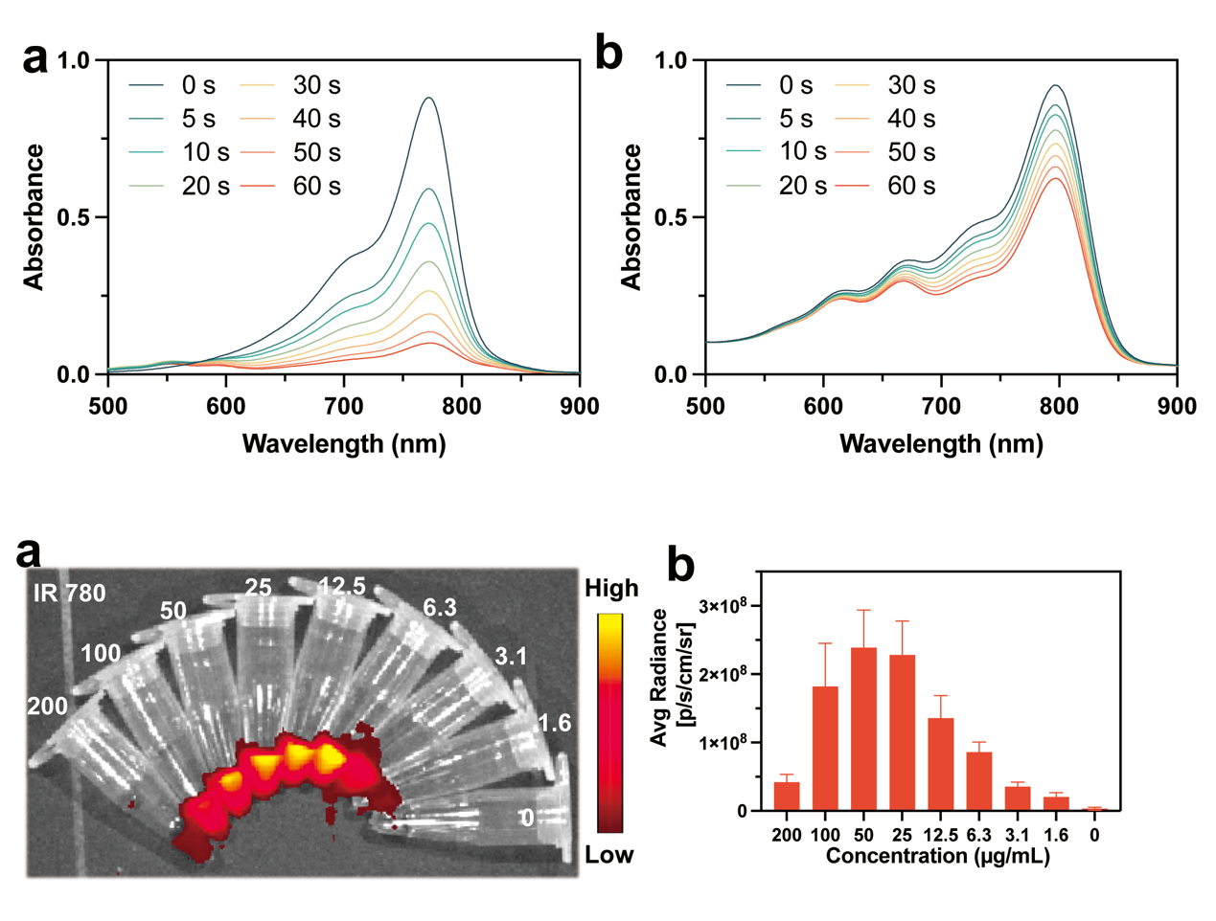
Figure S1. UV-vis spectrums of a) free IR 780, b) ILA@Lip after a series of time laser irradiation (808 nm, 1.0 W cm⁻²).

Figure S2. a) Fluorescence imaging of a series of concentrations of free IR 780 solution in the tube. b) Quantitative analysis of average radiance in free IR 780 solutions of different concentrations.

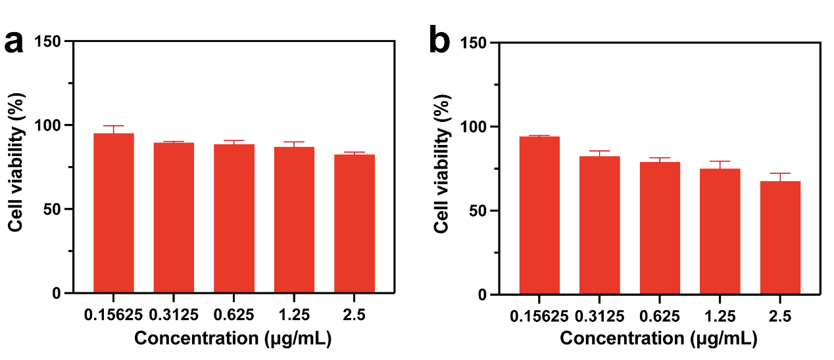
Figure S3. The viabilities of a) HUVEC cells and b) L929 after being treated with ILA@Lip were evaluated using CCK-8 assay. Values represent means ± SD, n= 3.

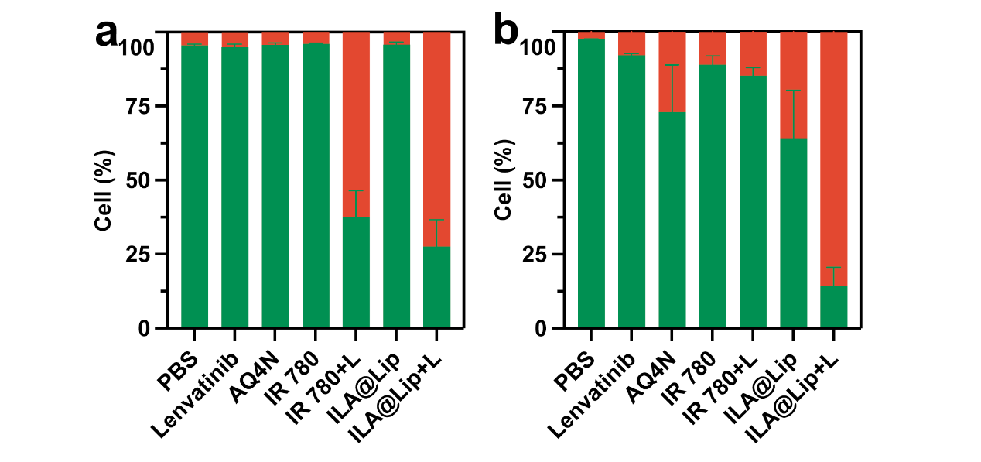
Figure S4. Quantitative analysis of Live/dead staining of MDA-MB-231 cells being treated with lenvatinib, AQ4N, IR 780, and ILA@Lip with or without laser irradiation in a) normoxia or b) hypoxia. Live cells and dead cells were signaled in green and red, respectively. n=3.

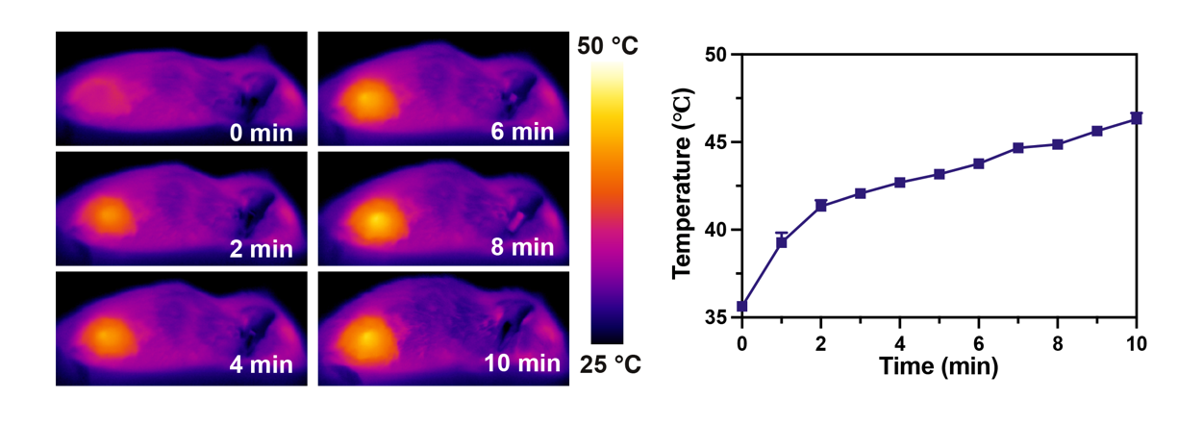
Figure S5. a) IR thermal images of subcutaneous 4T1 tumor-bearing mice with intravenous injection of IR 780, b) and their tumor temperature variations during a 10 min period of laser (808 nm, 1.0 W cm⁻²) irradiation at the tumor site.

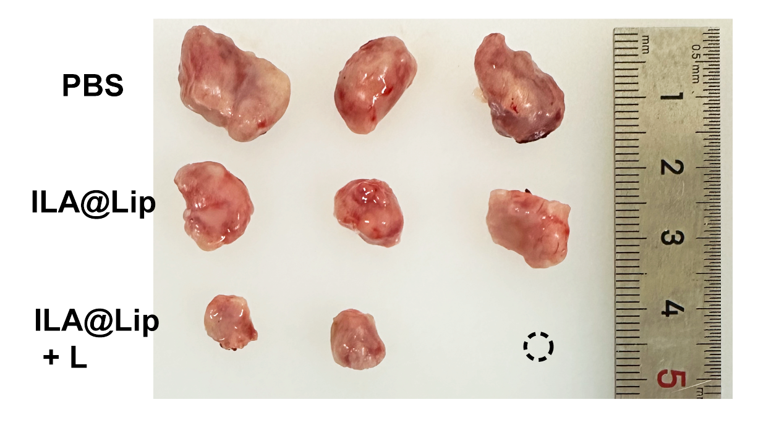
Figure S6. Photos of tumors from orthotopic 4T1 breast tumor-bearing mice after being treated with PBS, and ILA@Lip with or without laser irradiation (808 nm, 1.0 W cm⁻²).

