SUPPLEMENTARY DATA
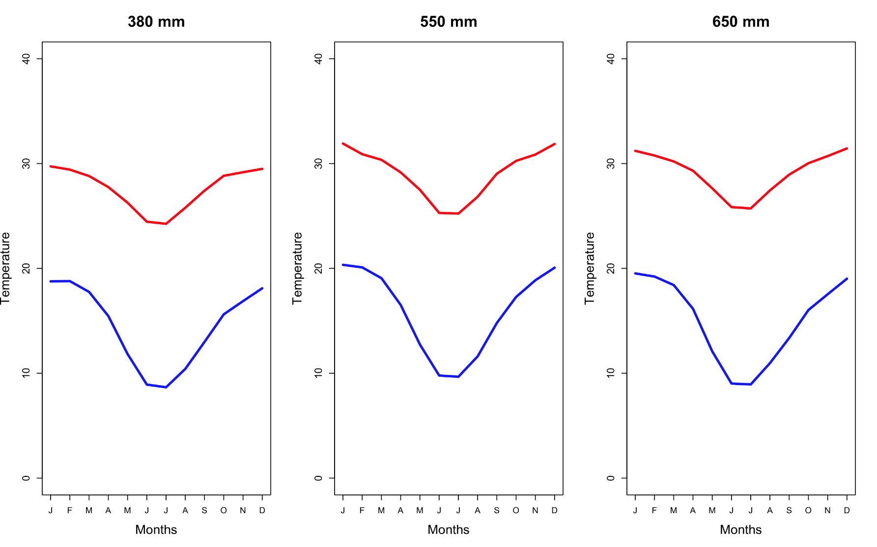

Figure S1. The mean minimum and maximum monthly temperatures at the 380 mm, 550 mm and 650 mm savanna sites. Data derived from WorldClim (2021) based on site co-ordinates.

WO
WC
DC
DO
GO
GC
WC
WO

50 m
Figure S2: Layout of decomposition bags across the 50 m x 50 m (0.25 ha) plots. At each of the 20 positions (indicated by black squares), in the 4 x 5 grid, there were 8 decomposition bags. Four wood (W) - two open (O) and two closed (C); two grass (G) – one open (O) and one closed (C) and two dung (D) - one open (O) and one closed (C).

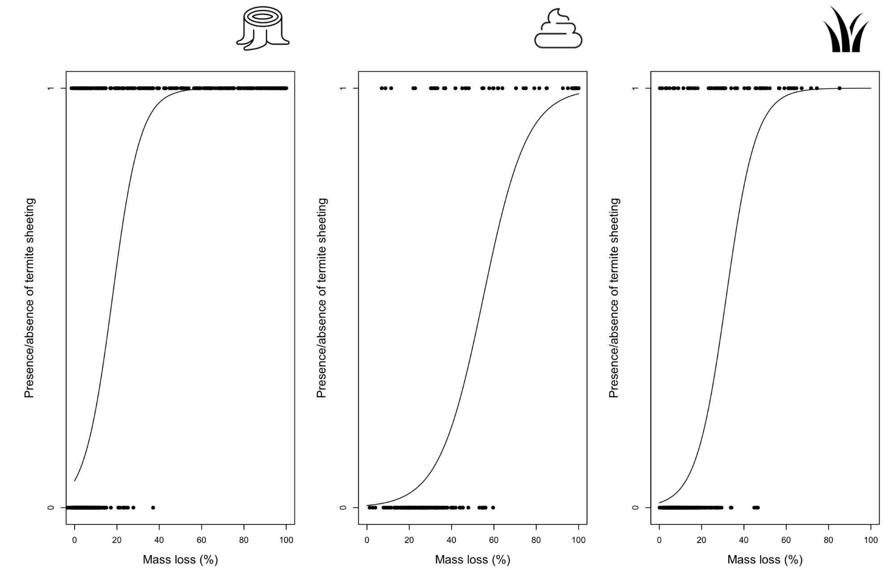
Figure S3a. The relationship between the presence of sheeting in open bags and mass loss (%) within open decomposition bags containing wood, grass and dung across all three sites, where 0 represents the absence of sheeting and 1 represents the presence.

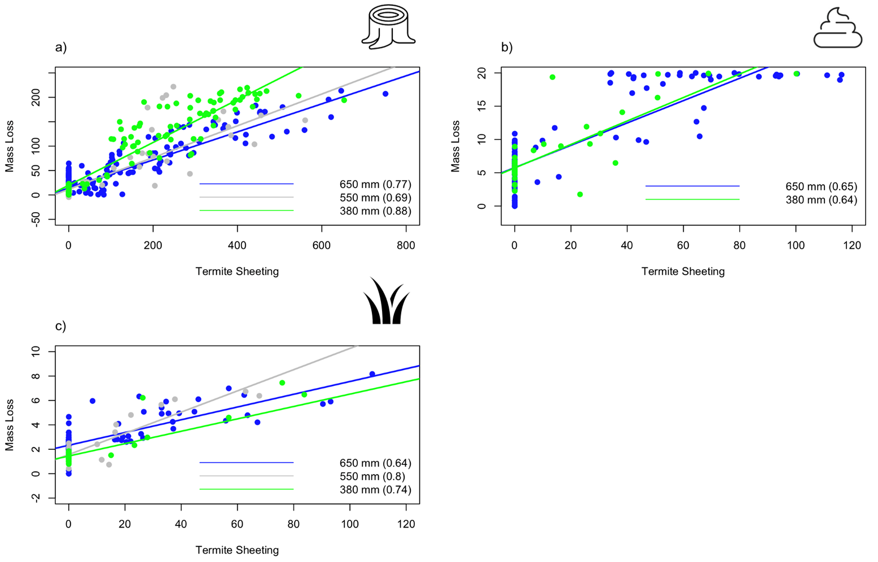
Figure S3b. Mass loss (g) versus the quantity of termite soil (g) found within (a) wood 6 months; b) wood 1 year; c) dung 112 days and d) grass 112 days open decomposition bags in the 380 mm (green), 550 mm (grey) and 650 mm (blue) savanna sites. The r-squared values appear brackets in legends of each plot.

b)
a)
Figure S4. (a) The absolute number of termite hits (total) encountered across feeding groups (the total number of wood-feeding termites encountered is indicated).and (b) The relative proportion of hits across feeding groups in the 380 mm, 550 mm, and 650 mm savanna sites. The termites were sampled using the active searching transect method
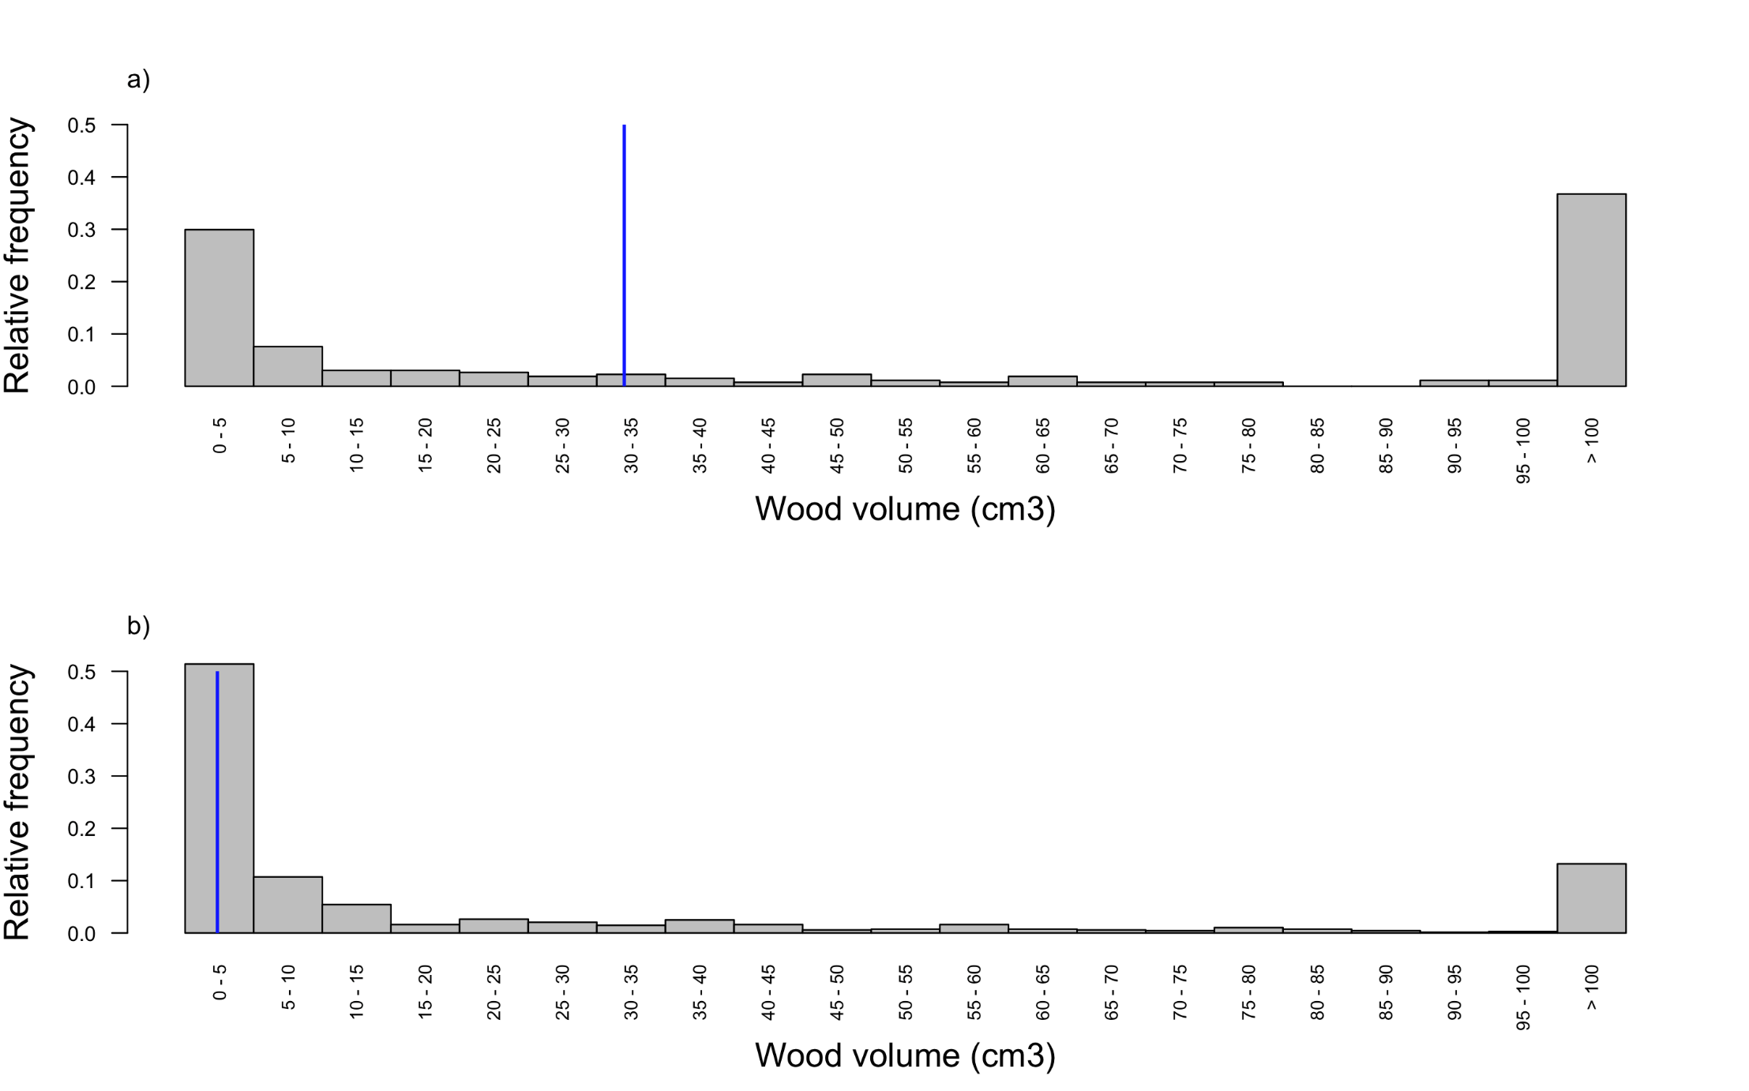
Figure S5. Histograms of coarse wood volume across a) 650 mm site and b) 380 mm site. The medians (a) 33.9 & b) 4.7 a indicated by vertical blue lines.

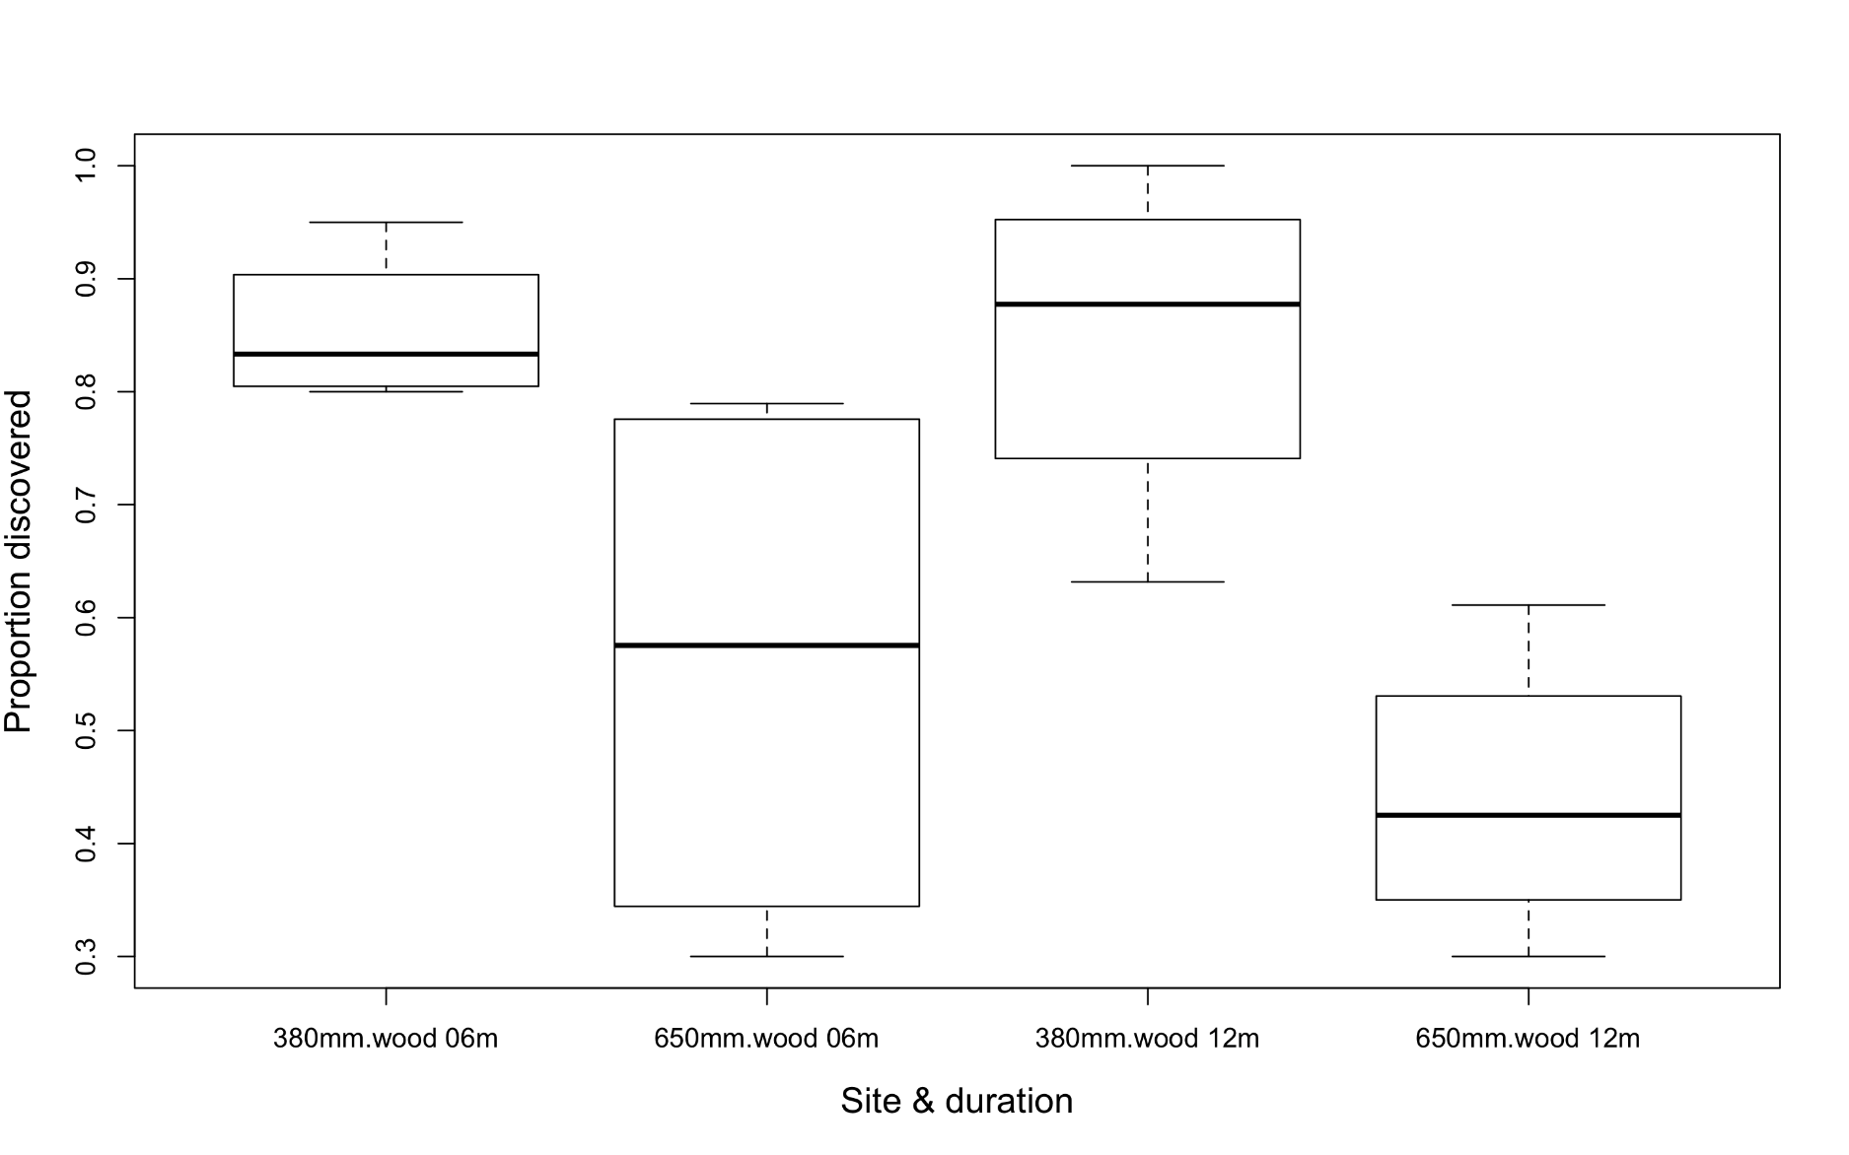

Figure S6: Proportion of wood decomposition bags discovered across the collection intervals (6 months & 1 year) at the 380 mm and 650 mm savanna sites.

Table S1. The effects of rainfall (380 mm, 550 mm and 650 mm savanna sites) and bag treatment (open versus closed) on mass loss from decomposition bags (wood 6 months; wood 1 year, dung and grass). Significant differences between the treatment levels were assessed using pairwise mean comparisons (Tukey’s posthoc tests) from the glht function in the ‘multcomp’ package in R. Z-values displayed with level of significance depicted in brackets: ‘***’ – 0.001; ‘**’ – 0.01; ‘*’ – 0.05 displayed where applicable.

Bag Treatment | Wood | Dung | Grass
Microbial decomposition (closed vs closed bags):
380 mm – 550 mm | -3.52 (**)
550 mm – 650 mm | -3.28 (***) |  | 3.59 (**)
380 mm – 650 mm
Microbial plus termite decomposition (open vs. open bags):
380 mm – 550 mm
550 mm– 650 mm |  |  | 3.50 (**)
380 mm– 650 mm | -3.17 (*) | 3.58 (**) | 2.86 (*)
Microbial (closed – left) versus microbial plus termites (open – right)
380 mm – 380 mm | 14.60 (***) | 3.08 (*) | 3.71 (**)
550 mm – 550 mm | 13.95 (***)
650 mm – 650 mm | 3.31 (**) | 6.53 (***) | 3.09 (*)

Table S2. Termite genera across the three savanna sites (380 mm, 550 mm and 650 mm). The feeding group to which the termite genera belongs is listed.
Termite Genera | Feeding Group  (Based on Uys 2002) | Donovan Feeding Group  (Donovan et al., 2000; Donovan et al., 2001) | 380 mm | 550 mm | 650 mm
Adaiphrotermes | soil | III |  | X
Allodontermes | mixed | llf |  | X | X
Ancistrotermes | mixed | llf | X | X | X
Angulitermes | dung | IIf |  |  | X
Nitiditermes | soil | lV |  |  | X
Macrotermes | mixed | IIf | X | X | X
Microcerotermes | wood | IIf |  | X
Microtermes | wood | IIf | X | X | X
Odontotermes | wood | llf |  | X | X
Psammotermes | wood | l |  | X
Schedarhinotermes | grass | I |  |  | X
Trinervitermes | grass | I |  |  | X
Unguitermes | soil | lV | X
Group I: lower termite dead wood and grass-feeders
Group II contains Termitidae with a range of feeding habits including dead wood, grass, leaf litter, and micro-epiphytes
Group III contains Termitidae feeding in the organic rich upper layers of the soil
Group IV contains the true soil-feeders (again all Termitidae), ingesting apparently mineral soil.

Table S3. Wood, dung, and grass mass loss (mean in grammes) attributed to microbes and invertebrates at the 380 mm, the 550 mm and the 650 mm savanna sites.

substrate | biological agent | calculated | 380 mm | 550 mm | 650 mm
wood 1 year | microbes | =closed bag | 8.81 | 0.43 | 6.65
wood 1 year | invertebrates | =open bag – closed bag | 53.32 | 44.65 | 12.20
dung 112 days | microbes | =closed bag | 24.64 | NA | 28.12
dung 112 days | invertebrates | =open bag – closed bag | 29.71 | NA | 50.75
grass 112 days | microbes | =closed bag | 13.16 | 15.19 | 23.75
grass 112 days | invertebrates | =open bag – closed bag | 14.44 | 17.93 | 13.68

Table S4. Decomposition constant (k) and half-life (in brackets) for decomposition bags containing wood, dung and grass across all collection intervals in the two sites at either end of the decomposition gradient (380mm and 650 mm).

Decomposition constant (k) | Biological agent | 380 mm | 650 mm
wood open | invertebrates + microbes | 0.3 (2.54 years) | 0.006 (108.12 years)
wood closed | microbes | 0.02 (29.23 years) | 0.005 (145.30 years
dung open | invertebrates + microbes | 2.47 (0.28 years) | 3.46 (0.20 years)
dung closed | microbes | 1.38 (0.50 years) | 1.44 (0.48 years)
grass open | invertebrates + microbes | 0.42 (1.64 years) | 1.24 (0.56 years)
grass closed | microbes | 0.34 (2.05 years) | 1.2 (0.58 years)

Table S5. Number of termite encounters per 100m of transect at the 380 mm, 550 mm, and 650 mm savanna sites.
 | Termite Encounters
Site | Mean per 100m | Minimum per 100m | Maximum per 100m
380 mm site | 21.75 | 13 | 29
550 mm site | 31.2 | 25 | 40
650 mm site | 54.5 | 30 | 85

SUPPLEMENTARY: Resource availability and termite discovery

We explored resource availability and termite discovery as a means to explore our findings.

METHODS

Resource availability
To establish if the rate of wood decomposition was related to the amount of coarse woody debris present on the soil surface, we conducted coarse woody debris transects at the two ends of the rainfall gradient: the 380 mm and the 650 mm site in October 2019. This was achieved using a line-intercept method (see Marshall et al., 2000) where 2 x 50 m of tape were laid out across each plot and every piece of dead wood that intercepted the path of the tape was measured (length and diameter). Wood volume across each plot was calculated using the formula (pole length × π × diameter).

Termite discovery
We used the presence of termite sheeting to confirm the discovery of the individual decomposition bags. This allowed us to determine if the rate of discovery over the collection intervals, differed across sites. We note that the use of soil as an indicator of termite activity is a conservative estimate as it does not consider the activity of non-fungus growing termites such as Trinervitermes - a grass-feeding specialist that does not produce sheeting.

RESULTS

Resource availability

Our highest rainfall site (650 mm) has seven times the volume of wood than that of our driest site 380 mm, Figure S1), The median wood volume at the 650 mm site is 33.9 cm³ while the median wood volume at our dry site is 4.7 cm³.

Termite discovery
Termites discover significantly more of the wood decomposition bags the 380 mm site than they did at the 650 mm site both after 6 months and after 1 year. After six months 85% of wood decomposition bags at the 380 mm site had been discovered compared to only 56%at the 650 mm site. There is a great deal of variability in the proportion of bags discovered across the plots at the 650 mm site (30 – 79%) compared with those at the 380 mm site (63 – 100%).

