Additional file 1
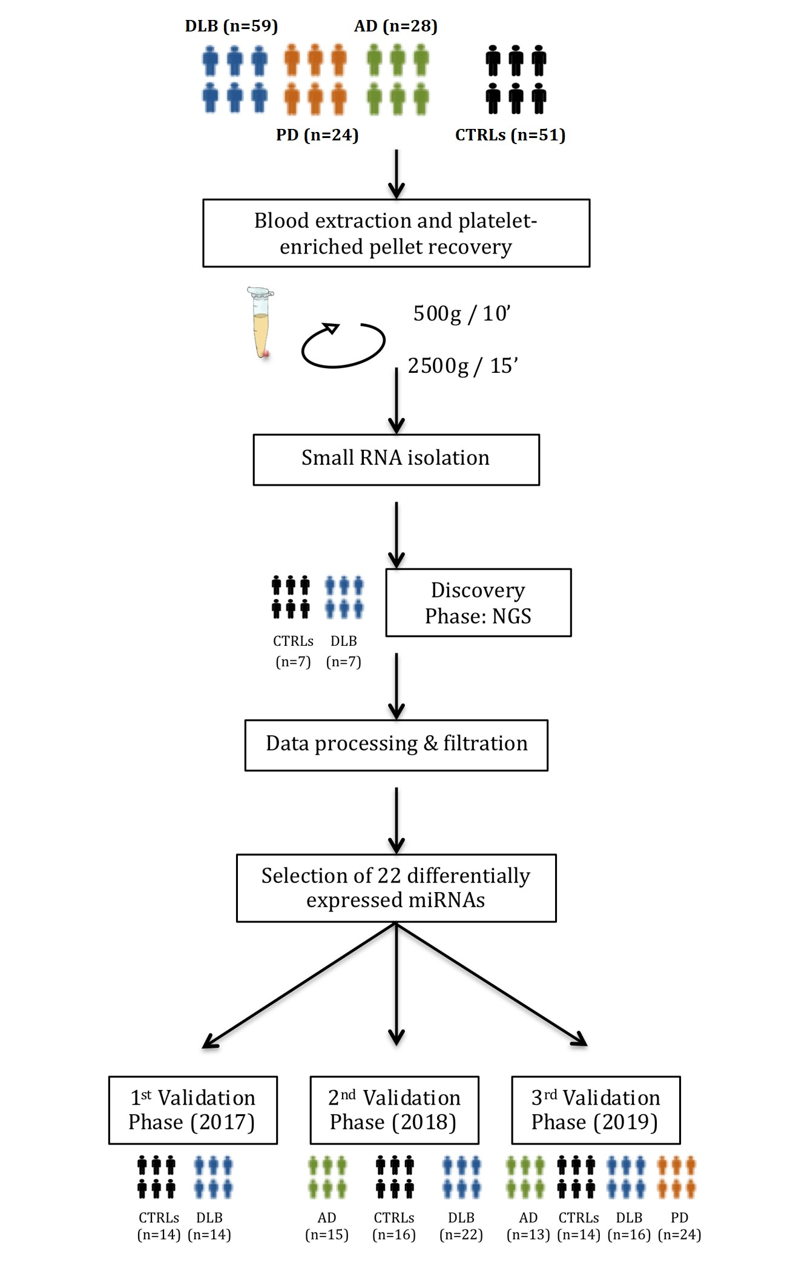
Supplemental Figure 1. The complete workflow of the study. A first discovery phase by Next-generation sequencing included a cohort of 7 DLB patients and 7 healthy controls. Selected miRNAs were validated in three independent qPCR validation studies.
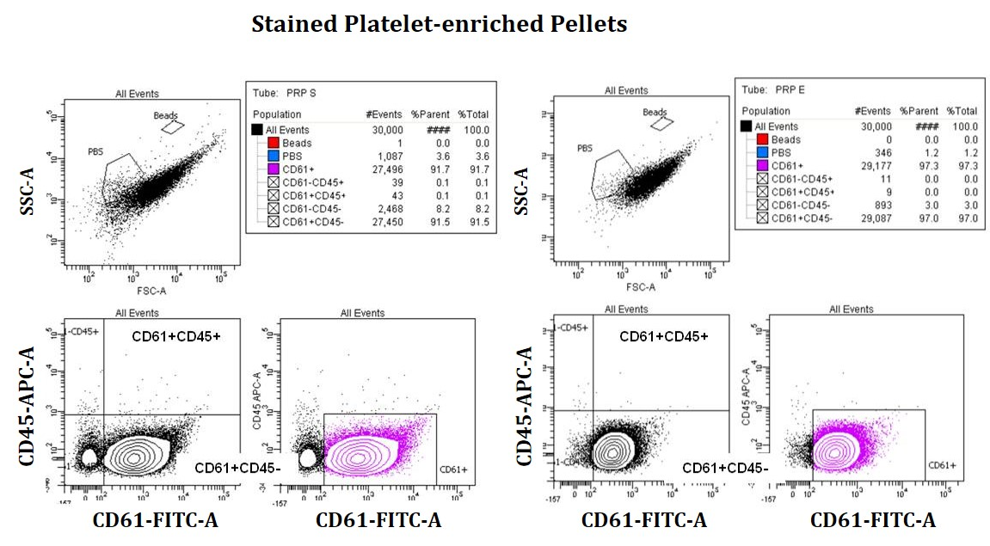

Supplemental Figure 2: Additional samples analyzed by flow cytometry for the expression of CD61 as platelet marker and CD45 as leukocyte marker.

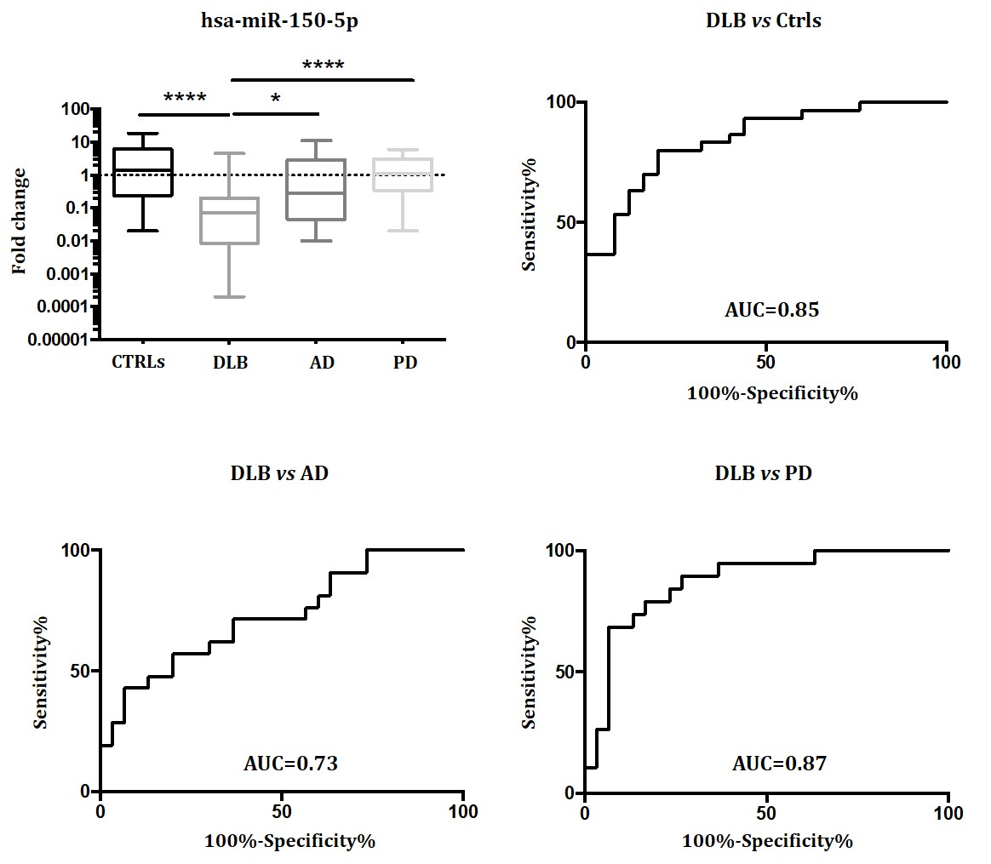

Supplemental Figure 3. hsa-miR-150-5p expression in DLB, AD, PD and controls. (a) Expression change by qPCR. Mean, and Min to Max values are plotted. (b) ROC curve for DLB cases vs controls. (c) ROC curve for DLB vs PD. (d) ROC curve for DLB vs AD.

Supplemental Table 1: MiRNA expression in whole blood of DLB, PD and AD patients and control individuals
miRNA DLB vs CTRLs AD vs CTRLs PD vs CTRLs
n 16 16 16 16 16 16

let-7d-5p
expr changeª 0.84 1.27 0.48
dev range^{b} 0.66-1.07 0.90-1.80 0.47-0.72
p-value^{c} 0.48 0.66 0.042
miR-128-3p
expr change 0.71 1.01 0.73
dev range 0.53-0.95 0.81-1.29 0.56-0.96
p-value 0.44 0.59 0.53
miR-132-5p
expr change 1.78 2.08 0.45
dev range 1.32-2.41 1.97-2.21 0.42-0.47
p-value 0.33 0.16 0.031
miR-139-5p
expr change 0.69 0.98 0.49
dev range 0.43-1.12 0.69-1.43 0.22-1.09
p-value 0.30 0.56 0.15
miR-142-3p
expr change 0.99 1.31 1.23
dev range 0.80-1.23 1.27-1.38 0.91-1.67
p-value 0.74 0.62 0.72
miR-146a-5p
expr change 0.76 1.33 0.85
dev range 0.62-0.94 1.22-1.47 0.73-0.99
p-value 0.33 0.20 0.66
miR-150-5p
expr change 0.66 0.86 0.81
dev range 0.50-0.86 0.79-0.95 0.88-1.03
p-value 0.14 0.29 0.81
miR-25-3p
expr change 0.83 1.28 0.75
dev range 0.026-1.52 0.94-1.41 0.02-1.08
p-value 0.16 0.67 0.66
miR-26b-5p
expr change 1.33 2.00 0.58
dev range 0.02-1.83 1.49-1.70 0.013-1.07
p-value 0.56 0.25 0.44
miR-6747-3p
expr change 0.72 1.02 1.10
dev range 0.65-0.80 0.92-1.14 1.07-1.14
p-value 0.16 0.67 0.71
ªexpr change, expression change obtained by the deltadeltaCt method after comparing two groups; ^{b}dev range, deviation range of the expression change; ^{c}p-value obtained by the Wilcoxon-Mann-Whitney. Significant results are highlighted in bold.

