Graphic Abstract
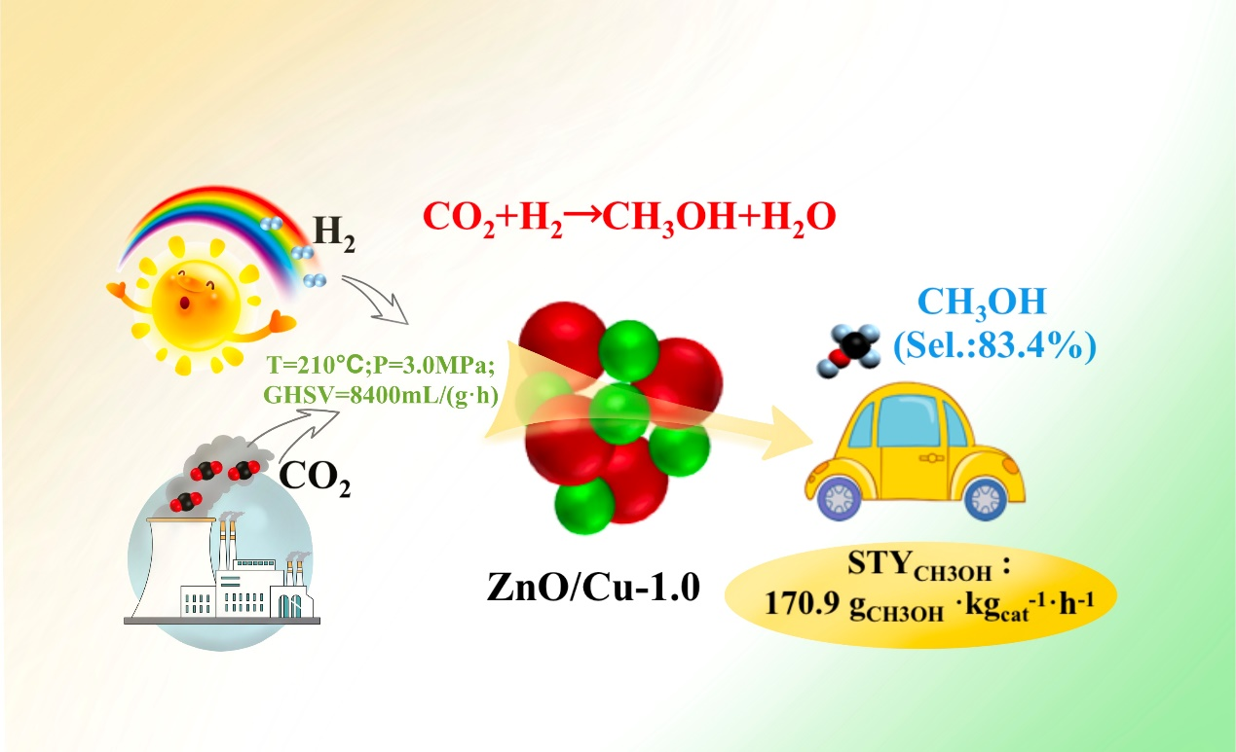
Typical inverse ZnO/Cu-1.0 catalysts have been demonstrated and achieved to significantly facilitate the activation of inert CO₂ molecules to produce methanol, due to its special physicochemical properties and strong ZnO-Cu interaction.

