Supporting Information
Optimizing Interfacial Interaction between Cu and Metal Oxides Boosts Methanol Yield in CO₂ Hydrogenation
Xiaojun Liª, Yudong Xiaª, Yangzhou Xuª, Haitao Li^{a, *}, Jiangchao Huangª, Jie Yao^{b}, Heng Zhao^{b}, Xinhua Gao^{c}, Jinghao Yu^{d}, Lisheng Guo^{e, *}, Jie Li^{a, *}
ª School of Chemistry and Chemical Engineering, Yangzhou University, Yangzhou 225002, China
^{b} Department of Applied Chemistry, School of Engineering, University of Toyama, Gofuku 3190, Toyama 930-8555, Japan
^{c} State Key Laboratory of High-efficiency Utilization of Coal and Green Chemical Engineering, Ningxia University, Yinchuan, 750021, China
^{d} Baeight Pty Ltd., Suite 6 Level 7 161 London Circuit, Canberra, ACT 2601, Australia
^{e} School of Chemistry and Chemical Engineering, Anhui University, Hefei 230061, China
* Corresponding author, E-mail address: htli@yzu.edu.cn; lsguo@ahu.edu.cn; Jieli@yzu.edu.cn.

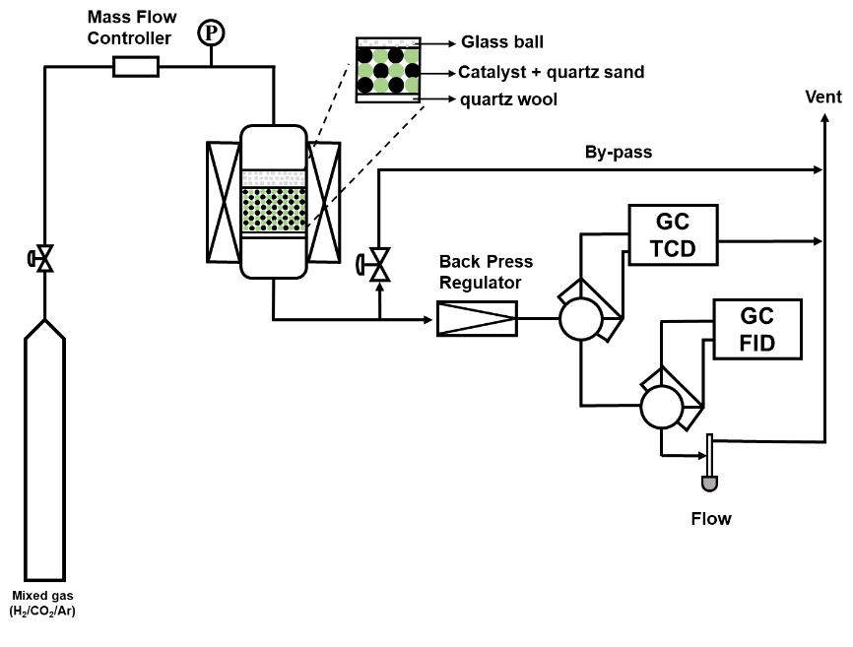
Figure S1. Reaction apparatus configuration of methanol synthesis from mixed gas (H₂/CO₂/Ar).

Figure S2. Powder X-ray diffraction (XRD) patterns of the fresh Cu-base catalysts.

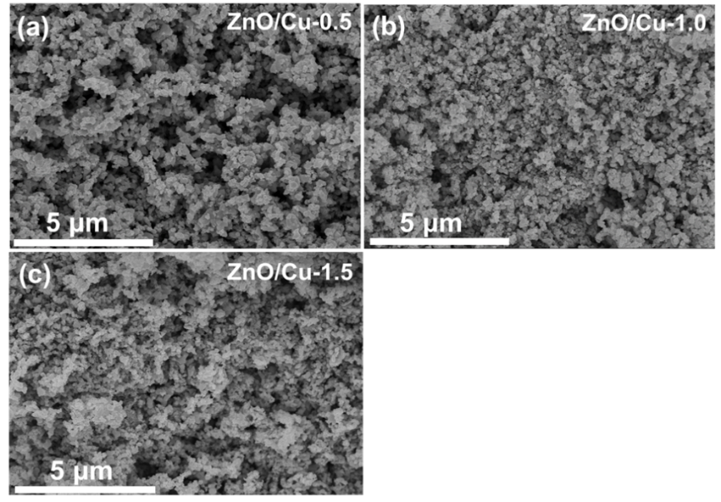
Figure S3. Scanning electron microscope (SEM) images of (a) ZnO/Cu-0.5, (b) ZnO/Cu-1.0 and (c) ZnO/Cu-1.5 catalysts.

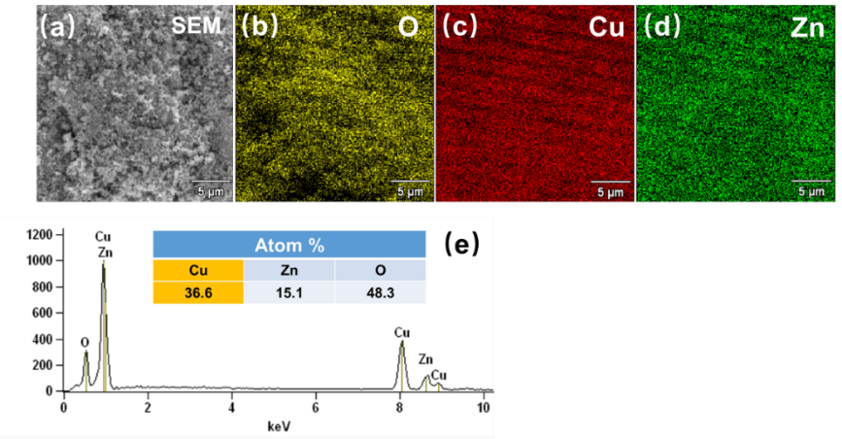
Figure S4. (a-d) SEM and elemental mapping images and (e) EDS profile of ZnO/Cu-1.0 catalysts.

Figure S5. H₂ temperature-programmed reduction (H₂-TPR) profiles of fresh Cu-base catalyst.
The CuO reduction temperature of as-obtained catalysts are lower than that of the pure CuO (339.6 °C). Interestingly, changing the preparation method of the inverse ZnO/Cu catalysts results in a completely different reduction temperature for the CuO. The reduction peak of the IM-ZnO/Cu catalyst is shifted to a higher temperature compared to the C-ZnO/Cu catalyst, probably due to the formed larger copper particles in the second cycle of calcination.[1] Moreover, as the CuO crystal size of the ZnO/Cu-x catalysts gradually increase with increasing impregnation concentration (Table 1), the reduction temperature shift to high temperature. This can be attributed to the large area contact or interface between CuO and ZnO (Figure 2) with SMOI, causing an increase in reduction temperature. In addition, the reduction temperature of the Cu/ZnO catalyst is 276.2 °C, indicating that the ZnO support increases the dispersion of CuO.[2]
Figure S6. XPS spectra of Cu 2p regions for fresh Cu-based catalysts.

Figure S7. CO₂ Temperature programmed desorption (CO₂-TPD) of the fresh Cu-base catalyst.

The desorption peaks of the ZnO/Cu-0.5 and ZnO/Cu-1.5 catalysts become wider and diminish in intensity between 80 and 690 °C as the impregnation concentration increases. However, the ZnO/Cu-0.5 catalyst is dominated by medium basic sites, and CO₂ adsorbs on its surface to form bidentate carbonate species, which are involved in hydrogenation reactions to create a higher amount of CO.[3] Moreover, the basic sites of the ZnO/Cu-1.5 catalyst are more widely dispersed in the all medium and strong base range than the ZnO/Cu-0.5 catalyst, forming less methanol and a little more CO.
Interestingly, the C-ZnO/Cu and IM-ZnO/Cu catalysts show a significant increase in surface basicity, mainly influenced by the different preparation methods, causing a change in the number and strength of basic sites. The desorption peak of the IM-ZnO/Cu catalyst occurs mainly in the ultra-strong basic range, where the presence of large amounts of ZnO on the Cu surface causes an increase in surface basicity. This configuration favors CO₂ adsorption and forms unidentate species, resulting in further hydrogenation forming methanol.[4] However, IM-ZnO/Cu catalyst exhibits poor CO₂ conversion compared to ZnO/Cu-1.0 catalyst (Figure 5a), as the ultra-strong basic sites of the IM-ZnO/Cu catalyst suppress CO₂ activation by strong combination with CO₂. The C-ZnO/Cu and ZnO/Cu-0.5 catalysts have similar basicity, resulting in similar product selectivity. In addition, few CO₂ desorption peaks are observed on pure Cu. Nevertheless, it clearly stands out that a significant increase in the intensity of CO₂ adsorption is associated with the presence of a large number of moderate basic sites when Cu is loaded onto ZnO (Cu/ZnO), which is similar to those of the C-ZnO/Cu catalyst.

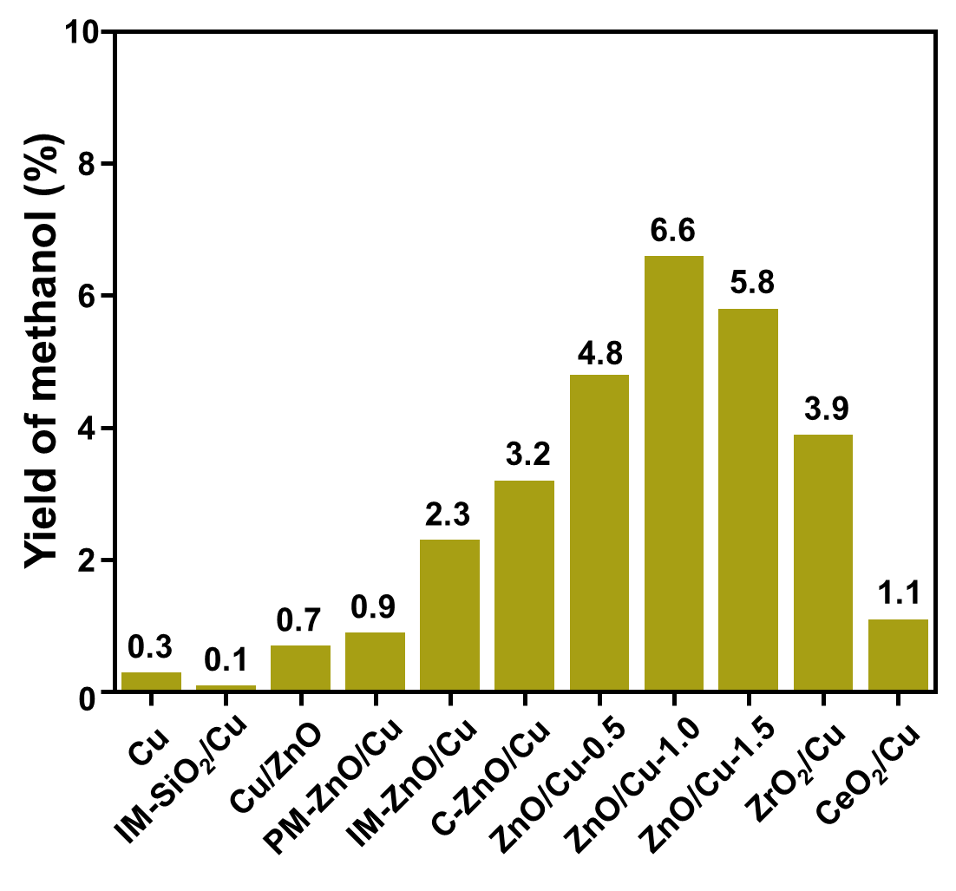
Figure S8. The yield of methanol over a series of Cu-base catalysts in CO₂ hydrogenation. Reaction conditions: temperature, T=210 °C; pressure, P=3.0 MPa; flow rate, GHSV=3600$\text{ mL∙}{{\text{g}}_{\text{cat}}}^{\text{-1}}\text{∙}{\text{h}}^{\text{-1}}$; catalyst weight, 0.5 g; H₂/CO₂/Ar=73.0:24.0:3.0; time on stream, 6 h.
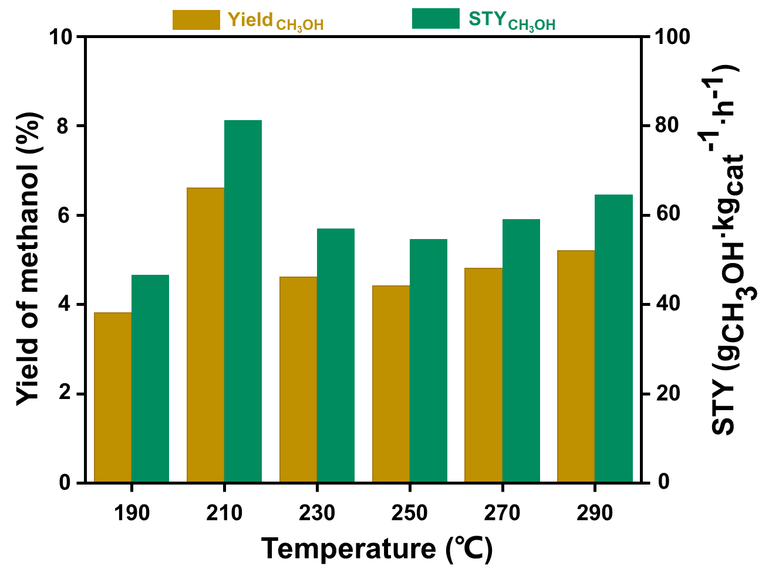
Figure S9. The yield of methanol and CH₃OH STY over the ZnO/Cu-1.0 catalyst at different temperature in CO₂ hydrogenation. Reaction conditions: pressure, P=3.0 MPa; flow rate, GHSV =3600$\text{ mL∙}{{\text{g}}_{\text{cat}}}^{\text{-1}}\text{∙}{\text{h}}^{\text{-1}}$; catalyst weight, 0.5 g; H₂/CO₂/Ar=73.0:24.0:3.0; time on stream, 6 h.
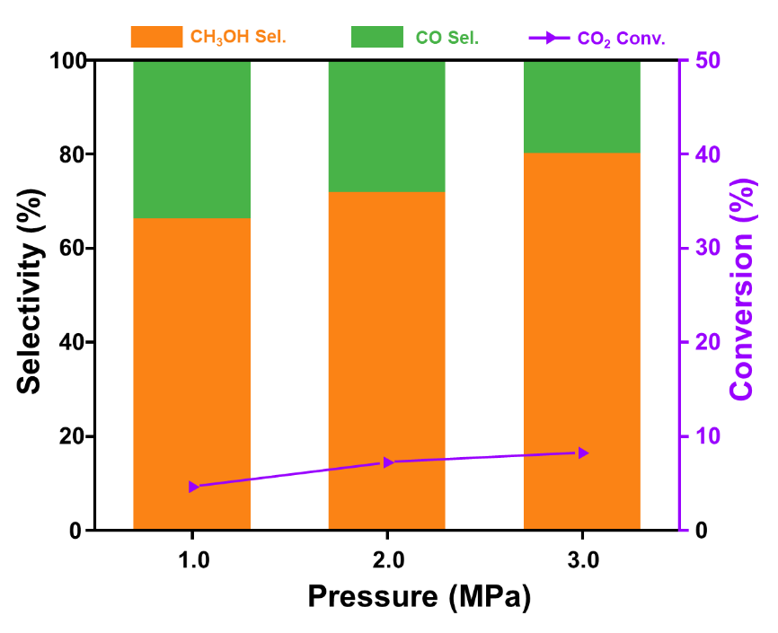
Figure S10. The CO₂ conversion, CH₃OH selectivity and CO selectivity over the ZnO/Cu-1.0 catalyst at different pressure in CO₂ hydrogenation. Reaction conditions: temperature, T=210 °C; flow rate, GHSV =3600$\text{ mL∙}{{\text{g}}_{\text{cat}}}^{\text{-1}}\text{∙}{\text{h}}^{\text{-1}}$; catalyst weight, 0.5 g; H₂/CO₂/Ar=73.0:24.0:3.0; time on stream, 6 h.
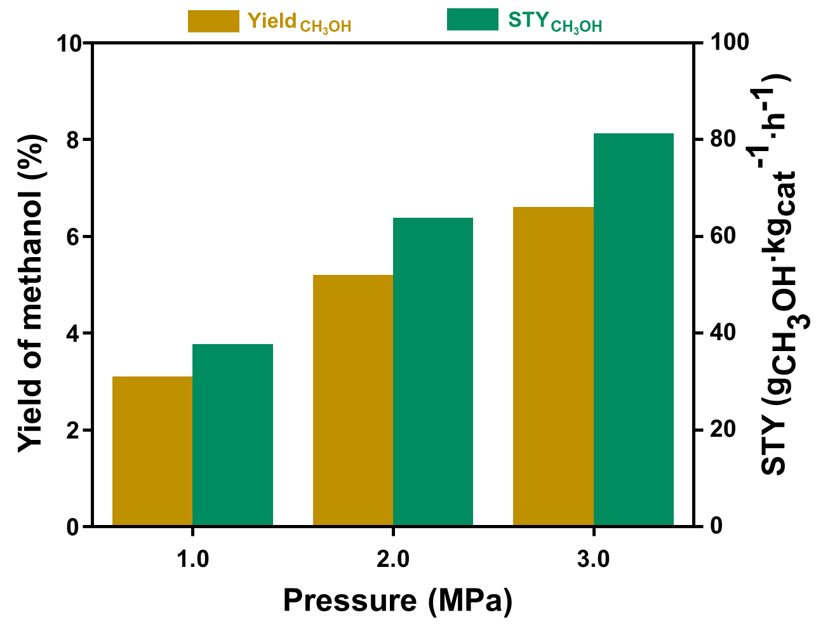
Figure S11. The yield of methanol and CH₃OH STY over the ZnO/Cu-1.0 catalyst at different pressure in CO₂ hydrogenation. Reaction conditions: temperature, T=210 °C; flow rate, GHSV =3600$\text{ mL∙}{{\text{g}}_{\text{cat}}}^{\text{-1}}\text{∙}{\text{h}}^{\text{-1}}$; catalyst weight, 0.5 g; H₂/CO₂/Ar=73.0:24.0:3.0; time on stream, 6 h.
(b)
(a)

Figure S12. Powder X-ray diffraction (XRD) patterns of the used Cu-base catalysts.

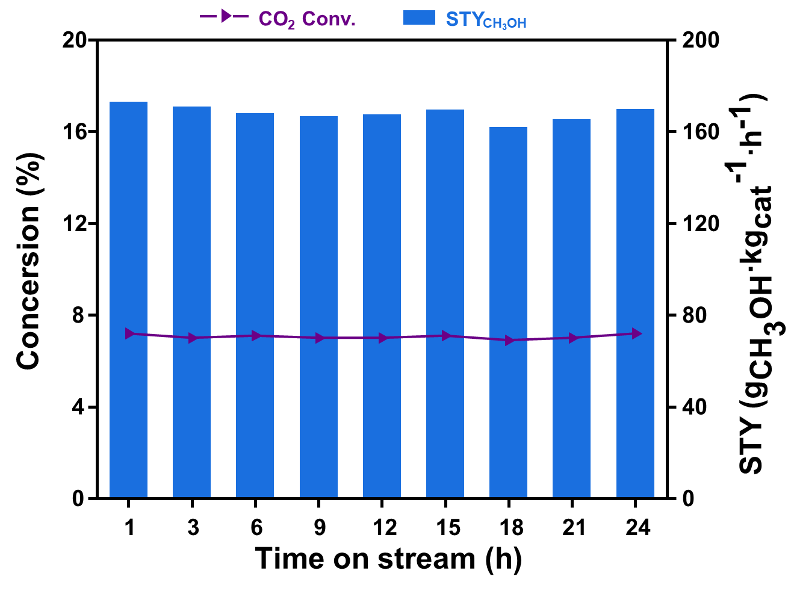
Figure S13. The CO₂ conversion and CH₃OH STY with time on stream over ZnO/Cu-1.0 catalyst in CO₂ hydrogenation. Reaction condition: temperature, T=210 °C; pressure, P=3.0 MPa; flow rate, GHSV=8400 $\text{mL∙}{{\text{g}}_{\text{cat}}}^{\text{-1}}\text{∙}{\text{h}}^{\text{-1}}$; catalyst weight, 0.5 g; H₂/CO₂/Ar=73.0:24.0:3.0.

References
1. K. Stangeland, H.H. Navarro, H.L. Huynh, W.M. Tucho, Z. Yu, Chem. Eng. Sci. 238 (2021).
2. T. Qi, W. Li, H. Li, K. Ji, S. Chen, Y. Zhang, Mol. Cata. 509 (2021)
3. E. Choi, K. Song, S. An, K. Lee, M. Youn, K. Park, S. Jeong, H. Kim, Korean. J. Chem. Eng. 73-81, 35 (2018)
4. J. Di Cosimo, V. Dıez, M. Xu, E. Iglesia, C. Apesteguıa, J. Catal. 499-510, 178 (1998)

