Supplementary Information
Title: Phosphorus fertilization affects litter quality and enzyme activity in a semiarid grassland

Authors: Jirui Gongª*, Xuede Dongª*, Xiaobing Liª, Kexin Yueª, Jiayu Shiª, Liangyuan Songª, Zihe Zhangª, Weiyuan Zhangª, Ying Liª.
Affiliations: ªState Key Laboratory of Earth Surface Processes and Resource Ecology, Faculty of Geographical Science, No. 19 Xinjiekouwai Street, Haidian District, Beijing Normal University, Beijing, 100875, China.

* Corresponding authors
Corresponding authors’ address: Faculty of Geographical Science, Beijing Normal University, No. 19 Xinjiekouwai Street, Haidian District, Beijing 100875, China. Tel./Fax: +86-10-5880-5726, E-mail: jrgong@bnu.edu.cn (J. Gong), dongxuede@mail.bnu.edu.cn (X. Dong).

Appendix 1: Method for the determination of litter enzymatic activity
The activities of BG, NAG, and AP were determined by fluorimetric. First, 1.5 g of litter samples and 50 ml of Tris buffer (pH = 8) were added into a 200 ml sterilization box, then, the mixture was fully stirred with a magnetic stirrer to ensure homogeneity. Next, 200 μl of litter suspension, 150 μl of substrate were added to the microplate wells that served as the sample assay. The substrates for the detection of BG, NAG and AP were 4-Methylumvelliferyl β-D-glucopyranoside (200 μM), 4-Methylumvelliferyl N-acetyl-β-D glucosaminide (200 μM), 4-Methylumvelliferyl Acid phosphate (200 μM), respectively. Add 200 μl of litter suspension and 50 μl of Tris buffer as blank. The microplates were incubated in the dark at 25°C for 3 hours. After incubation, 10 μl of 1 M NaOH was added to each well to terminate the reactions, and fluorescence values were detected using a microplate reader (Synergy H1, Bio Tek, USA) with the excitation and emission filters of 365 and 450 nm, respectively.
The activities of PhOx and PerOx were measured spectrophotometrically using 3,4-dihydroxy-L-phenylalanine (DOPA, 25 mM) as the substrate. Specifically, PhOx assays add 200 μl of litter suspension and 50 μl of DOPA as sample assay. PerOx assays add 200 μl of litter suspension, 50 μl of 25 mM DOPA and 10 μl of 0.3% H₂O₂. For PhOx, add 200 μl of litter suspension and 50 μl of buffer as blank. For peroxidase, blank wells also contained 10 μl of H₂O₂. The microplates were incubated in the dark at 25°C for 4 hours, and absorbance values were detected at 450 nm using a microplate reader.

Appendix 2: Method for the determination of litter quality
The contents of total C and N were measured by an automatic elemental analyzer (Vario EL, Elementar, Langenselbold, Germany). Specifically, 100 mg of litter samples were weighed in a tin cup, and the wrapped samples were placed in a CN elemental analyzer, the C and N contents in the litter were determined by the combustion method (Shi et al. 2021). The contents of total P, calcium (Ca), magnesium (Mg), and Mn were measured using axial-view inductively coupled plasma spectrometry (SPECTRO Analytical Instruments, Kleve, Germany). Specifically, 0.2000 g of litter samples were weighed in a polytetrafluoroethylene digestion container, then 2 ml of high-grade pure concentrated nitric acid was added, and the mixture was digested for 4 hours before being heated in the oven at 165 °C pressure digestion for 4 hours. Finally, dilute to 10ml with ultrapure water, and measure the content of each element on the machine (Li et al. 2022). The van Soest method was used to determine the cellulose (Cel) and lignin (Lig) contents. Specifically, plant tissues were digested using a 1 mol L⁻¹ H₂SO₄ and cetyltrimethylammonium bromide, and then the cellulose of the litter was digested with 12 mol L⁻¹ H₂SO₄, and the Cel content in the litter was calculated according to the difference between the two times. Then, the ash was left after burning in a muffle furnace, the Lig content was calculated according to the difference between the two (Van Soest 1967).

Li Y, Gong J, Zhang Z, et al (2022) Grazing directly or indirectly affect shoot and root litter decomposition in different decomposition stage by changing soil properties. CATENA 209:105803. https://doi.org/10.1016/j.catena.2021.105803
Shi J, Gong J, Baoyin T, et al (2021) Short-term phosphorus addition increases soil respiration by promoting gross ecosystem production and litter decomposition in a typical temperate grassland in northern China. CATENA 197:104952. https://doi.org/10.1016/j.catena.2020.104952
Van Soest PJ (1967) Development of a Comprehensive System of Feed Analyses and its Application to Forages. J Anim Sci 26:119–128. https://doi.org/10.2527/jas1967.261119x

Fig. S1 Precipitation and air temperature at the study sites from 2018 to 2020.

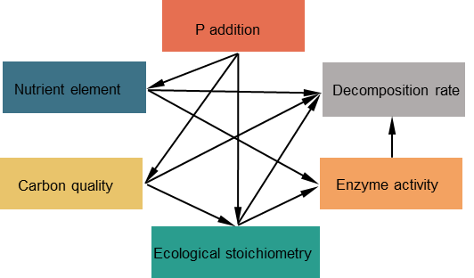
Fig. S2 A priori model for partial least squares-path modeling of litter decomposition under P addition.

Fig. S3 Standard total effects of P addition, nutrient element, carbon quality, ecological stoichiometry, and enzyme activity on above- and belowground litter decomposition rates.

