Title Chromatin insulation orchestrates matrix metalloproteinase gene cluster expression reprogramming in aggressive breast cancer tumors

Authors: Pere Llinàs-Arias¹, Javier I. J. Orozco², Miquel Ensenyat-Mendez¹, Sandra
Íñiguez-Muñoz¹, Betsy Valdez², Matthew P. Salomon³, Chikako Matsuba³, Borja Sesé¹, Anja Mezger⁴, Mattias Ormestad⁴, E Shelley Hwang⁵, Javier Cortés^{6,7,8}, Maggie L. DiNome⁵, Manel Esteller^{9,10,11,12}, Alexander D. Boiko¹³, Mathieu Lupien^{14,15,16} and Diego M. Marzese^{1,*}
From:
1. Cancer Epigenetics Laboratory at the Cancer Cell Biology Group, Health Research Institute of the Balearic Islands (IdISBa), 07120 Palma, Spain.
2. Saint John's Cancer Institute, Providence Saint John's Health Center, Santa Monica, CA, USA.
3. USC Research Center for Liver Diseases, Keck School of Medicine, University of Southern California, Los Angeles, CA, USA
4. Science for Life Laboratory, 17665 Solna, Sweden.
5. Department of Surgery, Duke University School of Medicine, Durham, NC, USA.
6. International Breast Cancer Center (IBCC), Pangaea Oncology, Quiron Group, 08017 Barcelona, Spain.
7. Medica Scientia Innovation Research SL (MEDSIR), 08018 Barcelona, Spain.
8. Department of Medicine, Faculty of Biomedical and Health Sciences, Universidad Europea de Madrid, 28670 Madrid, Spain.
9. Josep Carreras Leukaemia Research Institute, Badalona, Barcelona, Catalonia, Spain.
10. Centro de Investigación Biomédica en Red Cancer (CIBERONC), 28029, Madrid, Spain.
11. Institució Catalana de Recerca i Estudis Avançats (ICREA), Barcelona, Catalonia, Spain.
12. Physiological Sciences Department, School of Medicine and Health Sciences, University of Barcelona (UB), Barcelona, Catalonia, Spain.
13. Cedars-Sinai Medical Center, Samuel Oschin Comprehensive Cancer Institute, Department of Medicine, Los Angeles, CA 90048, USA
14. Princess Margaret Cancer Centre, Toronto, Ontario M5G 1L7, Canada.
15. Department of Medical Biophysics, University of Toronto, Toronto, Ontario M5G 1L7, Canada.
16. Ontario Institute for Cancer Research, Toronto, Ontario M5G 0A3, Canada.

*Corresponding Authors Information:
Diego M. Marzese, PhD
Cancer Epigenetics Laboratory
Institut d'Investigació Sanitària Illes Balears
Palma, Balearic Islands, 07120 Spain.
+34 (871) 205-234
Email: diego.marzese@ssib.es

Supplemental Figures
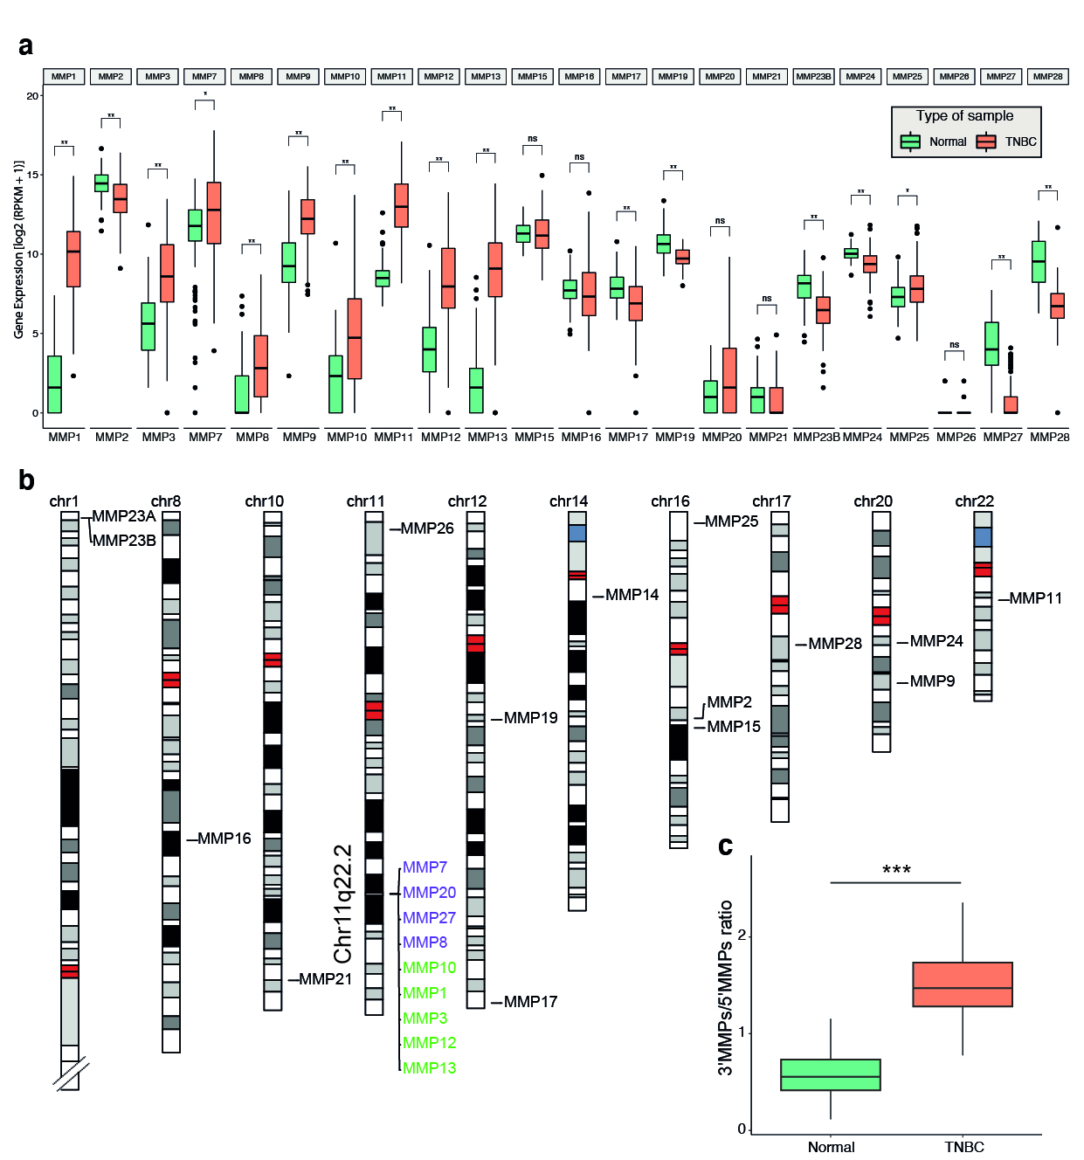
Supplemental Figure 1. Related to Figure 1. a. Gene expression of all human MMP genes in normal and TNBC samples. b. MMP gene distribution across chromosomes. c. The ratio of the 3’MMPs/5’MMPs between normal and TNBC samples. Mann-Whitney test. ns: no significant, *P<0.05, **P<0.01, ***P<0.001.

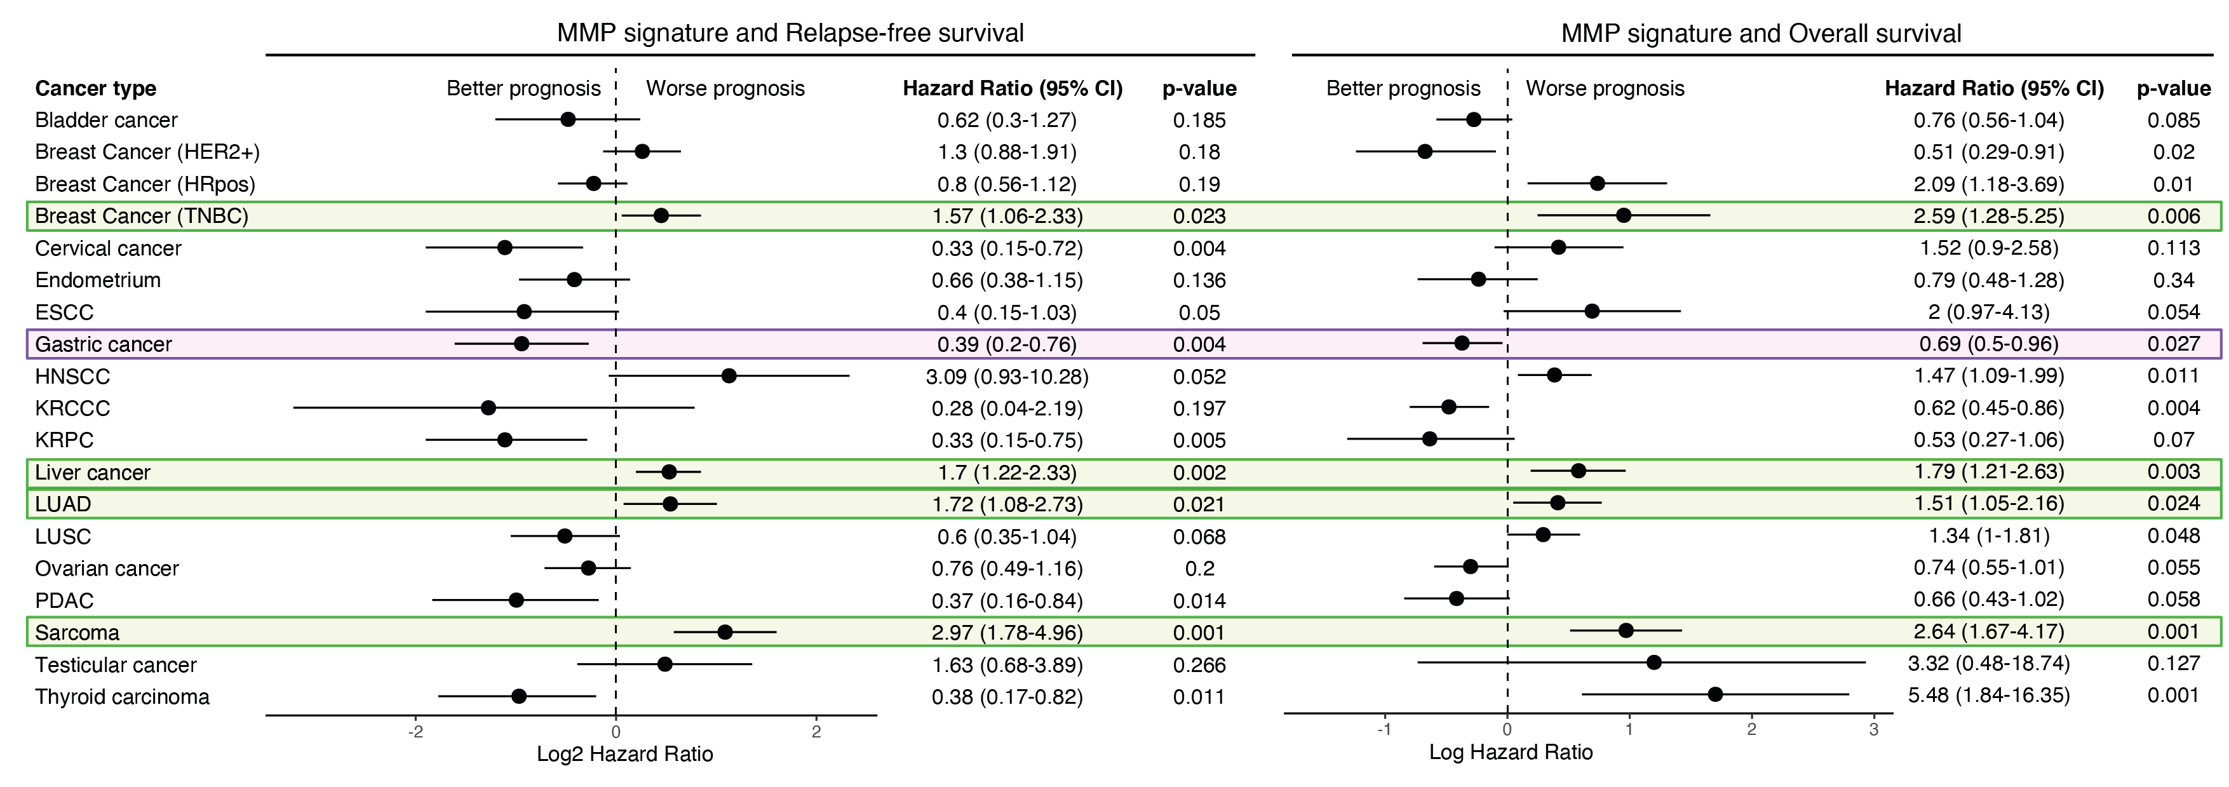
Supplemental Figure 2. Related to Figure 1. Forest plots displaying the Log2 Hazard ratio (RFS, left; OS right) of MMP signature (defined by high expression of 3’MMPs and low expression of 5’MMPs) in different cancer studies included in the KM plotter. Cancer subtypes where MMP signature was associated with worse prognosis in both RFS and OS appear highlighted in green, whereas purple highlight corresponds to the cancer subtype where MMP signature is associated with better prognosis. HRpos: hormone receptor-positive; ESCC: esophageal squamous cell carcinoma; HNSCC: head and neck squamous cell carcinoma; KRCCC: kidney renal clear cell carcinoma; KRPC: kidney renal papillary cell carcinoma; LUAD: Lung adenocarcinoma; LUSC: Lung squamous cell carcinoma; PDAC: Pancreatic ductal adenocarcinoma.
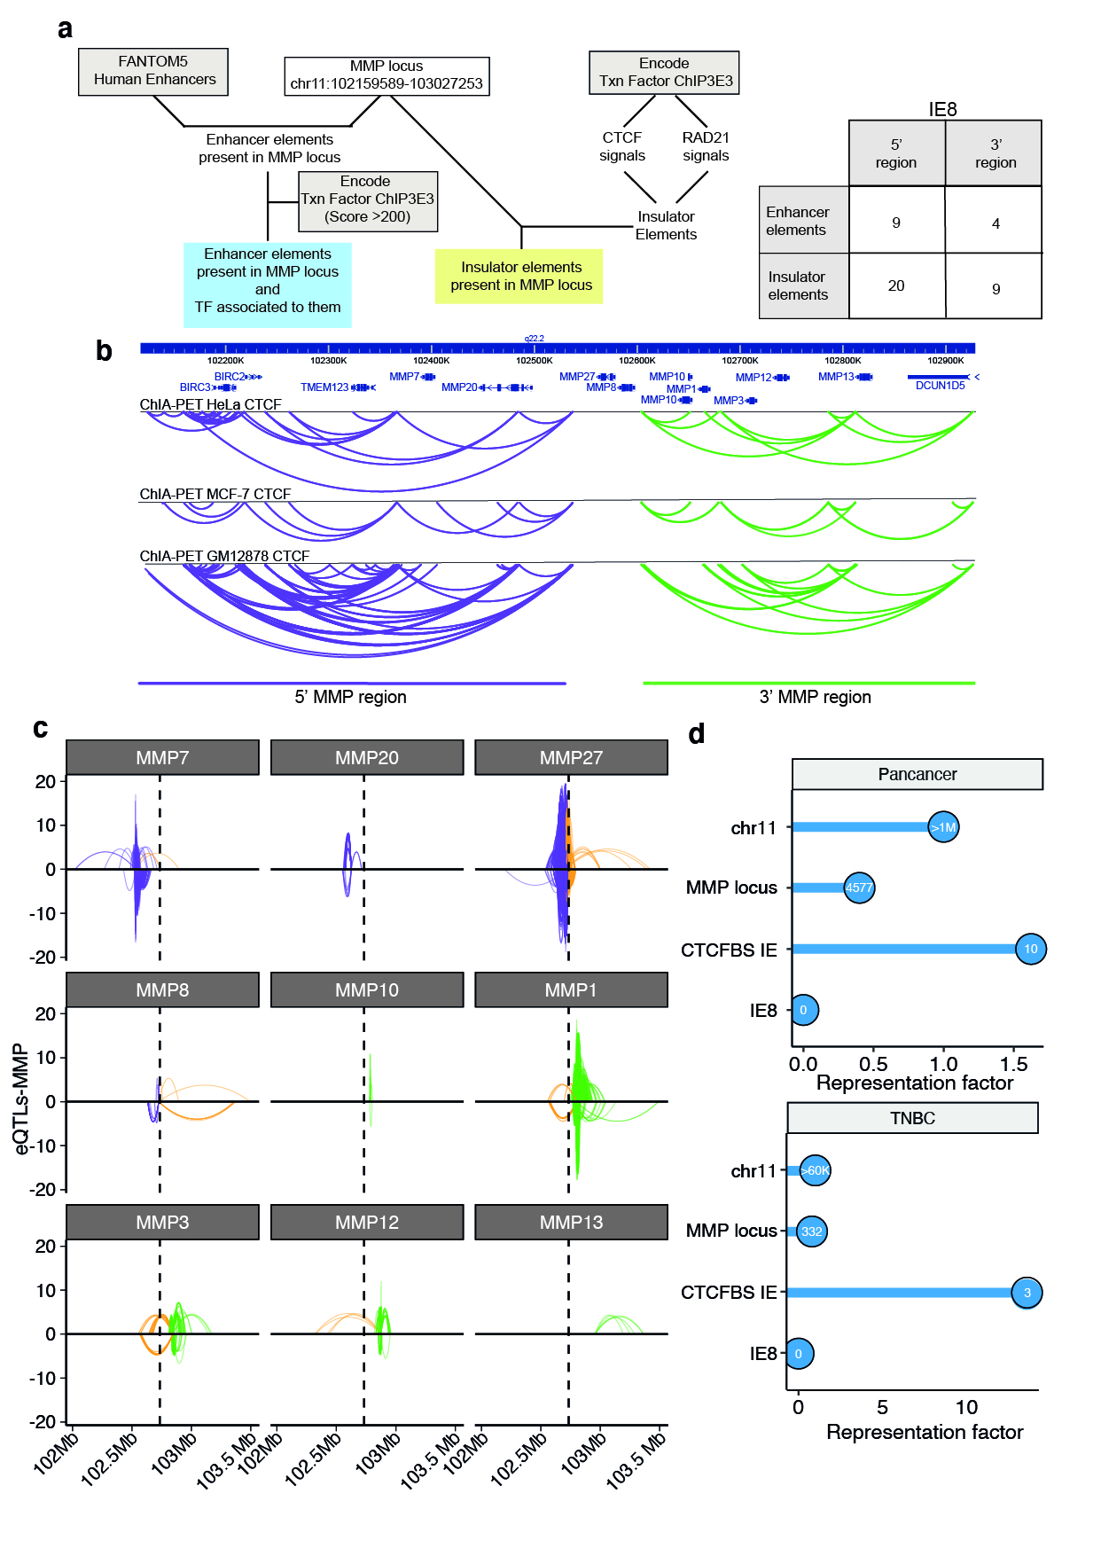
Supplemental Figure 3. Related to Figure 2. a. Workflow for gene regulatory elements identification (left) and summary of characterized gene regulatory elements by spatial location (right). b. ChiA-PET against CTCF at Chr11q22.2 in different cell lines. c. Representation of eQTLs modulating the expression of each MMP gene at Chr11q22.2. Arc colors summarize the interactions according to their relative location. Purple arcs link SNPs and TSS located at the 5’MMP locus, green arcs connect both SNPs and TSS found at the 3’MMP locus and orange arcs correspond to interactions that cross IE8, which is indicated by a dashed vertical line. Arc height is represented by -log₁₀(p-value) for eQTL that are associated with an increase in expression and log₁₀(p-value) for eQTL is linked to a decrease in expression. d. Representation factor of SNPs located at MMP locus, CTCF binding sites of Insulator Elements, and IE8. All data are normalized to chr11 mutation considering the length (bp) of segments. Lollipops also include the raw number of mutations.

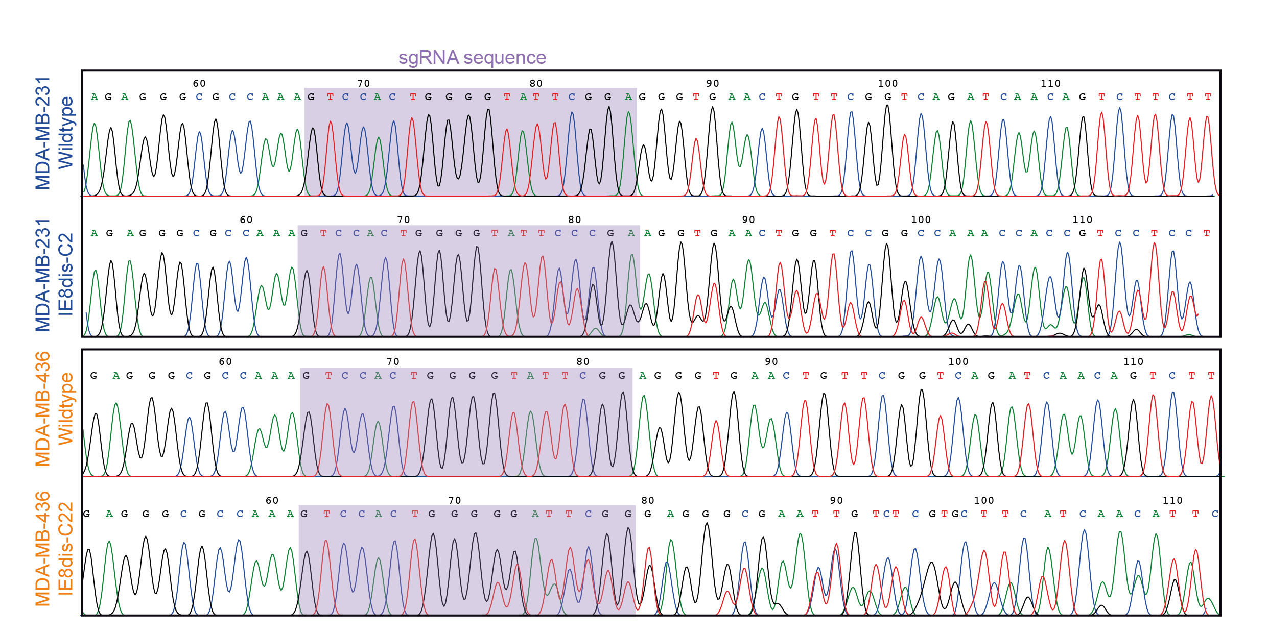

Supplemental Figure 4. Related to Figure 2. Electropherograms of the sgRNA surrounding sequence (highlighted in purple) in MDA-MB-231 and MDA-MB-436 wildtype and selected clone
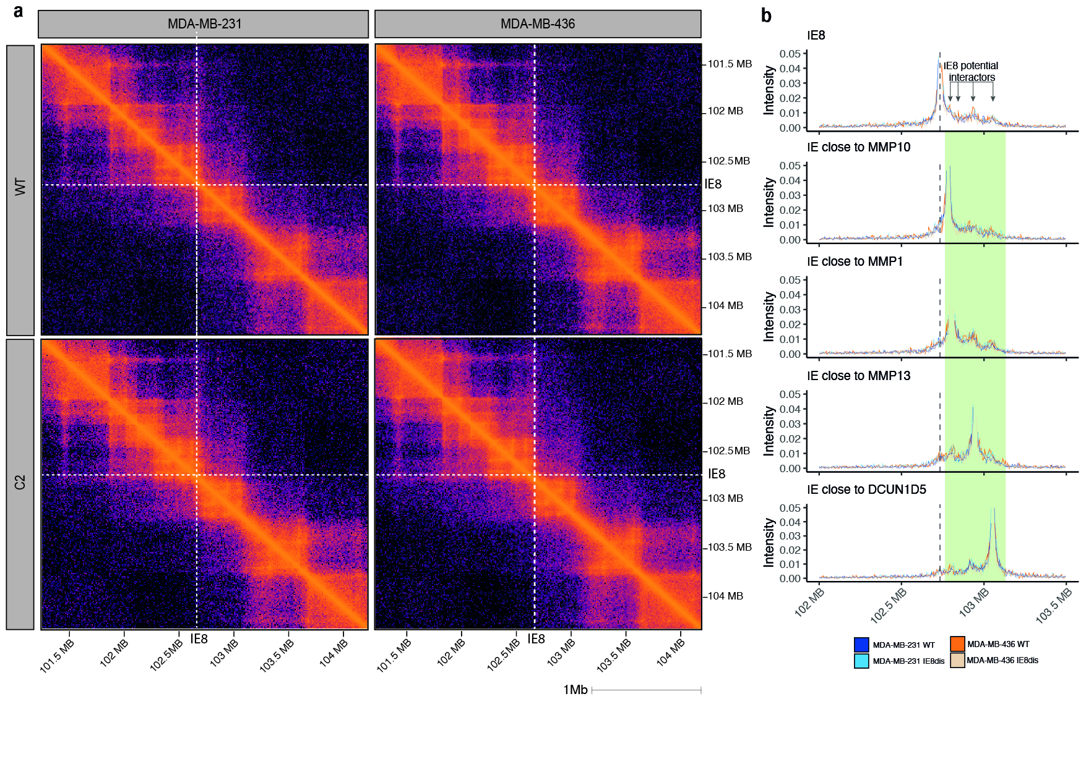
Supplemental Figure 5. Related to Figure 2. a. H-iC contact frequency matrix for the 3Mb genomic region surrounding IE8 binned at 10-kb resolution in MDA-MB-231 and MDA-MB-436 before and after IE8 disruption. b. The intensity of contact interactions of IE8 and its potential partners.
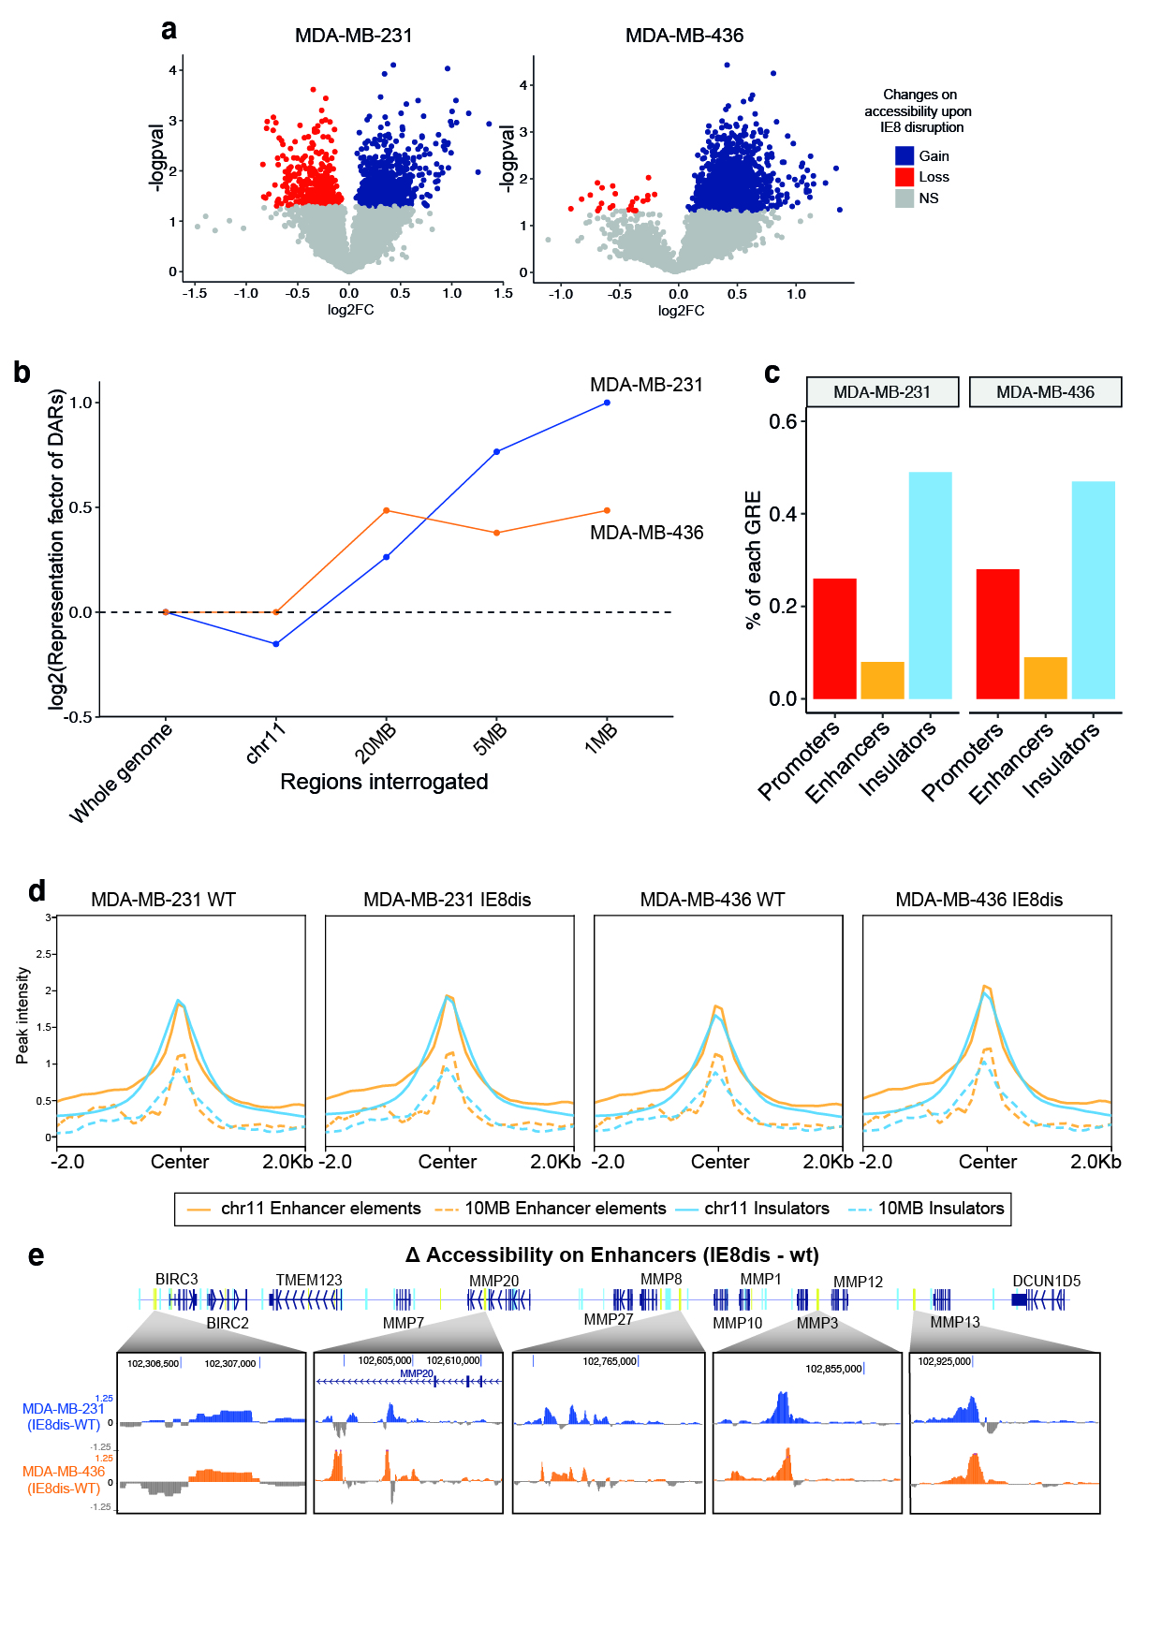
Supplemental Figure 6. Related to Figure 3. a. Volcano plot of overlapping peaks between WT and IE8dis conditions in (left) MDA-MB-231 and MDA-MB-436. b. Gene regulatory element assignment of differential peaks. c. ATAC-seq chromatin accessibility of enhancer elements and insulators located on chr11 and 10MB around IE8. d. Illustrative examples of the variation in promoter accessibility on MMP locus after IE8 disruption in MDA-MB-231 and MDA-MB-436. e. Illustrative examples of the variation in enhancer accessibility on MMP locus after IE8 disruption in MDA-MB-231 and MDA-MB-436.
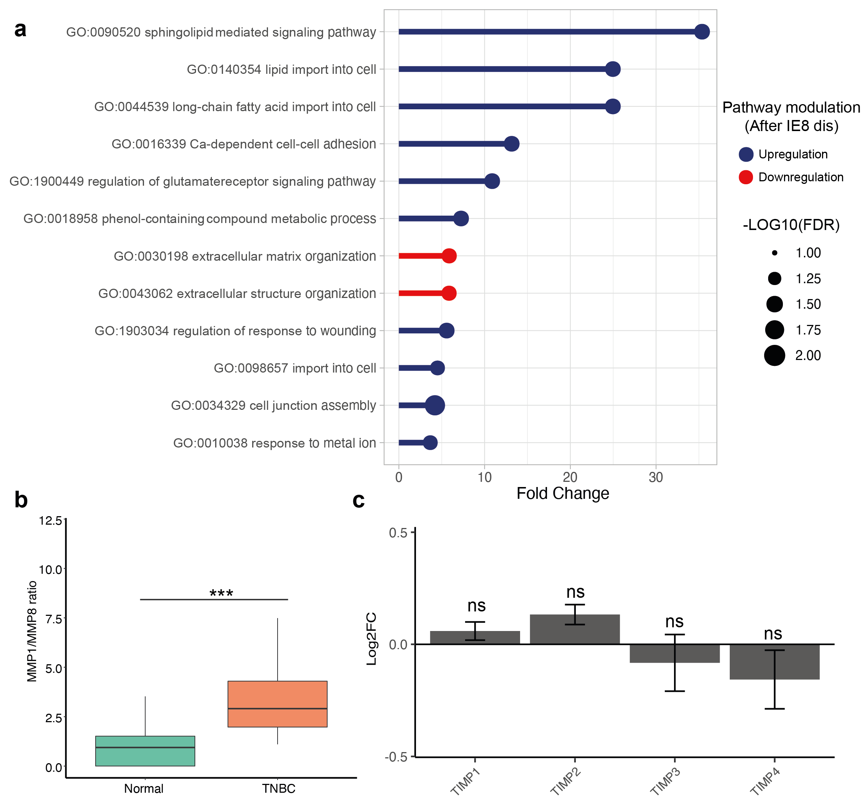

Supplemental Figure 7. Related to Figure 4. a. Gene Ontology showing the most enriched biological processes from RNA-seq differentially expressed genes upon IE8 disruption. b. The ratio between MMP1/MMP8 comparing normal and TNBC samples. Mann-Whitney test. ***P<0.001. c. A variation in TIMP1-4 expression in MDA-MB-231 was determined by RNA-seq. ns: no significant.
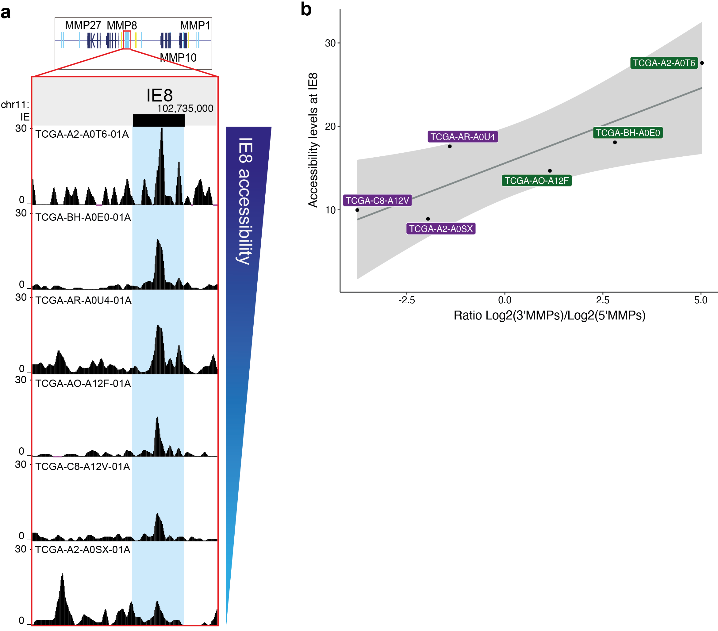

Supplemental Figure 8. Related to Figure 4. a. Accessibility determined as peak intensity on TCGA TNBC samples b. Correlation between IE8 accessibility and log2 ratio of expression between 3’MMPs (MMP1, MMP3, MMP10, MMP12, MMP13) and 5’MMPs (MMP7, MMP8, MMP20, MMP27).

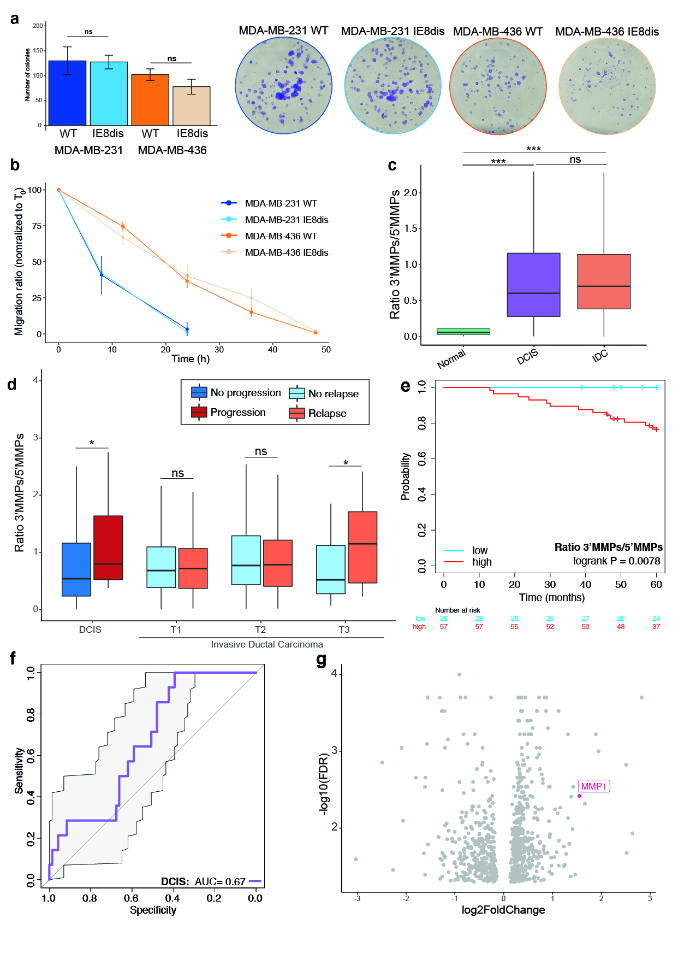
Supplemental Figure 9. Related to Figure 5. a. Number of colonies (left) and illustrative examples generated from 200 cells from MDA-MB-231 and MDA-MB-431 before and after IE8 disruption (right). b. migration ratio of MDA-MB-231 and MDA-MB-431 before and after IE8 disruption. c. 3’MMPs/5’MMPs ratio comparing normal samples with DCIS and invasive ductal carcinoma. d. MMP1/MMP8 ratio of standardized gene expression DCIS and invasive ductal carcinoma. Mann Whitney test. ns: non-significant, **P<0.01. e. Kaplan-Meier curves of relapse-free survival of DCIS using MMP1/MMP8 ratios. f. ROC curves displaying the performance of MMP1/MMP8 ratio in in situ ductal carcinoma. g. MMP1 is upregulated in DCIS which displayed an ipsilateral breast event. Adapted from Strand S.H. et al, 2022.

Supplemental tables

Table S1. List of primers used in sgRNA design, amplicon generation, amplicon sequencing, qPCR from enriched chromatin, and qPCR from RNA-derived cDNA.
Technique | Name | Sequence
sgRNA cloning | sgRNA_Fd | CACCGTCCACTGGGGTATTCGGA
sgRNA cloning | sgRNA_Rv | AAACTCCGAATACCCCAGTGGAC
Amplicon containing sgRNA for sequencing verification | Amplicon_IE8_Fd | CCCTACTTCAGTCCCCTCT
Amplicon containing sgRNA for sequencing verification | Amplicon_IE8_Rv | TTCAAAACCTGGGCTCATCC
Sanger sequencing | Amplicon_IE8_seq | TTCAATGAAGTCACGGATGG
CUT&RUN | IE8_r2_Fd | TGCTAGTGGTCATCATGCCC
CUT&RUN | IE8_r2_Rv | AGTTCACCCTCCGAATACCC
qPCR | qGAPDH_Fd | TGCACCACCAACTGCTTAGC
qPCR | qGAPDH_Rv | GGCATGGACTGTGGTCATGAG
qPCR | qMMP1_Fd | CCCACAAACCCCAAAAG
qPCR | qMMP1_Rv | GATTTGTGCGCATGTAGAATCT
qPCR | qMMP8_Fd | AGTTTTCCAGCAAGAACATT
qPCR | qMMP8_Rv | CAGTTAAGCCATTTATTGCC
qPCR | qMMP2_Fd | GATAACCTGGATGCCGTCGT
qPCR | qMMP2_Rv | CGAAGGCAGTGGAGAGGAAG
qPCR | qMMP9_Fd | ATGCCATTCACGTCGTCCTT
qPCR | qMMP9_Rv | TGACAGCGACAAGAAGTGGG

Supplemental methods

Generation of stable models. Single guide RNA (sgRNA) against the CTCF binding site located on the 3’-side of the MMP8 gene (chr11:102,730,781-102,736,005) was designed using the CHOPCHOP web tool (https://chopchop.cbu.uib.no/) [1]. sgRNA was assembled and cloned into a PsPCas9pSpCas9(BB)-2A-GFP (PX458) as described by Ran, Fa et al [2]. PX458 was a gift from Feng Zhang lab (Addgene # 48138). TNBC cell lines were transiently transfected with either the sgRNA-containing plasmid or the empty vector (EV) using lipofectamine 3000 (Thermofisher), following the manufacturer’s instructions. Two days after transfection, the cells were sorted by FACS, and the EV-transfected GFP-positive cells were collected and maintained as the wild-type population. On the other hand, GFP-positive cells transfected with sgRNA-containing plasmid were serially diluted in 96-well plates to isolate single clones. The disruption of the sgRNA target sequence was analyzed by Sanger sequencing (Macrogen, Madrid). Briefly, clones were grown and DNA was purified using Quick-DNA Microprep Kit (Zymo research). DNA containing the sgRNA target sequence was amplified by PCR, purified using NucleoSpin Gel and PCR clean-up kit (Macherey-Nagel), and sequenced using Macrogen external service. PCR primers used for amplicon generation and sequencing were designed using Primer3 webtool²². PCR primers used for sgRNAs generation, amplicon generation and sequencing are listed in Table S1.

High‐throughput chromosome conformation capture (Hi-C). Hi-C was performed following the manufacturer's protocol from Cantata Bio at the National Genomics Infrastructure, Sweden. 10⁶ cells were fixed, digested, and cross-linked. Chromatin fragments were extracted and captured using magnetic beads to Chromatin Capture Beads. Library prep was done using the NEBNext Ultra II DNA Library Prep (Illumina). NEBNext Multiplex Oligos for Illumina were used as indexes. Sequencing was performed using NovaSeq S4, 151nt(R1)-19nt(I1)-10nt(I2)-151nt(R2). 5 kb bin contact matrices for each replicate were generated.

Protein-chromatin interaction. CTCF binding disruption was assessed by Cleavage Under Targets and Release Using Nuclease (CUT&RUN) followed by qPCR in the two cell line models. First, cells were fixed in 0.1% formaldehyde methanol free (Thermo Scientific) for 2 min at room temperature. Crosslinking was stopped by 1X Glycine Solution (#7005, Cell Signaling Technology (CST)) for 5 min and washed with Complete Wash Buffer (containing 1x Protease inhibitor cocktail and 1x spermidine) twice, and centrifuged at 3,000g at 4 °C for 3 min. All CUT&RUN reactions were performed using CUT&RUN Assay Kit (#86652, CST) following the manufacturer’s instructions. Antibodies were added at the following concentrations: H3K4me3 (C42D8, CST) 1:50; CTCF (3418S, CST) 1:50; IgG isotype control (#66362, CST) 1:20. Input DNA was sonicated using 5 cycles of -15s/45s on/off- at 25% of the power. Enriched chromatin DNA samples and DNA input were purified using DNA Purification Buffer and Spin Column system (#14209, CST). Enriched chromatin DNA samples and DNA input were analyzed by qPCR using CFX96 Touch Real-Time PCR Detection System (Bio-Rad). H3K4me3-chromatin enrichment was used as the positive control, following the manufacturer’s guidelines. Fold enrichment was assessed by dividing CTCF-enriched into IgG-enriched chromatin extracts. PCR primers are listed in Table S1.

Chromatin accessibility profiling by ATAC-seq. 100,000 viable cells were collected and centrifuged for each replicate. Cell pellets were gently lysed for 3 min on ice. Cell nuclei were incubated for 30 min at 37ºC 1000 rpm in a thermal mixer in the presence of tagmentase. DNA product was purified using MinElut purification columns (Qiagen). Samples were sent to the National Genomics Infrastructure, Sweden. Libraries were prepared following the OmniATAC protocol [3]. All libraries were purified using AMPure XP beads (Beckman Coulter) with a 1:1.8 ratio and sequenced in paired-end mode with a read length of 51nt(R1)-10nt(I1)-10nt(I2)-51nt(R2) on a Novaseq6000(Illumina) following the manufacturer’s instructions. Data was processed following the Galaxy project ATACseq guidelines [4]. Briefly, raw sequencing reads were first processed using cutadapt to remove low-quality reads and adapters. Trimmed reads were then aligned to the human reference genome assembly hg38 using bowtie2. Poorly mapped reads, PCR duplicates, and reads that mapped to mitochondrial DNA were removed using BAMtools. Peaks were generated using MACS2 without building any shifting model. The resulting bedgraphs were used to generate bigwig files, which were used to visualize the peaks on the UCSC genome browser. Consensus peaks for each cell line and condition were defined by their presence in all three replicates. Bedtools v2.18 was employed to determine common and exclusive peaks between each condition. Heatmaps around TSS, insulators, and enhancers were performed using the computeMatrix tool in Galaxy. NCBI RefSeq genes were considered for TSS regions. Insulator elements were defined as the intersection of CTCF and RAD21 ChIP-seq peaks. The location of Enhancer elements was downloaded from the FANTOM5 website [5].

RNA expression analysis by RNA-seq. Total RNA was purified using the EZNA Total RNA Kit I (Omega Biotek). For qPCR, 1 μg of RNA was retrotranscribed using SensiFAST cDNA Synthesis Kit (Bioline). qPCR reactions were performed using PerfeCTa qPCR SuperMix (Quantabio) in a CFX96 Touch Real-Time PCR Detection System (Bio-Rad). Data were normalized using GAPDH as an endogenous control. qPCR primers are listed in Table S1. RNA-seq was performed for three independent replicates of the MDA-MB-231 WT and MDA-MB-231 IE8-disrupted cell lines at NIMGENETICS, Madrid. Briefly, RNA quality was controlled by RNA ScreenTape (Agilent). All samples showed an RNA Integrity Number (RIN) equal to 10. Libraries were prepared with TruSeq stranded mRNA kit (Illumina) and sequenced in paired-end mode with a read length of 2x100bp on a HiSeq2000 (Illumina) following the manufacturer’s protocol. An average of 50 million pairs of 100-bp paired-end read per sample was generated. After adapter trimming and quality score calculation, an average of 64 to 87 million reads was left on each sample. Table counts were processed using the DEseq2 package to identify differentially expressed genes (DEGs). Gene Ontology was performed using the topGO R package. DEGs were also used to calculate the local enrichment of expression changes, comparing DEGs 1MB around IE8, the entire chromosome 11 (chr11), and the entire genome. The representation factor was assessed through a hypergeometric test.

MMP1 protein level determination. Free Pro-MMP1 was determined using the Human Pro-MMP1 Quantikine ELISA Kit (DMP100, R&D) using Quantikine Immunoassay Control Set 656 for Human Pro-MMP-1 as an internal control (QC125, R&D). The optical density values were interpolated to a standard curve to calculate the corresponding concentration of the unknown samples.

Cell proliferation. Cell viability was assessed by the Celltiter-GLO® assay (Promega). 1,000 cells/well were seeded in 96-well white opaque plates. Cell viability was assessed by adding 25uL of Celltiter reconstituted reagent on each well and measuring luminescence using microplate reader Synergy H1(Biotek). Luminescence signals were normalized to time zero for each cell line and condition.

Colony formation assay. 200 cells per well were seeded in 6-well plates and incubated at 37ºC and 5% CO₂ for 10 days. After incubation, colonies were fixed using 4% formaldehyde for 10 minutes and stained with 1% crystal violet for 1h. Wells were washed using PBS twice. After drying overnight, colonies were manually counted. Images were taken using iPhone 10.

Wound healing assay. A longitudinal line was drawn on each well of 6-well plates before seeding 500,000 cells/well. Cells were incubated at 37ºC and 5% CO₂. Vertical scratch wounds were performed using 200uL pipette tips once the cells reached 95% confluence. Then, wells were gently washed with PBS and continuously cultured until the wound was completely closed. Images were taken at different time points using Axio Vert.A1 inverted microscope (Zeiss). Then, images were processed using the ImageJ Wound_healing_size_tool plugin. Area calculations were performed following the plugin author’s guidelines.

Spheroid invasion assay. 5,000 cells for each cell type and condition were seeded into low attachment Biofloat 96-well plates (faCellitate, Mannheim). Cells were incubated for 72h at 37ºC and 5% CO₂ for spheroid formation. Then, cells were embedded in a mixture of cold 8mg/ml EBM (Thermofisher) and 250ug/ml of rat collagen I (Thermofisher), which was loaded into each well while the plate was placed on ice. The plate was centrifuged at 200 x g for 2min and reincubated at 37°C and 5% CO2 for one hour. Subsequently, 100uL of RPMI complete media was added to the top of the matrix mixture. Plates were incubated for 10 days. Images of spheroids were taken with Axio Vert.A1 microscope (Zeiss) to evaluate the extent of spheroid proliferation and invasion. Spheroids were analyzed using Fiji. Spheroid volume was calculated from the area, which was first determined by combining the threshold, magic wand, and measurement tools.

Collagen-based cell invasion assay. Cells were incubated for 18h in serum-free media. Cells were seeded in QCM-24-well collagen-based cell invasion assay (ECM551, Merck). The assay was performed following the manufacturer’s guidelines. Briefly, 300uL of pre-warmed serum-free media was added to the chamber inserts, which were deposited on 24-well plates. Inserts were incubated to rehydrate the collagen layer for 30 min at 37ºC and 5% CO₂. Then, 250uL of media was replaced by 250uL of cell suspension in serum-free media containing 100,000 cells. Complete media was added to the lower chamber to act as a chemoattractant. The plate was incubated for 48h at 37ºC and 5% CO₂ to allow cell invasion. Inserts were stained for 20 min and washed following the kit instructions. Cell staining was quantified using extraction buffer followed by optical density determination through microplate reader Synergy H1 (Biotek). Cell invasion index was normalized to MDA-MB-231 WT signal.

Extended methods - references

1. Labun K, Montague TG, Krause M, Cleuren YNT, Tjeldnes H, Valen E. CHOPCHOP v3: expanding the CRISPR web toolbox beyond genome editing. Nucleic Acids Res. Oxford University Press; 2019;47:W171–4.

2. Ran FA, Hsu PD, Wright J, Agarwala V, Scott DA, Zhang F. Genome engineering using the CRISPR-Cas9 system. Nat Protoc. 2013;8:2281–308.

3. Corces MR, Trevino AE, Hamilton EG, Greenside PG, Sinnott-Armstrong NA, Vesuna S, et al. An improved ATAC-seq protocol reduces background and enables interrogation of frozen tissues. Nat Methods [Internet]. Nature Publishing Group; 2017 [cited 2023 Mar 8];14:959–62. Available from: https://www.nature.com/articles/nmeth.4396

4. Delisle L, Doyle M, Heyl F. ATAC-Seq data analysis (Galaxy Training Materials) [Internet]. Galaxy Train. Netw. Galaxy Training Network; [cited 2022 Dec 16]. Available from: https://training.galaxyproject.org/training-material/topics/epigenetics/tutorials/atac-seq/tutorial.html

5. Lizio M, Abugessaisa I, Noguchi S, Kondo A, Hasegawa A, Hon CC, et al. Update of the FANTOM web resource: expansion to provide additional transcriptome atlases. Nucleic Acids Res. 2019;47:D752–8.

