APPLICATION OF ALGINATE EXTRACTION RESIDUE FOR AL(III) IONS BIOSORPTION: A COMPLETE BATCH SYSTEM EVALUATION

Heloisa Pereira de Sá Costa¹, Meuris Gurgel Carlos da Silva¹, Melissa Gurgel Adeodato Vieira¹*
¹Department of Processes and Products Design, School of Chemical Engineering, University of Campinas, Albert Einstein Av., 500, Campinas, São Paulo, 13083-852, Brazil
* Corresponding author: Prof. Dr. Melissa Gurgel Adeodato Vieira.
E-mail address: melissag@unicamp.br. Telephone: +55.19.3521.0358

Supplementary Material
Fig 1S Adjustments of the experimental data for the initial Al concentration of 1 mmol/L by the kinetic models: a) Pseudo-first order and Pseudo-second order; b) Intraparticle diffusion; c) Boyd model and d) EMTR
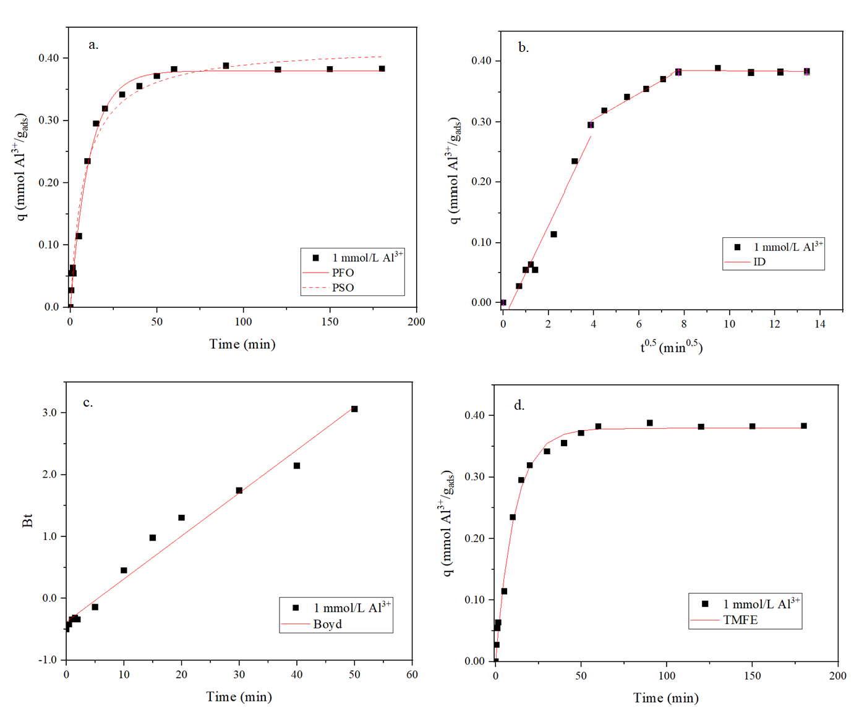
Fig 2S Adjustments of the experimental data for the initial Al concentration of 2 mmol/L by the kinetic models: a) Pseudo-first order and Pseudo-second order; b) Intraparticle diffusion; c) Boyd model and d) EMTR

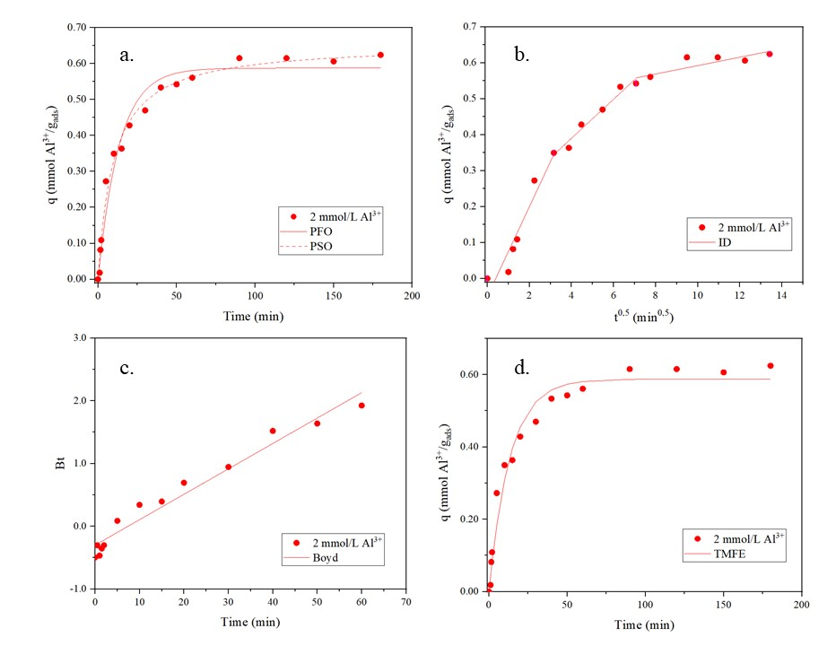
Fig 3S Adjustments of the experimental data for the initial Al concentration of 3 mmol/L by the kinetic models: a) Pseudo-first order and Pseudo-second order; b) Intraparticle diffusion; c) Boyd model and d) EMTR
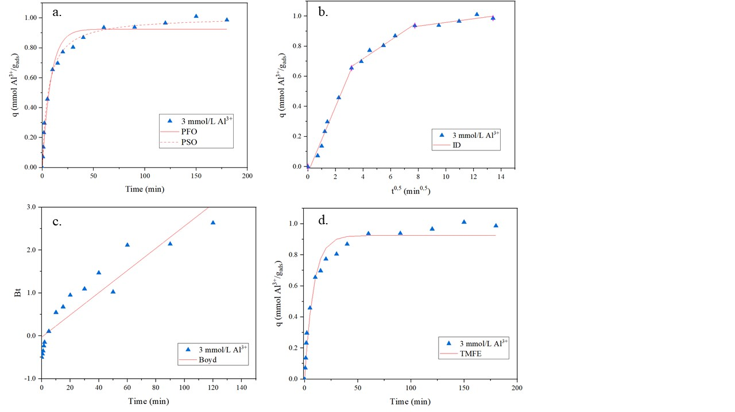

Fig 4S Plot of ln (K) versus 1/T to obtain the thermodynamic parameters
