Supplementary Figure 1. Flow chart of analysis.
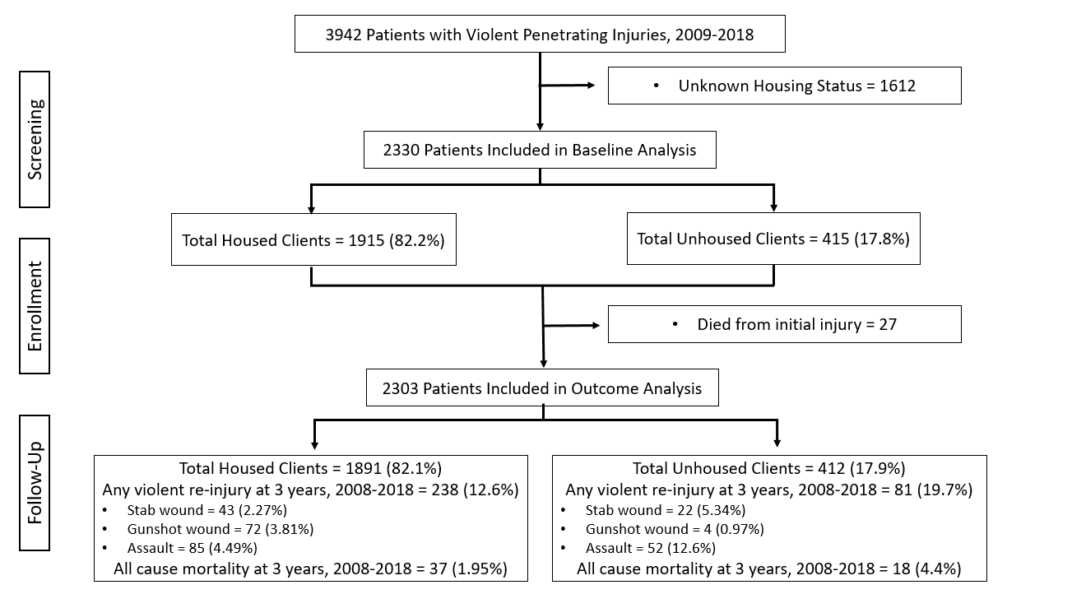

Supplementary Table 1. Primary causes of death for survivors of violent penetrating injury.
Cause of Death | Number of deaths at 3 years post-injury
Drug or alcohol overdose/overuse death | 22
Firearm discharge/Gun-shot wound | 16
Adult respiratory distress syndrome/Chronic obstructive pulmonary disease (COPD) | 2
Assault by sharp object | 2
Atherosclerotic cardiovascular disease | 2
Intentional self-harm by hanging, strangulation, or suffocation | 2
Unspecified diabetes mellitus: without complications | 2
Assault by unspecified means | 1
Intentional self-harm by other or unspecified firearm discharge | 1
Legal intervention involving firearm discharge | 1
Motor vehicle crash | 1
Obesity, unspecified | 1
Other ill-defined and unspecified causes of mortality | 1
Subarachnoid hemorrhage, unspecified | 1

Supplementary Table 2. Risk of all-cause mortality at 3 years after surviving a penetrating injury treated at Boston Medical Center, 2009-2018
All-Cause Mortality | n (%) | Univariate Model |  |  | Age-Adjusted Model |  |  | Full Multivariable Model |  |  | Final Multivariable Model
 |  | HR (95% CI) | p |  | HR (95% CI) | p |  | HR (95% CI) | p |  | HR (95% CI) | p
Total Deaths | 55 (2.4)
Age |  | 1.03 (1.01-1.05) | 0.006 |  | - |  |  | 1.01 (0.98-1.04) | 0.308 |  | 1.02 (0.99-1.04) | 0.07
Housing Status |  |  | 0.004 |  |  | 0.031 |  |  | 0.342 |  |  | 0.07
Housed | 37 (2.0) | 1.00 |  |  | 1.00 |  |  | 1.00 |  |  | 1.00
Unhoused | 18 (4.4) | 2.27 (1.29-3.98) |  |  | 1.91 (1.06-3.42) |  |  | 1.36 (0.72-2.57) |  |  | 1.71 (0.96-3.08)
Gender |  |  | 0.102 |  |  | 0.089 |  |  | 0.05 |  |  | 0.09
Female | 4 (1.1) | 1.00 |  |  | 1.00 |  |  | 1.00 |  |  | 1.00
Male | 51 (2.6) | 2.34 (0.84-6.46) |  |  | 2.42 (0.87-6.70) |  |  | 2.49 (0.89-6.97) |  |  | 2.40 (0.87-6.64)
Race/ethnicity |  |  | 0.013 |  |  | 0.034 |  |  | 0.105 |  |  | 0.04
Black | 32 (2.1) | 1.00 |  |  | 1.00 |  |  | 1.00 |  |  | 1.00
Hispanic | 8 (1.9) | 0.89 (0.41-1.95) |  |  | 0.93 (0.43-2.01) |  |  | 1.01 (0.46-2.20) |  |  | 0.93 (0.43-2.02)
White | 14 (6.1) | 3.06 (1.64-5.74) |  |  | 2.70 (1.43-5.11) |  |  | 2.47 (1.27-4.80) |  |  | 2.61 (1.37-4.95)
Other | 0 (0.0) | - |  |  | - |  |  | - |  |  | -
Unknown | 1 (1.8) | 0.88 (0.13-6.47) |  |  | 0.89 (0.12-6.49) |  |  | 0.99 (0.14-7.37) |  |  | 0.88 (0.12-6.43)
Insurance Payer |  |  | 0.478 |  |  | 0.566 |  |  | 0.442
Medicaid/Medicare | 35 (2.5) | 1.00 |  |  | 1.00 |  |  | 1.00
Private | 9 (3.3) | 1.33 (0.64-2.77) |  |  | 1.32 (0.63-2.74) |  |  | 1.71 (0.81-3.63)
No Health Insurance | 3 (1.3) | 0.54 (0.17-1.75) |  |  | 0.57 (0.18-1.87) |  |  | 0.67 (0.20-2.22)
Unknown | 9 (2.2) | 0.79 (0.36-1.71) |  |  | 0.81 (0.38-1.75) |  |  | 0.91 (0.42-1.98)
Injury type |  |  | 0.729 |  |  | 0.765 |  |  | 0.145
Gunshot wound | 24 (2.3) | 1.00 |  |  | 1.00 |  |  | 1.00
Stab wound | 31 (2.5) | 1.10 (0.64-1.87) |  |  | 0.92 (0.53-1.60) |  |  | 0.63 (0.34-1.17)
Employment status |  |  | 0.042 |  |  | 0.042 |  |  | 0.221
Employed | 11 (1.4) | 1.00 |  |  | 1.00 |  |  | 1.00
Unemployed | 33 (3.0) | 2.26 (1.14-4.47) |  |  | 2.29 (1.16-4.52) |  |  | 1.84 (0.90-3.78)
Unknown | 11 (2.7) | 2.00 (0.87-4.61) |  |  | 1.80 (0.78-4.16) |  |  | 1.60 (0.65-3.90)
Comorbidities
Any mental health disorder | 17 (3.8) | 1.88 (1.06-3.33) | 0.031 |  | 1.73 (0.97-3.08) | 0.062 |  | 1.40 (0.76-2.57) | 0.289
Cox proportional hazards regression model was used to estimate hazard ratios (HR) and 95% confidence intervals (CI). Full multivariable model is adjusted for housing status, age, gender, race/ethnicity, insurance status, employment status, any mental health disorder, and injury type. Final multivariable model is adjusted for housing status, age, gender, and race/ethnicity.

Supplementary Table 3. Risk of all-cause violent re-injury at 3 years after surviving a penetrating injury treated at Boston Medical Center, 2009-2018
All-Cause Reinjury | n (%) | Univariate Model |  |  | Age-Adjusted Model |  |  | Full Multivariable Model |  |  | Final Multivariable Model
 |  | HR (95% CI) | p |  | HR (95% CI) | p |  | HR (95% CI) | p |  | HR (95% CI) | p
Total Violent Reinjuries | 319 (14)
Housing Status |  |  | <0.0001 |  |  | <0.0001 |  |  | 0.13 |  |  | 0.02
Housed | 238 (13) | 1.00 |  |  | 1.00 |  |  | 1.00 |  |  | 1.00
Unhoused | 81 (20) | 1.67 (1.30-2.14) |  |  | 1.74 (1.34-2.26) |  |  | 1.24 (0.94-1.65) |  |  | 1.39 (1.06-1.83)
Age |  | 0.99 (0.98-1.01) | 0.88 |  | - |  |  | 0.98 (0.97-0.99) | 0.001 |  | 0.98 (0.97-0.99) | 0.0004
Gender |  |  | 0.16 |  |  | 0.16 |  |  | 0.045
Female | 40 (11) | 1.00 |  |  | 1.00 |  |  | 1.00
Male | 279 (14) | 1.27 (0.91-1.77) |  |  | 1.27 (0.91-1.77) |  |  | 1.41 (1.01-1.98)
Race/ethnicity |  |  | <0.0001 |  |  | <0.0001 |  |  | 0.0005 |  |  | 0.0003
Black | 242 (16) | 1.00 |  |  | 1.00 |  |  | 1.00 |  |  | 1.00
Hispanic | 40 (10) | 0.58 (0.42-0.81) |  |  | 0.58 (0.42-0.81) |  |  | 0.59 (0.43-0.84) |  |  | 0.58 (0.42-0.82)
White | 34 (15) | 0.98 (0.68-1.40) |  |  | 0.99 (0.69-1.42) |  |  | 0.78 (0.54-1.14) |  |  | 0.79 (0.55-1.14)
Other | 0 (0) | - |  |  | - |  |  | - |  |  | -
Unknown | 3 (6) | 0.25 (0.11-1.09) |  |  | 0.35 (0.11-1.09) |  |  | 0.40 (0.13-1.26) |  |  | 0.40 (0.13-1.24)
Insurance Payer |  |  | 0.27 |  |  | 0.27 |  |  | 0.75
Medicaid/Medicare | 210 (15) | 1.00 |  |  | 1.00 |  |  | 1.00
Private | 32 (12) | 0.77 (0.53-1.11) |  |  | 0.77 (0.51-1.15) |  |  | 0.99 (0.68-1.44)
No Insurance | 26 (12) | 0.77 (0.51-1.16) |  |  | 0.77 (0.53-1.12) |  |  | 0.91 (0.60-1.38)
Unknown | 51 (13) | 0.83 (0.61-1.13) |  |  | 0.83 (0.61-1.13) |  |  | 0.84 (0.62-1.16)
Comorbidities
Any substance use/abuse | 112 (35) | 2.37 (1.89-2.99) | <0.0001 |  | 2.88 (2.22-3.72) | <0.0001 |  | 2.34 (1.77-3.09) | <0.0001 |  | 2.46 (1.88-3.22) | <0.0001
Any mental health disorder | 89 (20) | 1.71 (1.34-2.19) | <0.0001 |  | 1.72 (1.35-2.21) | <0.0001 |  | 1.46 (1.12-1.89) | 0.006 |  | 1.40 (1.09-1.81) | 0.01
Injury type |  |  | 0.53 |  |  | 0.50 |  |  | 0.51
Gunshot wound | 142 (14) | 1.00 |  |  | 1.00 |  |  | 1.00
Stab wound | 177 (14) | 1.07 (0.86-1.34) |  |  | 1.08 (0.86-1.36) |  |  | 0.92 (0.72-1.18)
Employment status |  |  | <0.0001 |  |  | <0.0001 |  |  | <0.0001
Employed | 67 (8) | 1.00 |  |  | 1.00 |  |  | 1.00
Unemployed | 173 (16) | 2.02 (1.52-2.68) |  |  | 2.02 (1.52-2.67) |  |  | 1.63 (1.22-2.18)
Unknown | 79 (19) | 2.51 (1.81-3.47) |  |  | 2.52 (1.82-3.49) |  |  | 2.30 (1.64-3.22)

Supplementary Figure 2. Cumulative incidence of violent reinjury by stab wound at 3 years after surviving a penetrating injury treated at Boston Medical Center, 2012-2021.
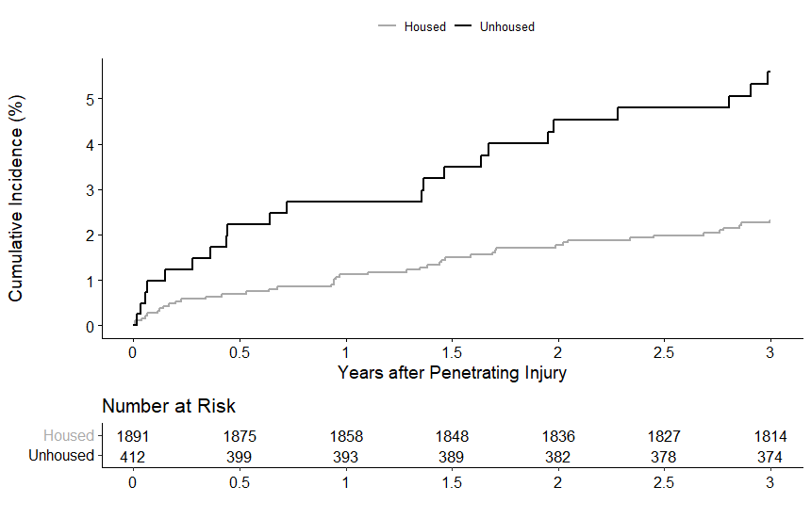

Supplementary Figure 3. Cumulative incidence of violent reinjury by gunshot wound at 3 years after surviving a penetrating injury treated at Boston Medical Center, 2012-2021.
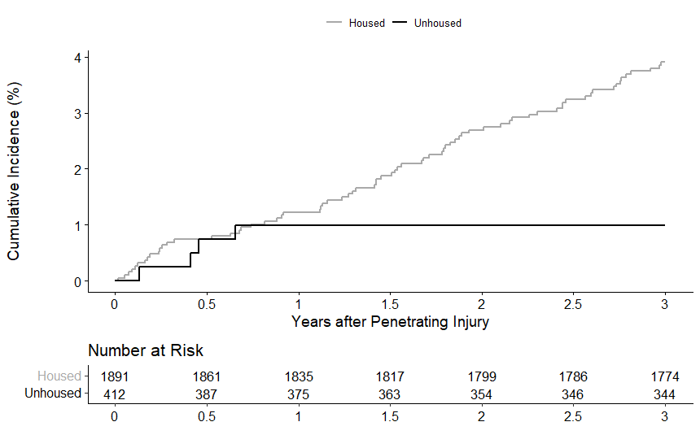

Supplementary Figure 4. Cumulative incidence of violent reinjury by assault at 3 years after surviving a penetrating injury treated at Boston Medical Center, 2012-2021.
